Name: ______Adam Capdeville__ Lab 2

Database Systems September 11, 2019

**Part I. Get Ready (5pts)**

1. Figure 1 represents an abstract view for a small boutique airline booking system.

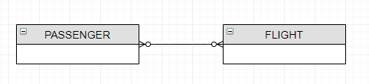

Figure 1 - Passenger Flights

Use Draw.io to reconstruct the ERD for a simple airline booking system. Include all primary and foreign key attributes. Think creatively to construct two additional entities that relate to any of the entities below entities. When developing new entities, you want to think about how your system can be extended to provide additional services and store more data.

PASSENGER - Stores relevant passenger data.  
PILOT - Stores pilot information. Each comment is associated with a blog and a user.

TERMINAL– Stores terminal information.

FLIGHT – Stores flight information including origination and destination terminals and pilot information.

RESERVATION – Stores information related to passengers and the flights they book.

NEW ENTITY 1 (provide description for new entity 1)

NEW ENTITY 2 (provide description for new entity 2)

NEW ENTITY 3 (provide description for new entity 3)

**Part II. Get Set (10pts)**

Refer to the following ERD, which maps courses to prerequisites. Answer questions 3 – 12.

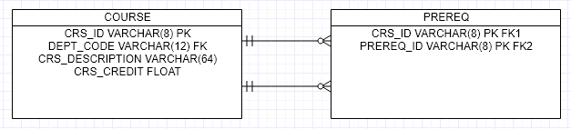

1. (T || F) _____PREREQ is a strong entity.
2. (T || F) _____The relationship COURSE:PREREQ is weak.
3. (T || F) _____All prerequisite courses (crs_code) in PREREQ, must link with a valid course in COURSE.
4. (T || F) _____A PREQ can exist without an existence of a course if the PREREQ course has not been defined yet.
5. (T || F) _____The foreign key in PREREQ is a composite key (CRS_ID, PREREQ_ID).
6. (T || F) _____Upon implementation, table indexes are automatically generated for both tables.
7. (**4pts**) What does it mean to say that a database displays both entity integrity and referential integrity? How are each established?

**Part III. Go (10pts)**

Consider the database SaleCo, comprised of the following tables, attributes and data.

|  |
| --- |
| **Database name: SaleCo** |
| **Table name: CUSTOMER** |
|  |
| **Table name: INVOICE** |
|  |
| **Table name: LINE** |
|  |
| **Table name: PRODUCT** |
|  |
| **Table name: VENDOR** |
|  |

Complete the table below and identify candidate key(s), primary key(s) and foreign keys, and whether or not the entities exhibit entity and relational integrity.

|  |  |  |  |  |
| --- | --- | --- | --- | --- |
| **Table** | **8.**  **Primary Key(s)** | **9.**  **Foreign Key(s)** | **10.**  **Entity Integrity  (Y || N || NA)** | **11.**  **Relational Integrity (Y || N || NA)** |
| CUSTOMER |  |  |  |  |
| PRODUCT |  |  |  |  |
| VENDOR |  |  |  |  |
| INVOICE |  |  |  |  |
| LINE |  |  |  |  |

**Part IV. Go (15pts)**

Ex. Project columns for name and date. Provide a screenshot of your query window as well as your query results.

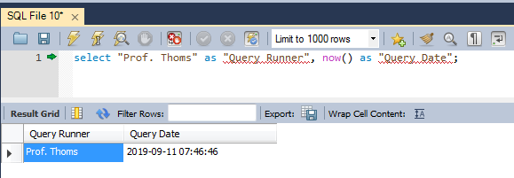

1. Create the SQL to project customer data and restrict the results based on customers having balances greater than $0. Project all fields shown below. Also project two new columns to display your name and date the query was run. Provide a screenshot that shows the query as depicted above.   
   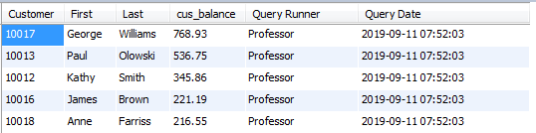
2. Create the SQL to project product data and restrict the results based on products provided by Bryson, Inc. and Gomez Bros. Project all fields shown below. Also project two new columns to display your name and date the query was run. Provide a screenshot that shows the query as depicted above. Sort your results first by vendor and then by product price. (This query requires a table join on PRODUCT and VENDOR).  
   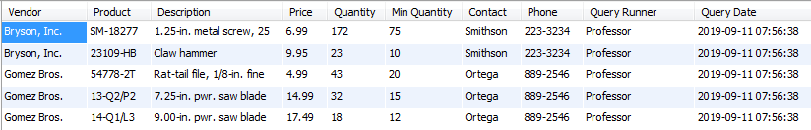
3. Create the SQL to return products sold which have no associated vendor. Project all fields shown below. Also project two new columns to display your name and date the query was run. Provide a screenshot that shows the query as depicted above. 
4. Create the SQL to project invoice information for customers with outstanding balances. Project all fields shown below. Also project two new columns to display your name and date the query was run. Provide a screenshot that shows the query as depicted above. (This query requires a multi-table join with CUSTOMER and INVOICE and INVOICE and LINE).   
   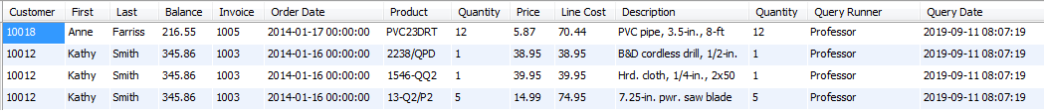
5. Create the SQL to project the savings customer Leona Dunne would make when purchasing 10 Claw Hammers. Project all fields shown below. Also project two new columns to display your name and date the query was run. Provide a screenshot that shows the query as depicted above. (This query requires a multi-table join).  
   
6. (**5pts**) Reverse engineer the ERD for SaleCo. Include all identifying attributes as well as appropriate datatypes.