Name: _____________________ Lab 3

Database Systems September 18, 2019

For this lab, you will construct databases for ERDs created during Lab 1. Please be sure to create the appropriate schemas for each database. For each database, create the database in MySQL and reverse engineer it in MySQL Workbench as shown in the example below. Ensure your databases exhibit entity and referential integrity.

**Part I. Get ready. Get Set. Go!**

Ex. CIToots is a new database that tracks undergraduate academic tutors across all majors. Only valid CI students may tutor and a tutor my tutor multiple subjects. A single major may list multiple subjects available for tutoring. Reconstruct the database in MySQL and reverse engineer the database as shown below. (0pts)

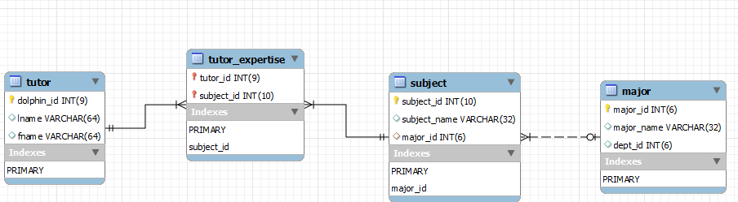

1. CIMinors is a database that tracks students and their minors. Students are required to declare a minor and a single student may have multiple minors declared. A student minor must link back to a valid CI academic program. Reconstruct the database in MySQL and reverse engineer the output based on the ERD below. (5pts)  
   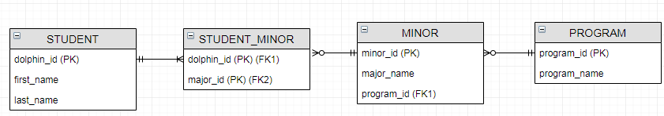
2. CIBB is an online bulletin board, which allows students with a valid CI email address to post things online. A single post consists of basic data such as student / contact, post content and date. A student may post multiple bulletin board items. Reconstruct the database in MySQL and reverse engineer the output based on the ERD below. (5pts)

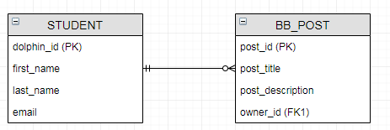

1. CIResearch is a database that will track campus research. The database will capture students, faculty mentors and research projects. Students may work on multiple projects, but only one faculty can lead a project. Reconstruct the database in MySQL and reverse engineer the output based on the ERD below. (5pts)  
   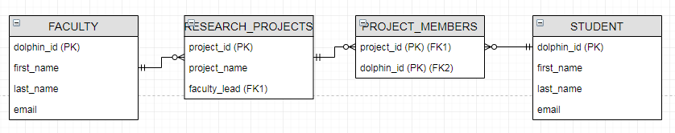
2. CIMusicShare allows students to share MP3s. CI students can upload and share their music. A single MP3 can be downloaded by many students. Reconstruct the database in MySQL and reverse engineer the output based on the ERD below. (5pts)  
   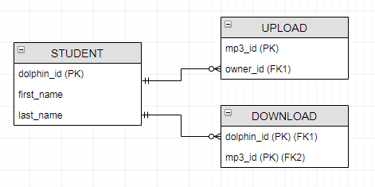
3. CIClubs is a database to track student clubs at CI. This DB consists of clubs, club members and advisers. Each club may consist of many students, but a single club will be advised by only one faculty member. A club may have only one faculty adviser, president, vice president and treasurer. Faculty may advise multiple clubs. Reconstruct the database in MySQL and reverse engineer the output based on the ERD below. (5pts)

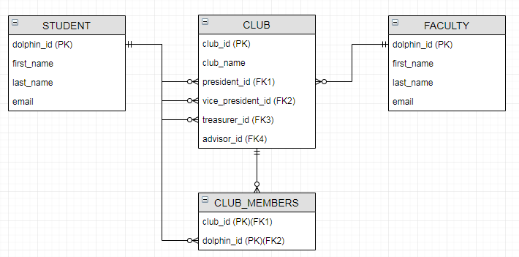

1. CISoftServ is a new CI listing agency that matches CSIT majors with technology internships. Many students may participate in many internships. Reconstruct the database in MySQL and reverse engineer the output based on the ERD below. (5pts)

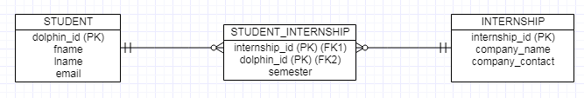

1. Channel Island Artists (CIA) is a broker for secret artists at CSU CI. Reconstruct the database in MySQL and reverse engineer the output based on the ERD below. (5pts)

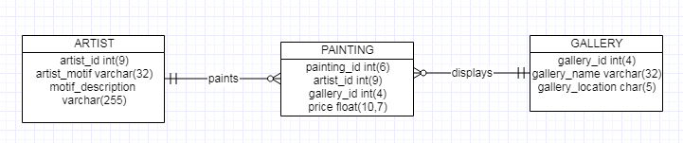

1. Below is the conceptual model for CI Clinic (CIC), which tracks patients, doctors, drugs and prescriptions. Reconstruct the database in MySQL and reverse engineer the output based on the ERD below. (5pts)

