Name: Adam Capdeville Lab 7

Database Systems November 11, 2019

In the programming language of your choice, construct an application (GUI preferred) to interact with the AirSupply database created for Lab 5. Your application should include proper authentication and will accommodate all CRUD functionality, including read, write, update and delete commands. Your application should also consider proper security constraints requiring only registered users to connect. The application should also have a dedicated database user id and password.

Grading for Lab 7 is based on the [Technology Acceptance Model](https://en.wikipedia.org/wiki/Technology_acceptance_model).

**Part I**

Authentication (15pts) – System login credentials including appropriate user id and password to log into the application and dedicated database id and password to allow the system to connect to database. For Part I, you will need a new entity to track application users and passwords. Include data for two users; one with your Dolphin ID as the user name and another with professor as the user name (set the password equal to letmein420 for both). In the space below, provide a screenshot of the reverse engineered database (ERD). Also create a query to return the data captured in your new user table.

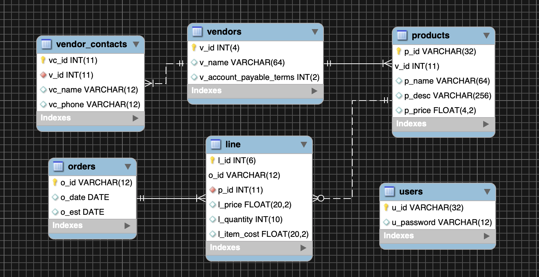

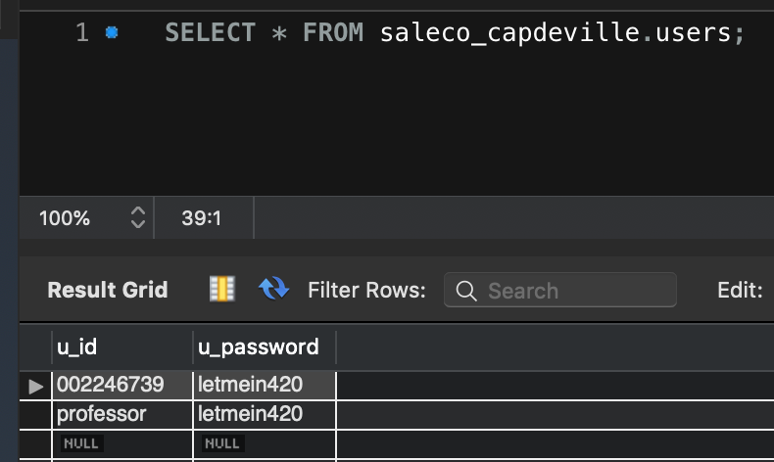

**Part II**

Ease of Use (15pts) - The system is simple and easy to use for the end-user and provides explicitly instructions for functionality. In the space below, provide screenshots of the system interface (i.e. login system, menu structures for CRUD commands and sample data response formatting). Remember to display your name in all output.

**Part III**

Usefulness (30pts) – Of a suitable level of complexity, your system will include functionality for querying (creating, reading, updating, deleting) pertinent database information, including dynamic information, based on arguments passed in from the application. Try to use views and stored procedures created in Lab 5. In the space below, provide screenshots of your system’s query execution (views, stored procedures). For all output, remember to display your name and the date your query was executed.  
  
Uploaded the code onto GitHub: <https://github.com/AGCapdeville/JAVA_CRUD_MySQL>

