**Instructions to Modify or Compile the Modified Survival Game Project**

**TO INSTALL UNITY, OPEN AND MODIFY OUR PROJECT, FOLLOW THE SEQUENCE OF STEPS BELOW:**

1. You can download the Unity Editor and open the project folder through an interface called **Unity Hub**. To download the Unity Hub, follow this link: <https://unity3d.com/get-unity/download>. After navigating to the webpage, simply click on the **Download Unity Hub**. See screenshot below:



1. Once the Unity Hub is downloaded, launch it, and click on **Installs** and then select a version of the Unity Editor. Then, click **Download**. See screenshot below:

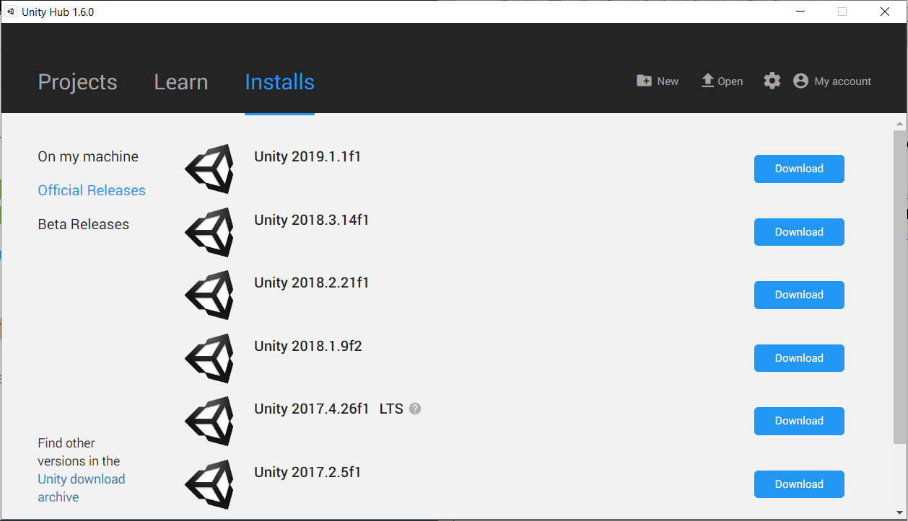

1. Once you have installed the Unity Editor, now it’s time to **open the *modified* Survival Shooter’s project folder**. Simply, launch the Unity Hub and click on **Projects**. Then, click **Open** and navigate to our project folder in your PC. See screenshot below:

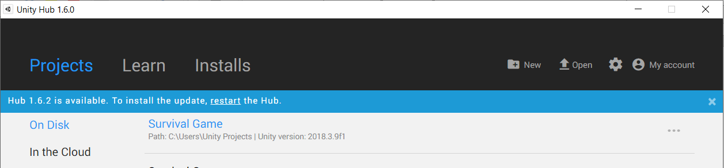

1. Finally, click on Survival Game, and the Unity Editor will automatically launch, opening the project folder. See screenshot below:

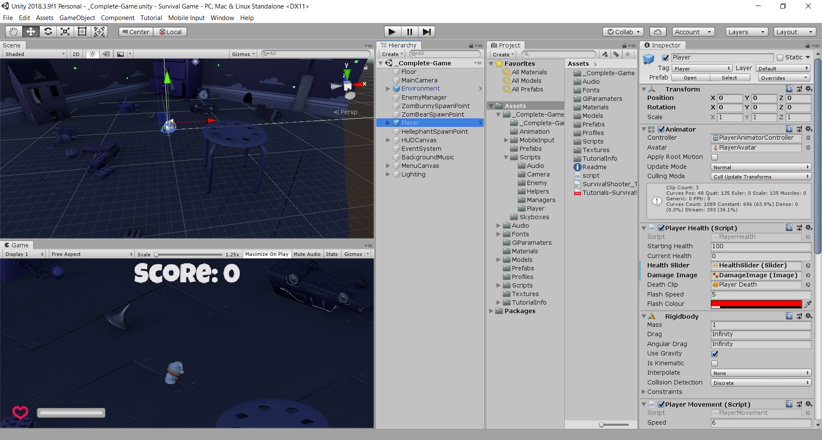

1. Now, you are ready to start modifying the game and its scripts! Just familiarize yourself with the Editor above. You can **follow the Survival Shooter tutorial series** linked below, and you will be able to start modifying the game.

**TO LEARN HOW TO WORK WITH UNITY AND HOW TO MODIFY THE SURVIVAL GAME, FOLLOW THESE STEPS:**

**NOTE:** *Unity has a great community with a ton of resources available for beginners to start modifying or developing games. Extremely easy! There are a series of very high quality tutorials that will help you learn ALL about Unity!*

1. Either type, “Unity Survival Game Tutorials” in Google search, or simply click the following link to start a series of video tutorials **to learn how to modify Survival Shooter game by learning how it was developed!** Here is the page for the Survival Shooter tutorials: <https://unity3d.com/learn/tutorials/s/survival-shooter-tutorial>.

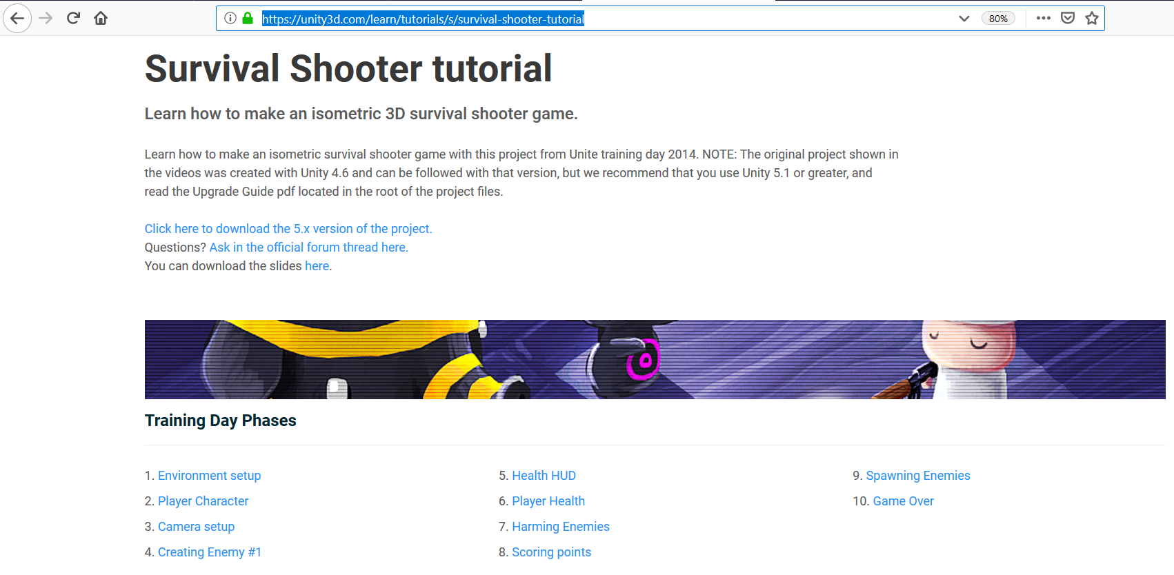

1. **To learn Unity** **in general**, Unity has a complete series of tutorials for **all** aspects of how to use Unity! For example, if you want to know how to write scripts using Unity, you can watch that particular topic only. Here is the link to **complete Unity tutorials page**: <https://unity3d.com/learn/tutorials>.

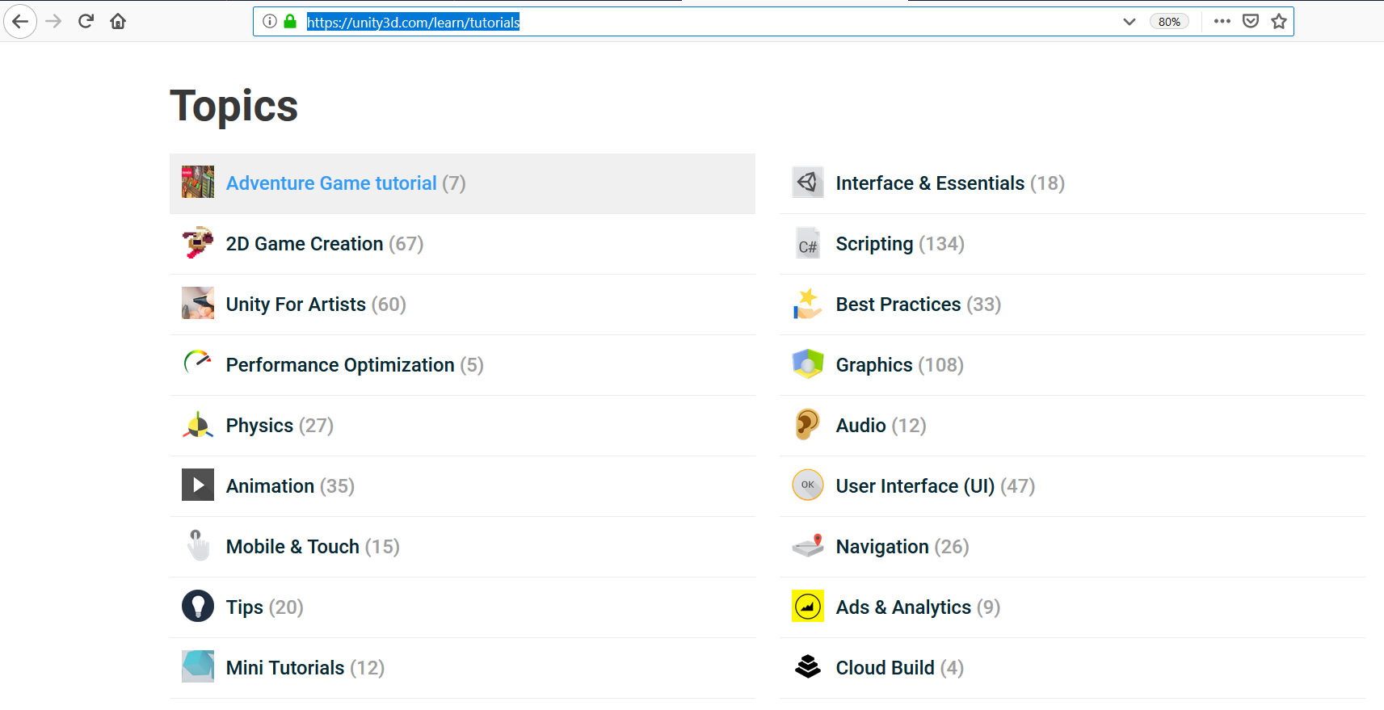

**NOTE:** If you **only** want to **further modify the Survival Shooter game ONLY**, just follow step 1 above. Those series of tutorials are for how to develop or modify Survival Shooter game only.

**TO PLAY OUR MODIFIED VERSION OF THE SURVIVAL SHOOTER IN THE UNITY EDITOR, FOLLOW THESE STEPS:**

1. Download the project folder somewhere in your computer.
2. Then, simply launch the Unity Hub, click Open in the Unity Hub window, then navigate to and open the project folder. Unity Editor will launch, opening the project folder
3. To use the PulseSensor device with our modified Survival Shooter game, just follow this quick tutorial from the developers of the PulseSensor device. Very straightforward and nicely illustrated! It should take you 2 minutes to watch the video! Here is the link to their tutorial page: <https://pulsesensor.com/pages/installing-our-playground-for-pulsesensor-arduino>
4. Once you are familiar with the PulseSensor and Arduino, connect them to your computer and to your finger to start monitoring your heart rate.
5. Launch the game by opening **_Complete-Game** folder, then **double clicking on the _Complete-Game file**. See screenshot below:

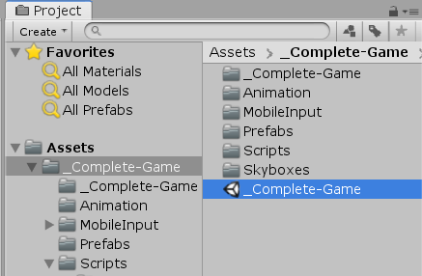

6. Run the game in the test window of your Unity Editor by clicking the Play icon. See screenshot below:

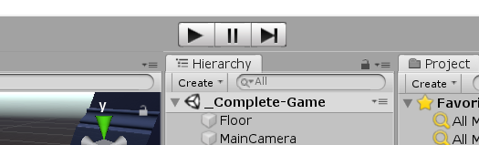

**IN OUR MODIFIED VERSION OF THE SURVIVAL SHOOTER GAME, ONLY THE FOLLOWING SCRIPTS ARE MODIFIED OR ADDED AS NEW:**

1. **HeartBPM** script is attached to the Player object. **HeartBPM is developed from scratch**.
2. **PlayerMovement** script is an original script. This script was slightly **modified** to allow HeartBPM to increase or decrease movement speed of the player.
3. **EnemyManager** script is an original script. This script was slightly **modified** to delay enemy from spawning for 60 seconds so that a baseline heart rate can be calculated for the player.

IMPORTANT**: *Where* are the modified and new scripts located?**

1. To access HeartBPM and PlayerMovement scripts, open the Survival Game project folder in Unity Editor, open the _Complete-Game folder. See screenshot below.

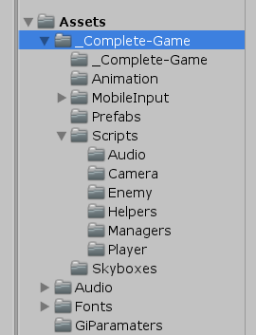

1. Then open the Scripts folder. See screenshot below.

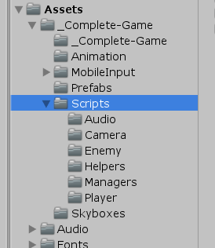

1. Then, open the Player folder. The HeartBPM and PlayerMovement scripts can be seen on top right in the screenshot below.

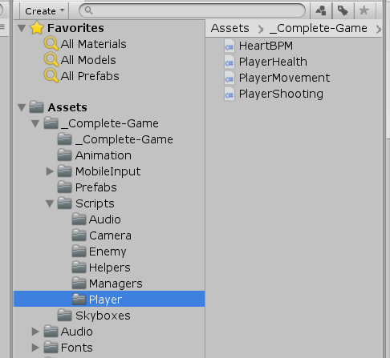

1. To access EnemyManager script, simply click on Managers folder and you will see the EnemyManager script within. See screenshot below.

