Week 2

Project Title: Exploring World Bank Data & ER Model Design

Objective: This step aims to explore World Bank datasets, design an Entity-Relationship (ER) model,

and refine the database schema to support meaningful research questions.

**Step 1: Selected Indicators from World Development Indicators**

1. GDP per Capita growth (annual %)

The GDP per capita growth is widely used to perform any research related to world economy. It measures the percentage change in the GDP per person every year in terms of economic development, standard of living.

1. Foreign Direct Investment, net Inflows (% of GDP)

This indicator represents the net inflows of foreign investments into a country's economy, as a percentage of its GDP. High FDI net inflows implies great international business engagement. In our research we use this indicator to examine the relationship between FDI and economic growth.

1. Inflation, Consumer Prices (Annual %)

The annual percentage change in consumer price index is calculated using this indicator. In our research Inflation, Consumer Prices (Annual %) is chosen to measure the average change in the prices of commodities and estimate the purchasing power of households. High inflation indicates economic instability, while low or moderate inflation usually means steady economic growth and price stability.

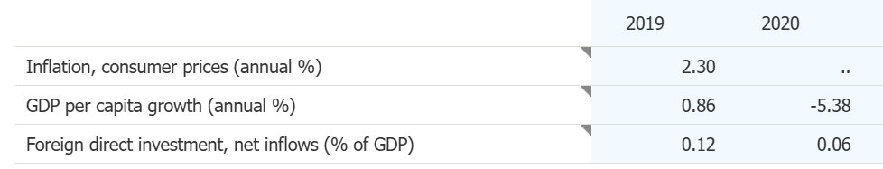

**Step-2**

**Developed an ER model**

**Entity Attribute**

Country Country_ID(PK), Name, Region

Indicator Indicator_ID(pk), Name, Description, Source

Data_Records Record_ID(PK), Country_ID(FK), Indicator_ID(FK), Year, Value

**ER relationship model: -**

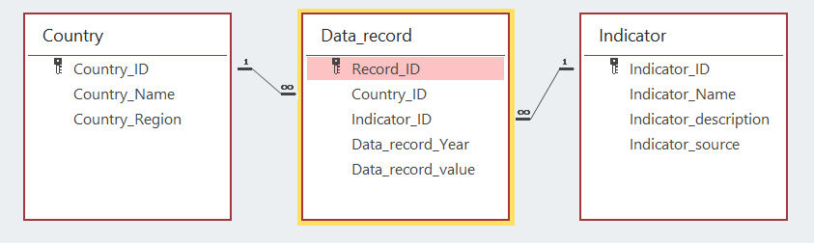

The one-to-many relationships ensure that each **Country** can have multiple data records, and each **Indicator** can be recorded for different countries over various years. The **Data_record** table connects them, storing indicator values for each country annually. This structure maintains data consistency, prevents duplication, and enables efficient analysis.

**Step 3:**

Global Financial Development:

1. Pension funds asset to GDP
2. Mutual funds asset to GDP
3. Private credit by deposit money banks to GDP
4. Bank concentration
5. Bank return on assets(% before tax)
6. Bank return on equity(% before tax)
7. Bank return on assets(% after tax)
8. Bank return on equity(% after tax)
9. Credit flows by fintech and big companies to GDP
10. Bank z-score
11. Firms using banks to finance working capital
12. Stock market capitalization to GDP
13. Non-life insurance premium volume to GDP
14. Life insurance volume to GDP
15. Electronic payments used to make payments (% age 15+)
16. Firms identifying access to finance as a major constraint
17. Insurance company assets to GDP
18. Outstanding domestic public debt securities to GDP
19. Outstanding domestic private debt securities to GDP
20. Outstanding international public debt securities to GDP
21. Outstanding international private debt securities to GDP
22. Stock market capitalization to GDP
23. Stock market return (% year to year)
24. Stock market turnover ratio
25. Stock price volatility
26. Working capital financed by banks
27. Mobile phones used to pay bills (% age 15+)
28. Mobile phones used to send money (% age 15+)
29. Credit card (% age 15+)
30. Domestic credit to private sector (% age 15+)
31. Debit card (% age 15+)

Enterprise surveys:

1. Percent of firms identifying crime, theft and disorder as a major constraint
2. Percent of firms choosing crime, theft and disorder as their biggest obstacle
3. Products shipped to supply domestic markets that were lost due to theft (% of product value) *
4. Proportion of products lost to breakage or spoilage during shipping to domestic markets (%) *
5. If there were losses, average losses due to theft and vandalism (% of annual sales)
6. Percent of firms using material inputs and/or supplies of foreign origin*
7. Percent of firms using e-mail to interact with clients/suppliers
8. Percent of firms exporting directly or indirectly (at least 10% of sales)
9. Percent of firms experiencing losses due to theft and vandalism
10. Percent of firms choosing customs and trade regulations as their biggest obstacle
11. If there were outages, average losses due to electrical outages (% of annual sales)
12. Age of the establishment (years)
13. Percent of firms experiencing water insufficiencies
14. Percent of firms identifying an inadequately educated workforce as a major constraint
15. Percent of firms using technology licensed from foreign companies
16. Percent of firms with majority female ownership
17. Proportion of temporary workers (out of all workers)
18. Real annual sales growth (%)
19. Real annual labor productivity growth (%)
20. Annual employment growth (%)
21. If there were outages, average duration of a typical electrical outage (hours)
22. Number of electrical outages in a typical month
23. Percent of firms experiencing electrical outages
24. Number of water insufficiencies in a typical month
25. Number of workers
26. Number of years firm operated without formal registration
27. Percent of firms identifying access to finance as a major constraint
28. Percent of firms whose new product/service is also new to the main market
29. Percent of firms with a female top manager
30. Percent of firms with female participation in ownership

World Development Indicators:

1. Logistic performance index: overall (1=low to 5=high)
2. container port traffic (TEU: 20foot equivalent units)
3. Merchandise trade (% of GDP)
4. Exports of goods & services (% of GDP)
5. Imports of goods & services (% of GDP)
6. Air transport, freight (million ton-km)
7. Railway, goods transported (million ton-km)
8. ICT goods exports (% of total growth exports)
9. High Technology exports (% of manufactured exports)
10. Cost of export (Border compliance) ($US)
11. Cost of imports (Border compliance) ($US)
12. Time to export (documentary compliance) ($US)
13. Time to import (documentary compliance) ($US)
14. Insurance & financial services (% of service exports, Bop)
15. Insurance & financial services (% of service imports, Bop)
16. Coverage of social insurance programs (% of population)
17. Domestic credit to private sector (% of GDP)
18. Bank non-performing loans to total gross loans (%)
19. Out-of-pocket expenditure (% of current health expenditure)
20. Risk of catastrophic for surgical care (% of people at risk)
21. Adjusted savings: Particulate emission damage (% of GNI)
22. Adjusted savings: natural resources depletion (% of GNI)
23. Renewable energy consumption (% of total final energy consumption)
24. CO2 emissions excluding LULUCF per capita ( t co2e/ capita)
25. Forest area (% of land area)
26. Annual freshwater withdrawals, total ( % of internal resources)
27. Population living in areas where elevation is below 5 meters (% of total population)
28. Disaster risk reduction progress scale (1-5 scale, 5=best)
29. Access to electricity (% of population)
30. Mortality rate, under -5 (per 1000 live births)

**Research questions:**

1. How does stock market capitalization to GDP vary across countries with different levels of logistic performance index?
2. How do bank return on assets and bank return on equity compare between high-income and low-income countries?
3. How does the coverage of social insurance programs differ across countries with high and low domestic credit to the private sector?
4. What are the regional differences in ICT goods exports and high-tech exports based on trade openness?
5. How does CO₂ emissions per capita vary among countries with different levels of insurance and financial services exports?
6. How has pension fund assets to GDP evolved over the last 20 years across different economic regions?
7. What are the trends in stock market turnover ratio and stock price volatility over time for developing vs. developed countries?
8. How has the use of mobile phones for financial transactions changed over time in relation to domestic credit to the private sector?
9. How has container port traffic trended over the last two decades in relation to exports of goods & services?
10. How has the risk of catastrophic health expenditure changed in countries with varying levels of insurance coverage over the past 10 years?
11. Can we predict a country’s economic stability based on trends in bank z-score, stock price volatility, and insurance penetration?
12. Can future private credit flows be forecasted based on past trends in banking concentration and fintech lending?
13. Can we predict a country’s export performance based on logistic performance index and cost of exports (border compliance)?
14. What is the relationship between renewable energy consumption and domestic credit to the private sector across countries?
15. How does banking sector stability (bank return on assets and z-score) correlate with adjusted savings from natural resource depletion over time?
16. What are the key factors driving financial inclusion and digital payments adoption?
17. How does financial development impact firms' access to finance and overall business growth?
18. What are the effects of infrastructure and logistics on firm productivity and business expansion?
19. How does financial market development influence stock market performance and investment trends?
20. Does improved transport infrastructure boost exports?
21. Do firms with female leadership perform better financially?
22. Does crime and theft negatively impact firm revenue growth?
23. Does logistics performance impact a country's trade volume?
24. How does access to domestic credit for the private sector (WDI & GFD) impact business growth (ES) across different countries?
25. How does stock market development impact on trade openness?
26. Does access to electricity improve firm productivity and financial returns?
27. How do climate risks affect business stability and financial markets?
28. Does high public debt reduce access to credit for businesses?
29. Does better healthcare spending improve workforce productivity?
30. Does increased mobile payment usage improve financial inclusion in developing countries?
31. How do firms' risk mitigation strategies influence their resilience against theft and vandalism?
32. What are the economic impacts of electrical outages on manufacturing and service firms?
33. What is the relationship between digital connectivity (email usage) and firm efficiency?
34. What is the economic cost of crime, theft, and disorder for businesses in developing economies?
35. How do non-life insurance penetration rates influence businesses' ability to recover from disasters?
36. How does the size of insurance company assets affect financial sector resilience?
37. How does bank profitability (ROA & ROE) influence the availability of credit for small enterprises?
38. How does private credit availability affect business survival rates during financial crises?
39. How does pension fund asset growth contribute to long-term financial stability and economic growth?
40. How do crime-related losses vary by industry and country, and what factors contribute to these variations?
41. What is the role of the bank z-score in measuring financial stability and predicting banking crises?
42. What is the relationship between mutual fund asset growth and economic development?
43. How does bank concentration impact lending competition and financial access for businesses?
44. How do high insurance costs affect small businesses' willingness to adopt risk mitigation strategies?
45. How do firms adapt their financing strategies in response to economic crises and financial shocks?
46. What proportion of GDP is made up of merchandise trade?
47. How much freight is transported via air and rail each year?
48. How much freshwater is withdrawn annually as a percentage of internal resources?
49. How many years do firms operate informally before formal registration?
50. What percentage of firms have female-majority ownership?
51. How old are most business establishments on average?
52. What percentage of firms face water insufficiencies affecting their operations?
53. What proportion of firms export at least 10% of their sales directly or indirectly?
54. How many firms struggle with an inadequately educated workforce?
55. What is the CO₂ emissions per capita, excluding land use and forestry?
56. Are firms in countries with higher renewable energy consumption less likely to experience electrical outages and losses due to outages?
57. How do water insufficiencies affect annual employment growth across different industries?
58. Are countries with higher disaster risk reduction scores more resilient in terms of economic stability and employment growth?
59. How do CO₂ emissions per capita relate to high-technology exports across countries?
60. How have CO₂ emissions per capita changed over the past 20 years
61. How have trends in female ownership of firms changed