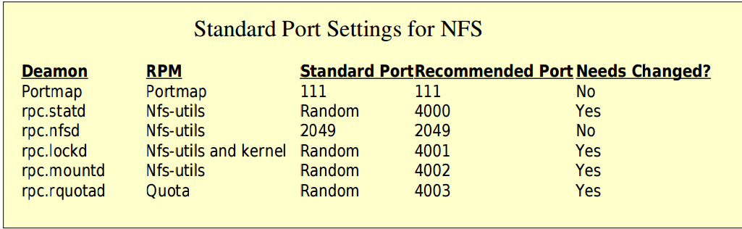

To see which ports are listinging with NFS

$ rpcinfo -p