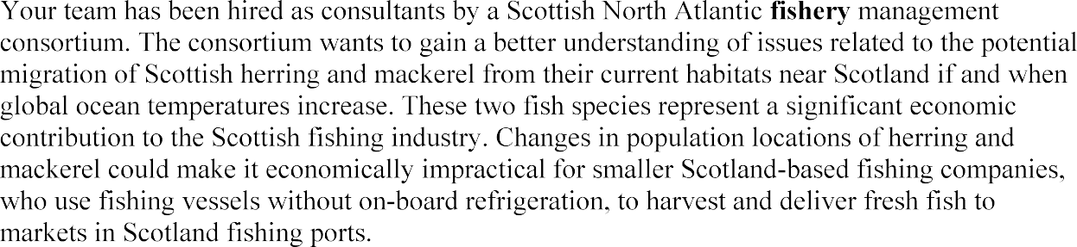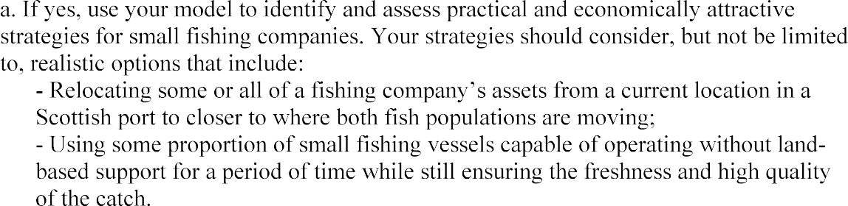

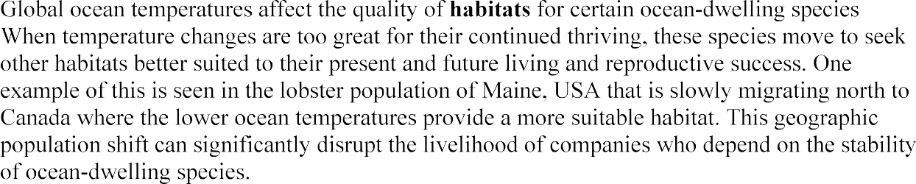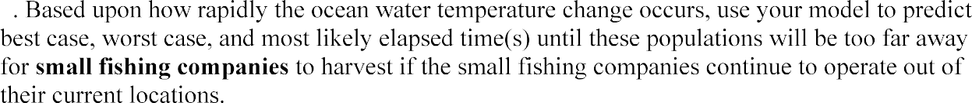









*Hook Line and*

*Sinker*

