Problem Chosen  ABCDEF | 2020  MCM/ICM  Summary Sheet | Team Control Number  1111111

The Evaluation and Prediction of Sustainable Development
Summary
Nowadays, sustainable development is playing a significant role in managing increasing population and consumption with the earth’s finite resources. Therefore，the method of sustainability evaluation should be improved to identify highly effective strategies，which serves the sustainable development.
In this paper, after analyzing the influencing factor of sustainable development, we adopt genetic algorithm (GA), the general contrast algorithm, and analytic hierarchy process(APH) to calculate the universal evaluation formulae. And then, we use this formula to evaluate sustainability of Cambodia. Further, combining the actual situation of Cambodia, a 20-year sustainable development plan is created and 0-1 linear programming model was established to assess the effectiveness of sustainable strategies. Finally, we established system dynamics (SDy) model to optimize our solution and indentify highly effective strategies more scientifically and reasonably.
For problem 1, firstly, based on the characteristics of the indicator systems of the sustainable development, we get the exponential universal formulae of classified indicators by using GA. Secondly, combining the general contrast algorithm with AHP, the weight of different subsystems is obtained and the sustainability evaluation model was established. Finally, utilizing MATLAB to calculate the sustainability of Cambodia, which indicates that Cambodia’ sustainable condition is poor, and it’s urgent to improve its sustainability.
For problem 2, based on SDy, three subsystems are established. Combining the internal relations of each subsystem with Cambodia general situation, we put forward a 20-year sustainable development plan, including strategies in population, economy, natural resource and society. Then, we predicted the effect our strategies have on the sustainability of Cambodia, and comparing with the original model, the rationality of our plan was proved.
For problem 3, we chose indicators, including population growth, energy productivity, GINI coefficient and GDP, to build efficiency matrix. Then 0-1 linear programming model is established and using Hungarian method we find that in the first stage of sustainability improvement, more attention is supposed to be paid upon economic strategy.
Finally, we use SDy to optimize our method of indentifying highly effective strategies. By implement our plan, the multiple objectives of Cambodia’ development can be pursued sustainably to achieve a better quality of life for every citizen, now and for generation to come.
Keywords: sustainable development; effective strategies；GA optimum；system dynamics；Stella

Contents
1. Introduction 1
1.1 Background 1
1.2 Introduction of System Dynamics 1
1.3 Introduction of Least Developed Country 2
2. Problem statement and analysis 2
2.1 Problem statement 2
2.2 Overall analysis 3
3. Basic assumption 3
4. Glossary & Symbols 4
Glossary 4
Symbols 4
5. Problem I Sustainability evaluation model 4
5.1 Analysis approach 4
5.2 Model preparation 5
5.3 Model establishing--sustainability evaluation model based on Genetic Algorithm 6
5.4 Model solving – evaluating Cambodia’ sustainability 7
5.5 Result analysis 8
5.6 Model test 8
6. Problem II The 20-year sustainability plan 9
6.1 Problem analysis 9
6.2 Model preparation 9
6.3 Model establishing and solving 10
6.4 Result analysis 12
7. Problem III Simulate the 20-year sustainability plan 12
7.1 Analysis approach 13
7.2 Model preparation -- building efficiency matrix 13
7.3 Model establishing and solving 13
7.4 Result analysis 13
8. Optimization solution for problem III 14
8.1 Model preparation 14
8.2 Model solving 14
9. Evaluation and Spread of the Model 15
9.1 Evaluation of the Model 15
9.2 The Extension of Models 15
References 16

1. Introduction
1.1 Background
With the development of national economy, as well as the advancement of global trade, people has gradually realized that the earth resources limit human development, and declare that the earth resources need to be more configured reasonably. What’s more, one of the largest challenges of our era is how to coordinate the increasing population consumption with the earth’s finite resources. In order to reconcile this difficult balance between increasing population and finite resources, the concept of sustainable development was introduced in the 1980’s. Sustainable development is defined by The Brundtland Commission as the “ability to make development sustainable—to ensure that it meets the needs of the present without compromising the ability of future generations to meet their own needs.” ^{[1]}The concept of sustainable development is now enshrined on the masthead of Environment magazine in the years following.
The United Nations (UN) predicts the world’s population will level at 9 billion people by 2050. This, coupled with increased consumption, places a significant strain on the earth’s finite resources. Governments have to realize the sustainable development of the social economy and the environment is the inevitable choice of human survival and development. ^{[2]} Many countries not only accepted the theory of sustainable development, but also took sustainable development as the goal of political, economic and cultural development.
1.2 Introduction of System Dynamics
The System Dynamics played an increasing important role in the past few years since there is a growing awareness of environmental and resources problems. And the surge of interest towards SD, many scholars have written series of works，form which we could reasonably receive the conclusion that SDy is an ideal methodology to analyze the complexity which is normally present in sustainability issues. When it comes to the measure distinguishing more sustainable countries and policies from less sustainable ones, we can reference the Urban Dynamics.
In the late 1960s, Forrester put forward Urban Dynamics theory, which mainly research in the results of the theory and application of the study concerning American cities’ blossom-decline ^{[3]}. Yu-feng Ho has established the SDy model for the sustainable development of science city, and points out that more attention should be paid to the harmonious and coordinated development among the economic, social and environmental ^{[4]}. Jorge a. Duran took AURA in Puebla Mexico as object, established a complete framework of the SDy model ^{[5]}. And In the case of the Puerto Aura project, SDy has proved to be an excellent method and tool for helping key urban actors, from diverse disciplines, to relate actions from the different dimensions involved in a situation as complex as this project.
After reading the works about the urban sustainable development, we concluded that sustainable development is mainly divided into there parts: social, economic and environment, and these subsystems have interaction and mutual influence to each other. The subsystem is shown as follows.
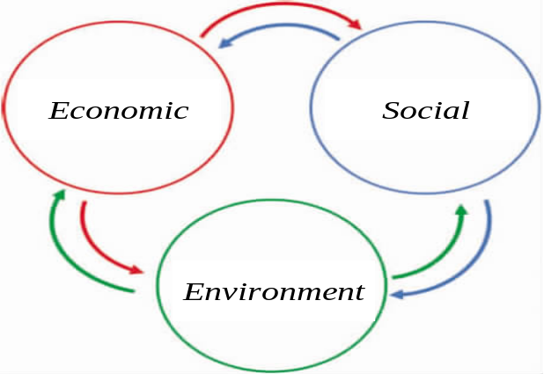
Fig.1 Three subsystems of sustainable development
1.3 Introduction of Least Developed Country
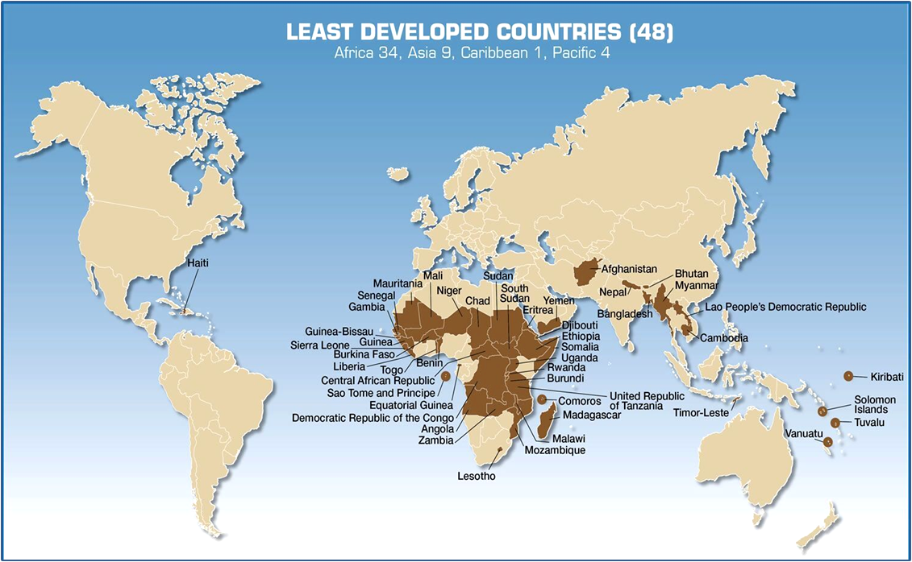
A least developed country (LDC) is a country that, according to the United Nations, exhibits the lowest indicators of socioeconomic development, with the lowest Human Development Index ratings of all countries in the world. The concept of LDCs originated in the late 1960s and the first group of LDCs was listed by the UN in its resolution 2768 (XXVI) of 18 November 1971. LDC criteria are reviewed every three years by the Committee for Development Policy of the UN Economic and Social Council (ECOSOC). The classification (as of 24 January 2014) applies to 48 countries ^{[6]}, which can be shown as follows.
Fig.2 Distribution of the Least Developed Countries (48)

2. Problem statement and analysis
2.1 Problem statement
The International Conglomerate of Money (ICM) expects us to evaluate the sustainability of countries, and then give a 20 year sustainable development plan for the less sustainable country we selected. By carrying out this plan, the selected country should becoming more sustainable form the aspects of demographic, natural resources, economic, social and political conditions, and the world will be a more sustainable one. In order to fulfill the 4 tasks scientifically and reasonably, we need to solve the following problems.
- Develop a sustainability evaluation model to distinguish more sustainable countries and policies from less sustainable ones. What’s more, the model should clearly define when and how a county is sustainable or unsustainable. Finally Using the model and research from Task 1 to evaluate the sustainability of the less sustainable country which is selected form the 48 LDC list.
- Put forward a 20-year sustainable development plan based on the evaluation result and valuate the effect our plan has.
- Evaluate the effect our 20-year sustainability plan has through the model established above and analyze which programs or policies in the plan produce the greatest effect on the sustainability measure and finally identify highly effective strategies to be implemented to create a more sustainable world.
2.2 Overall analysis
Firstly, three subsystems should be divided: environment, economy, and society. Considering the influence factor in each subsystem, and then based on the factors chosen, we can establish the sustainability evaluation model to distinguish the more sustainable countries and policies from less sustainable ones. Secondly, after evaluating the selected country, we can give the improvement plan form the aspects of demographic, natural resources, economic, social and political conditions. Thirdly, valuate the effect of each strategy, and try to figure out the highly effective strategies.
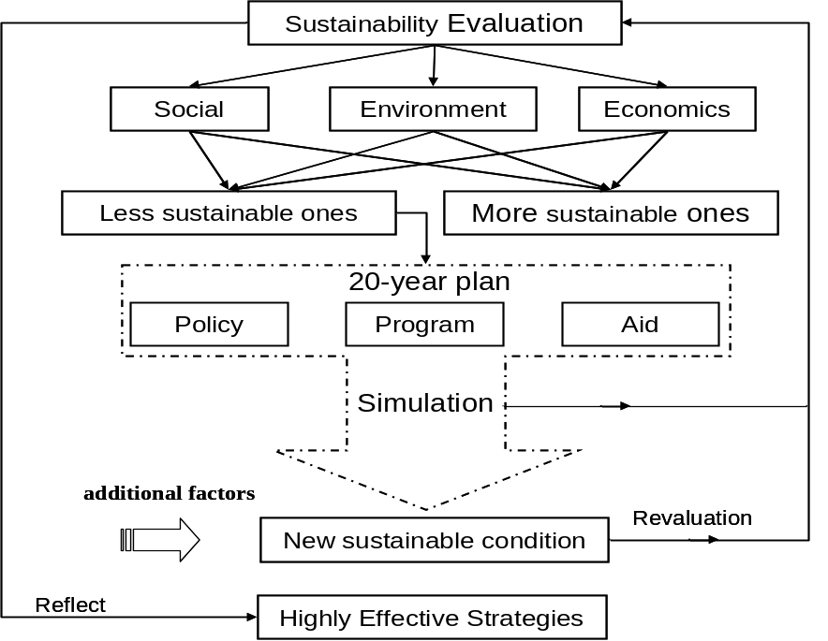
Fig.3 Modeling Flow Chart

3. Basic assumption
- Assuming the indicators chosen can fully reflect the countries’ sustainable development level and won’t influence the following simulation.
- Assuming the total investment for each strategy supported by ICM is fixed.
- Assuming the total cost of the strategy implementation is fixed
- In order to simplify 0-1linear programming model, our article assumes that the interaction of each strategy can be neglect.
- Assuming there is no deviation among the inner relationship of indicators in system dynamics analysis.

4. Glossary & Symbols

Glossary
  - Renewable resources： Resources that be consumed faster than the rate at which they are renewed.
  - Non-renewable resources: Resources that must not be consumed at a rate faster than that which they can be substituted for by a renewable resource.
  - GINI coefficient: a ratio of the areas on the Lorenz curve diagram that theoretically range from 0 (complete equality) to 1 (complete inequality), which consider it to be a measure of social inequality.
  - Genetic algorithm：A search heuristic that mimics the process of natural selection. This metaheuristicis routinely used to generate useful solution to optimization and search problems.
  - Energy production: refers to forms of primary energy--petroleum (crude oil, natural gas liquids, and oil from nonconventional sources), natural gas, solid fuels (coal, lignite, and other derived fuels), and combustible renewable and waste--and primary electricity, all converted into oil equivalents.

Symbols
Tab.1 Variables and their meanings
Number | Sign | Significance
1 |  | The single index we selected to reflect the corresponding indicators
2 | 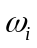 | The weight of indicators after using general contrast algorithm
3 | n | The number of indicators in each subsystem
4 | 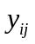 | The normalized value of indicators calculated through Genetic Algorithm
5 | Y | The synthesis scores of sustainability evaluation
6 | C | Efficiency matrix in 0-1 linear programming model

5. Problem I Sustainability evaluation model
5.1 Analysis approach
The interpretation of the trend in each block of time may be quite different (Simon Bell and Stephen Morse,in 2008).^{[7]} Therefore, we should put forward a graded standard to judge which sustainability degree countries belong as well as shed light how a county is sustainable or unsustainable. What more, the time scale over is a further dimension, which helps to explain when a county is sustainable or unsustainable and reveals the changes of countries’ sustainability? The problem analysis is shown below, represent indictors of each subsystem.
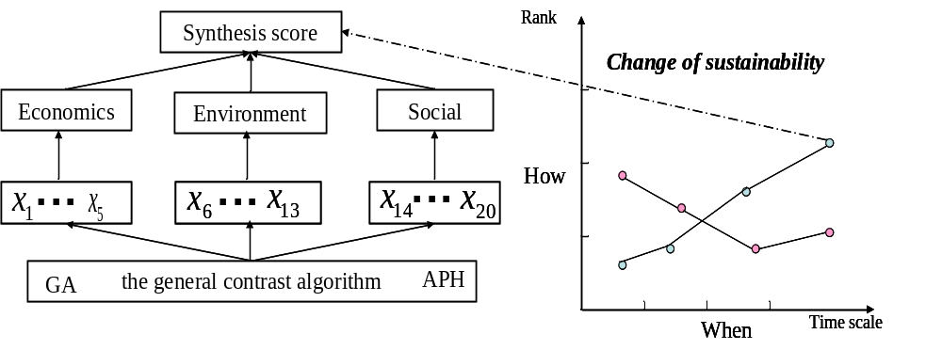
Fig.4 thinking flowchart
5.2 Model preparation
5.2.1 Indicator systems of the sustainable development
When it comes to the evaluation of sustainability, the evaluation indictor system can be divided into there subsystem, social, economic and environment. In order to select specific indictors of each subsystem, we should follow the principles of scientificity, conciseness, harmony and integrality. We referenced international articles and establish an optimistic, scientific, predictable and comparable variable set. They are shown in table 2.
Tab.2 Indicator System
sector | short | indicator | Significance
economy | ET |  | Ratio of Export tax to total tax (%)
economy | IOD | 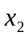 | Import of goods（BoP，Present price $）
economy | GDP |  | Gross Domestic Product
economy | ROF | 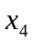 | Ratio of Foreign direct investment outflows to GDP (%)
economy | ROTG | 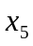 | Ratio of Tax to GDP (%)
economy | PG | 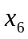 | Poverty gap, measured at $1.25 a day（PPP）(%)
environment | PCCL | 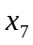 | Per capita cultivated land（ hectare）
environment | PCRF | 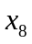 | Per capita Renewable inland freshwater resources（steres）
environment | EY | 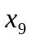 | Energy yield（thousand tons of oil equivalent）
environment | ECOD | 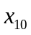 | Energy consumption of per Unit GDP（2005 constant  purchasing power parity dollars/kg of oil equivalent）
environment | PCGY | 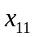 | Per capita Grain yield (tonnes)
environment | PCCD | 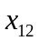 | Per capita carbon dioxide emissions（tonnes）
environment | ROFA | 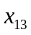 | Ratio of forestry area to total land area）
society | GINI | 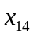 | The GINI coefficient
society | ROYT | 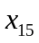 | Ratio of young people to total unemployment  （The annual percentage）
society | ROPG | 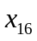 | Rate of population growth (%)
society | PD | 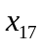 | Population density（population per kilometer Land area）
society | TU | 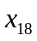 | Total unemployment（The percentage of labor total amount）（Simulate labor organization to estimate）
society | LE | 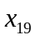 | Life expectancy at birth（year）
society | TIOM | 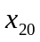 | The incidence of malnutrition（The percentage of total population）
5.2.2 Steps of genetic algorithm
Generally, there of three stages during the process of social and economic development, slow, fast, and saturated stages. Therefore, when describing the development degree of each subsystem by using these indicators, the s-shaped growth curve formula is applied universally and UA is used to optimize by transforming different parameter into the shared value.
The steps of genetic algorithm are:(1)set up the objective function for the given optimization problem; (2) set the change interval of estimated parameters; (3) encode the estimated parameters to binary code;(4) generate initial population randomly; (5) calculate and evaluate the fitness of individuals in each population; (6) the crossover of parent; (7)the mutation of filial generation; (8) repeated iteration, until meet specific indicators or stop at a certain genetic algebra.
5.2.3 The general contrast algorithm
When synthesize the single indicators into comprehensive subsystem ones, we should impair the function of indicators whose value of  is smaller, and strength the function of indicators whose value of 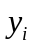 is bigger. Therefore, the general contrast algorithm should be applied to calculate the weight of three subsystems.
5.3 Model establishing--sustainability evaluation model based on Genetic Algorithm
Step1: universal formulae of classified single indicators
Firstly, use s-shaped growth curve formula to describe the development degree
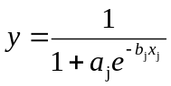（1）
Secondly, optimize the parameter by GA
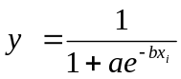（2）
Step2: calculate the synthesis scores of three subsystems
We should calculate the weight as
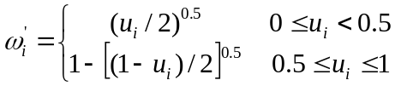（3）
Secondly, normalize 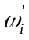 to obtain the weight and calculate synthesis scores as
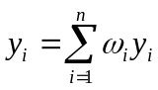（4）
Where, is calculated by formula (2).
Step3: calculate the synthesis scores of countries
Firstly, build array R according to AHP and then calculate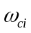.
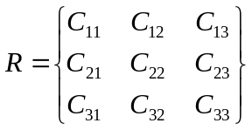（5）
Finally, calculating 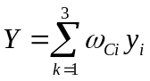（6）
5.4 Model solving – evaluating Cambodia’ sustainability
The graded standard and normalized value of 20 single indicators for each subsystem in Cambodia (2002~2013) are shown in table3.
Tab.3 Graded standard and normalized value of indicators
sector | indicator | evaluation criterion |  |  | Cambodia's indicator values
sector | indicator | grade 1 | Grade 2 | grade 3 | 2002 | 2008 | 2013
economy | ET | 3 | 5 | 10 | 1.35 | 3.85 | 7.24
economy | IOD | 7 | 10 | 20 | 6.27 | 5.34 | 11.46
economy | GDP | 5 | 7 | 10 | 3.26 | 4.53 | 6.45
economy | ROF | 1 | 1.5 | 3 | 0.61 | 0.87 | 1.47
economy | ROTG | 3 | 5 | 10 | 1.43 | 1.61 | 3.24
economy | PG | 8 | 12 | 15 | 7 | 9 | 11
environment | PCCL | 10 | 16.67 | 50 | 13.95 | 25.71 | 23.61
environment | PCRF | 6.67 | 10 | 20 | 6.28 | 7.92 | 11.09
environment | EY | 20 | 33.3 | 83.3 | 19.21 | 51.02 | 35.28
environment | ECOD | 1.56 | 10 | 62.5 | 7.16 | 23.96 | 53.76
environment | PCGY | 9.09 | 43.48 | 200 | 7.01 | 29.14 | 50.17
environment | PCCD | 8.3 | 33.3 | 100 | 6.91 | 27.78 | 25.38
environment | ROFA | 1.43 | 5.6 | 20 | 3.46 | 10.67 | 12.33
society | GINI | 8.33 | 10 | 12.5 | 6.19 | 10.97 | 9.24
society | ROYT | 9.8 | 9.95 | 10 | 5.13 | 8.62 | 9.96
society | ROPG | 10 | 15 | 30 | 9.81 | 10.95 | 13.64
society | PD | 15 | 20 | 30 | 13.6 | 17.2 | 21.44
society | TU | 10 | 15 | 25 | 5.09 | 10.4 | 17.34
society | LE | 15 | 25 | 50 | 6 | 9 | 18
society | TIOM | 15 | 30 | 50 | 13 | 25 | 37
Note: In order to keep consistent among the sort of evaluation standard, we exchange the rank1 with rank3 as regard to the indicator of Per capita carbon dioxide emissions (tonnes).
①Establish the objective function of three subsystems：
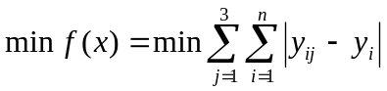（7）
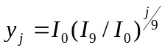
Where,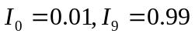, when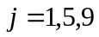, 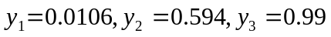
②Calculating the universal formulae by GA：
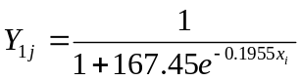（8）
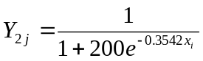 （9）
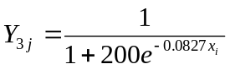 (10)
③Calculate the weight of each indictor
There are three ranks, whenbelong to rank1, rank2, rank3, the corresponding value of 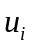 is 0.3, 0.5, 0.7, and when is the beyond the ranks, is 0.9. Therefore, we figure out is 0.3873, 0.5, 0.6128 and 0.7764.
④Calculating weight according to AHP:
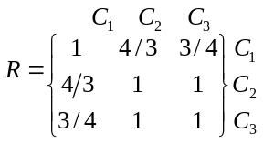
⑤Through the calculation of MATLAB：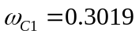, 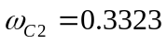,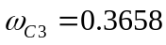
Thus, the sustainability evaluation formula is
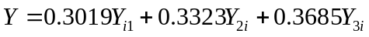 (11)
The graded standard and the synthesis scores of three subsystems in Cambodia is shown in the table4.
Tab.4 Graded standard and the synthesis scores of each subsystem
Subsystem | Graded Standards |  |  | Cambodia's scores
Subsystem | I | II | III | 2002 | 2008 | 2013
Economic | 0.0347 | 0.3015 | 0.5643 | 0.0521 | 0.0934 | 0.1055
Environment | 0.2365 | 0.3478 | 0.6217 | 0.1954 | 0.2891 | 0.2548
Social | 0.1023 | 0.3285 | 0.5931 | 0.0964 | 0.3047 | 0.2372
Y | 0.1268 | 0.3277 | 0.5955 | 0.1162 | 0.2366 | 0.2039
By using similar, dissimilar and inverse connection numbers and their state sorting analysis ^{[8]} we figure out the corresponding relationship between the degrees of sustainable development and the synthesis scores of sustainability evaluation (Showed in table 5).
Tab.5 The corresponding relationship
Ranks | weaker | weak | sustainable | strong
Score Range | （0, 0.1268] | （0.1268，0.3276] | （0.3276，0.5955] | （0.5955, 1]
5.5 Result analysis
According to the results shown in table4 & table 5, the sustainability of Cambodia couldn’t reach the sustainable level, even worse there is a downward trend. Combining with the real-world, owing to the boom of Cambodia construction industry, agriculture and tourist industry, its economic had growth about 10 percent，which contributing to the rise in 2008.And because of globe recession and the economic growth was slowing down in the following years, the rate of Cambodia’s economic growth decrease to 7 percent. What’s the more, the increase of the net population rate limit Cambodia’s sustainable development. As for the society and policy, Cambodian social political stability has been enhanced since the third-term government was established in July 2004, and the foreign investors are full of confidence to the future economic development ^{[9]}.
In addition, reviewing the general situation of this country, Cambodian is a traditional agriculture country, weak in industry. Its energy utilization technology is backward. And due to the imbalance of the ecological environment and overfishing, the aquatic resources decreased in the recent years. The result of our model is accordance with the real world, which proves the scientificity and accuracy of the sustainability evaluation measure.
5.6 Model test
Similarly, we use the Sustainability evaluation model to assess the sustainability of France, Guinea and Japan. If the result is in accordance with the real-world, the scientificity and rationality of the model established above can be proved. The synthesis scores of France, Guinea and Japan are shown below.
Tab. 6 synthesis scores of France, Guinea and Japan
 | France | Guinea | Japan
Economy | 0.4526 | 0.2156 | 0.6425
Environment | 0.2105 | 0.1252 | 0.3163
Society | 0.3151 | 0.3425 | 0.5426
Y | 0.3227 | 0.2027 | 0.6023
Compared with the graded standard in table 6, we know that the sustainability of Guinea, France and Japan is weak, sustainable and strong respectively. As we know, France is industrial power, and its agricultural technology is very advanced. What’s more, its GDP index is in the first class of the world, which makes its Economic index high. But the lack of mining of mineral resources and the resources that difficult to exploit make its Environment low. Combining these two kinds of the situations, the fact is in accord with the result our sustainability evaluation model. Guinea and Japan can be analyzed in the same way, and their situations are also in accord with the model, so the rationality and applicability of the model can be proved.

6. Problem II The 20-year sustainability plan
6.1 Problem analysis
In order to put forward a scientific and reasonable plan, we should take the internal relations of each subsystem into consideration, combining with Cambodia general situation. What’s more, considering that Cambodia is agricultural country, and the development of manufacturing industry and service industries is poor, what’s worse, its energy development is insufficient. Considering the complexity of indicator system，we analyze the effect of the strategies by selecting the GDP index of economic aspect, the energy productivity of environment aspect, the GINI of social aspect and growth rate of population.
6.2 Model preparation
Take the subsystem of population for example(shown in figure 5)，as for the arrow，indicator in the head of arrow has impact on the other side one.
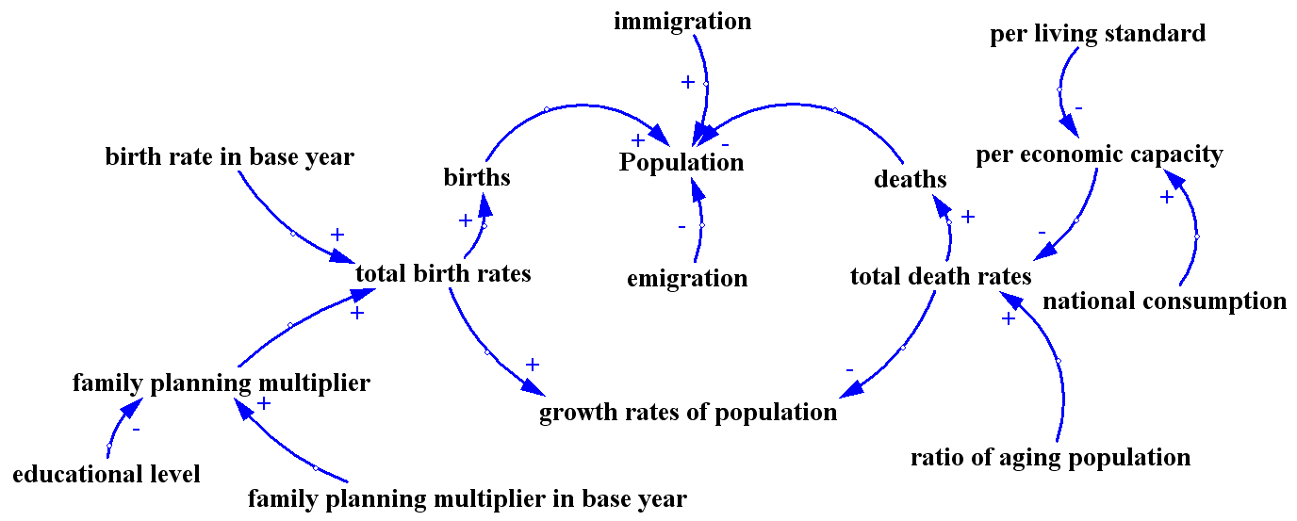
Fig.5 Causal Loop Diagram
6.3 Model establishing and solving
For sensitivity analysis, we mainly leverage Stella to perform. Take population and natural resource for example, firstly we establish population and natural resources sector respectively, by analyze the relation between the two part we can finally establish the population and natural resource model, which is shown in Figure 6.
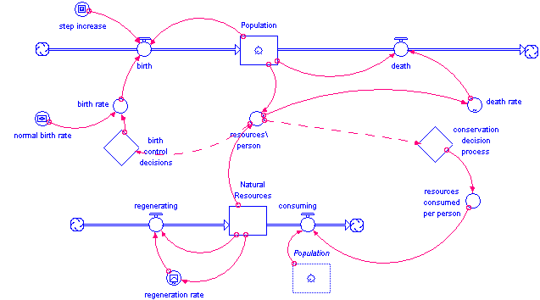
Fig.6 System diagram
Input the data of energy production, the output of Stella is shown in the Figure7, form which we can see that the fast growth of population lead to the excessive consumption of the energy production, and with the time goes by, the shortage of energy may cause the increase of death rate and finally result in the decrease of population.
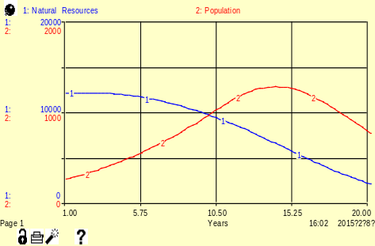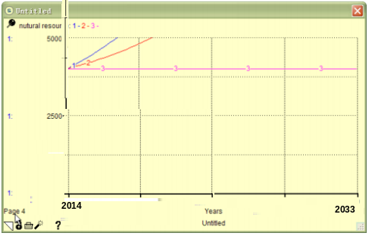
Fig.7 Output of Stella Fig.8 Sensitivty analysis result
The analysis result can be seen in the Figure 8, series 1& 2 represent the population size of 9 & 11mllion reprehensively. Under these circumstances, the resources are on the rise. And when the size of Cambodia’s population is 13 million, equilibrium state is arrived. Namely, when the population size is smaller than 13 million, resource would increase then, on the contrary, when it’s bigger than 13 million, the resources would decrease.
These subsystems are mutual linked and influenced. Similarly, cultivated area and water shortages would reduce grain yield, and then affect the national health, population growth and economic development, even have influence on the development and use of energy. We use the same method to analyze the relationship between each subsystem. Based on the analysis above，Combining with the actual situation，we put forward the strategies form 4 aspects：
- Economic strategy
Accelerate the development of industrial manufacturing industry (Policy)
Cambodia is a agricultural country, and industrial manufacturing industry is relatively backward, so industrial manufacturing should be developed to coordinate the development of agriculture and finally support the development of agriculture.
- Natural resource strategy
Upgrade the energy structure：Building Hydropower and gas station (Program)
Cambodia energy production especially rich in hydropower resources .But as for the shortage of development, as well as the backwardness of supporting infrastructure, the cost of water and electricity and gas is high. Therefore, it’s essential to focus on the development of available energy means a great deal to Cambodia. The government can make medium-term plan to develop all potential Hydropower and gas station. In the long term, the country will realize diversified energy supply and reduce the dependence on oil.
- Demographic strategy：
Improve healthcare (Policy)
Policy: as for the poor medical condition and backward economy, coupled with the high rate of infection with HIV/AIDS and other infectious diseases, the infant mortality and adult mortality of Cambodia is high. And life expectancy also reduced, which makes the Cambodian population stay in the risk of abnormal decrease. However， the backward economy causes the increase of growth rate of population, which brings the Cambodian population into the risk of excessive growth. The government should integrate the two factors, and improve the health care policies, to sustain Cambodian population growth rate in the normal level.
- social and political strategy
Eliminate poverty (Policy &Aid)
The GINI coefficient is extent index to judging whether income distribution is fair. The measures are as follows. a. make reasonable tax policy. b. Intensify the poverty alleviation, and constantly enhance the knowledge and technological level of the vulnerable group, and broaden their income channels.
Considering the complexity of indicator system，we analyze the effect of the strategies by selecting the GDP index, energy productivity, GINI and growth rate of population to assess. The result is shown below.
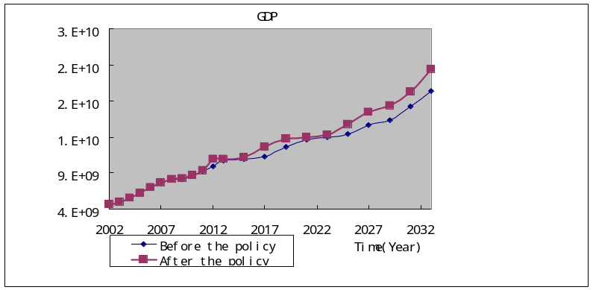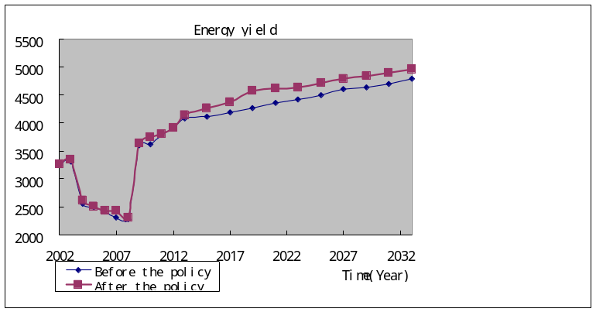
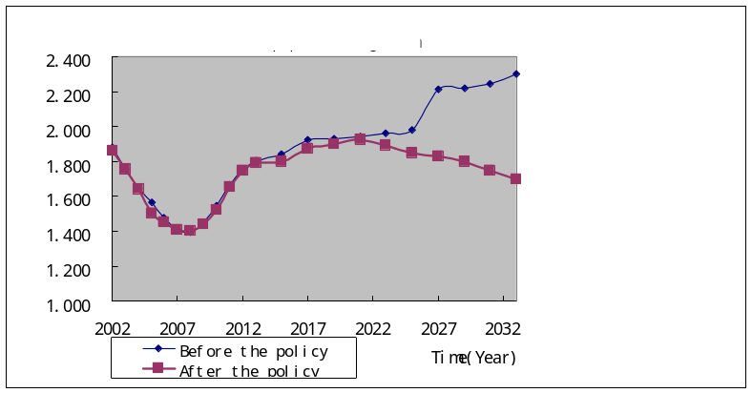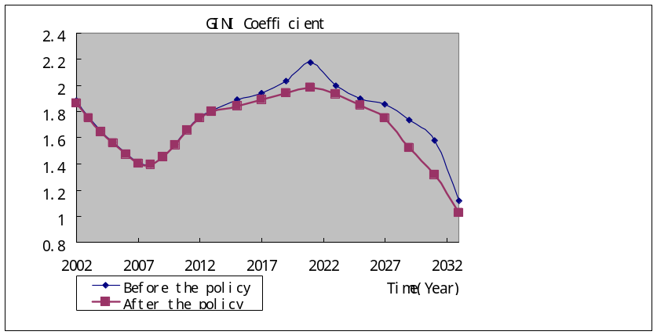
Fig.9 the changes of Indicator before & after
6.4 Result analysis
Model simulation period is 2002-2033. Comparing with the historical data in 2002-2013 is a kind of calibration of the model. After 2013, we use the model’s scenario simulation to analyze the effects of different strategic choices for the future.
①GDP :According to the latest data of the World Bank in 2013, in the case of implementation of policy, Cambodia’s GDP is obviously higher than the expected level that without policy implementation.
②Energy productivity: According to the latest data of the World Bank in 2013, the energy yield of Cambodia is 4085.267(One thousand tons of oil equivalent). After the implementation of policy，the energy yield of Cambodia will reach 4964.387(One thousand tons of oil equivalent).
③Population growth rate: Shown in figure 9, the Cambodian population growth rate tended to rise before the implementation of policy. However, after the implementation of the policy, he population growth rate will be tardily adjust and tend to go down, that will fell to 1.72 in 2033 year.
④GINI coefficient
Factors include the level of economic development, traditional social cultural, political system, etc. In addition, improving the GINI coefficient can narrow the gap between poverty. Model simulation period is 2002-2033. And there are historical data in 2002-2013 year, which can be the calibration of the model by compared with simulated data. After 2007 year, use the scenario simulation to analyze the effects of different strategic choices for the future.

7. Problem III Simulate the 20-year sustainability plan
7.1 Analysis approach
Accomplishing the maximum efficiency and figuring out highly effective strategies can be regarded as the progress of maximizing the objective function. Thus, we chose population growth, energy productivity, GINI coefficient and GDP as the indicator to represent population, environment, society and economic respectively. Then 0-1 linear programming model is established and efficiency matrix is built. Finally, Hungarian method is used to solve the model.
7.2 Model preparation -- building efficiency matrix
Set the effect of population growth on population is 1, similarly, the effect of Energy productivity on natural resources is 1, the effect of GINI coefficient on society is 1, and the influence of GDP on the economy is 1. Refer to the World Bank Data, build the efficiency matrix about the population, natural resources, economic, social and political conditions.
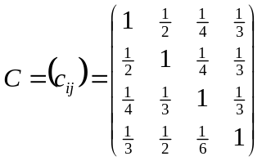
7.3 Model establishing and solving
Step1：set 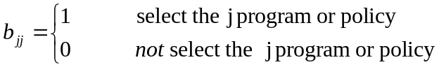 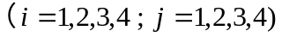
Step2：Calculating the objective function using Hungarian method
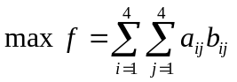
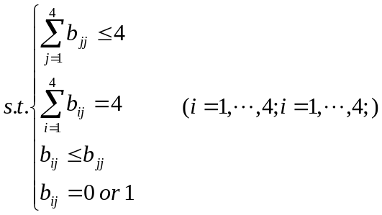
Obtaining the optimum solution
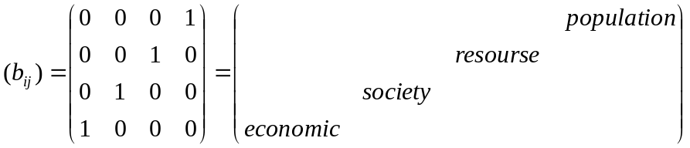
7.4 Result analysis
Assuming invests time is divided into four stages, according to the results, the investment strategy is as follows.
Stage I：In this stage, the programs or policies in the economic subsystem have the greatest effect on the sustainability improvement. In other word, the first stage of investment will focus on economic aspects. According to the calculation formula of GDP based on expenditure method, GDP = consumption + investment + (exports - imports). So that ICM can create a more sustainable world by intervening consumption, investment and export, import aspects of interested countries.
Stage II：The programs or policies in the social and political subsystem have the greatest effect on the sustainability improvement. Based on GINI coefficient's influence on the social aspect, attention is supposed to be focused on how to narrow the gap between rich and poor. As the growth of the national economic, the gap between rich and poor will increase simultaneously. In order to have a more sustainable future, government should take the initiative to make policies to reduce the income gap, such as Change the way of distribution.
Stage III：In this stage, natural resources should be focused on. The related programs or policies have larger impact on sustainable development in this period. Some developing countries are rich in hydropower resources, but because of the lack of mining technology in relevant field, which leads to low energy production. The ICM should tender an olive branch to the developing country, which helps to create a more sustainable world.
Stage IV：Programs or policies in the population subsystem are more effective for sustainable development in this stage. In terms of population, government can control the birth rate and mortality rate to make growth rate of population more reasonable, such as carrying out family planning policy. On the other hand, infection of disease are more serious in some developing countries, government can implement related programs or policies to improve medical and healthcare system.

8. Optimization solution for problem III
8.1 Model preparation
The sustainable development is closely related to the countries’ demographic, natural resources, economic, social and political conditions. The problem of evaluate the effect of our development strategies requires a systematic and flexible methodology, including an indicators system and most importantly, a simulation model to relate the social, ecological and economic aspects of urban planning together as a whole ^{[10]}. System dynamics can assist in strategy assessment and provides insights into possible changes in the system during policy implementation (Sterman, 2000).
8.2 Model solving
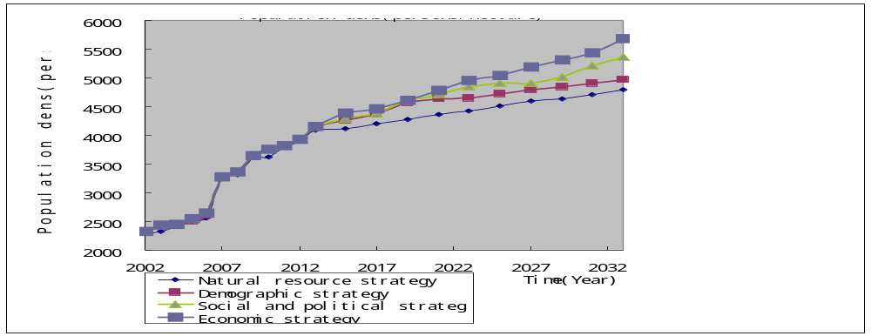
Fig.10 The effect of strategy on population dense
In order to make the country more sustainable development, formulate the corresponding policy from population, natural resources, economic, social and political conditions. Then we select population density, and gain the effect of the country's population density on policies. As shown in figure 10, you can see the population policy follows, and the influence of economic policy is the minimum.

9. Evaluation and Spread of the Model
9.1 Evaluation of the Model
9.1.1 Strengths
Problem 1: Sustainability evaluation model based on Genetic Algorithm
- The model is simple in computation without being limited by the number of indicators. Additionally, the evaluation method is intuitive, practical with strong comparability.
- The weights are calculated by the general algorithm and AHP respectively for different levels. The former method is well-defined and calculated strictly; based on the importance principle, the latter one can make appropriate adjustment according the actual situation. Therefore, the weight calculation is normative, flexible and scientific.
Problem 2: The 20-year sustainability plan
- Combing the fundamental realities of the Cambodia，the strategies would be more practical and scientific.
- Using a variety of mathematical software (like Matlab, Stella), learn from each other in mutual emulation, to make the calculation results more accurate.
Problem3 Simulate the 20-year sustainability plan
- During the process of indentifying highly effective strategies, control variate method is used to calculate the influence of each single indicator, and greatly simplified the solution.
9.1.2 Weaknesses
- If the graded standard is highly disparate from the normalized value in table 3, the optimized parameters a and b will be different. Thus, the graded standard should be improved to be more accurate and more universally applicable.
- The weight calculation has inevitable subjectivity and may cause error.
9.2 The Extension of Models
SDy emphasizes the connection, development and movement of system, considering the behavior patterns and characteristics of the system mainly rooted in its internal dynamic structure and feedback mechanism. In addition to the application for the analysis of factors influencing the sustainable development of inner link, it can also promote regional planning policy to energy management enterprise management marketing strategy Transportation and other fields.

References
[1]World Commission on Environment and Development (WCED), Our Common Future (New York: Oxford University Press, 1987), 8.
[2]Lan Guo-liang. Study on Construction and Application of Indexes System of Sustainable Development[D] (Sustainable development has become a goal for international aid agencies, planners, governments, and non-profit organizations.）
[3]Forrester, J. W. Urban Dynamics. [M] Cambridge MA: Productivity Press, 1969.
[4]Ho, Yufeng, ShuSone Wang.System Dynamics Model for the Sustainable Development of Science City.[C] The 23rd International Conference of the System Dynamics Society, Boston, US,2005
[5]Duran -Encalada J, Paucar Caceres A. System Dynamics Urban Sustainability Model for Puerto Aura in Puebla Mexico [J]. System Practice and Action Research, 2009,22(2): 77-99
[6]http://en.wikipedia.org/wiki/Least_developed_country
[7]Bell, Simon and Stephen Morse. 2008. Sustainability Indicators: measuring the immeasurable. Earthscan, London.
[8] Li Zuoyong, Gan Gang,SHEN Shi-Iun. Appraisal index systems and assessment model of social，economical and environmental coordinative developmen [J]. Chengdu University of Information TechnoIogy. 2001, 16(3) （in Chinese）
[9]http://globserver.cn
[10] Ho Y F, Wang S S. System Dynamics Model for the Sustainable Development of Science City[C]//The 23rd International Conference of System Dynamics Society, Sloan School of Management, MIT, USA. 2005.
[11]Legasto, Augusto A., Jay Wright Forrester, and James M. Lyneis, eds.System dynamics. New York: North-Holland publishing company, 1980.
[12]Wang Qifan．System Dynamics［M］．Beijing：Tsinghua University Press,1994: 151-195.（in Chinese）

