**COMP4442 Service and Cloud Computing**

Group Project

|  |  |  |
| --- | --- | --- |
| **Name** | **Student ID** | **Email** |
| Cheung Sui Wing | 21027547D | 21027547D@connect.polyu.hk |
| Lau Man Chun | 21027257D | 21027257D@connect.polyu.hk |
| Kwong Chun Him | 21028468D | 21028468D@connect.polyu.hk |
| Cheng Chi Kit | 21028079D | 21028079D@connect.polyu.hk |

Table of Contents

Group tasks performed by each member 1

Cheung Sui Wing 1

Lau Man Chun 1

Kwong Chun Him 1

Cheng Chi Kit 1

AWS App link: 1

Folder structure: 1

System Specification 2

Operation system 2

Programming language with version 2

System software 2

Required packages 2

Functional modules 3

Key functions 3

Summary Web Page 3

Monitor Web Page 5

Monitor Record Page 5

Spark 5

Upload data to database 6

Generate data for real time monitor 6

Relationship among them 6

System architecture 7

Deployment procedures 7

Operations in AWS 7

Scripts to be executed locally 10

Testing reports for different functions 11

Use cases 11

Screenshots of testing results 12

References: 20

# Group tasks performed by each member

## Cheung Sui Wing

* Spark script
* Database SQL, upload data script, initSQL
* Flask App: summary bar chart and pie chart
* Setup/deploy the app in AWS S3, EC2, RDS, EMR
* Report Document

## Lau Man Chun

* Summary table/ fetch SQL/ filter etc.
* Monitor record page, bug fix
* Doc

## Kwong Chun Him

* Monitor function and monitor page
* Monitor record page, record database/SQL
* Report Document

## Cheng Chi Kit

* Testing
* Deploy the app in AWS
* Report Document

# AWS App link:

<http://web-env.eba-qttvhmqs.us-east-1.elasticbeanstalk.com/>

# Folder structure:

# System Specification

## **Operation system**

AWS EC2:

* Python 3.8 running on 64bit Amazon Linux 2/3.3.12

In Local:

* Windows 10 / Google Colab

## **Programming language with version**

Python 3.8

MySQL 8.0.28

## **System software**

In AWS:

* AWS Spark,
* AWS EMR,
* AWS S3,
* AWSElastic BeanStalk,
* AWSElastic BeanStalk Loadbalancer

In Local:

* Visual Studio code
* Google colab
* MySQL workbench 8.0

## **Required packages**

certifi==2020.6.20

click==8.1.2

colorama==0.4.4

Flask==2.1.1

itsdangerous==2.1.2

Jinja2==3.1.1

MarkupSafe==2.1.1

mysql-connector==2.2.9

numpy==1.22.3

pandas==1.4.2

py4j==0.10.9.3

PyMySQL==1.0.2

pyspark==3.2.1

python-dateutil==2.8.2

pytz==2022.1

six==1.16.0

Werkzeug==2.1.1

wincertstore==0.2

# Functional modules

## **Key functions**

### **Summary Web Page**

The Summary page includes all the functions below, it is for viewing the driving behavior of the people in a selected amount of date and time or viewing a specific person’s driving behavior.

* **Summary data table**

Show the summary data according to the the selecting day in table form

* **Date and time Selection**

Select data and time for data to be shown and for generating bar chart and pie chart.

* **Filter**

Find driving behavior according to DriverID or Car Plate Number, etc. (only filter the data existing in the table)

* **Generating Bar Chart**

Generate a Bar Chart according to the data of each or every driver, which include abrupt acceleration times, abrupt brake times, overspeed times, etc.

* **Generating Pie Chart**

Generate a Pie Chart according to the data of each or every driver, which include abrupt acceleration times, abrupt brake times, overspeed times, etc.

### **Monitor Web Page**

* Can search the driver ID that you want to monitor.

* Show the real time driving speed of this driver (update the data every 30 seconds), when the speed of driver high than 80 will alert “speed too fast” message.

### **Monitor Record Page**

Show the Monitor Record according to the selected driver and select time period (show the speed data from the dataset provided)

### **Spark**

* File for using in EMR: DB/Spark_aws_EMR.py
* File for using in development (Google Colab) : DB/ spark_colab.ipynb
* We hard code the S3 input output path, no need to use sys.args.

Basic logic

* First, read all 10 text data
* Then, Filter out all the record that do no have any special behaviour

e.g.:

In our case, only count the line that have more than 8 records



* Then use driver, carPlateNumber, Time as a key to sum up all other behaviour primary in that day.
* Final output as a single csv file

*Reference: Huawai Driving Behavior Data Analysis [1]*

### **Upload data to database**

* Path: DB/upload_data_to_DB.py
* Upload csv data generate by the spark function

### **Generate data for real time monitor**

* Path: DB/ gen_data_for_monitor.py
* Generate random data for real time monior function

## **Relationship among them**

Summary and Moniotr are the fontend function

Summary includes functions that are Data and time selection, Filter, Generating Bar Chart, and Generating Pie Chart, they all are configed into a single page for easier browsing. The data used is come from spark processing.

The Monitor Web Page shows the real-time driving data generated by using the local script.

# System architecture

(System architecture to show how you orchestrate the AWS services.)

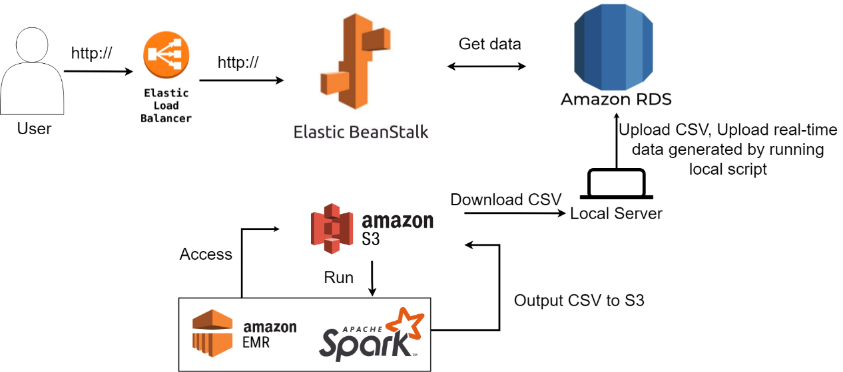

# Deployment procedures

## Operations in AWS

1. Create storage Buckets



1. Upload the python script and data to the bucket

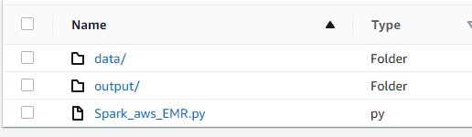

**data/** storing the 10 orginal data

**output/** use to store the csv output after running the python script

and the **python script**

1. Setup EMR

1. Add Step

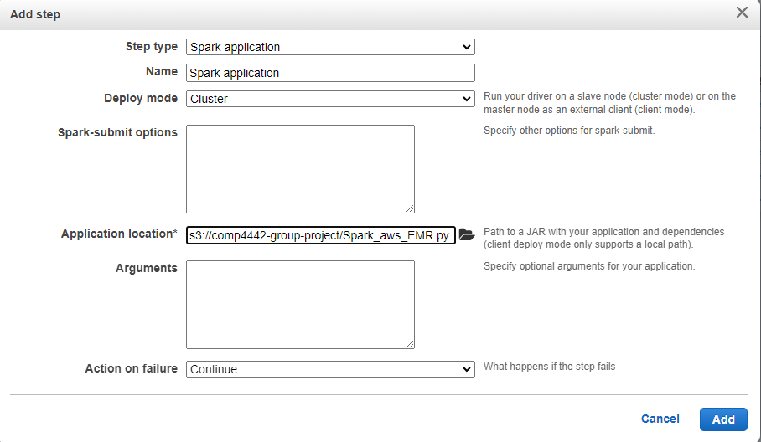

(hard code path, no args are needed)

1. Wait for complete

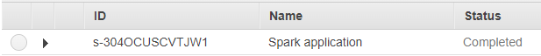

1. Find the csv in S3://comp4442-group-project/output/

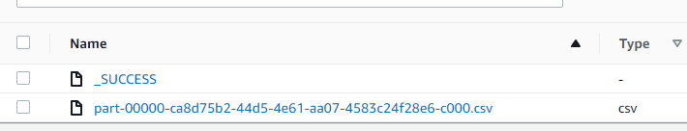

1. Download the csv and store in local
2. Set up AWS RDS database

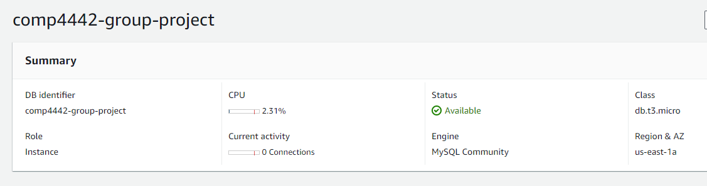

1. Add groupmate’s IP and 0.0.0.0/0 to security Inbound rule

1. Setup MySQL workbench

1. Copy the create table query in DB/initDB.sql and execute it to create DrivingRecords and Monitor tables.

1. Run upload_data_to_DB.py to upload the csv data to DB

python upload_data_to_DB.py

1. Develop the Flask application locally

python application.py

1. Load balancer

1. Deploy the Flask app to AWS Elastic Beanstalk

url: <http://web-env.eba-qttvhmqs.us-east-1.elasticbeanstalk.com/>

## Scripts to be executed locally

* DB/ upload_data_to_DB.py

Use once to upload the csv data to database

* DB/ gen_data_for_monitor.py

Run this script to generate fake data for real time monitor function

# Testing reports for different functions

## Use cases

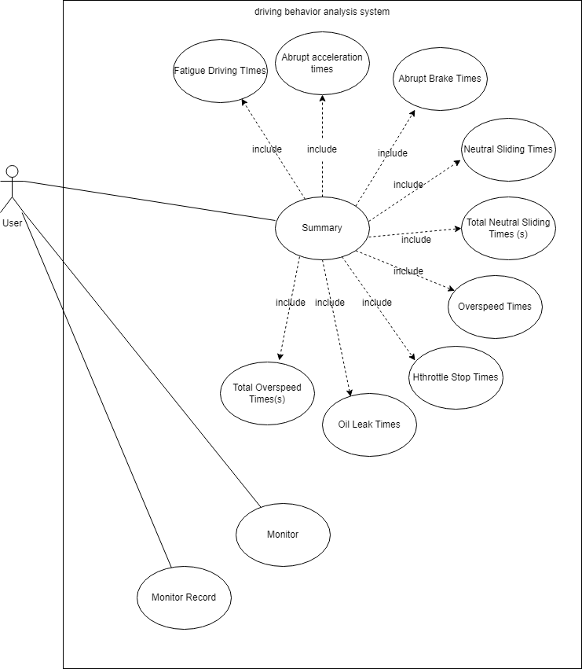

## Screenshots of testing results

* Home Page

* Summary button

* Monitor button

* Summary-Date and time button

* Summary-Choosing date and time



* Summary-Submit button

* Summary-Filter

* Summary-Abrupt acceleration times

* Summary-Abrupt Brake Times

* Summary-Neutral Sliding Times

* Summary-Total Neutral Sliding Times (s)

* Summary-Overspeed Times

* Summary-Total Overspeed Times(s)

* Summary-Fatigue Driving Times

* Summary-Hthrottle Stop Times

* Summary-Oil Leak Times

* Monitor-Submit

* Monitor-Over Speed

* The data of the chat should same with the database
* Data of database

* Simple 1 : The last data of chart

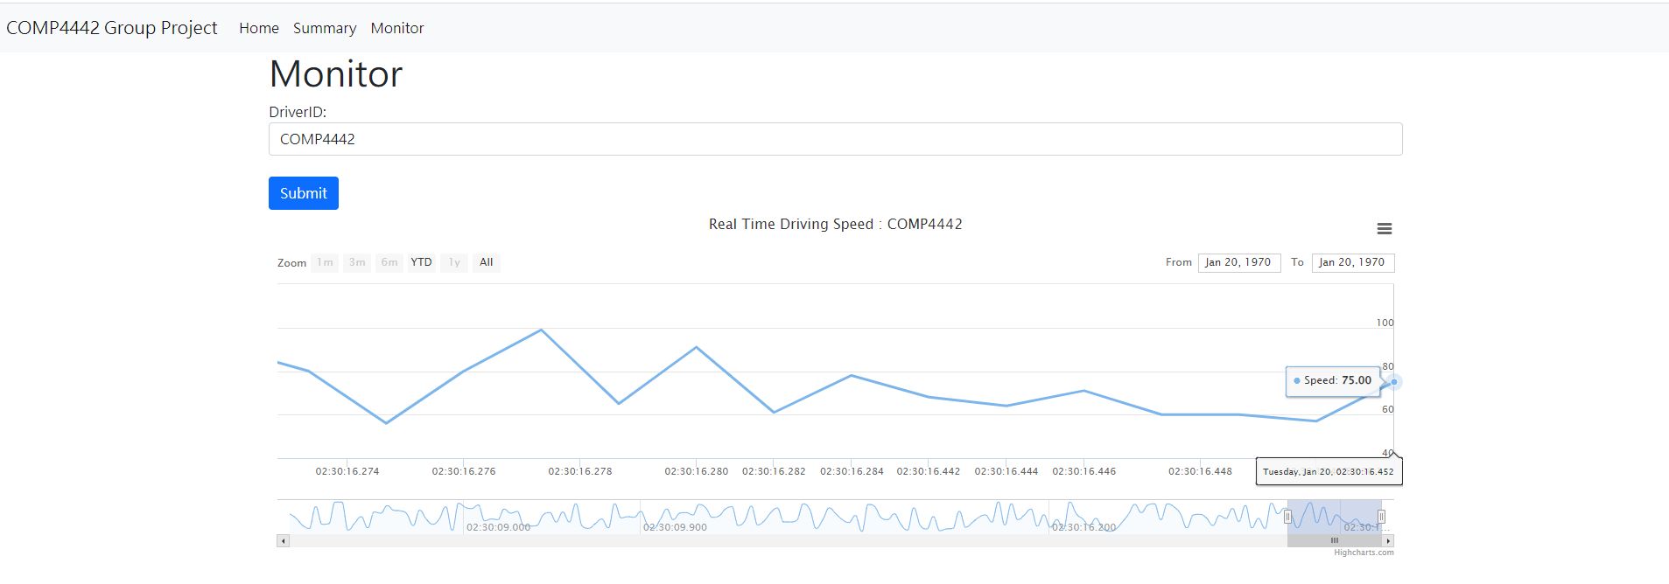

* Simple 2 : The second to last data of chart

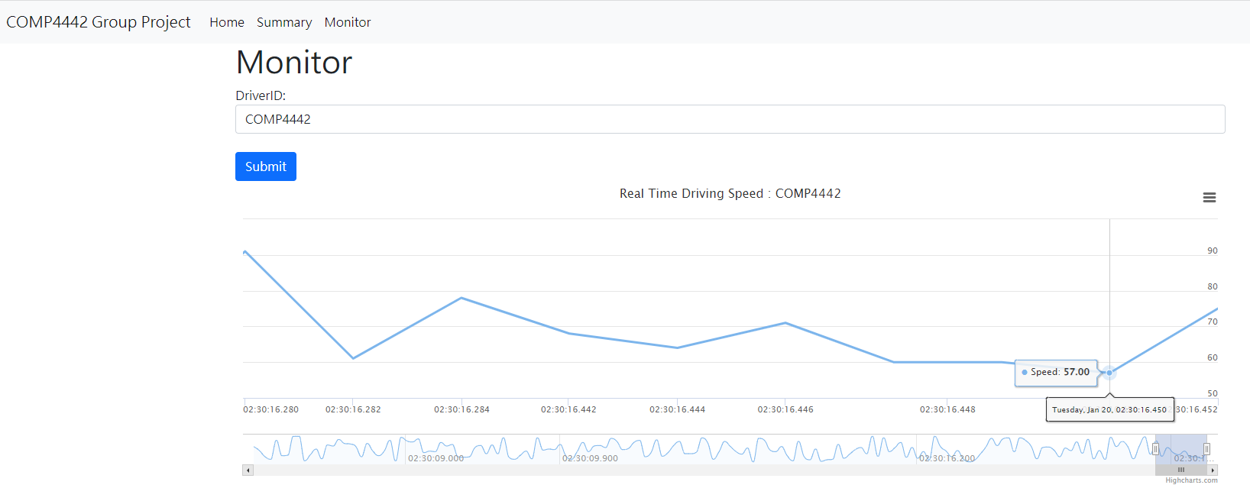

* Simple 3 : The third to last data of chart

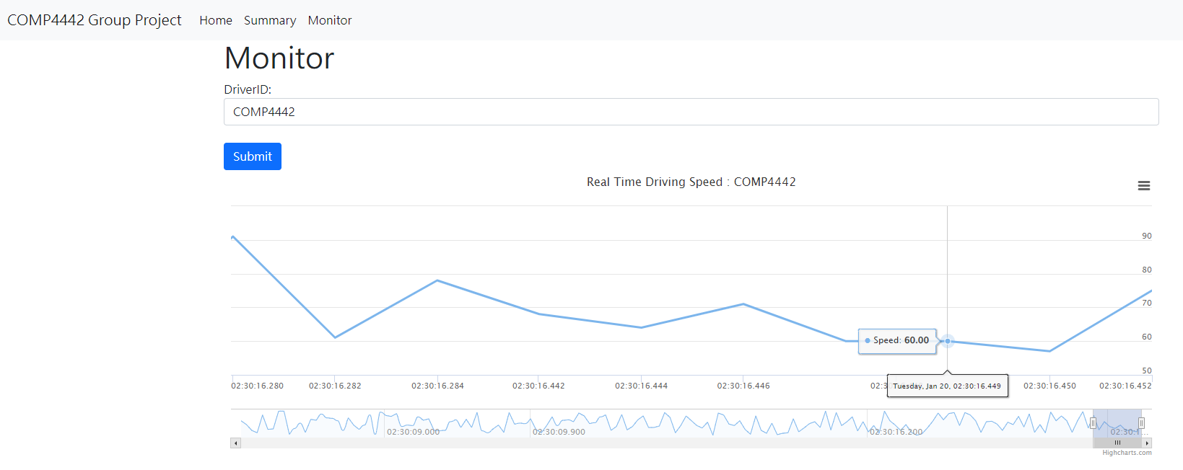

* Result: all the data of the chat is same with the data base
* Monitor Record

* 5M

* 1M

# References:

[1] Haiwai, Driving Behavior Data Analysis, Apr 01, 2022, <https://support.huaweicloud.com/intl/en-us/bestpractice-dli/dli_05_0001.html>