Hong Kong Institute of Vocational Education (Shatin)
Department of Information Technology

Higher Diploma in Software Engineering

Contemporary Topics in Software Engineering (ITP4507) – Short Report
(2020/2021)

We declare that this is a group project and that no part of this submission has been copied from any other student’s work or from any other source except where due acknowledgement is made explicitly in the text, nor has any part been written for us by another person.

Student | Std No.
Cheung Sui Wing | 190049170

Table of Contents

1. Assumptions regarding the problem context 3
2. Application design with class diagram 4
3. Discussion and explanation on each of the design patterns applied to the application 5
4. User Guide 11
5. Test Plan and Test cases 14

Assumptions regarding the problem context
- Development JDK:
- Java 15 https://www.oracle.com/java/technologies/javase-downloads.html
- Each user can only have one order at a time.
- User always input the right name of the main dish
- The orders will be handled on a first come first server basic.

Application design with class diagram

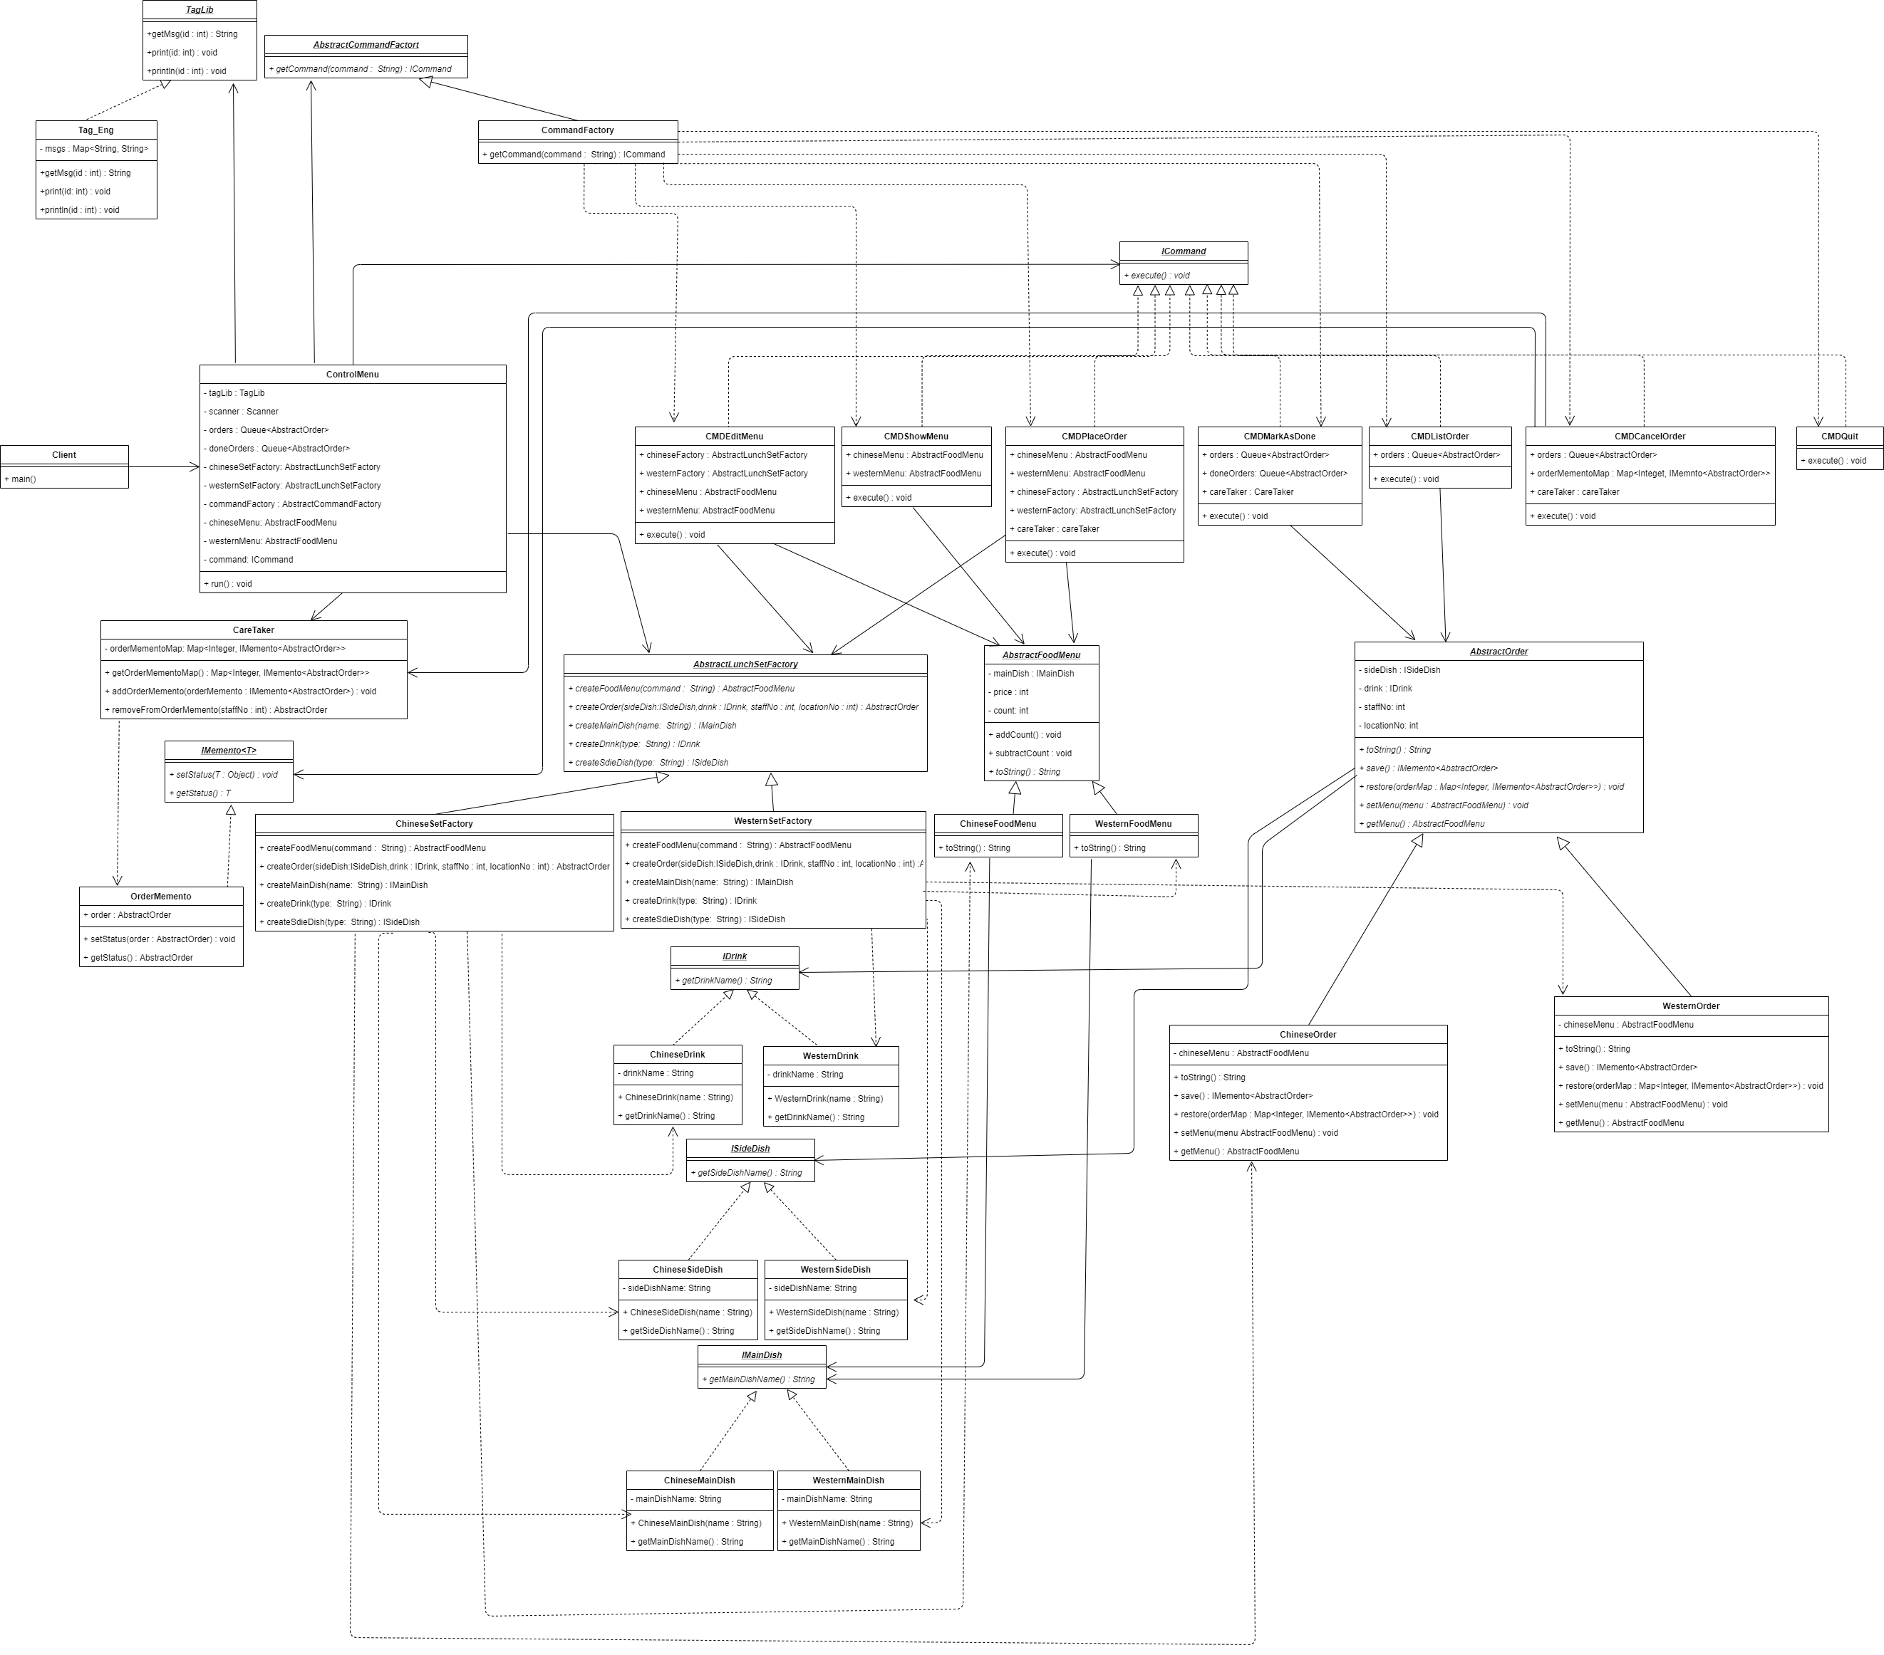
(/Report/Class Diagram.png)
Credit: draw.io

Discussion and explanation on each of the design patterns applied to the application

- Open Close Principle
- Most of the class will implement an interface or extend from an abstract Class according to different type instead of hard coding the type; E.g. Command Object, Chinese set object and Western Set Object.
- Using Command pattern to handle different action,
- Using Factory pattern to create different type of object
- Using Memento Pattern to save and restore each order make, and support the cancel order function.

Command Pattern
- Provide total 7 Commands.
- All of them implements ICommand, which need to provide execute() function
Edit Menu | - Call LunchSetFactory to create different type of FoodMenu Object  - Edit the ChineseFoodMenu and WesternFoodMenu Object
Show Menu | - Call ChineseFoodMenu and WesternFoodMenu to print their toString()
Make Order | - Call different LunchSetFactory to create the Drink, SideDish and Order Object according to the user input  - Call related FoodMenu to remove 1 stock when Order successful created.  - Save the order to the Order Queue and OrderMemento.
Cancel Order | - Call the restore() of removed Order Object, which use the OrderMemento to rebuild the OrdersQueue.
List Orders | - Call the toString() of each order in the Order Queue
Mark order as done | - Call the Poll function of the Order Queue  - Call Caretaker to Update the OrderMemento(remove the poll order)  - Save to doneOrderList
Quit program | - Call System.exit(0)

- Factory Pattern
- Three Factories to maintain three type of object creation: Command, Chinese Set Object, Western Set Objects
CommandFactory | - Control the command object creation of each command:  - CMDEditMenu  - CMDShowMenu  - CMDPlaceOrder  - CMDMarkAsDone  - CMDListOrder  - CMDCancelOrder  - CMDQuit
ChineseSetFactory | - Extend from the AbstractLunchSetFactory  - Create Chinese Set related Object  - ChineseMainDish  - ChineseSideDish (Chinese rice only)  - ChineseDrink  - ChineseMenu  - ChineseOrder
WesternSetFactory | - Extend from the AbstractLunchSetFactory  - Create Western Set Related Object  - WesternMainDish  - WesternSideDish  - WesternDrink  - WesternMenu  - WesternOrder

- Memento Pattern
- Support the Cancel Order function when user input the staffNo
- A CareTaker class to keep and control the OrderMemento Map
- A Save and Restore function in each Order

Flow:
- Each time when the Order create, the CMDPlaceOrder will also call the save() to clone the Order to the OrderMemeto and Map with the staffNo as Key;
- Each Time the Order is Done, CMDMarkAsDone will call the caretaker to remove the OrderMemento form the Map with the Done Order’ staffNo
- Each Time when User Cancel Order, CMDCancelOrder will call the caretaker to remove the Order from the Map with the staffNo, Then call the restore function of the Order object, which using the current OrderMemento Map to rebuild the Order Queue.
- Extension
- Since we use above pattern, if the company need to add the third type of lunch set, they can add the object like this:
- 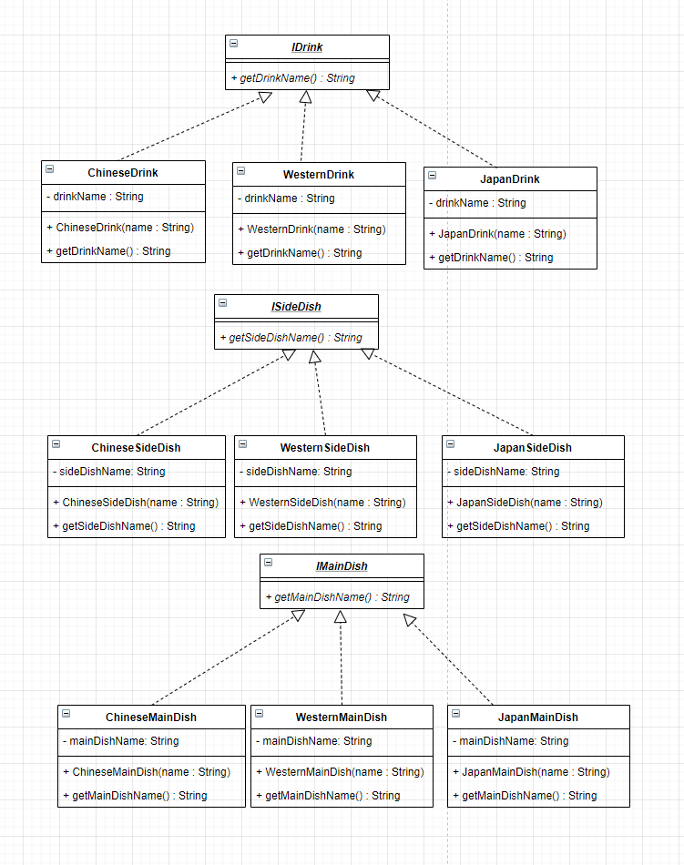
- Then add the JapanMenu and JapanOrder object

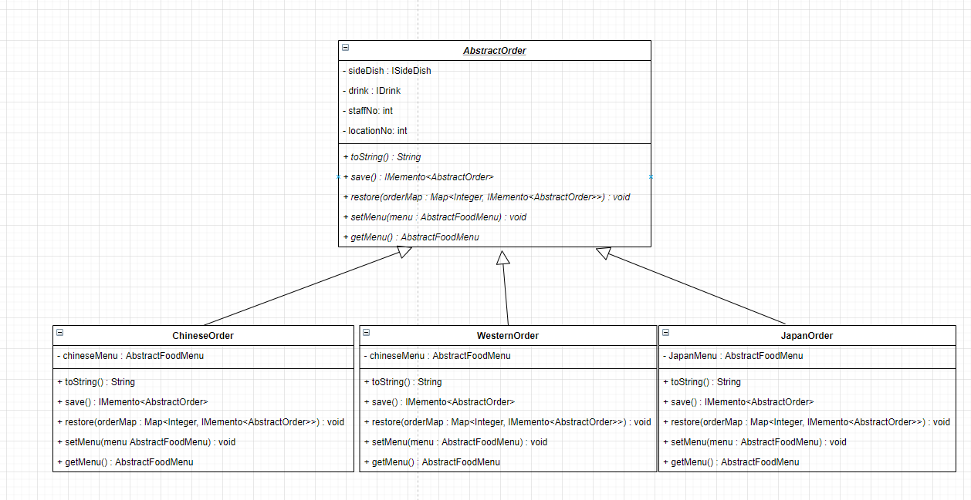

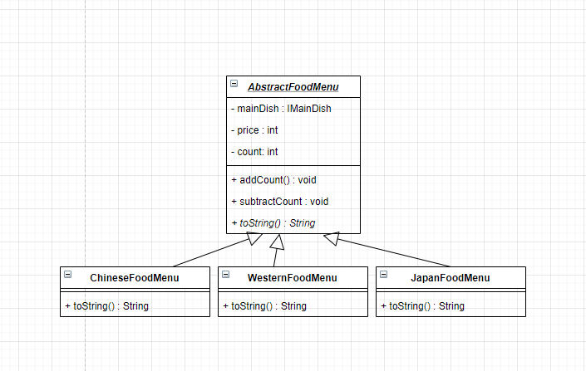
- Also, add a JapanFactory to manage all the object creation
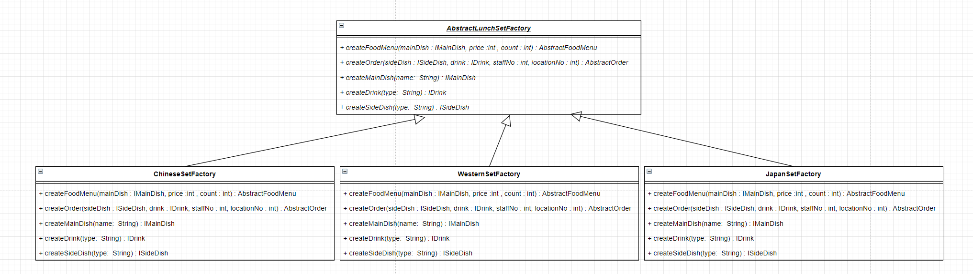

- Finally, add these as the receiver to the corresponding Command
- and update the menu string that store in TagLib

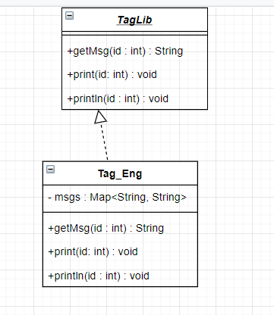

User Guide
Command Menu

Actions | Description
- Edit Menu | - Input “e” for edit menu  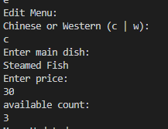  - User need to choose “c” or “w” to edit the chinese or western menu  - Then enter the Main Dish name(String)  - Then enter the Price (int) and should be greater than 0  - Finally, enter the count for the menu (int) and should be greater than 0.
- Show Order | - Input “s” for show menu, then the menu will show  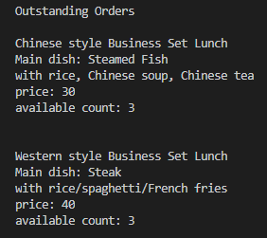
- Place order | - Input “p” for place Order  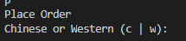  - Then choose the type of the order by input “c” for Chinese or “w” for western  - For Chinese Order, user also need to choose the type of drink , “h” for hot and “i” for cold  - For Western Order, user need to choose the side dish, “r” for rice, “s” for spaghetti, “f” for French fries  - Also, user need to choose the type of drink, “ht” for Hot Tea, “it” for Cold Tea, “hc” for Hot Coffee, “ic” for Iced Coffee  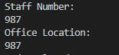  - Finally, user need to input the staff number and Office Location, both are integer number
- Cancel order | - Input “c” for cancel order  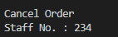  - Then user need to input the staffNo for find his/her order to cancel  - Then the order will be cancelled if exist
- List Order | - Input “l” for list order  - Then the order Queue will be printed
- Mark Order as Done | - Input “d” for mark order as done  - Then the first order on the Queue will mark as done and remove from order Queue
- Quit Program | 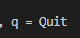  - Input “q” for quit the program

Test Plan and Test cases
- It will be 2 Phase during the test plan,
- The first phase are using the case (5 cycle) from the Assignment script provided. It is use to test the input in normal flow and use will always input the right value that the system need.
- The Second phase will test the program with own data that contain exception case, such as input type, menu count logic, memento restore logic for each module.

Files in bin:

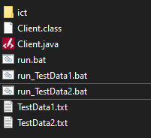

“ict” file are the package
“Client.java” is the main program
“run.bat” will run the Client.java
“run_TestData1.bat” will run the Client.java with TestData1.txt
“run_TestData2.bat” will run the Client.java with TestData2.txt

“TestData1.txt” keep the input in test Phase1
“TestData2.txt” keep the input in test Phase2

- 1st Phase : Test the program that the user always input the right input (same with the 5 Cycle that assignment script provided)

- 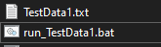

- Run_TestData1.bat will run the Client Program with the input in TestData1.txt

- Result:
- Pass
- Successfully to run all 5 cycle and all values are same with the Assignment Script

- 2nd Phase : Test the program with some exception case, such as wrong input format, test the count number calculation, restore result of the OrderMemento

- 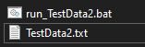will run the test as show below
Related Module | Main Menu
Description | Input empty Line or wrong input
Input | - (Enter key)  - asdf  - 0
Expected Result | Print the message to tell the user that there is no such command
Result | Pass
Screenshot
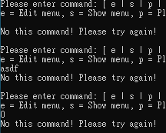

Related Module | Show Menu
Description | Show menu before edit menu
Input | - s
Expected Result | It will show Chinese set menu and western set menu, with count = 0, price = 0, main dish = Not Set
Result | Pass
Screenshot
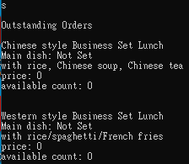

Related Module | Place Order
Description | Place Order but all the menu count is 0
Input | - p
Expected Result | It will show the message that “No Menu is available!”
Result | Pass
Screenshot
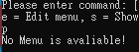

Related Module | Show Order, Cancel Order, Mark Order as Don
Description | Show Order when there is no order in the queue,  Then Cancel Order but there is no order in the queue  Finally, Mark Order as done while there are no Order
Input | - l  - c  - d
Expected Result | It will show the message that  “No Order!” for List Order  “No Order can cancel!” for Cancel Order  “No Order” for Mark Order as Done
Result | Pass
Screenshot
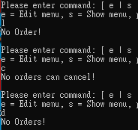

Related Module | Edit Menu
Description | Check with different wrong input during the edit menu
Input | - a  - c  - (Enter Key)  - -1  - 1.1  - a  - (Enter Key)  - 10  - -1  - 1.1  - (Enter Key)  - 10
Expected Result | Only c and w will be accepted for menu type  Main Dish Name cannot be empty  Only positive integer will be accepted for price  Only positive integer will be accepted for count
Result | Pass
Screenshot
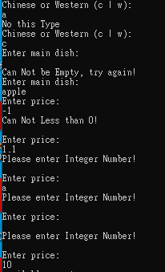 → 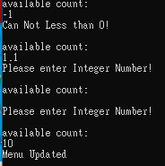

Related Module | Place Order, Show Menu
Description | Check with different wrong input during the Place Order, Menu Object will -1 count
Input | - p  - a  - w  - p  - c  - a  - h  - a  - (Enter Key)  - 1.0  - 1  - a  - 1.0  - 1  - s
Expected Result | Only “c” and “w” will be accepted for order type  Only “c” or “i” will be accepted for Chinese drink type  Only Integer will be accepted for staff number and location number  Chinese Menu will -1 (from 10 to 9).
Result | Pass
Screenshot
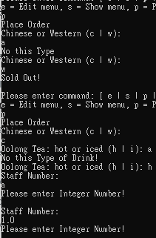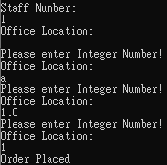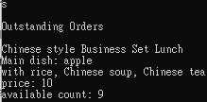

Related Module | List Order
Description | Check the Order Queue
Input | - Edit WesternMenu with Main Dish: banana, price = 10, count = 2  - Add 1 Western order with StaffNo 2 and location 2  - Add 1 Chinese Order with StaffNo 3 and location 3  - Add 1Western Order with StaffNo 3 and location 3  - Change the StaffNo to 4 and location 4  - List order  - Show menu
Expected Result | - When the western Order with staffNo 3 input, the system will tell the user that Number had an order already.  - List order will show all 4 orders will correct queue position  - Show menu will show there are 8 chinese set left and 0 western set left
Result | Pass
Screenshot
Place Western Order : StaffNo 2, Location 2
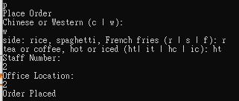

Place Chinese Order : StaffNo3, Location 3
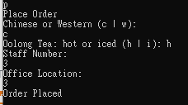

Place Western Order: StaffNo 3,
Since the staffNo already had an order, it will print his/her order
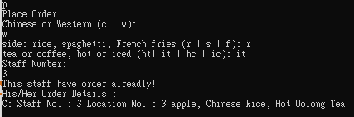

Change the staffNo to 4, location 4
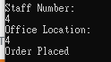

List Order (first Order print first):
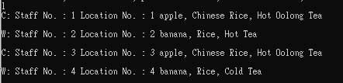

Show Menu
(Chinese Order Count 10 become 2)
(Western Order Count 2 become 0)
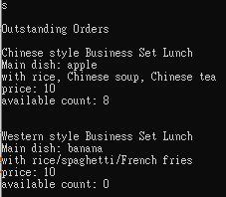

Related Module | Cancel Order
Description | Check the wrong input with cancel order  Check the Order Queue after cancel  Check the menu count after cancel
Input | - c  - a  - 2  - 2
Expected Result | - staffNo will only accept integer StaffNo input  - If that staffNo has no Order, it will show “This staff has no order”  - It that staffNo has order, it will show the order and remove from the queue  - The menu count will +1 after cancel action is success
Result | Pass
Screenshot
Cancel order with wrong input
Then cancel order with staffNo 2
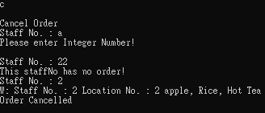
Show Order List (StaffNo 2’s Order cancelled)
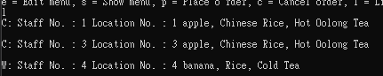
Show Menu (Since staffNo 2’ order is Western Order, The Count Of western Order +1)
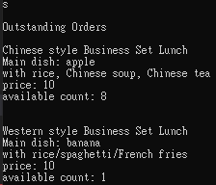

Related Module | Mark Order As Done, Cancel Order
Description | Mark one order as done  The list the order
Input | - d  - l
Expected Result | - StaffNo 1’s order will mark as done  - Order Queue will remain Order with Staff No 3, 4
Result | Pass
Screenshot
Mark first order as done
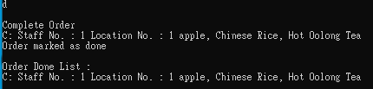

Current Order List
