COMP3211: Software Engineering (2021-2022)

Group Project – Monopoly

API design document

Cheung Sui Wing (21027547D)

Lau Man Chun (21027257D)

Kwong Chun Him (21028468D)

Cheng Chi Kit (21028079D)

Table of Contents

1. Class/Method description 1

1.1. Main.py 1

1.2. Data.py 1

1.3. Menu.py 1

1.4. GameBoard 2

1.5. Block.py 4

1.6. Player.py 8

2. System models 10

2.1. Class Diagram 10

2.2. Activity Diagram 14

2.3. Sequence Diagram 19

# Class/Method description

* 1. Main.py

The first py to be run, will import and call different py, such as call Menu.py for the player to choose “New Game” or “Continue”, and if the answer is “New Game”, Main.py will call the required py to start the game.

|  |  |  |
| --- | --- | --- |
| Variable | | |
| Name | Type | Description |
| +block_list | List [Block] | To store the all block objects |
| +player_list | List [Player] | To store the all player objects |

|  |  |
| --- | --- |
| Method | |
| Name | main() |
| Argument | N/A |
| Return Type | void |
| Description | The main program, calls the print_menu() from menu.py, and get the return number and generate the players, blocks, and gameboard and run the game. |

* 1. Data.py

Data.py stores all the data, in different forms, mainly in JSON, secondly is a enum class for storing colors.

|  |  |  |
| --- | --- | --- |
| Variable | | |
| Name | Type | Description |
| +START_MONEY | INT | The amount of money present to the player when new game start |
| +SALARY | INT | The amount of money present to the player when the player passes the Start block |
| +MAX_TURN | INT | The maximum turns of the game |

* 1. Menu.py

Menu.py is called by Main.py when the program starts, it’s use is to print the menu for the player to choose different options, which are “New Game”, “Continue”, and “Check Game Rule”.

|  |  |
| --- | --- |
| Method | |
| Name | print_menu() |
| Argument | N/A |
| Return Type | INT |
| Description | Print the menu when the game starts. Ask the user to start a new game, continue the last game, check the game rule, or exit  Return 0 for new game  Return 1 continue game |

* 1. GameBoard

GameBoard provides all the main logic of the program, first, print the game board with similarity same as the Monopoly game with all the details, houses, money, dice, etc. Second, it checks if the player is in jail, if not, call the roll dice method, after the roll dice method is finished and move the player to another block(square, box), it will call the activateBlockEffect method in Block.py to perform the expected action when landing on a block, such as when the player landed on a building, it will check if the building has been bought and if yes, the player will need to pay a rent, etc.GameBoard.py main method will keep looping before the maximum of turn have been reached or the player chooses to save the same and continue later.

|  |  |  |
| --- | --- | --- |
| Variable | | |
| Name | Type | Description |
| +turn | INT | The current turn of this game |
| +players | List [Player] | The player object list |
| +blocks | List [Block] | The block object list |
| +jailList | List [Player] | A list of players who is in jail |
| +fine | INT | Fine needed to pay for getting out of the jail |
| +current_player | Player | The current player object |

|  |  |
| --- | --- |
| Method | |
| Name | __init__() |
| Argument | players: List [Player]  blocks : List [Player] |
| Return Type | void |
| Description | Constructor of GameBoard |

|  |  |
| --- | --- |
| Method | |
| Name | print_board() |
| Argument | N/A |
| Return Type | void |
| Description | Print the game board on the command line |

|  |  |
| --- | --- |
| Method | |
| Name | set_currentPlayer() |
| Argument | player : Player |
| Return Type | void |
| Description | Set the current player |

|  |  |
| --- | --- |
| Method | |
| Name | roll_dice() |
| Argument | N/A |
| Return Type | Void |
| Description | Call the dice() and move the player to new position |

|  |  |
| --- | --- |
| Method | |
| Name | add_to_jail_list() |
| Argument | player: Player  fine : int |
| Return Type | void |
| Description | Add the player to the jailList and set the fine number |

|  |  |
| --- | --- |
| Method | |
| Name | save_game() |
| Argument | N/A |
| Return Type | void |
| Description | Record all the game status and output a save file |

|  |  |
| --- | --- |
| Method | |
| Name | roll_dice_face() |
| Argument | N/A |
| Return Type | INT |
| Description | Random the index of the dice face then return (0-3) |

|  |  |
| --- | --- |
| Method | |
| Name | dice() |
| Argument | N/A |
| Return Type | INT |
| Description | Call roll_dice_face() then get the target face, then randomize the index (0-2) and get the final dice number, then return |

|  |  |
| --- | --- |
| Method | |
| Name | run() |
| Argument | N/A |
| Return Type | Void |
| Description | Run the gameboard with the logic in the functional requirement. |

* 1. Block.py

Class Block stores all the logic to change any data when the player landed on a specific block, and the activateBlockEffect method, each block will perform different action and check if the player has the required data to perform the action, such as enough money to pay the rent.

**Abstract Class: Block**

|  |  |  |
| --- | --- | --- |
| Variable | | |
| Name | Type | Description |
| +block_data | Dict | The block data |
| +position | List [Player] | The block position |
| +name | List [Block] | The block name |

|  |  |
| --- | --- |
| Method | |
| Name | __init__ () |
| Argument | block_data : Dict |
| Return Type | Void |
| Description | Constructor of the Block |

|  |  |
| --- | --- |
| Method | |
| Name | activate_block_effect() |
| Argument | player : Player  game_Board : GameBoard |
| Return Type | Void |
| Description | This method will execute the logic of the block, default, there is no effect, only provide a save game option. |

**Class: Start**

|  |  |  |
| --- | --- | --- |
| Variable | | |
| Name | Type | Description |
| +sub_text | Str | The subtext of the block |

|  |  |
| --- | --- |
| Method | |
| Name | __init__ () |
| Argument | block_data : Dict |
| Return Type | Void |
| Description | Constructor of Start |

|  |  |
| --- | --- |
| Method | |
| Name | activate_block_effect() |
| Argument | player : Player  game_Board : GameBoard |
| Return Type | Void |
| Description | No Effect, call super() |

**Class: Property**

|  |  |  |
| --- | --- | --- |
| Variable | | |
| Name | Type | Description |
| +price | INT | The price of the property |
| +rent | INT | The rent that the player needs to pay |
| +owner | Player | The property owner |

|  |  |
| --- | --- |
| Method | |
| Name | __init__ () |
| Argument | block_data : Dict |
| Return Type | Void |
| Description | Constructor of Property |

|  |  |
| --- | --- |
| Method | |
| Name | activate_block_effect() |
| Argument | player : Player  game_Board : GameBoard |
| Return Type | Void |
| Description | When the property has no owner, ask the player to buy it  When the porterty has owner, ask the player to pay the rent |

|  |  |
| --- | --- |
| Method | |
| Name | reset_owner() |
| Argument | N/A |
| Return Type | Void |
| Description | Reset the owner to None |

|  |  |
| --- | --- |
| Method | |
| Name | set_owner() |
| Argument | player : Player |
| Return Type | Void |
| Description | Set the player to be the owner |

**Class: IncomeTax**

This object used to handle if a player lands on this square, she pays 10% of her money (rounded down to a multiple of 10) as tax.

|  |  |  |
| --- | --- | --- |
| Variable | | |
| Name | Type | Description |
| +subText | Str | The subtext of the block |
| +tax | INT | The tax % |

|  |  |
| --- | --- |
| Method | |
| Name | __init__ () |
| Argument | block_data : Dict |
| Return Type | Void |
| Description | Constructor of Income Tax |

|  |  |
| --- | --- |
| Method | |
| Name | activate_block_effect() |
| Argument | player : Player  game_Board : GameBoard |
| Return Type | Void |
| Description | Calculate the price that the player have to pay and subtract the money of the player |

**Class: Jail**

|  |  |  |
| --- | --- | --- |
| Variable | | |
| Name | Type | Description |
| +subText | Str | The subtext of the block |
| +fine | INT | The fine needed to pay for getting out of the jail |
| +turn | INT | The max turns that the player need to stay in the jail |

|  |  |
| --- | --- |
| Method | |
| Name | __init__ () |
| Argument | block_data : Dict |
| Return Type | Void |
| Description | Constructor of Jail |

|  |  |
| --- | --- |
| Method | |
| Name | activate_block_effect() |
| Argument | player : Player  game_Board : GameBoard |
| Return Type | Void |
| Description | No Effect, call super() |

**Class: Chance**

|  |  |  |
| --- | --- | --- |
| Variable | | |
| Name | Type | Description |
| +subText | Str | The subtext of the block |
| +min | INT | Minimum price player have to pay |
| +max | INT | Maximum price player can get |

|  |  |
| --- | --- |
| Method | |
| Name | __init__ () |
| Argument | block_data : Dict |
| Return Type | Void |
| Description | Constructor of Chance |

|  |  |
| --- | --- |
| Method | |
| Name | activate_block_effect() |
| Argument | player : Player  game_Board : GameBoard |
| Return Type | Void |
| Description | Randomize the number 0-1 to see if the player losees or gains money  Then, calculate the amount of money of the player that need to be changed |

**Class: FreeParking**

No effect of this block

|  |  |  |
| --- | --- | --- |
| Variable | | |
| Name | Type | Description |
| +subText | Str | The subtext of the block |

|  |  |
| --- | --- |
| Method | |
| Name | __init__ () |
| Argument | block_data : Dict |
| Return Type | Void |
| Description | Constructor of FreeParking |

|  |  |
| --- | --- |
| Method | |
| Name | activate_block_effect() |
| Argument | player : Player  game_Board : GameBoard |
| Return Type | Void |
| Description | No Effect, call super() |

**Class: GoToJail**

|  |  |  |
| --- | --- | --- |
| Variable | | |
| Name | Type | Description |
| +jail_position | INT | The position of Jail Block |
| +fine | INT | The fine needed to pay for getting out of the jail |
| +turn | INT | The max turns that the player need to stay in the jail |

|  |  |
| --- | --- |
| Method | |
| Name | __init__ () |
| Argument | block_data : Dict |
| Return Type | Void |
| Description | Constructor of GoToJail |

|  |  |
| --- | --- |
| Method | |
| Name | activate_block_effect() |
| Argument | player : Player  game_Board : GameBoard |
| Return Type | Void |
| Description | Set the player position to the jail position Set how many turn(s) left before the player leaves the jail |

* 1. Player.py

Player.py is the object that stores the properties, attributes of the players, such as the number of players, is the player alive or not, and is the player in jail or not, it will also perform the action to pay any money such as rent, and money when landed on the “Chance” block if unlucky, or jail, moreover, add money, such as when the player reached the “Start” block, other player landed on the player property(s), and when landed on the “Chance” block if lucky.

|  |  |  |
| --- | --- | --- |
| Variable | | |
| Name | Type | Description |
| +player_number | INT | The player number (1-6) |
| +money | INT | The money that the player have |
| +position | INT | The position of the player in the game board |
| +jail_left | INT | How many turns that the player should stay at the jail |

|  |  |
| --- | --- |
| Method | |
| Name | __init__ () |
| Argument | player_number : int  money : int  position : int |
| Return Type | Void |
| Description | Constructor of Player |

|  |  |
| --- | --- |
| Method | |
| Name | pay_money() |
| Argument | money : int |
| Return Type | Void |
| Description | Subtract the player’s money according to the argument |

|  |  |
| --- | --- |
| Method | |
| Name | add_money() |
| Argument | money : int |
| Return Type | Void |
| Description | Add the player’s money according to the argument |

|  |  |
| --- | --- |
| Method | |
| Name | is_alive() |
| Argument | N/A |
| Return Type | Boolean |
| Description | If the player’s money >= 0, return True,  If not, return False |

|  |  |
| --- | --- |
| Method | |
| Name | is_in_jail() |
| Argument | N/A |
| Return Type | Boolean |
| Description | If the number of jail_left is 0, return False  If not, return True |

# System models

* 1. Class Diagram
     1. Overall

Simple version:

Detailed version (horizontal):

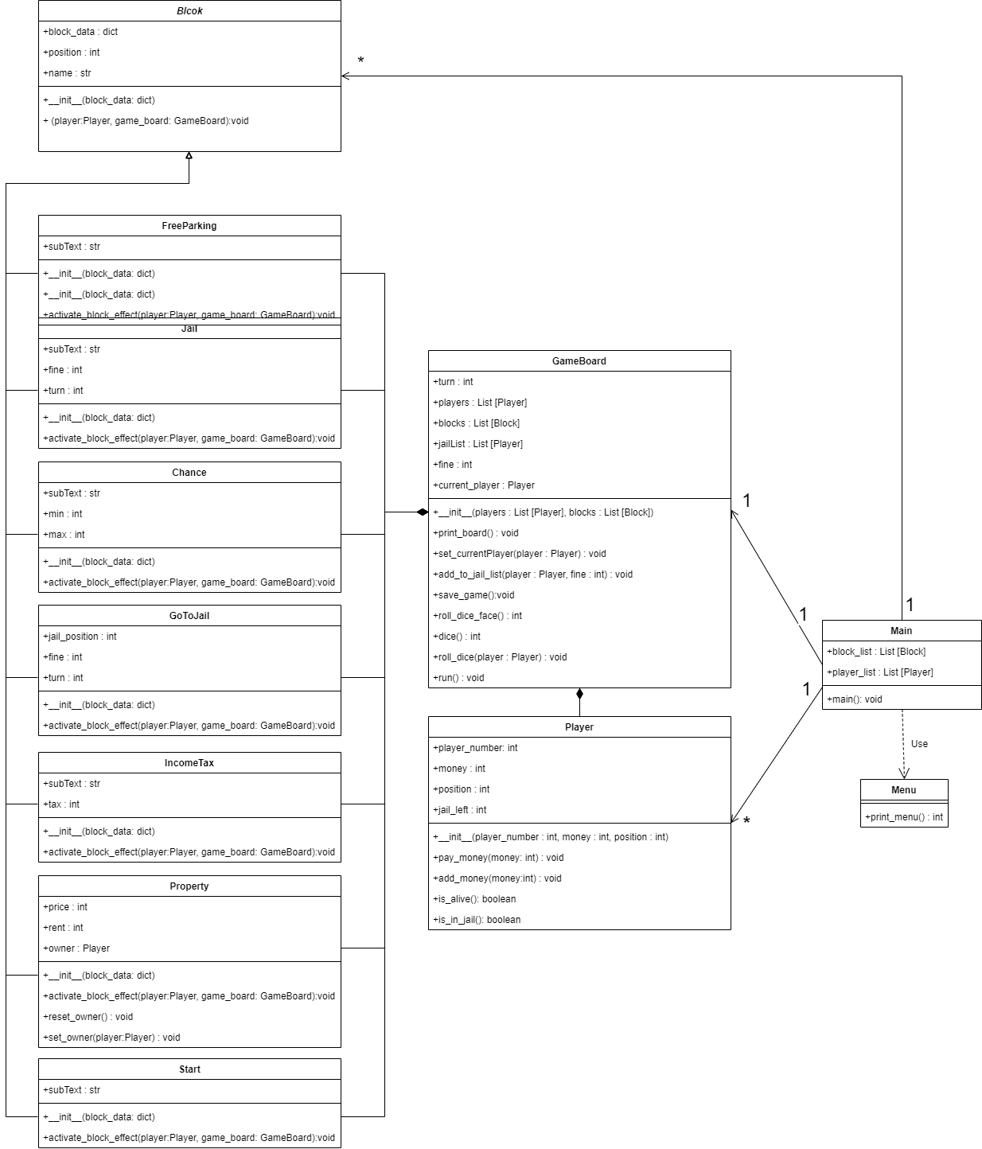Detailed version (vertical):

* + 1. Block

* + 1. GameBoard

* + 1. Main

* + 1. Menu

* + 1. Player

## Activity Diagram

* + 1. Main

* + 1. Print Board

* + 1. Roll dice

* + 1. Add to jail list

* + 1. Save game

* + 1. Roll dice face

* + 1. Dice

* + 1. Run(main game logic)

## Sequence Diagram

* + 1. Main

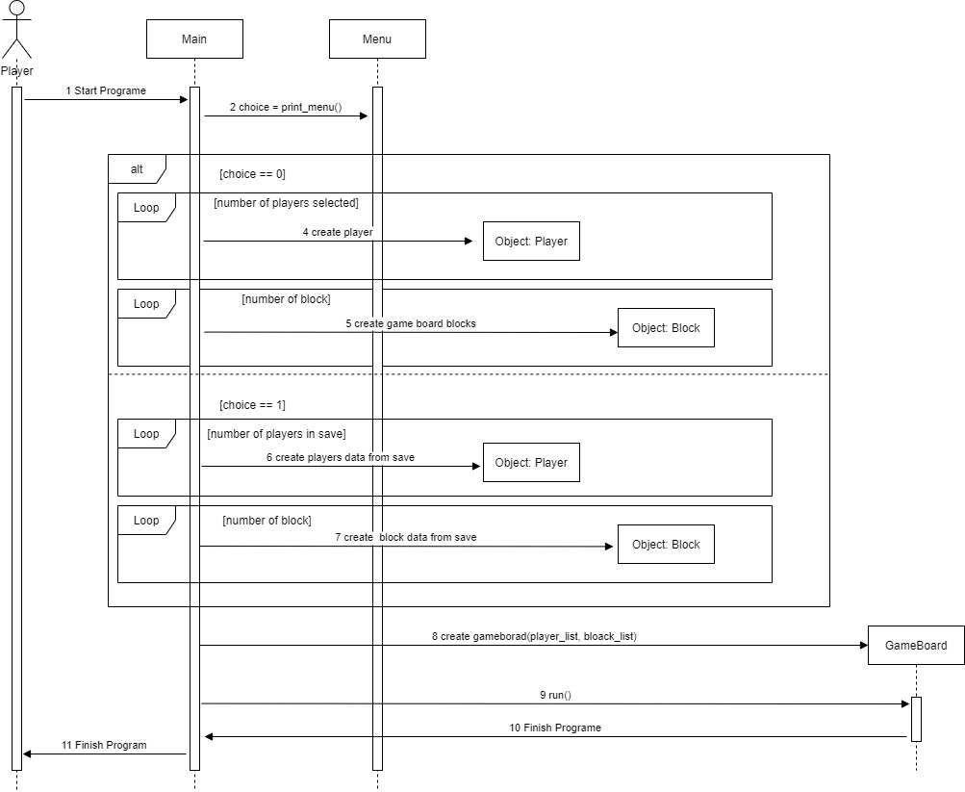

* + 1. 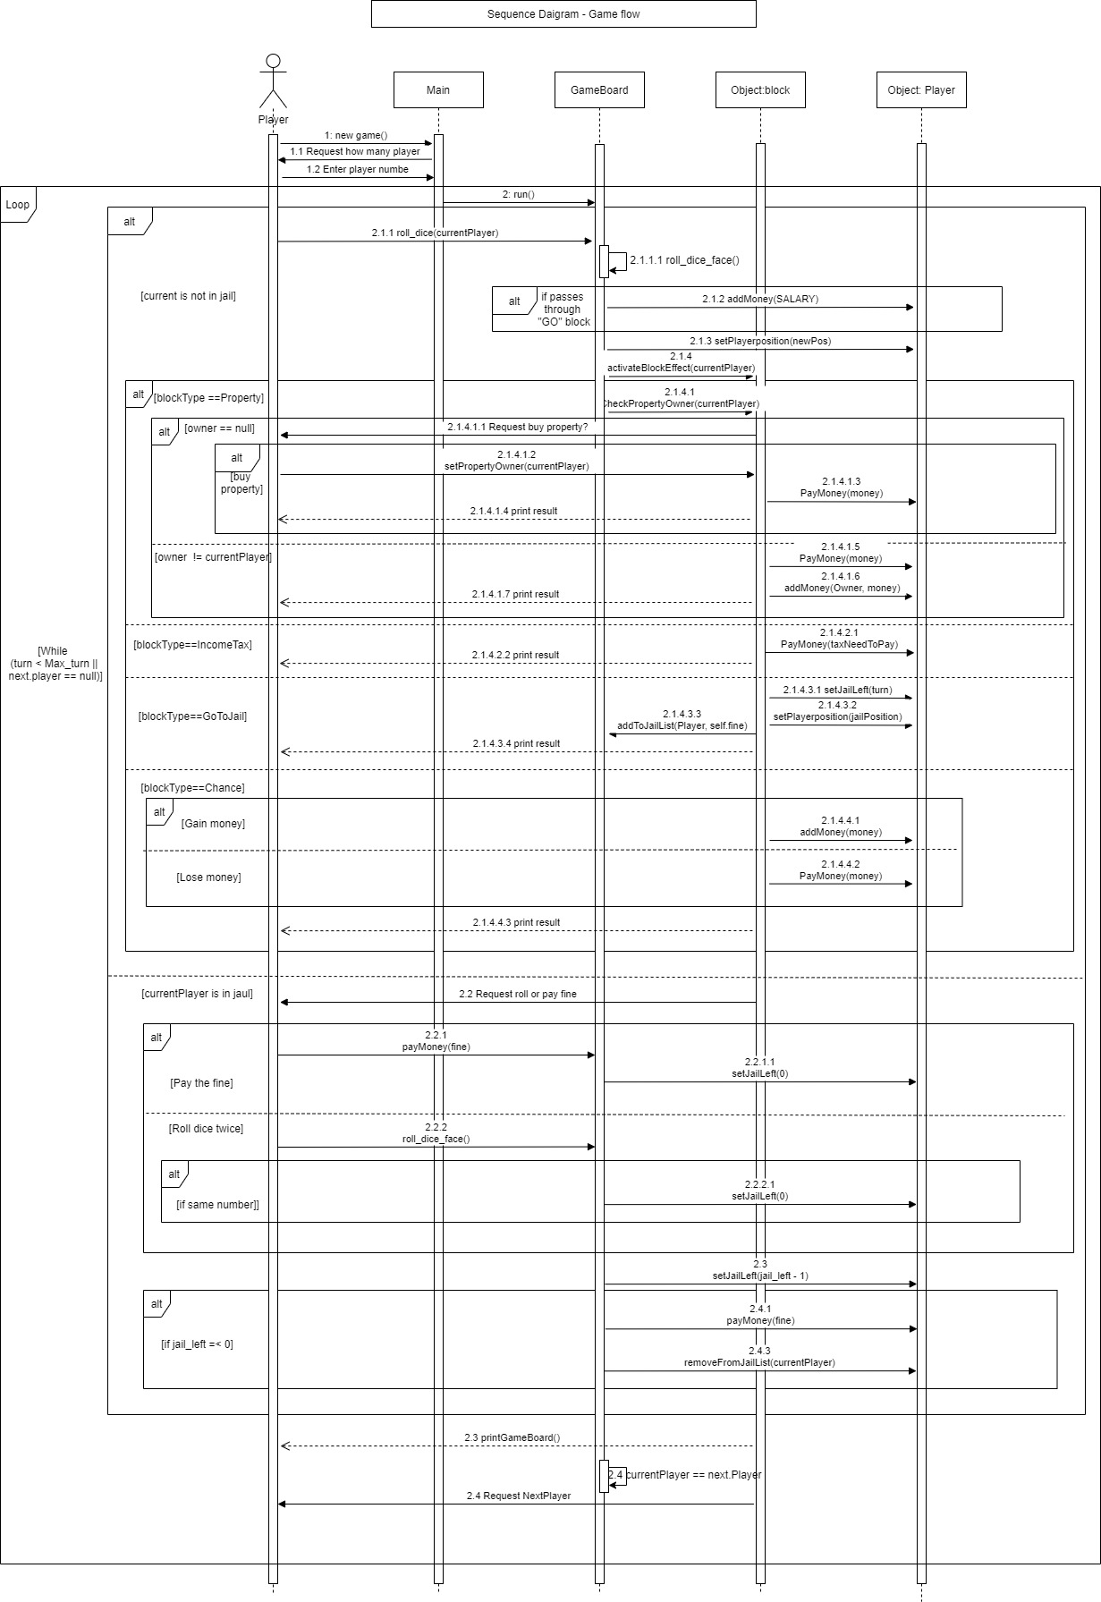run(Main Game Logic)