Work Done

**姓名： 程劭伟**

**日期：**2024-11-30

**对926日志文件轨迹中所有标签为2020的点进行分析，得出的轨迹图，置信度90以上的统计总点数和定位错误点。**

**置信度90以上：**

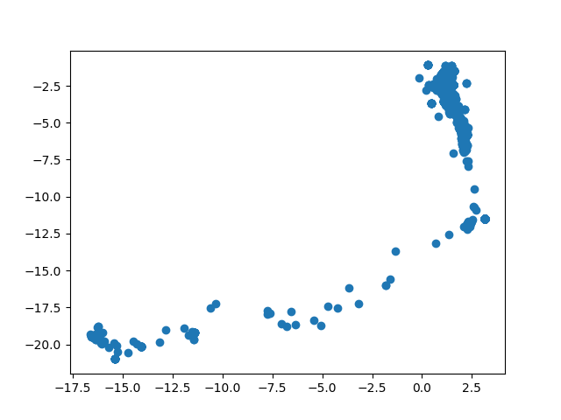

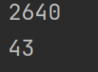

**对这43个点中连续两次定位偏差较大的点进行单独分析：**

# point=[22550.0, 0, 0, 0, 0, 0, 0, 0, 0, 0, 0, 0, 0, 0, 0, 0, 0, 20110.0, 0, 11570.0, 0, 13700.0, 0, 0, 0, 0, 0, 0, 0, 0, 0, 0, 0, 0, 0, 0, 0, 0, 0, 0, 0, 0, 0, 0, 0, 0, 0, 0, 0, 0, 0, 0, 0, 0, 0, 0, 0, 0, 0]  
# point=[21740.0, 0, 10390.0, 0, 0, 0, 0, 0, 0, 0, 0, 0, 0, 0, 0, 0, 0, 19290.0, 18810.0, 11310.0, 0, 0, 0, 0, 0, 0, 0, 0, 0, 0, 0, 0, 0, 0, 0, 0, 0, 0, 0, 0, 0, 0, 0, 0, 0, 0, 0, 0, 0, 0, 0, 0, 0, 0, 0, 0, 0, 0, 0]  
# speed: 14.812766529815427(定位不准)  
# point=[0, 17530.0, 0, 17630.0, 0, 0, 0, 0, 0, 0, 0, 0, 0, 0, 0, 0, 0, 0, 0, 0, 0, 15420.0, 0, 0, 0, 0, 0, 0, 0, 0, 0, 0, 0, 0, 0, 0, 0, 0, 0, 0, 0, 0, 0, 0, 0, 0, 0, 0, 0, 0, 0, 0, 0, 0, 0, 0, 0, 0, 0]  
# point=[0, 16360.0, 0, 16340.0, 0, 0, 0, 0, 0, 0, 0, 0, 0, 0, 0, 0, 0, 0, 0, 0, 0, 16090.0, 0, 0, 0, 0, 0, 0, 0, 0, 0, 0, 0, 0, 0, 0, 0, 0, 0, 0, 0, 0, 0, 0, 0, 0, 0, 0, 0, 0, 0, 0, 0, 0, 0, 0, 0, 0, 0]  
# speed: 24.45796809423835(类别相似)  
# point=[0, 14440.0, 0, 16970.0, 0, 0, 0, 0, 0, 0, 0, 0, 0, 0, 0, 0, 0, 0, 0, 0, 0, 15060.0, 0, 0, 0, 0, 0, 0, 0, 0, 0, 0, 0, 0, 0, 0, 0, 0, 0, 0, 0, 0, 0, 0, 0, 0, 0, 0, 0, 0, 0, 0, 0, 0, 0, 0, 0, 0, 0]  
# point=[0, 16360.0, 0, 16110.0, 0, 0, 0, 0, 0, 0, 0, 0, 0, 0, 0, 0, 0, 0, 0, 0, 0, 14350.0, 0, 0, 0, 0, 0, 0, 0, 0, 0, 0, 0, 0, 0, 0, 0, 0, 0, 0, 0, 0, 0, 0, 0, 0, 0, 0, 0, 0, 0, 0, 0, 0, 0, 0, 0, 0, 0]  
# speed: 24.355533248943583(单纯定位不准)  
# point=[0, 18140.0, 0, 15090.0, 0, 0, 0, 0, 0, 0, 0, 0, 0, 0, 0, 0, 0, 0, 0, 0, 0, 14690.0, 0, 0, 0, 0, 0, 0, 0, 0, 0, 0, 0, 0, 0, 0, 0, 0, 0, 0, 0, 0, 0, 0, 0, 0, 0, 0, 0, 0, 0, 0, 0, 0, 0, 0, 0, 0, 0]  
# point=[0, 15390.0, 0, 17330.0, 0, 0, 0, 0, 0, 0, 0, 0, 0, 0, 0, 0, 0, 0, 0, 0, 0, 16350.000000000002, 0, 0, 0, 0, 0, 0, 0, 0, 0, 0, 0, 0, 0, 0, 0, 0, 0, 0, 0, 0, 0, 0, 0, 0, 0, 0, 0, 0, 0, 0, 0, 0, 0, 0, 0, 0, 0]  
# speed: 24.83477999593738(单纯定位不准)  
# point=[0, 17110.0, 0, 18840.0, 0, 0, 0, 0, 0, 0, 0, 0, 0, 0, 0, 0, 0, 0, 0, 0, 0, 16390.0, 0, 0, 0, 0, 0, 0, 0, 0, 0, 0, 0, 0, 0, 0, 0, 0, 0, 0, 0, 0, 0, 0, 0, 0, 0, 0, 0, 0, 0, 0, 0, 0, 0, 0, 0, 0, 0]  
# point=[0, 20460.0, 0, 19870.0, 0, 0, 0, 0, 0, 0, 0, 0, 0, 0, 0, 0, 0, 0, 0, 0, 0, 16910.0, 0, 0, 0, 0, 0, 0, 0, 0, 0, 0, 0, 0, 0, 0, 0, 0, 0, 0, 0, 0, 0, 0, 0, 0, 0, 0, 0, 0, 0, 0, 0, 0, 0, 0, 0, 0, 0]  
# speed: 24.695832514481026(类别相似点)  
# point=[0, 20460.0, 0, 19870.0, 0, 0, 0, 0, 0, 0, 0, 0, 0, 0, 0, 0, 0, 0, 0, 0, 0, 16910.0, 0, 0, 0, 0, 0, 0, 0, 0, 0, 0, 0, 0, 0, 0, 0, 0, 0, 0, 0, 0, 0, 0, 0, 0, 0, 0, 0, 0, 0, 0, 0, 0, 0, 0, 0, 0, 0]  
# point=[0, 17100.0, 0, 19960.0, 0, 0, 0, 0, 0, 0, 0, 0, 0, 0, 0, 0, 0, 0, 0, 0, 0, 16940.0, 0, 0, 0, 0, 0, 0, 0, 0, 0, 0, 0, 0, 0, 0, 0, 0, 0, 0, 0, 0, 0, 0, 0, 0, 0, 0, 0, 0, 0, 0, 0, 0, 0, 0, 0, 0, 0]  
# speed: 24.660972578551263(类别相似点)  
# point=[0, 17280.0, 0, 18160.0, 0, 0, 0, 0, 0, 0, 0, 0, 0, 0, 0, 0, 0, 0, 0, 0, 0, 17630.0, 0, 0, 0, 0, 0, 0, 0, 0, 0, 0, 0, 0, 0, 0, 0, 0, 0, 0, 0, 0, 0, 0, 0, 0, 0, 0, 0, 0, 0, 0, 0, 0, 0, 0, 0, 0, 0]  
# point=[0, 18480.0, 0, 18820.0, 0, 0, 0, 0, 0, 0, 0, 0, 0, 0, 0, 0, 0, 0, 0, 0, 0, 18750.0, 0, 0, 0, 0, 0, 0, 0, 0, 0, 0, 0, 0, 0, 0, 0, 0, 0, 0, 0, 0, 0, 0, 0, 0, 0, 0, 0, 0, 0, 0, 0, 0, 0, 0, 0, 0, 0]  
# speed: 12.322493190613478(类别相似点)  
# point=[0, 9870.0, 17840.0, 13750.0, 0, 0, 0, 0, 0, 0, 0, 0, 0, 0, 0, 0, 0, 0, 0, 0, 0, 10390.0, 0, 0, 0, 0, 0, 0, 0, 0, 0, 0, 0, 0, 0, 0, 0, 0, 0, 0, 0, 0, 0, 0, 0, 0, 0, 0, 0, 0, 0, 0, 0, 0, 0, 0, 0, 0, 0]  
# point=[0, 13260.0, 18920.0, 12480.0, 0, 0, 0, 0, 0, 0, 0, 0, 0, 0, 0, 0, 0, 0, 0, 0, 0, 12120.0, 0, 0, 0, 0, 0, 0, 0, 0, 0, 0, 0, 0, 0, 0, 0, 0, 0, 0, 0, 0, 0, 0, 0, 0, 0, 0, 0, 0, 0, 0, 0, 0, 0, 0, 0, 0, 57160.0]  
# speed: 19.529883521355234（单纯定位不准点）

**其中错误原因主要分为两类：**

**一类是两次信号虽然差异不大，但由于信号量为3个，较少，导致两次定位结果偏差较大**

**第二类是在备选的得分高的指纹点范围中，这些指纹点聚合成两类，且这两类指纹点置信度相当。**

**对于第一类错误原因，提高定位门槛，即将每次信号维度大于等于4进行定位，则错误点降为16个，且这16个点偏差不大。**

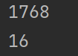

**对于第二类，考虑将两类指纹点的匹配结果都输出，交由后面的拟合来确定一个好的定位结果**