

**General Sir John Kotelawala Defense University**

**Faculty of Computing**

**Department of Computer Science**

Group Project Undertaken in partial fulfillment of the requirement for the

BSc Computer Science/ Computer Engineering/ Software Engineering Degree

**Intake 36**

**PROJECT PROPOSAL**

|  |  |  |  |
| --- | --- | --- | --- |
|  | **Group Details** | | |
| **Group Number** | **Student Number** | | **Student Name** |
| Group 9 | D/BSE/19/0004 | | C S Wanigasooriya |
| D/BSE/19/0003 | | MFAR Fernando |
| D/BSE/19/0005 | | SHCKD Silva |
| D/BCE/19/0001 | | PSM De Silva |
|  | D/BSE/19/0001 | | PH Perera |
|  | C/BCE/5714 | | RLBJS Jayawardhana |
|  | **Project Details** | | |
| **Project Title** |  | Result Management System | |
| **Supervisor** |  |  | |
| **Co-Supervisor** |  |  | |

**Table of Contents**

**List of Figures** 3

**List of abbreviation** 3

**1.Introduction** 4

**1.1 Background and Motivation** 4

**1.2 Problem Domain** 4

**1.3 Aim** 4

**1.4 Objectives** 4

**2. Literature Review** 5

**2.1 Existing System** 5

**3. Methodology** 5

**3.1 Hypothesis** 5

**3.2 Functional Requirements** 6

**3.3 Non-Functional Requirements** 6

**3.4 Technology** 7

**4. Time Plan** 7

**5. Conclusion** 8

**6. References** 8

# **List of Figures**

Figure 1.1: Gantt Chart

|  |  |  |
| --- | --- | --- |
| **List of abbreviation** |  |  |
| **KDU** |  | Kotelawala Defense University |
| **Info** |  | Information |
| **App** |  | Application |
| **HOD** |  | Head of the Department |

# **1.Introduction**

# **1.1 Background and Motivation**

The Faculty of Computing of the Kotelawala Defense University (KDU) conducts its end semester examinations bi-annually. However, the time lapse between the conclusion of the examination and the release of results is disproportionately large. This could create disruption in the students’ lives and maybe be a taxing process for the administrative staff and lecturers.

An examination results management system could be the solution to alleviating this delay. We believe that if such a system was to be developed it would help in the release of results at an earlier date and reduce the burden placed on administrative staff and lectures. This document purposes the outline of the development of such a system.

# **1.2 Problem Domain**

The process of results released at KDU is time consuming and tedious. This delay in the release of results could cause disruption in the students’ lives and may limit the level of improvement by reducing the time period they have to study for their repeat exams. In addition, there is no way for the lecturers and the department to view a summarized report of a student’s examination results. Part of the reason for this time lapse could be the use of too many manual processes. We believe that if a majority of those processes were to be computerized, the whole process would speed up and examination results could be made available far earlier for the students. In addition, it would reduce the burden on the administrative staff and make it easier for the lecturers to log in their respective results.

# **1.3 Aim**

The aim of this results management system would be to build an efficient and easy to use system that could speed up the process of release of examination results.

# **1.4 Objectives**

The objectives of the development of such a system would be to:

1. Facilitate the release of examination in a timelier manner.
2. Computerize as many of the processes involved in the computation of examination results
3. Make the procedure easier and more efficient for all users of the system

# **2. Literature Review**

# **2.1 Existing System**

The current system is mainly processed using hard photocopies of the four sheets (Detailed Mark Sheet x2, Marks Return Sheet, and Comment Sheet) which is not time effective again since the listed sheets must be hand delivered to each relevant persons. Another problem that has been faced to persuade our team to proceed with this project is that lecturers don’t get a summarized report of each individual student.

Steps are shown as below.

1. Setter checks the paper and fills the detailed mark sheet.
2. Moderator again checks the paper and fills another detailed mark sheet.
3. Both mark sheets are sent to the HOD.
4. HOD cross checks the two given sheets to see if there is an unacceptable pair of marks.
5. If there is a big difference, then the HOD adjusts the marks as he/she sees fit.
6. The mark sheets (including the mark sheet containing the final marks for each student) are then sent back to the setter for him/her (Setter) to continue to proceed on to the marks return sheet and the comment sheet.
7. Then the marks return sheet and the comment sheet are sent to the examination dept.

Our system is based on issuing end-semester results, calculating the GPA of each student of the Faculty of Computing at General Sir John Kotelawala Defense University and finalizing it at the end of the final semester. This system’s purpose is also to further diminish the long-time consumption for lecturers as well as when entering the marks into the database. It will also reduce the amount of paperwork for each lecturer, the time taken to pass-on the said paperwork to the other relevant persons.

# **3. Methodology**

# **3.1 Hypothesis**

In the planning of this system, we have hypnotized that a major reason for the delay in the release in examination results is the fact that many activities involved in the process are carried out manually and could be time consuming.

Thus, we believe that with a proper computerized system, this entire procedure could happen much faster and more efficiently.

# **3.2 Functional Requirements**

Functional Requirements describe the tasks expected to be performed using our system. In our desktop application we are going to provide following features:

* A new document to be filled which is a collaboration of the three sheets- detailed mark sheet, marks returned sheet and comments sheet. This sheet contains all relevant fields which make the document contain less redundant fields and substitute certain fields which simply can be generated automatically. (e.g.: - **Total** which can be calculated by adding marks for each question)
* Faster transfer of documents to and from relevant people
* Providing summarized reports for each individual student
* Ability to confirm setter and moderator
* Preparing Class/Group-wise Result
* Graphical view of students’ performance
* Allows to generate result of students for different examination and different types of exams during the year as oral, practical, written, etc. [1]
* Manage the results of the university students and keep a record of results of the students throughout the year.

# **3.3 Non-Functional Requirements**

* Usability: The Web application should be able to use without any extra effort. The initial configurations should be easy to learn.
* Reliability: since we are providing students information and some notifications to the lecturers, that information must be reliable, and the user should be able to depend on those details.
* Performance: The Web application should be able to access offline.
* Start -up-time: The startup time of the app should be minimum in order to increase the efficiency.
* Security: Outside users cannot access student and lecturer details. Need to take database backup in case of crashing database due to virus or OS failure.
* Scalability: It can be easily run in any platform.
* Application size: The web application size must be compact to view.
* Responsiveness: The web application should complete the task according to the given time.
* Efficiency: User can easily access the system and search very fast.
* Delivery: The entire system is expected to be delivered in one year of time.

# **3.4 Technology**

Front end development:

* Java SE 1.8.0_231_b11
* PHP, JavaScript, CSS, HTML
* Java APIS
* Google Firebase

Back end development:

* MYSQL 8.0.17 community edition (Database)

Server-side development:

* MYSQL server

Description:

* Java SE 8.0.17 – To develop and design applets and programs that runs in web browsers. (web services)
* PHP JavaScript, CSS, HTML– To design the website in case the app connects with the internet.
* MYSQL 8.0.17 community edition – To develop and design the back-end database. Compatible with all front-end platforms and software.
* MYSQL server- To connect front-end and back-end database using data objects passing.
* Google firebase- To create cloud based database for the system.

# **4. Time Plan**

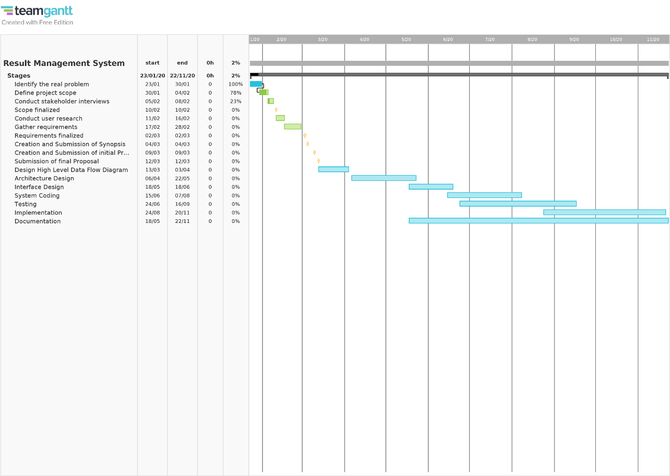We hope to carry out the design and implementation of this system over the course of our second year- 3rd and 4th semesters.

*fig.1.1 Gantt Chart*

# **5. Conclusion**

Currently the process of computation of examination results for end semester examinations at KDU is taxing, time consuming ad causes many delays. We believe that with the design and implementation of our results management system, we could help to alleviate many of these problems and make the process more user friendly and efficient.

# **6. References**

[1]"Exam Result Management", *Iolite.org.in*, 2020. [Online]. Available: https://www.iolite.org.in/exam-result-management/. [Accessed: 06- Feb- 2020].

[2] Development of Students Results Management system. (2020). [online] Researchgate. Available at: http://www.researchgate.net [Accessed 6 Feb. 2020].

[3]"TeamGantt", *App.teamgantt.com*, 2020. [Online]. Available: https://app.teamgantt.com/. [Accessed: 06- Feb- 2020].

[4]"Exam & Result Management System (ERMS)", *Virtual University Projects*, 2020. [Online]. Available: https://vuprojects.net/index.php/portfolio-items/exam-result-management-system-erms/. [Accessed: 06- Feb- 2020].

[5] Problem Statement Form Results Management System. (2020). [online] University of UYO. Available at: https://www.researchgate.net/figure/Problem-statement-for-Result-Management-System-as-taken-from-case-study [Accessed 6 Feb. 2020].