

**General Sir John Kotelawala Defense University**

**Faculty of Computing**

**Department of Computer Science**

Group Project Undertaken in partial fulfillment of the requirement for the

BSc Information Technol Computer Science/ Computer Engineering/ Software Engineering Degree

**Intake 36**

# **PROJECT PROPOSAL**

|  |  |  |  |
| --- | --- | --- | --- |
|  | **Group Details** | | |
| **Group Number** | **Student Number** | | **Student Name** |
|  |  | |  |
|  | |  |
|  | |  |
|  | |  |
|  | **Project Details** | | |
| **Project Title** |  |  | |
| **Supervisor** |  |  | |
| **Co-Supervisor** |  |  | |

**Project Proposal for Group Project in Software Development- Group 9**

1. **Introduction**

**1.1 Background and Motivation**

The Faculty of Computing of the Kotelawala Defense University (KDU) conducts its end semester examinations bi-annually. However, the time lapse between the conclusion of the examination and the release of results is disproportionately large. This could create disruption in the students’ lives and maybe be a taxing process for the administrative staff and lecturers.

An examination results management system could be the solution to alleviating this delay. We believe that if such a system was to be developed it would help in the release of results at an earlier date and reduce the burden placed on administrative staff and lectures. This document purposes the outline of the development of such a system.

* 1. **Problem Domain**

The process of results released at KDU is time consuming and tedious. This delay in the release of results could cause disruption in the students’ lives and may limit the level of improvement by reducing the time period they have to study for their repeat exams. In addition, there is no way for the lecturers and the department to view a summarized report of a student’s examination results. Part of the reason for this time lapse could be the use of too many manual processes. We believe that if a majority of those processes were to be computerized, the whole process would speed up and examination results could be made available far earlier for the students. In addition, it would reduce the burden on the administrative staff and make it easier for the lecturers to log in their respective results.

**1.3 Aim**

The aim of this results management system would be to build an efficient and easy to use system that could speed up the process of release of examination results.

**1.4 Objectives**

The objectives of the development of such a system would be to:

1. Facilitate the release of examination in a more timely manner.
2. Computerize as many of the processes involved in the computation of examination results
3. Make the procedure easier and more efficient for all users of the system
4. **Literature Review**

Our system is based on issuing end-semester results, calculating the GPA of each student of the Faculty of Computing at General Sir John Kotelawala Defense University and finalizing it at the end of the final semester. This system’s purpose is also to further diminish the long time consumption for lecturers as well as when entering the marks into the database. It will also reduce the amount of paper work for each lecturer, the time taken to pass-on the said paper work to the other relevant persons.

1. **Methodology**
   1. **Hypothesis**

In the planning of this system, we have hypnotized that a major reason for the delay in the release in examination results is the fact that many activities involved in the process are carried out manually and could be time consuming.

Thus we believe that with a proper computerized system, this entire procedure could happen much faster and more efficiently.

* 1. **Functional Requirements**

Functional Requirements describe the tasks expected to be performed using our system. In our desktop application we are going to provide following features:

* We introduce a new document to be filled which is a collaboration of the three sheets- detailed mark sheet, marks returned sheet and comments sheet. This sheet contains all relevant fields which make the document contain less redundant fields and substitute certain fields which simply can be generated automatically. (eg: - **Total** which can be calculated by adding marks for each question)
* Faster transfer of documents to and from relevant people
* Providing summarized reports for each individual student
* Ability to confirm setter and moderator
  1. **Non-Functional Requirements**
* Usability: The Desktop app should be able to use without any extra effort. The initial configurations should be easy to learn.
* Reliability: since we are providing students information and some notifications to the lecturers, that information must be reliable and the user should be able to depend on those details.
* Performance: The Desktop app should be able to access offline.
* Start -up-time: The startup time of the app should be minimum in order to increase the efficiency.
* Security: Outside users cannot access student and lecturer details. Need to take database backup in case of crashing database due to virus or OS failure.
* Scalability: It can be easily run in any platform.
* Application size: The desktop app size must be compact to download.
* Responsiveness: The desktop app should complete the task according to the given time.
* Efficiency: User can easily access the system and search very fast.
* Delivery: The entire system is expected to be delivered in one year of time.

**3.4 Technology**

Front end development:

* Java SE 1.8
* Java EE 1.8
* PHP, JavaScript, CSS, HTML
* Java APIS

Back end development:

* MYSQL 5.7.16.0 community edition(Database)

Server-side development:

* MYSQL server

Description:

* Java SE 1.8 – To develop and design applets and programs that runs in web browsers. (web services)
* Java EE 1.8 – To develop enterprise-oriented applications and servlets.
* PHP JavaScript, CSS, HTML– To design the website in case the app connects with the internet.
* MYSQL 5.7.16.0 community edition – To develop and design the back-end database. Compatible with all front-end platforms and software.
* MYSQL server- To connect front-end and back-end database using data objects passing.

1. **Time Plan**

We hope to carry out the design and implementation of this system over the course of our second year- 1st and 2nd semesters.  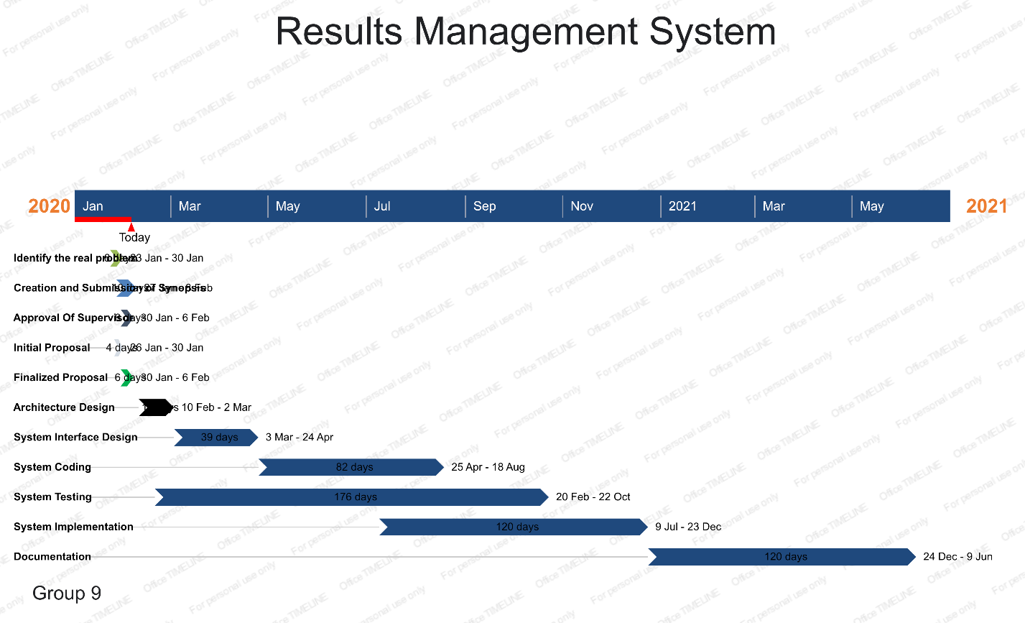

1. **Conclusion**

Currently the process of computation of examination results for end semester examinations at KDU is taxing, time consuming ad causes many delays. We believe that with the design and implementation of our results management system, we could help to alleviate many of these problems and make the process more user friendly and efficient.

**6. References**