**Console Calculator**

Description: To provide uses a console based calculator with basic functionalities like addition,subtraction,multiplication and division.

Topics covered :

1. Console I/O Operations
2. Date types
3. Operators
4. Conditional and looping statements
5. Typecasting

Steps:

1. Provide User a console based menu like below and ask to choose an option.

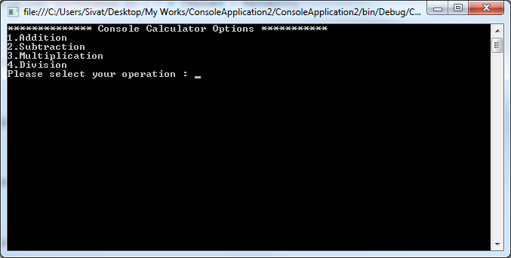

2. Once user selects operation ask for input values and perform respective operation.

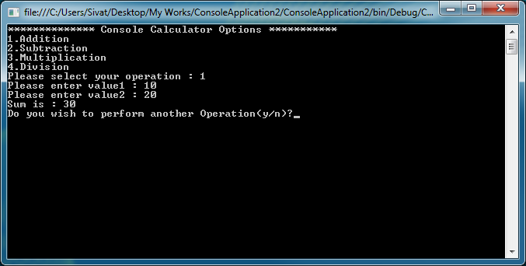

3. Use switch case to perform the operation and print result. Take confirmation from user that he/she may want to perform another operation.

i. if they choose yes (y/Y) repeat menu as below.

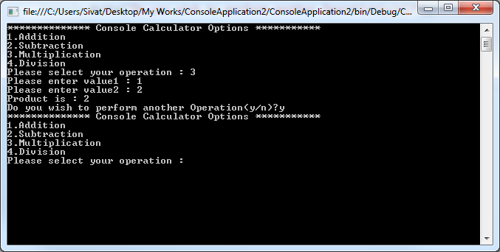

ii. If they choose no (n/N) say Thank you and exit from application.

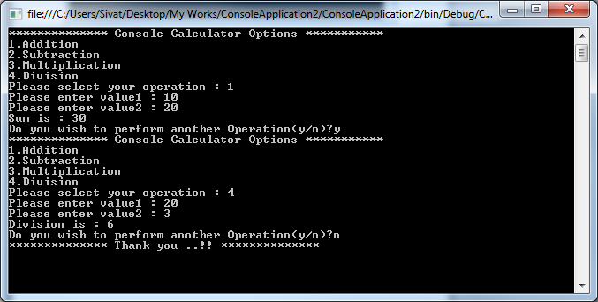

5. Add default case for invalid operation.

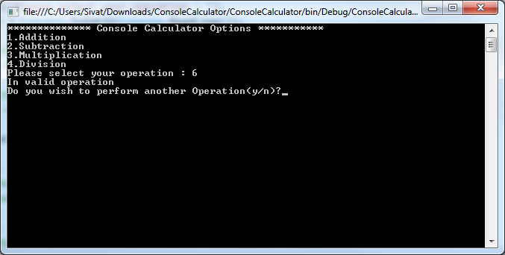

**Additional Task based on your interest:**

Include complex calculations like Power,Absolute values,Trigonometric functions(sin/cos/tan), Logarithmic values using Math class.

You can find details about Math class and its usage with examples in MSDN link @<https://msdn.microsoft.com/en-us/library/system.math(v=vs.110).aspx>