Automated Global Autism Prevalence Pipeline
Abstract
Awareness surrounding all types of mental health, including disorders, has grown over time. Autism Spectrum Disorder has received a lot of attention. Studies have been conducted to review the prevalence of Autism since 1962. This automated pipeline extracts data from all these studies compiled by the Center for Disease Control (CDC). The pipeline visualizes the rate of Autism prevalence and the rate at which studies are being conducted.
Introduction
While the dataset is small, these studies contain over 184 million people in total. The CDC does not give a clear estimate of Autism prevalence overall, they state that about 1 in 31 children who are 8 years old have Autism [1]. This does not give much insight into the overall Autism prevalence in our population.
Autism spectrum disorders are one of the most discussed mental disorders which are genetic. There was even a television show on Netflix called “Love on the Spectrum” which gained popularity. Has the rate of autism increased or is awareness and diagnosis more common? In this paper, we’ll investigate these two questions. The pipeline consists of two separate pipelines, one that utilizes Databricks to visualize the rate of Autism, and the other that runs locally to visualize the rate of studies conducted.
Technical Details
Architectural Diagram
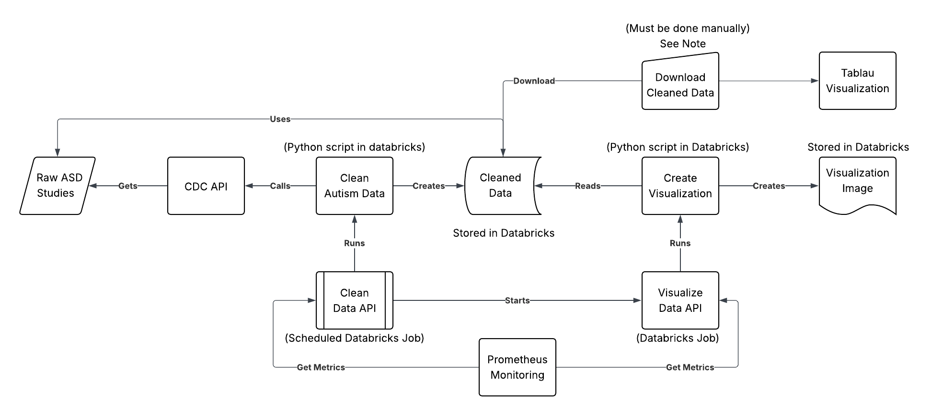
Figure 1. Pipeline Diagram
Note: Unfortunately, Databricks free edition does not allow access to reading files within the workspace, repos, or API results. Even connecting to Git is unsuccessful. Because of this, to produce the visualization in Tableau (displaying the rate at which studies are conducted), the cleaned data must be downloaded manually from Databricks (or a separate pipeline must be built).
Databricks was chosen for processing and storing the data because it allows parallel processing due to its serverless nature. Using Databricks free version severely limits the ability to use other tools except paid cloud services like AWS. However, Databricks would be a better tool in production because it integrates with those tools as well as Git repositories.
Databricks jobs allows for seamless integration with scripts stored in the Databricks workspace. Jobs can run processes and trigger other jobs to run and can be scheduled to run. The Clean Data API is the starting point of the pipeline. It’s scheduled to run once every day and can be called to run. It runs the script that retrieves the data from the CDC, cleans it, and stores the cleaned data in the workspace. Then, the job signals the Visualize Data job. This job runs a script that reads the cleaned data, creates a visualization, and stores it within the workspace. Both jobs are monitored by Prometheus.
Results
The pipeline collected Autism prevalence data from 187 studies, which included over 184 million people across different countries. The data comes from studies conducted across the Autism and Developmental Disabilities Monitoring Network, complied by the CDC into a single dataset.
Conclusion

References
[1] Data and Statistics on Autism Spectrum Disorder | Autism Spectrum Disorder (ASD) | CDC

