Automated Global Autism Prevalence Pipeline (AGAP)
Abstract
Awareness surrounding all types of mental health, including disorders, has grown over time. Autism Spectrum Disorder has received a lot of attention. Studies have been conducted to review the prevalence of Autism since 1962. This paper presents an automated pipeline that extracts data from a set of studies compiled by the Center for Disease Control (CDC). The pipeline automatically produces a visualization of the rate of Autism prevalence and the rate at which studies are being conducted.
Introduction
This paper answers the question; Has autism prevalence risen around the world over time? The Global Autism Prevalence Trends dataset reveals a steady rise in autism spectrum disorder (ASD) rates worldwide, especially in the U.S. since the 1960s. With needed attention under Robert F. Kennedy Jr.’s leadership at the DHS, understanding this growth is vital.
While the dataset is small, the CDC studies contain over 184 million people in total. The CDC does not give a clear estimate of Autism prevalence overall; they state that about 1 in 31 children who are 8 years old have Autism [1]. The studied age of being 8 does not provide much insight into the overall Autism prevalence in our global population, but great insight into the question. Autism spectrum disorders are one of the most discussed genetic mental disorders. Discussion leads to interest and research, such as the Diagnostic and Statistical Manual for Mental Disorders (DSM-5), being developed. The method of diagnosis changes with new guidelines. This led to a second question: Have ASD rates increased or is diagnosis more common? Autism prevalence is growing rapidly, and the United States has a particularly large growth compared to other countries. Do some research and investigate the studies. Encourage peers and colleagues to discuss mental disorders such as Autism; with enough community involvement, a cause might be found which can be prevented.
Technical Details
Finding a suitable dataset was the first big problem. Due to the nature of the field, mental health, there are limited datasets to choose from. Many studies come from surveys where diagnosis is self-reported. The first thought was to use the Census data. This would require a much greater amount of cleaning because each entry contains everything about a person. The Census data can be downloaded by a single year, which is still a very large file, but the purpose of this pipeline is to compare prevalence over time. Many separate large datasets would be required, which was not feasible. The CDC dataset was the next best option. It contains a collection of data sets from the Autism and Developmental Disabilities Monitoring (ADDM) network. Access to specific studies data almost always requires a request.
Once the suitable dataset was found, data exploration was performed in Databricks with a Notebook. The dataset was not complete. The data began with 207 different studies but ended up with 186. Of those 186, many rows have supplemented information calculated using averages. For rows where there was not enough information to support our needs, they were removed. The removed rows do not affect the results because they are missing the information required. Many changes were made, such as updating missing study years (years that the study was occurring) to the year published, adding “Unknown” to missing localities, averaging Male-Female Sex Ratio, etc. None of these changes alter the results because the data was not used.
Prometheus is used for monitoring the state of the Databricks jobs in the pipeline. Due to Databricks requests requiring an access token, it’s simpler to create a helper script for Prometheus. The helper python script, using Flask to host the results on a local port, calls each Databricks job using unique identifiers (instance, access token, and job ID) and grabs the metrics. Prometheus is configured to retrieve these metrics on the assigned ports.
The Automated Global Autism Prevalence Pipeline consists of Python scripts and Databricks jobs which produces a visualization using Matplotlib, showing autism prevalence along with sample size of each study. Another visualization is produced by manually downloading the clean data to a personal machine and loading it into Tableau. The second visualization shows autism prevalence by country.
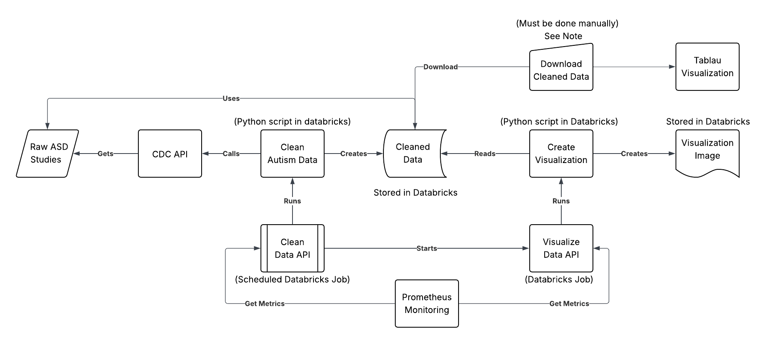
Figure 1: Pipeline Diagram
Note: Unfortunately, Databricks free edition does not allow access to reading files within the workspace, repos, or API results. Even connecting to Git is unsuccessful. Because of this, to produce the visualization in Tableau (displaying the rate at which studies are conducted), the cleaned data must be downloaded manually from Databricks (or a separate pipeline must be built).
Databricks was chosen for processing and storing the data because it allows parallel processing due to its serverless nature. Using Databricks free version severely limits the ability to use other tools except paid cloud services like AWS. However, Databricks would be a better tool in production because it integrates with those tools as well as Git repositories.
Databricks jobs allow for seamless integration with scripts stored in the Databricks workspace. Jobs can run processes and trigger other jobs to run and can be scheduled to run. The Clean Data API is the starting point of the pipeline. It’s scheduled to run once every day and can be called to run. It runs the script that retrieves the data from the CDC, cleans it, and stores the cleaned data in the workspace. Then, the job signals the Visualize Data job. This job runs a script that reads the cleaned data, creates a visualization, and stores it within the workspace. Both jobs are monitored by Prometheus.
Results
The pipeline collected Autism prevalence data from 187 studies, which included over 184 million people across different countries. The data comes from studies conducted across the Autism and Developmental Disabilities Monitoring Network, compiled by the CDC into a single dataset.
The studies show a clear increase in the prevalence of ASD since 1962. The graph below also shows an increase in the number of studies conducted. People should support awareness surrounding the growth of ASD and why this growth may occur. Read about Autism and how it can affect people. The world is experiencing growth. Read and donate, if possible, to research looking into minimizing growth.
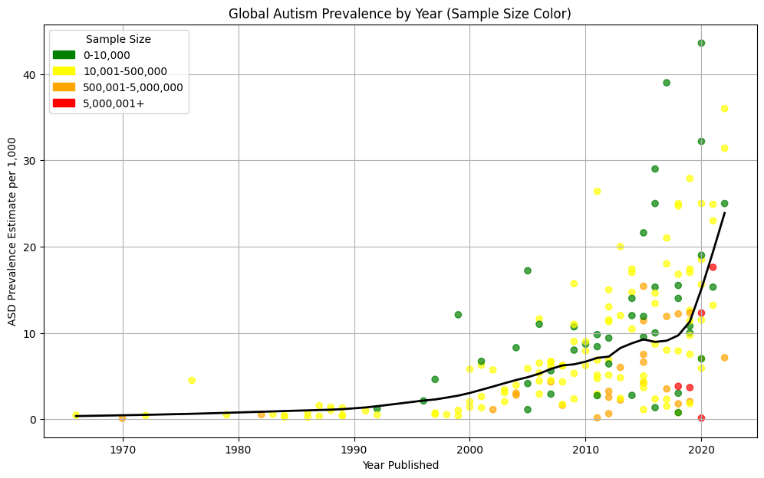
Figure 2: This line graph displays the growth of ASD from 1962-2022.
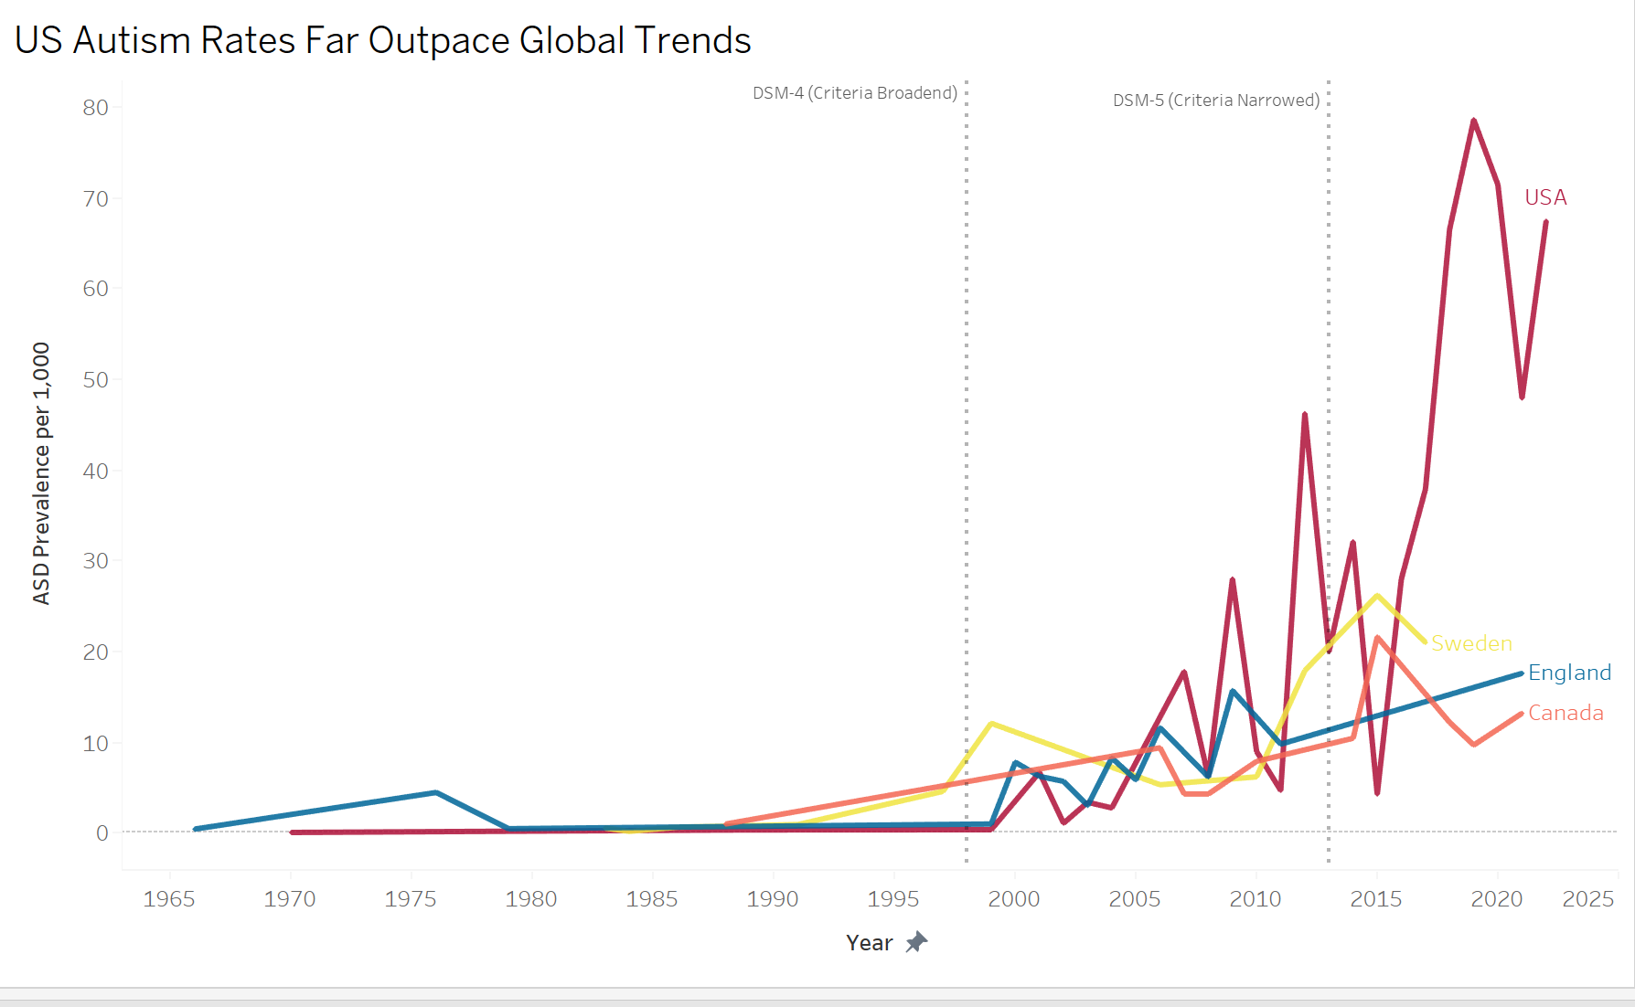
Figure 2: This line graph displays the growth of ASD by country.
Conclusion
The results of the ASD pipeline show that the ASD rates globally have increased since 1962, and specifically, the United States is experiencing much more growth than other countries. The growth in ASD rates and studies conducted showed increased awareness; between 1965 and 2000, there were only about 30 studies conducted. In the year 2000, shortly after the DSM-4 was created, there is a significant rise in the number of studies conducted. In the last decade, this rate of increase is still true. The Automated Global Autism Prevalence Pipeline uses Databricks to ingest, process, and visualize information about autism prevalence. The visualizations of these studies allow for a better understanding of how Autism Prevalence has changed over time. These graphs show an overall view of ASD prevalence as opposed to CDC’s “8-year-olds” analysis.

References
[1] Data and Statistics on Autism Spectrum Disorder | Autism Spectrum Disorder (ASD) | CDC

