Automated Global Autism Prevalence Pipeline (AGAP)
Abstract
Awareness surrounding all types of mental health, including disorders, has grown over time. Autism Spectrum Disorder has received a lot of attention. Studies have been conducted to review the prevalence of Autism since 1962. This paper presents an automated pipeline that extracts data from a set of studies compiled by the Center for Disease Control (CDC) [1]. The pipeline automatically produces a visualization of the rate of Autism prevalence and the rate at which studies are being conducted.
Introduction
This paper answers the question; Has autism prevalence risen around the world over time? The Global Autism Prevalence Trends dataset reveals a steady rise in autism spectrum disorder (ASD) rates worldwide, especially in the U.S. since the 1960s. With needed attention under Robert F. Kennedy Jr.’s leadership at the DHS, understanding this growth is vital.
While the dataset is small, the CDC studies contain over 184 million people in total. The CDC does not give a clear estimate of Autism prevalence overall; they state that about 1 in 31 children who are 8 years old have Autism [2]. The studied age of being 8 does not provide much insight into the overall Autism prevalence in our global population, but great insight into the question. Autism spectrum disorders are one of the most discussed genetic mental disorders. Discussion leads to interest and research, such as the Diagnostic and Statistical Manual for Mental Disorders (DSM-5), being developed. The method of diagnosis changes with new guidelines. This led to a second question: Have ASD rates increased or is diagnosis more common? Autism prevalence is growing rapidly, and the United States has a particularly large growth compared to other countries. Do some research and investigate the studies. Encourage peers and colleagues to discuss mental disorders such as Autism. With enough community involvement, a cause might be found which can be prevented.
Technical Details
Finding a suitable dataset was the first big problem. Due to the nature of the field and mental health, there are limited datasets to choose from. Many studies come from surveys where diagnosis is self-reported. The first thought was to use Census data. This would require a much greater amount of cleaning because each entry contains everything about a person. The Census data can be downloaded in a single year, which is still a very large file, but the purpose of this pipeline is to compare prevalence over time. Many separate large datasets would be required, which was not feasible. The CDC dataset was the next best option. It contains a collection of data sets from the Autism and Developmental Disabilities Monitoring (ADDM) network. Access to specific studies data almost always requires a request.
Once a suitable dataset was found, data exploration was performed in Databricks with a Notebook. The dataset was not complete. The data began with 207 different studies but ended up with 186. Of those 186, many rows have supplemented information calculated using averages. For rows where there was not enough information to support our needs, they were removed. The removed rows do not affect the results because they are missing the information required. Many changes were made, such as updating missing study years (years that the study was occurring) to the year published, adding “Unknown” to missing localities, averaging Male-Female Sex Ratio, etc. None of these changes alter the results because the data was not used.

Global Autism Prevalence Trends (1966–2025)
Author | The name of the researcher(s)
Author | Lotter | String
Year Published | The year the research was published.
Year Published | 1966 | Int (Categorical)
Country | Where the research took place.
Country | England | String
Area(s) | The county, area, state, etc. where the research was specifically conducted in a country.
Area(s) | County of Middlesex | String
Sample Size | The number of people studied during the research.
Sample Size | 78000 | Int
Number of Cases | How many cases of autism were discovered in the sample.
Number of Cases | 35 | Int
ASD Prevalence Estimate per 1,000 | How many people have autism out of a total of 1,000. ASD stands for Autism Spectrum Disorder.
ASD Prevalence Estimate per 1,000 | 0.45 (or 450 people) | Float
Male:Female Sex Ratio | The comparison of the number of males with autism versus the number of females with autism.
Male:Female Sex Ratio | 2.6 (For every one female with ASD there are 2.6 males with ASD) | Float
Year Started | The year the research started.
Year Started | 1966 | Int (Categorical)
Year Ended | The year the research was finished.
Year Ended | 1966 | Int (Categorical)
Youngest Age | The youngest age studied.
Youngest Age | 2.0 years | Float
Oldest Age | The oldest age studied.
Oldest Age | 12.0 years | Float

Data Quality Assessment
The Global Autism Prevalence Trends (1962–2025) quality assessment led to the following findings:
- Completeness - ~92% complete over all attributes
- Uniqueness - Wide distribution of attributes. Only 47 unique countries, 41 unique years published, and 49 Male:Female Ratios. Other attributes are over 50% unique.
- Accuracy – More studies are conducted between 2009 to present which would explain the interest in autism prevalence today. There’s no way to know the accuracy of the dataset since this is the only one accessible, but we can compare rows to each other.
- Validity – All years are realistic. No age range is outside of human life expectancy.
- Consistency – Some study years have a single year, a range, or two years separated by ‘&’
- Timeliness – Most recent data is from 2022. This is historical data, so ranges from 1962 are relevant.

The Automated Global Autism Prevalence Pipeline consists of Python scripts and Databricks jobs which produce a visualization using Matplotlib, showing autism prevalence along with sample size of each study. Another visualization is produced by manually downloading the clean data to a personal machine and loading it into Tableau. The second visualization shows autism prevalence by country.
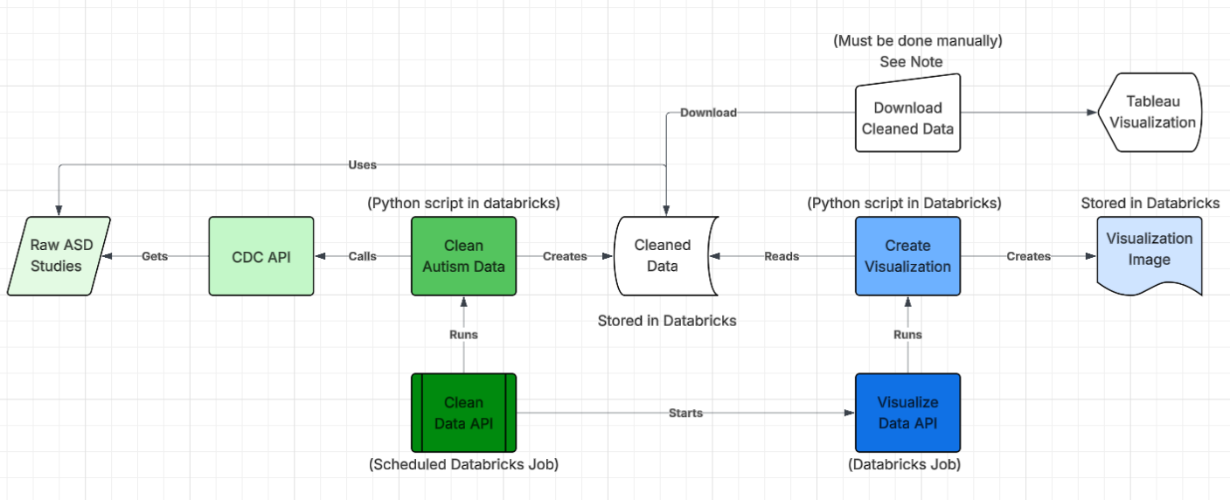
Figure 1: Pipeline Diagram
Databricks was chosen for processing and storing the data because it allows parallel processing due to its serverless nature. Using Databricks free version severely limits the ability to use other tools except paid cloud services like AWS. However, Databricks would be a better tool in production because it integrates with those tools as well as Git repositories.
Databricks jobs allow for seamless integration with scripts stored in the Databricks workspace. Jobs can run processes and trigger other jobs to run and can be scheduled to run. The Clean Data API is the starting point of the pipeline. It’s scheduled to run once every day and can be called to run. It runs the script that retrieves the data from the CDC, cleans it, and stores the cleaned data in the workspace. Then, the job signals the Visualize Data job. This job runs a script that reads the cleaned data, creates a visualization, and stores it within the workspace. Both jobs are monitored by Prometheus.
Prometheus is used for monitoring the state of the Databricks jobs in the pipeline. Due to Databricks requests requiring an access token, it’s simpler to create a helper script for Prometheus. Metrics are only exposed from job runs, not the job itself. The helper python script, using Flask to extract runs, hosts the results on a local port. It calls each Databricks job run using unique identifiers (instance, access token, and job ID) and grabs the metrics. Prometheus is configured to retrieve these metrics on the assigned ports.
Results
The pipeline collected Autism prevalence data from 187 studies, which included over 184 million people across different countries. The data comes from studies conducted across the Autism and Developmental Disabilities Monitoring Network, compiled by the CDC into a single dataset.

Autism Cases Explode Globally Since 1962

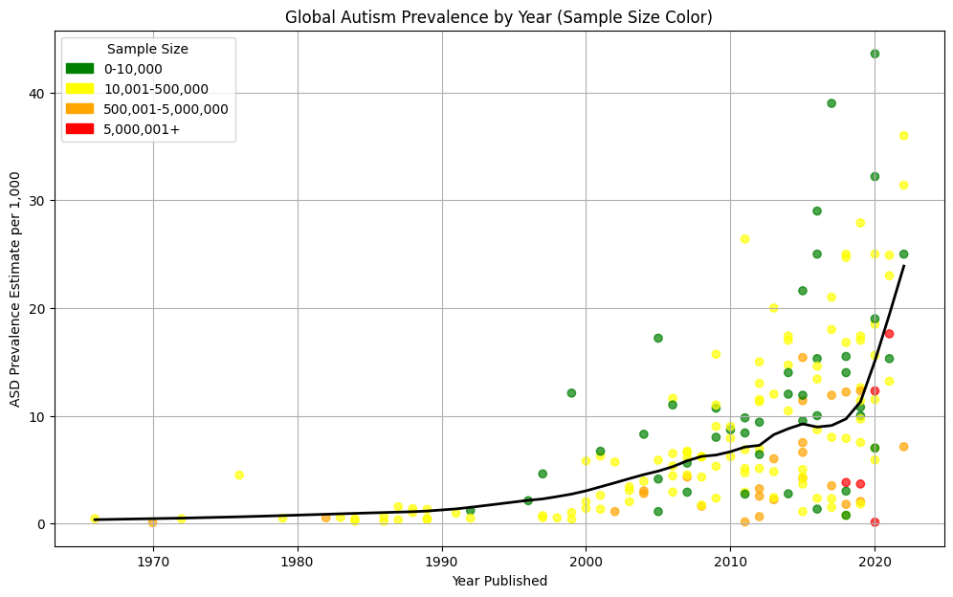
Figure 2: This line graph displays the growth of ASD from 1962-2022.

Global ASD rates have grown exponentially since 1962, with cases increasing each year. The above graph illustrates a steady rise in the number of studies conducted worldwide. As research expanded, ASD prevalence appears to grow in parallel, reflecting broader detection and reporting. Awareness initiatives should highlight both the scale of ASD growth and the factors driving this trend. Autism affects individuals across diverse contexts, underscoring the importance of education and understanding. Global growth in ASD prevalence demands continued research as more people begin learning about ASD.

US ASD Rates Outpace Global Trends

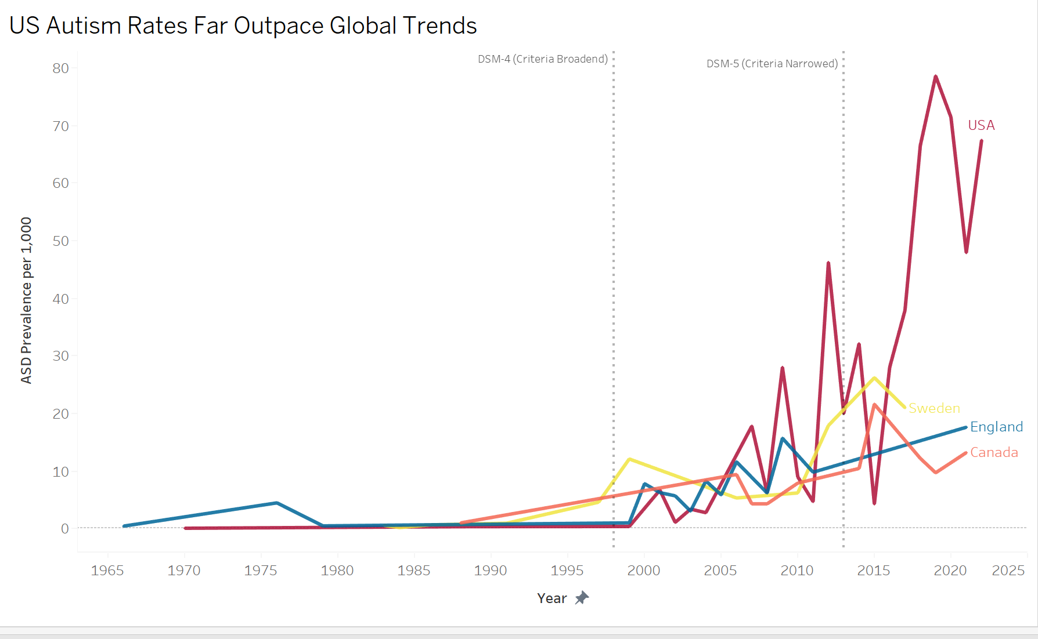
Figure 3: This line graph displays the growth of ASD by country.

Year-over-year ASD studies across countries with at least 20 years of data reveal that the United States far outpaces global ASD rates. England, Sweden, and Canada reported relatively small ASD populations until the early 2000s. ASD population increases accelerated after DSM-IV classifications in 1998 broadened diagnostic criteria and expanded the definition of autism [3]. Following this change, the United States overshadowed England, Sweden, and Canada throughout the next decade. Even after DSM-5 narrowed ASD classifications in 2013, the United States continued to dominate comparative rates, particularly after 2015, maintaining a clear lead over other nations [4].

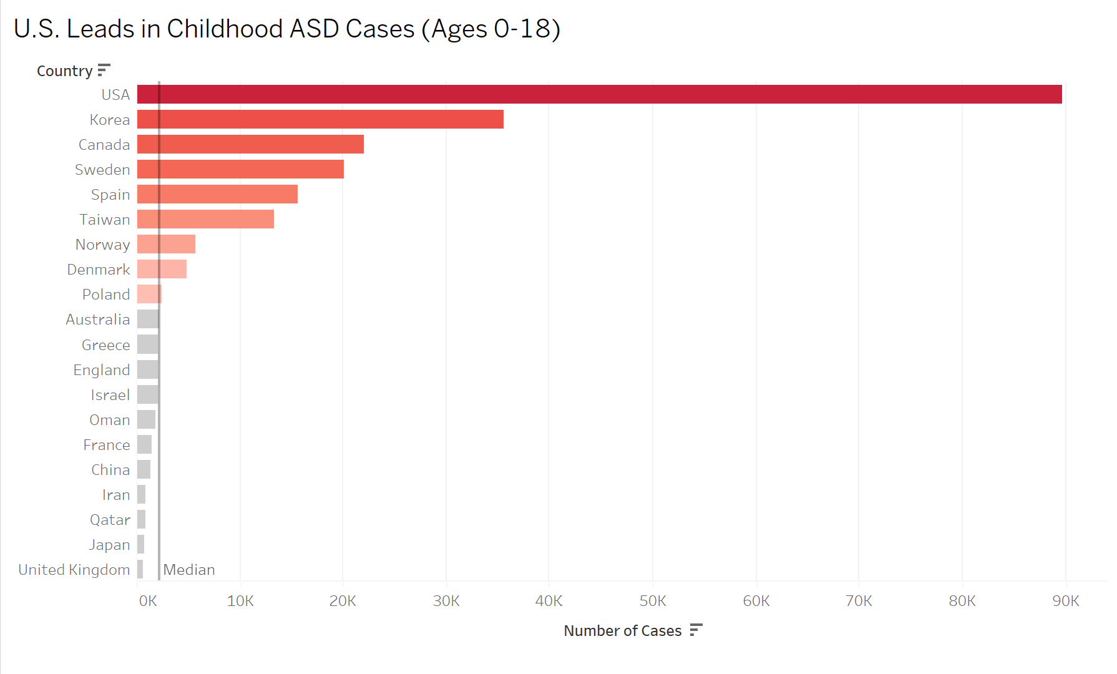
Figure 4: This line graph displays the total number of ASD cases for ages 0-18.

Deeper analysis of ASD prevalence among children aged 0–18 shows the United States leading in total autism rates for children 0-18 years old. Data indicate that the United States maintains a pool of children with ASD approximately 40% larger than South Korea, which ranks second in child autism prevalence.
Conclusion
The results of the ASD pipeline show that the ASD rates globally have increased since 1962, and specifically, the United States is experiencing much more growth than other countries. The growth in ASD rates and studies conducted showed increased awareness; between 1965 and 2000, there were only about 30 studies conducted. In the year 2000, shortly after the DSM-4 was created, there is a significant rise in the number of studies conducted. In the last decade, this rate of increase is still true. The Automated Global Autism Prevalence Pipeline uses Databricks to ingest, process, and visualize information about autism prevalence. The visualizations of these studies allow for a better understanding of how Autism Prevalence has changed over time. These graphs show an overall view of ASD prevalence as opposed to CDC’s “8-year-olds” analysis.

References
[1] Centers, “autism prevalence studies,” Cdc.gov, Jun. 25, 2020. https://data.cdc.gov/Public-Health-Surveillance/autism-prevalence-studies/9mw4-6adp/data_preview
[2] CDC, “Data and Statistics on Autism Spectrum Disorder,” Autism Spectrum Disorder (ASD), Apr. 15, 2025. https://www.cdc.gov/autism/data-research/index.html
[3] “DSM-IV – Diagnostic Classifications - Autism Society of Southern Arizona,” Autism Society of Southern Arizona, May 15, 2020. https://as-az.org/dsm-iv-diagnostic-classifications/
[4]“Autism diagnostic criteria: DSM-5,” Autism Speaks, 2022. https://www.autismspeaks.org/autism-diagnostic-criteria-dsm-5
‌

