Auto_PO_Export *User Guide*

This user guide corresponds to the ***Auto_PO_Export***, this is a useful tool to export automatically ***Assembly groups*** **[AG]** documentation from the Ulysses software.

# Inhalt

1 Inhalt 1

1. Configuring the export 2

1.1 Record Phase 2

1.1.1 Recording Rules 2

1.1.2 Open the *recorder.exe*, set the [AG] and *Ulysses PID.* 3

1.1.3 Click on the “Record” button. 3

1.1.4 4

# Configuring the export

There are two steps for the tool configuration, the first is a **“Record”** phase, where you can set the referring **[AG]** name and record the mouse and key events in order to create an export of the **[AG]** documentation, as result of this phase you will save an instruction file named ***instructions.json*** containing the recorded events.

The second phase is the **“Playing”** phase; here you just have to run the **“player.exe”** program. It will read the saved instructions from the **“Record”** phase (***instructions.json***) and replicate it in order to export the same **[AG]** documentation.

## Record Phase

### Recording Rules

For the recording of actions are some rules to follow, please consider that only the following events will be cached:

* Right Click
* Left Click
* “Return” Key pressed
* “Delete” Key pressed
* “Space” Key pressed

The first time the “***Return***” Key is pressed should be made on the ***Artikelnummer*** field from the Ulysses search window; this will tell the program to write there the **[AG]** number you give on the ***recorder.***

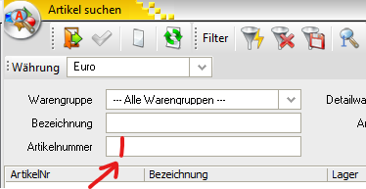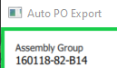

Figure 1: The first time the Return key is clicked means for the program, to write there and search the given Assembly group number.

The second time the Return Key is pressed will tell the program to write there the ***table name,*** of the **[AG]** number exported from Ulysses, in order to save it on the right path. The program will create a new folder called “***Projects***” on the top directory of the ***Auto_PO_Export*** Tool, and save the exported data there.

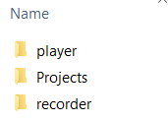

Figure 2: Top directory of the Auto_PO_Export. The "Projects" folder will contain the exported data.

### Open the *recorder.exe*, set the [AG] and *Ulysses PID.*

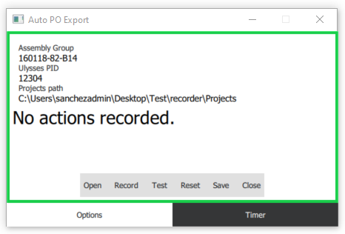Please register to Ulysses first and then go to the ***recorder*** folder and run the ***redorder.exe.*** The see the following window will appear***.***

* Set the **[AG]** number on the field ***“Assembly Group”, press “Return” to apply.***
* 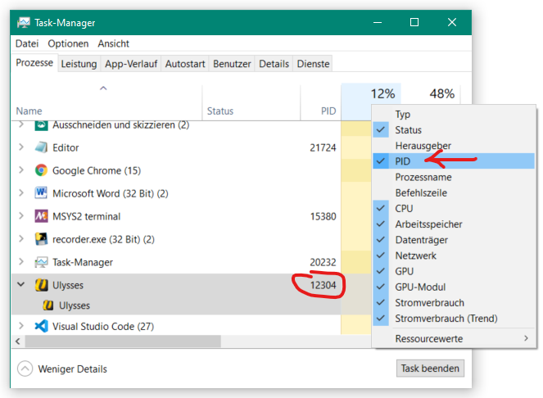Set the ***Ulysses PID*** on the field ***“Ulysses PID” , press “Return” to apply.*** You can read the Ulysses PID from the tasks manager, consider the following image:

### Click on the “Record” button.

The ***Recording*** will start and the Ulysses program will come to the front. On the left upper corner of your screen will appear the **S*top*** Button, please click it, to stop the recording actions (It might appear a console window showing the clicked positions).

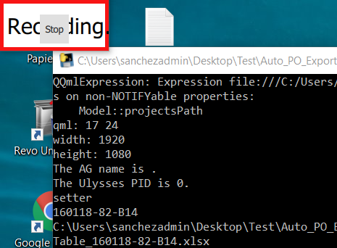

Figure 3: Recording state, showed on the left upper corner.

In case you click on the wrong position, just stop the recording and click the ***Reset*** button, this will delete all the saved events and you will have to record from the beginning again.

**Follow these events in order to save the right instructions:**

In Ulysses:

1. 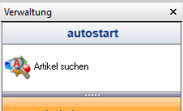***Left click*** on the “***Artikel suchen***” option:
2. ***Left click*** on the “***Artikelnummer***” field and write the **[AG]** number.
3. 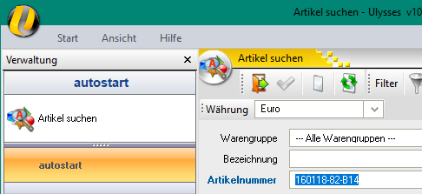***Press “Return”***
4. 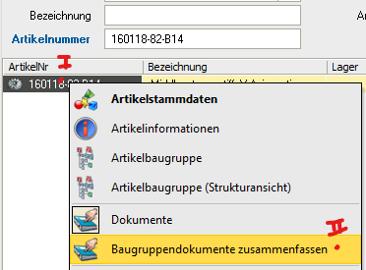***Right click*** on the founded Assembly group **[AG]** and ***left click*** on “***Baugruppendokummente zusammenfassen”*** on the dropdown menu.
5. 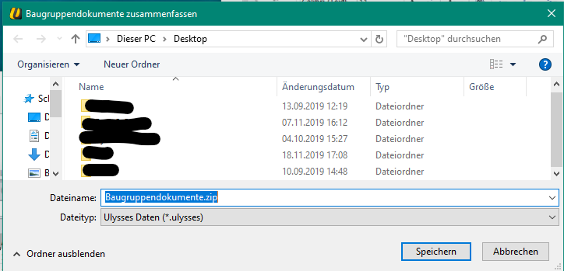On the pop-up window (*Baugruppendokumente zusammenfassen*) ***left click*** on the “***Dateiname***” field and ***Press “Return”***.
6. Go back to Ulysses and ***right click*** on the founded Assembly group **[AG]** and ***left click*** on “***Artikelbaugruppe (Strukturansicht)”*** from the dropdown menu.

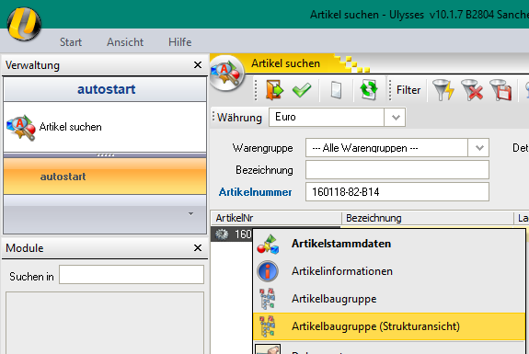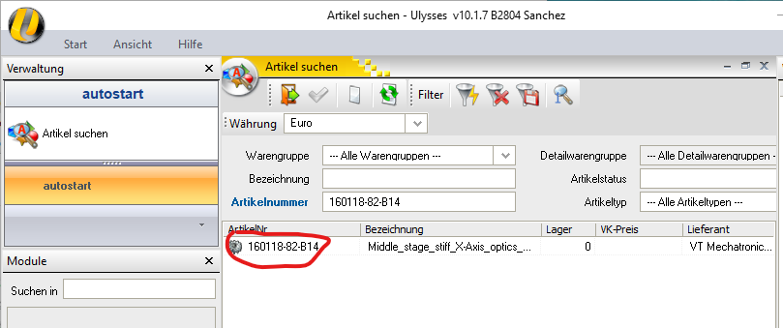

1. ***Press „Space“*** and wait until the *structure view window* appears (This means for the program to wait 6 seconds until the table load)
2. ***Right click*** on a column header, this will show a drop down menu.
3. ***Left click*** on “***Exportieren***” on the dropdown menu.
4. 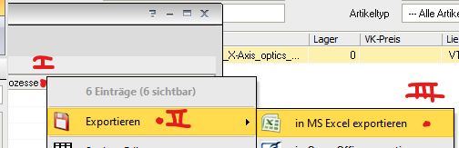***Left click*** on “***in MS Excel exportieren***”.
5. ***Press „Space“*** and wait until Excel appears.
6. 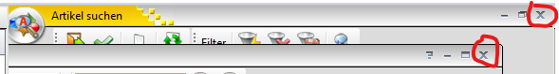***In Ulysses, close the structure view and the search windows***, this means to ***left click*** on the close Buttons of these windows.
7. 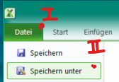Go to Excel, ***left click*** on “***Datei***” and ***left click*** on “***Speicher unter***”
8. On the “***Speichern unter***” window, ***Left click*** on the “***Dateiname***” field and ***press “Return”.***

(It does not matter the table was saved on the “*Dokumente*” folder, on the reply, the ***player*** will save this table on the “***Projects***” folder)

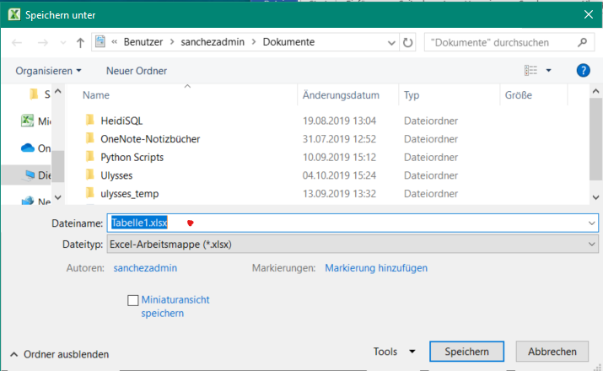

1. 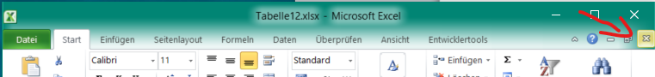***Close*** the Exel Window, so ***left click*** on the close button. (You don’t need to close the Excel program)
2. 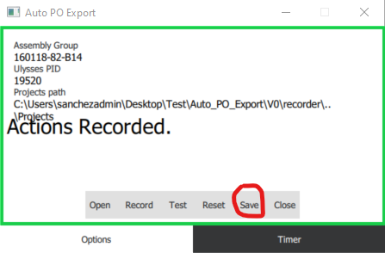Click on the ***Stop*** button and then click on ***Save***

At this point you should have successfully created the instructions for the player-program.

These Instructions are saved on an ***instruction.json*** file on the “***recorder***” folder

### 