 | AVISPA  IST–2001–39252  Automated Validation of  Internet Security Protocols and Applications

Consortium Agreement
Deliverable 8.3
(see also Dissemination and Use Plan)

Abstract
This document is the Consortium Agreement of AVISPA. It deals with legal aspects of the project, and it is signed by all Partner Institutes’ respresentatives.

Deliverable details
Report version: 1.0 (final)
Date of delivery: April 15th, 2003 Due on: June 30th, 2003
Classification: public Total pages: 31
Person-months required: 1

Project details
Contract Start Date: Jan 1st, 2003 Duration: 30 months
Project Co-ordinator: Alessandro ARMANDO
Partners: University of Genova, ETH Zürich, INRIA, Siemens AG

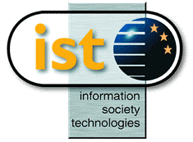 | Project funded by the European Community under the “Information Society Technologies” Programme (1998-2002)

