**2012**

**DEC.**



Vestbjerg Byggevare

Cristian-dan Cojocaru:

cristi toma:

Jozsef Kiraly:

petar savov:

robert ivanov:

*Participants:*

*Cristian-Dan Cojocaru*

*Cristi Toma*

*Jozsef Kiraly*

*Petar Savov*

*Robert Ivanov*

Report on Project

# Analysis of Business

## Description of the organizational structure

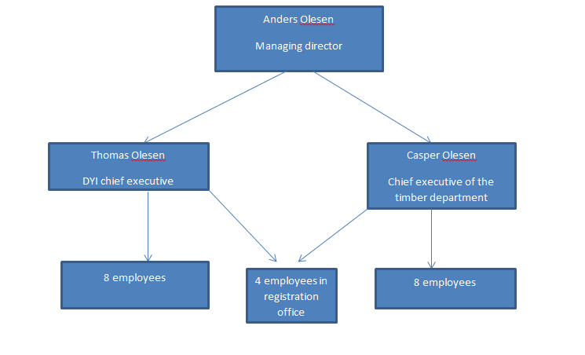

The managing director is Anders Olesen (who founded the company in 1987) along with is 2 sons, Casper who leads the timber department and Thomas Olesen who takes care of DIY centre.

Vestbjerg Byggecenter A/S has a total of 30 employees divided in 3 parts: 8 employees in DYI part of the company, 8 employees in the timber department and 4 in the registration office.

## Expectations for the new system

* Introducing the bar code system which is going to be effective to organize their products in stock
* Better backend for stock management, which means faster services, able to search for every single product using the bar code
* The new system should be easier to handle and to work with
* The new system should be able to handle the huge amount of information about the products, employees, customers and orders/rents, and give access to always up-to-date information
* User access levels should be present, so that the managers have access to the crucial part of the system, while the employees don’t (e.g. setting the prices of the products)
* The system has to provide multiple ways to display statistical information about the on goings of the two departments.

## Financial position

|  |  |  |  |
| --- | --- | --- | --- |
|  | 2007 | 2008 | 2009 |
| ROI | 7% | 11.70% | 10.80% |
| CM Ratio | 28.70% | 29.80% | 30.80% |
| PM Ratio | 3% | 5.20% | 4.80% |
| Assets turnover | 2.32 | 2.26 | 2.24 |
| ROE | 12.10% | 23.20% | 19.10% |
| Capacity Ratio | 1.12 | 1.21 | 1.19 |
| Solvency Ratio | 43.50% | 42.80% | 49.30% |
| Current Ratio | 2.64 | 2.25 | 2.41 |

Profitability.   
Increased from year 2007 to 2008 due to both increase in PM and assets turnover. From year 2008 to 2009 the ratios have been decreased. Level of changes: low. They have profited from the employment of debt (ROE is higher than ROI).

Earning capacity.  
There is an increase of 1 % for every year in the contribution margin.

Solvency.  
There is a decrease between 2007 and 2008 with a low increase to 2009.

## SWOT analysis

|  |  |
| --- | --- |
| Strengths  Stable company  Loyal customers  More than 30 years of experience | Weaknesses  Old system  Manual handling of stock  No communication between departments  No warehouse management |
| Threats  Other companies  Highly competitive market | Opportunities  Market extension (online)  Larger target customer groups |

Strengths

Having Anders Olesen for almost 40 years as a managing director makes Vestbjerg Byggercenter A/S a very stable company having their own loyal customers.

Weaknesses

Unfortunately his way of leading is a bit old fashioned which makes the company lose customers and profit.

Threats and opportunities

Even if this DIY system is quite new, many companies have already adopted it and it seems that the market is expanding every day.

## Leading style within the company

The managing director Anders Olesen along with is 2 sons, Casper who leads the timber department and Thomas Olesen who takes care of DIY centre, have succesfully developed Vestbjerg Byggercenter A/S, called Vestbjerg Byggermarked back in 1987 when it was founded.

Even if Anders Olesen is a little bit old fashion in term of leading , he knows everything about the company and knows how to run it.

Anders knows and trusts all the employees and has a good relationship with them.

The good thing is that he is conscious that his style of leading is kind of ''oldschool'' and puts a lot of responsabilities under his sons while he takes care more of the motivation of the employees.

Casper and Thomas are very well-trained in terms of new style of leading.

Problems, hypothesis and solution possibilities

|  |  |  |
| --- | --- | --- |
| ***Problems*** | ***Hypothesis*** | ***Solutions*** |
| Old-fashioned inventory control | Company does not use bar codes | New system will help to register the sales using a barcode reader |
| Unorganized and uncategorized warehouse | Orders should be better described and easy to reorder | New system can store information about customer, employee and products only by using the bar codes |
| Difficult to keep an eye on different machines and rental tools | This kind of job is manually handled by the employee | New program has a rental system developed in it |

Mission of the company

* To exceed our customers expectations in quality, delivery, and cost through continuous improvement and customer interaction.
* To provide work environments where their employees can meet their potential and thrive in an atmosphere of excellence.
* To maintain a superior level of integrity in interactions with business partners and associates.
* Build on their history of product excellence and technology innovation
* To provide the highest-quality and most reliable products and services to the customers.
* To provide a pleasant, nurturing and growth oriented environment which encourages their employees to be highly productive and to grow personally and professionally.

Strategic goals of the company

* The actual system that VB is using right now is an outdated UNIX based one which requires a lot effort from the staff. Since the majority of the employees are accustomed to Windows operating systems, it should be implemented instead, allowing a more user-friendly experience.
* Upgrading the actual website would give the opportunity to customers to directly buy their products online .
* Counting that DIY market is mostly popular in Denmark and Sweden, they would like to extend their market to other developed countries.
* Trying to reduce the fixed cost as much as possible in order to reduce prices without losing profit.
* With faster time-to-market comes first mover advantage, bringing value directly to the top line. VB can also help generate better product ideas and help you select the best ones to bring to market. It also makes it easier to tailor products to specific customer or industry needs.

Priority of the features in the system

* The system should be more user-friendly, easier and faster to access by the employees.
* It should contain a search engine
* It should contain sales statistics functions which will display information
* Continuously updated database
* Support for barcode system
* Control of inventory, storing information about products (location (both by department and by shelf), prices, description, current amount, etc)
* Storing the orders and rented device recipes

System definition

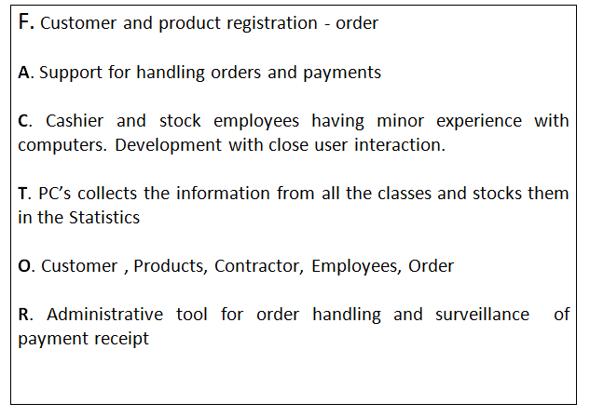

Use Case Diagram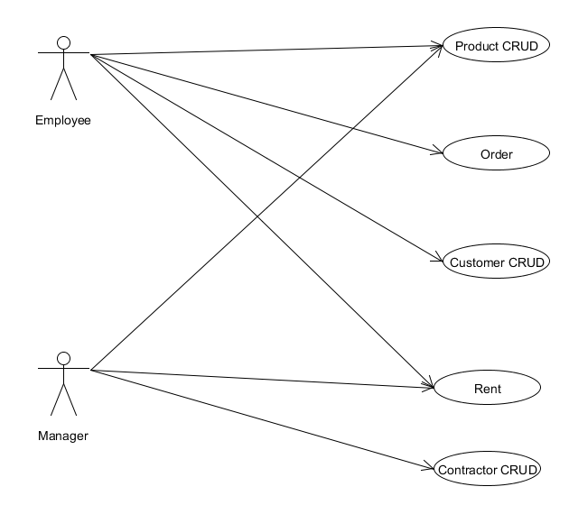

The employee has acces to the main functions excepting the Contractor who is charge by the manager.

The discount is set by the manager .

Fully dressed Use Case

**1.Use Case – Make an order**

**Primary actors:**

Employee

**Stakeholders and Interests:**

Customer – Wants to make an order

**Pre-condition:**

The product exists is in stock and customer wants to buy it

**Post-Condition:**

Customer has bought a product

**Main success scenario:**

1. Employee enters in Main menu
2. System display further options
3. Employee marks the product type
4. System display further options
5. Employee choose quantity of the product
6. System requires for – customer’s name and other information.
7. Employee enters the data
8. System receives the data
9. The product order is made successfully

**2.Use Case – List of ordered products**

**Primary actors:**

Employee

**Stakeholders and Interests:**

Employee – Want the list of ordered products for a user

**Pre-condition:**

Product list exists in the system and employee want to see it

**Post-Condition:**

Employee saw the list of the ordered products

**Main success scenario:**

1. Employee enter in Main menu
2. System display further options
3. Staff choose “Order” menu
4. System display further options
5. Staff choose “List of orders”
6. System requires for a Customer's name

7. Staff enter customer’s name

8. System prints the order list

Design Class Diagram- Domain Layer-CustomerOrder

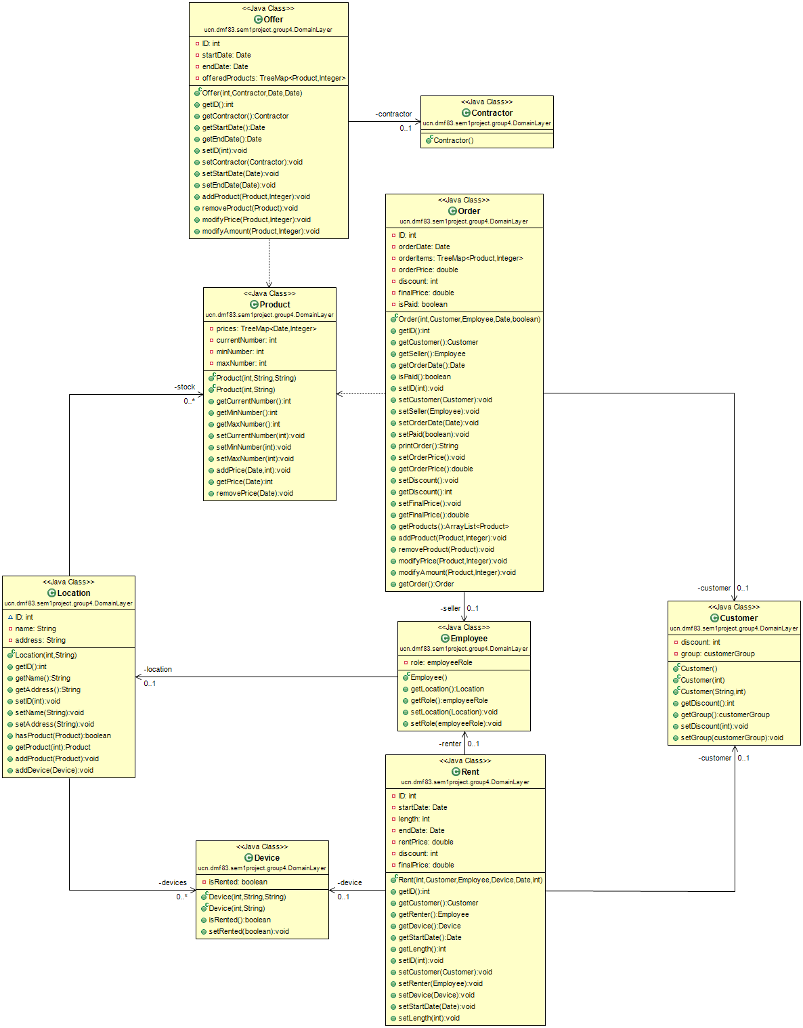

Class Diagram-User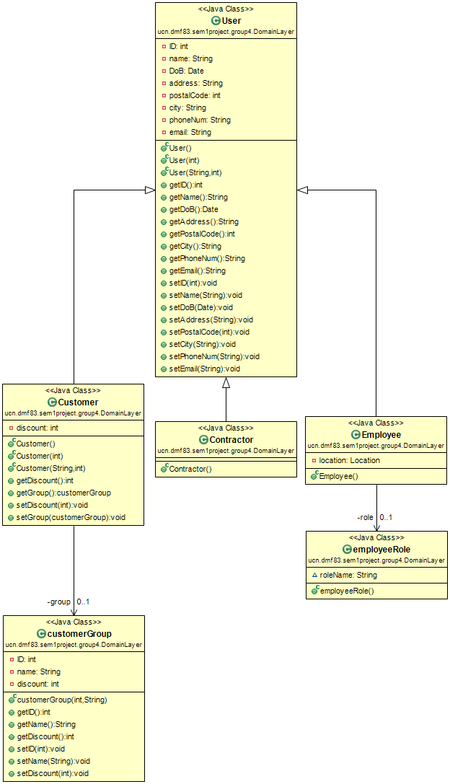

Operation Contracts-Order, Customer, Offer

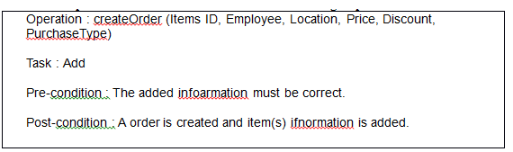

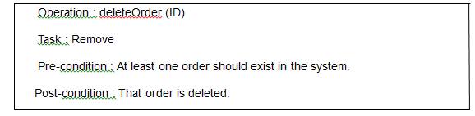

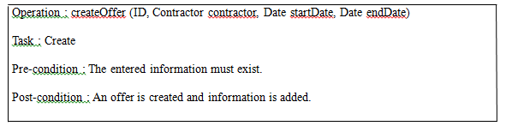

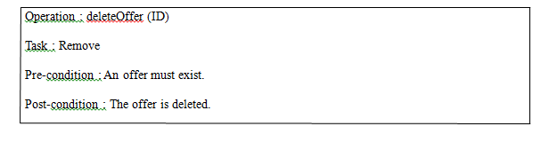

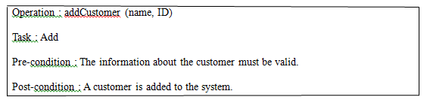

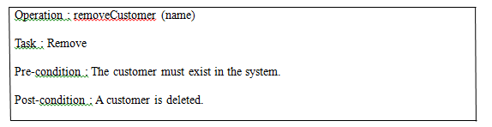

System Sequence Diagram

