Steve banh (1971537)

Lab #2: Introduction to LINQ and the List collection  
1. LINQ to Objects using an int array

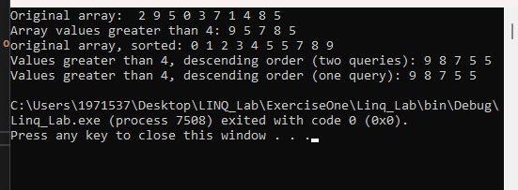

2. LINQ to Objects querying an array of Employee

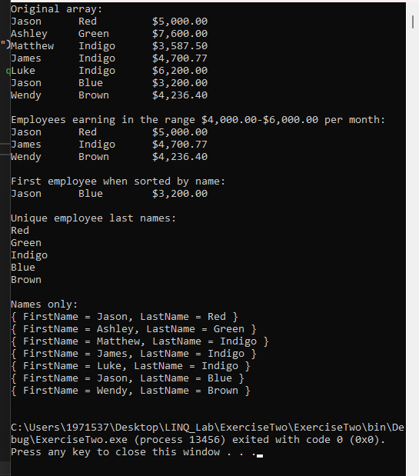

3.Generic LIST collection demonstration

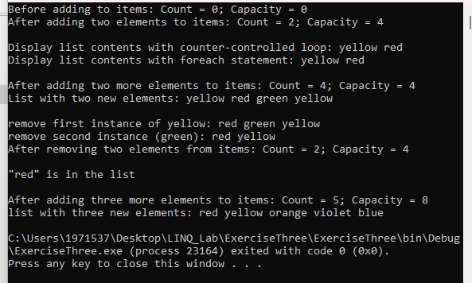

4. LINQ to Objects using a List<string>

