Project 4

This project constructs and simulates a weighted directed graph data structure by reading in specifically formatted data from a file. The simulation is modifiable through a user menu that supports a few operations. The supported graph operations through the user menu are as follows: (1) printing the adjacency list of the graph, (2) printing the single-source shortest path to all vertices using Dijkstra’s algorithm, (3) printing the indegree of each vertex, (4) printing a topological sort of the graph, and (5) exiting the program.

Running the Program

To run the program, first download the ***project4*** directory to a CSE machine. Once you are in the ***project4*** directory, compile the program by typing “g++ project4.cpp vertex.cpp” excluding the quotes. Finally, run the program by typing “./a.out” excluding the quotes.

After running the program, you will be prompted to enter the file name containing the data that will construct the graph. A default file labeled “in1.txt” is provided for testing if no additional file is added to the directory. Once the file name is entered and is successfully opened, the user menu will be displayed. To execute an operation simply type the parentheses-enclosed number that is associated with the operation.

Example of Running the Program

Compiling:

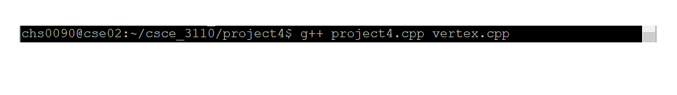

Running:



Entering a File:



User Menu:

