Project 5

This project simulates the mathematical concept of disjoint sets. The program supports a dynamic input size of disjoint sets as well as the find, union, and split operations on the disjoint sets.

Running the Program

To run the program, first download the ***project5*** directory to a CSE machine. Once you are in the ***project5*** directory, compile the program by typing “g++ project5.cpp” excluding the quotes. Finally, run the program by typing “./a.out” excluding the quotes.

After running the program, you will be presented with the user menu showing the supported operations. To execute an operation simply type the parentheses-enclosed number that is associated with the operation.

Example of Running the Program

Compiling:

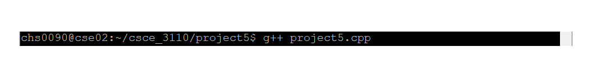

Running:



User Menu:

