**Home Building and Remodelling**

**Problem statement**

Home building and remodelling website will be useful to the users who wants to build their dream home or enhance their home. The user can select the designs as they like to build their dream home, after confirmation they can keep track of their home building from scratch to final touches and payment will be done simultaneously

**Motivation**

The users who want to build their home and who wants to remodel the home but they not in a stage of daily sighting.

**Objective**

Select the groundbreaking architectures to build the home and keep an eye on the construction of the home via images or videos.

**Use case**

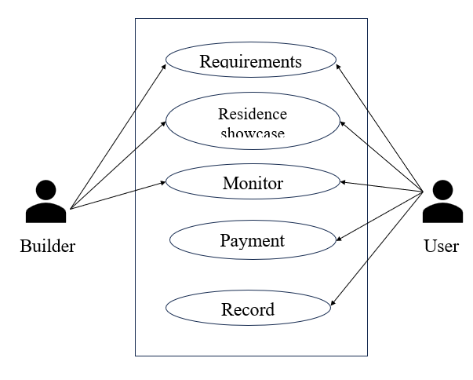

**Use case**

**Modules**

* 1. User requirements
     1. Build
     2. Remodel
  2. Residence showcase
  3. Monitor
  4. Payment
  5. Record

**Specifications**

Visual studio

Xampp server

Operating system(windows)