Figure : MongoDB Cluster Setup

Figure : Organization/Project Setup

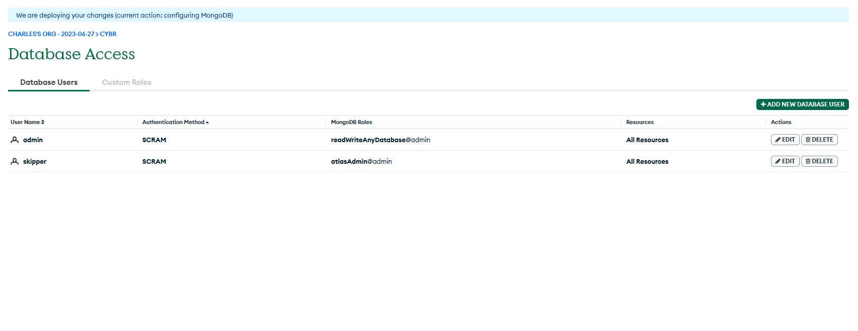

Figure : Security Provisions

Figure : Whitelist IP Addresses

Figure : Access the Cluster