Installation guide of Debian 12 server equipped with Apache, PostgreSQL and PHP on a virtual machine

Ilyès Drouiche

June 2024

Table of Contents
Part 1: installation of Debian 12 and tools on your machine. 1
Step 1: install the Debian system without graphic interface. 1
Step 2: installation of SSH. 2
Step 3: installation of Apache. 2
Step 4: installation of PostgreSQL. 2
Step 5: the cat /etc/fstab command. 3
Part 2: Access to documentation 4
Step 1: Access to apache server documentation. 4
Step 2: Access to php documentation. 4
Part 3: SQL queries and security of your password. 6
Step 1: you can make SQL queries from the virtual machine. 6
Step 2: try to work on your database in your host machine connected by ssh. 6
Step 3: vizualize the list of all your database on your postgresql server. 7
Step 4: secure your password with the SHA-256 encryption. 7
Part 4: Using the different tools and finalize 8
Step 1: making SQL queries with PhpPgAdmin. 8
Step 2: Query a PHP file. 9
Step 3: display the remaining storage space on the machine after all your installations. 9
Part 5: Appendices 10

Part 1: installation of Debian 12 and tools on your machine.
The main goal is to install the following system:
- Debian 12.x
- for x86 CPU 64 bytes
- with ISO image of type “netinst”

Step 1: install the Debian system without graphic interface.
Follow the parameters below to achieve the installation:
Language | English
Location | other/Europe/France
Locales | United_States, en_US.UTF8
Keyboard | French
Hostname | server-"YOUR NAME"
Root Password | A simple password
User Account – Full Name | Your full name
Username | Your name
User Password | A simple password
Partition disks | Guided – use entire disk
Partition disks | All files in one partition
Partition disks | Yes
Software Selection | The “Debian desktop” checkbox has to be ckecked and the “ssh server” checkbox has not to be ckecked
Install GRUB | Yes
Device for boot loader | /dev/sda
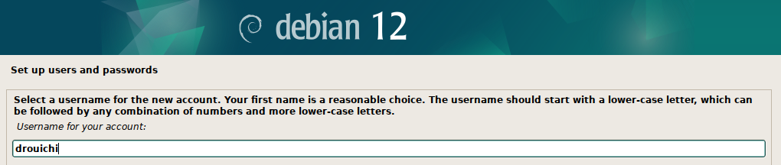
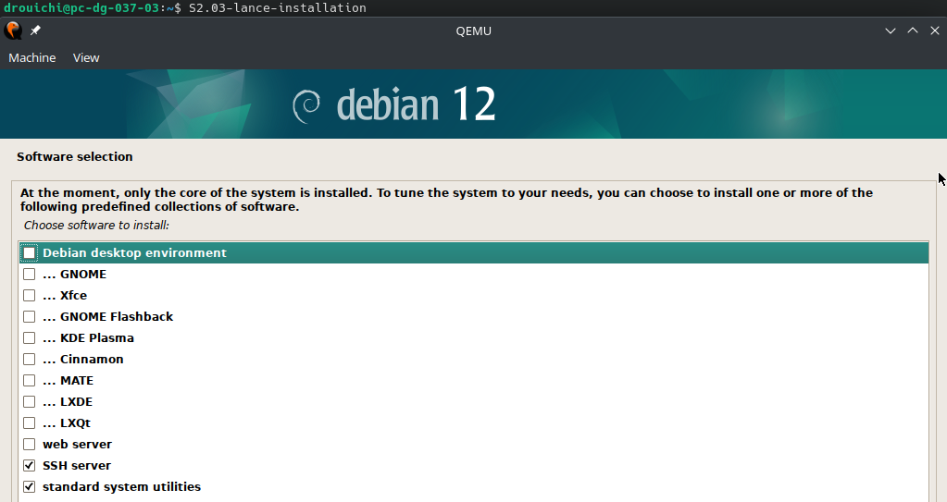

Go on the root shell with this command and type your root password :
drouichi@server-drouichi: $su -

Step 2: installation of SSH.
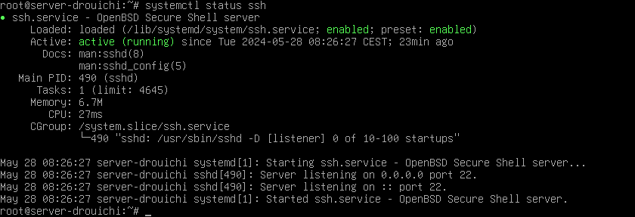
Normally, ssh is installed by default.To make you certain about that, you can type the following command and you must have the same screen as below:

Step 3: installation of Apache.

Install Apache with the following command:
root@server-drouichi: # apt install apache2

Verify if Apache is nicely installed and compare your screen with this :
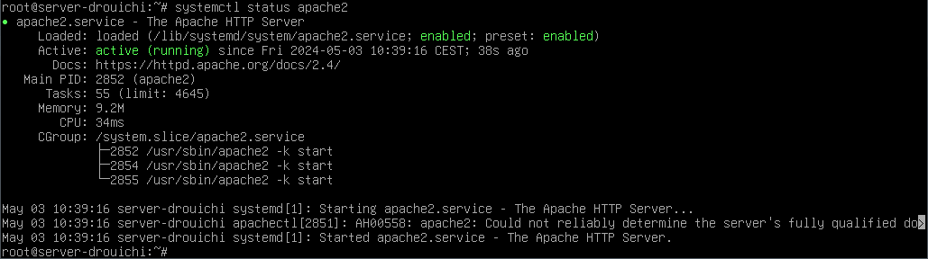

Step 4: installation of PostgreSQL.

Install PostgreSQL with the following command:
root@server-drouichi: # apt install postgresql

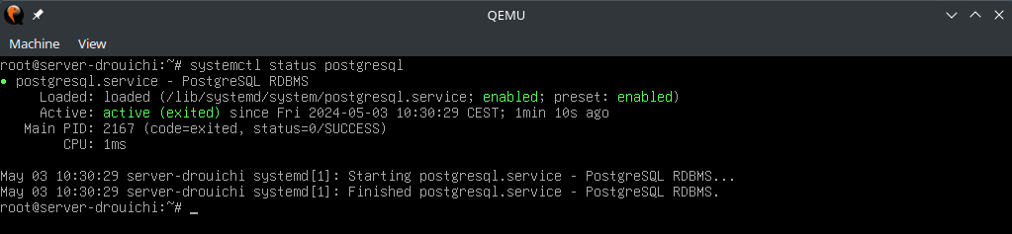
Verify if postgresql is nicely installed:

Step 5: the cat /etc/fstab command.
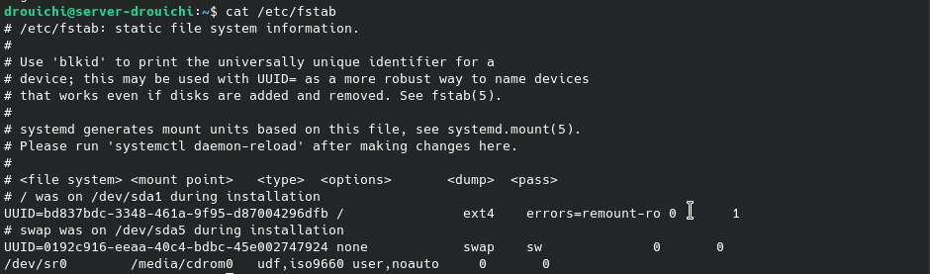
This command brings you the content of the fstab file which contains informations about the file system of your machine.

Part 2: Access to documentation

Step 1: Access to apache server documentation.
On the result of systemctl status apache2 command, a link will be displayed next to the word “Docs”. This link refers to the documentation of the Apache server you just installed
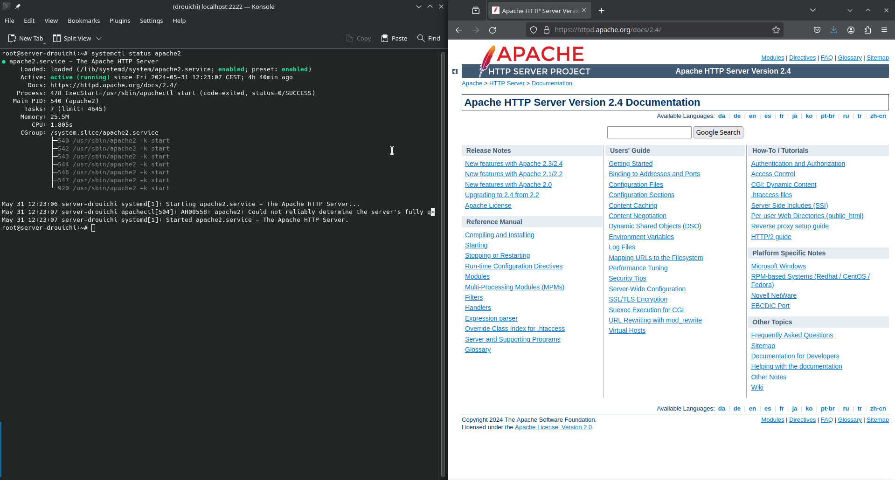

Step 2: Access to php documentation.
- With root user, create a file named info.php on the /var/www/html directory.
root@server-drouichi: # cd /var/www/html
root@server-drouichi:/var/www/html # touch info,php

- Edit this file with the following content:
<?php
phpinfo();
php(INFO_MODULES);?>
- Access to the link http://localhost/8080/info,php since the host machine
A page with the main characteristics of your php installation will be displayed
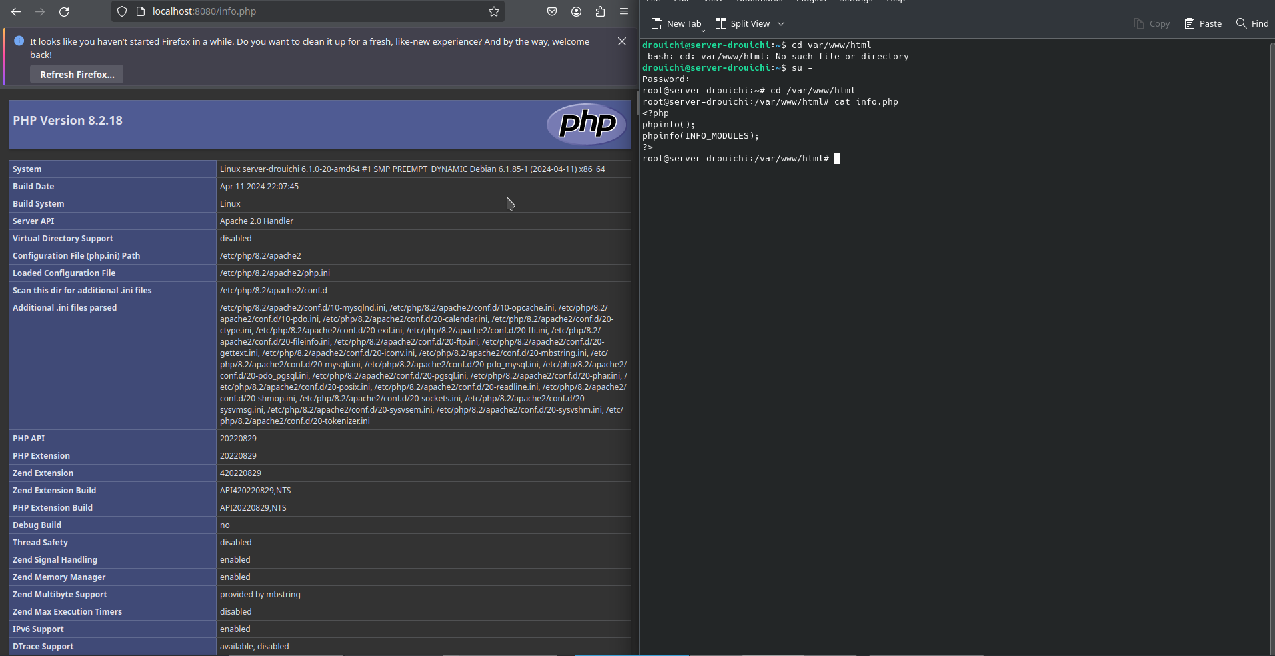

Part 3: SQL queries and security of your password.

Step 1: you can make SQL queries from the virtual machine.

- First, go on the root and connect you with su – postgres.
root@server-drouichi: # su – postgres
You are now connected on your postgresql server

- Create a database with the following command:
root@server-drouichi: # su – postgres
postgres@server-drouichi: $ create database ma_base;
create database ma_base creates an empty database on your postgresql server

- Connect you on the base you just created:
postgres@server-drouichi: $ psql ma_base;
You are now connected on the database.

- Create your first table with the following SQL command on the database you just created:
ma_base=# create table ma_table(prenom varchar, nom varchar, age int);
In this example, the table allows you to save the name, the full name and the age of someone.

- Set a value for each field of the table
ma_base=# insert into ma_table values (“Drouiche”, “Ilyès”, 20);
Because of this SQL command, you will insert into the table you created before the following values at this order. You can so pay attention of the order.

- Now, you can make SQL query to print the content of your table:

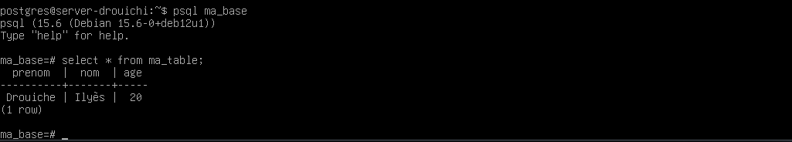
Step 2: try to work on your database in your host machine connected by ssh.
Connect you with ssh from your host machine with the following command:
drouichI@pc-dg-037-03:~$ ssh drouichi@localhost -p 2222
Replace « drouichi » by your username.

2222 is the port number (-p for port) of the ssh protocol which secures the TCP connection. On the file system of your virtual machine, you can find this: hostfwd=tcp::2222-:22 (S2.03-commun). It shows the port number where the user has to connect.
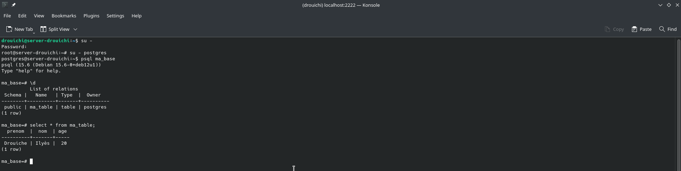

Step 3: vizualize the list of all your database on your postgresql server.
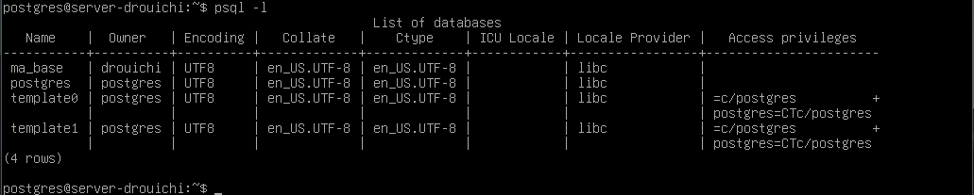
You can see the database you created before.

Step 4: secure your password with the SHA-256 encryption.
To secure your password, you have to modify two configuration files which are pg_hba.conf and postgresql.conf
postgres@server-drouichi= # nano /etc/postgresql/15/main/postgresql.conf
Thanks to this command, you can edit the postgresql.conf file and do the following actions:

- Research the CONNECTIONS AND AUTHENTICATION section

- Decomment the listen address line and replace it by
listen_adresses = “*’"
Now, the server is listening for connection requests from non-local IP addresses, we need to define an authentication rule that will be used for these requests.

- To do this, edit the authentication rules file:
postgres@server-drouichi= # nano /etc/postgresql/15/main/pg_hba.conf

- Add the following rule to only accept authenticated connections by a SHA-256 password.
#IPv4 remote connections:
host all all 0.0.0.0/0 scram-sha-256

- Go back to the root and confirm these new configurations by restarting your server.
postgres@server-drouichi= #exit
root@server-drouichi: #service postgresql restart

- After the restart of the machine, define a password with this command.
postgres=# \password

- Now, you can consult the pg_shadow table and see that the password has been hashed by the function SHA-256

Part 4: Using the different tools and finalize

Step 1: making SQL queries with PhpPgAdmin.

- Edit the Connection,php file
root@server-drouichi:# nano /usr/share/phppgadmin/classes/database/Connection,php

- On this file, change the line
case ‘14’ : return ‘Postgres’;break;
by
case ‘15’ : return ‘Postgres’;break;

- Now, you can access PhpPgAdmin with this url on a web browser
localhost:8080/phppgadmin/

- Before making a query, you have to grant the select permissions on the table you want to query like that
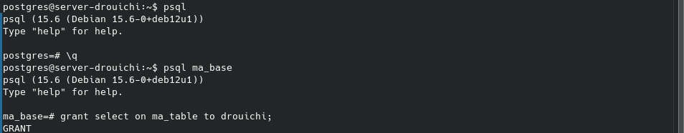
- Now, you can make a select query on the PhpPgAdmin page

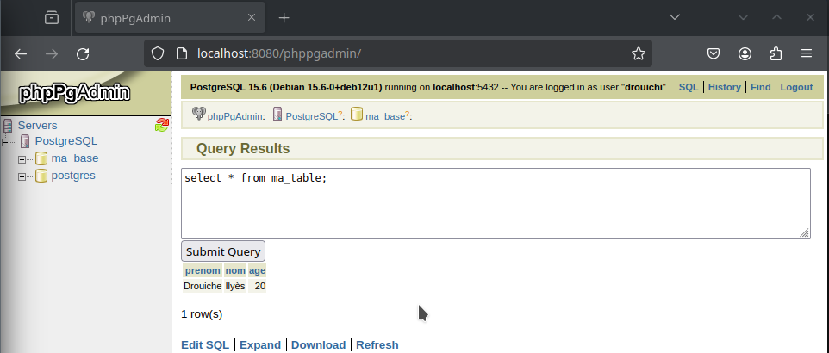

Step 2: Query a PHP file.
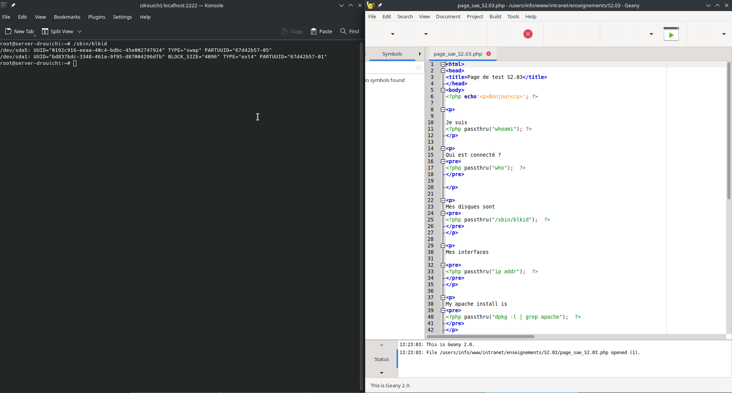

Step 3: display the remaining storage space on the machine after all your installations.
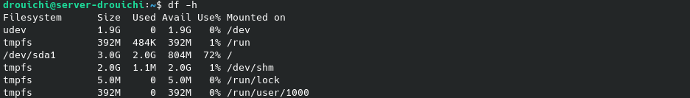

Now you have a fully functional Debian 12 system equipped with Apache, PostgreSQL and PHP

Part 5: Appendices

For more information, you can also ckeck out the following links.
- https://www.debian.org/
- https://www.debian.org/releases/stable/installmanual
- https://debian-facile.org/wiki
- https://httpd.apache.org/docs/2.4/en/install.html
- https://www.postgresql.org/
- https://www.php.net/manual/en/install.unix.php

