**Installing Dependencies**

Install R

For windows

* <https://cran.r-project.org/bin/windows/base/>

For Apple

* https://cran.r-project.org/bin/macosx/

After installation make sure to add R into your computer's path on Windows

* The path should be something like “C:\Program Files\R\R-4.1.2\bin\x64”

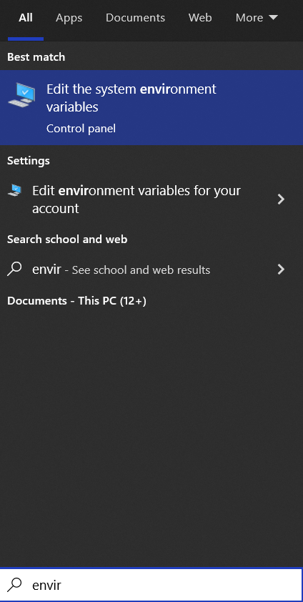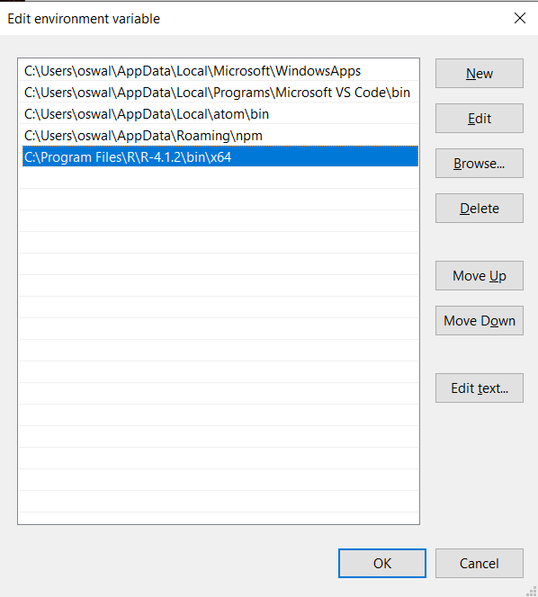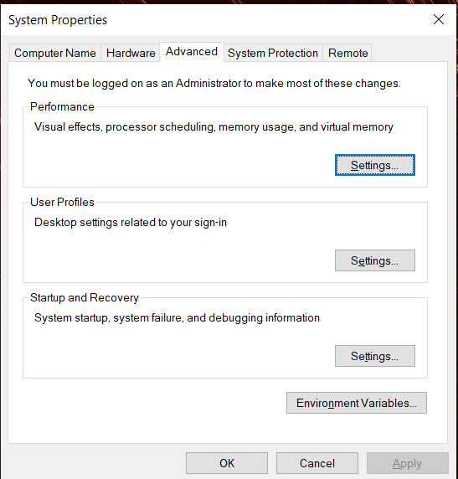

* After adding R to path, open R and run the following commands
  + install.packages(“pdftools”)
  + install.packages(“tm”)

Installing Python and its packages

Both Mac and Windows

* <https://www.python.org/downloads/>
* On Windows you can install python directly from the Windows store if desired.

Installing Packages

* Open up a terminal window and run the following commands
  + pip install pandas
  + pip install PyQt5

All dependencies should be installed now!

**VERSIONS:**

**R - 4.1.2**

**Python3 - 3.9.7, or higher**

**PyQt5 5.15.6**

**pandas 1.3.4**

**Using Application**

The application can be ran in two different ways:

1. Open the zip file and right click on the “main_window.py” file
2. Select Open with and choose Python 3.9
3. Once opened click the the button for open file and select folder with PDFs
4. Output csv file will appear in the folder with the “main_window.py” file.

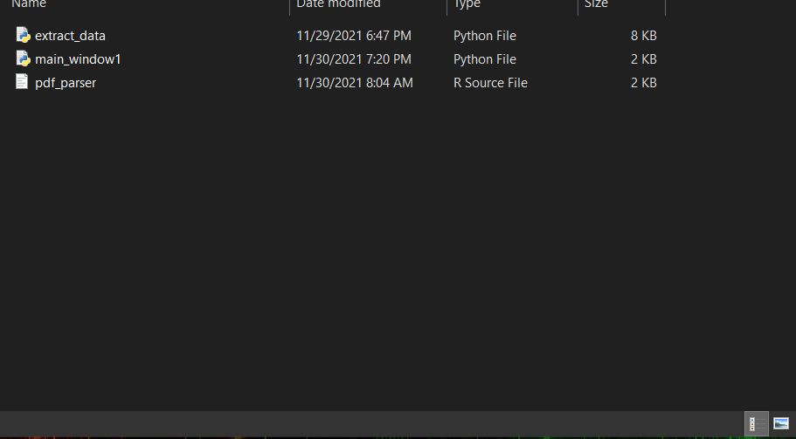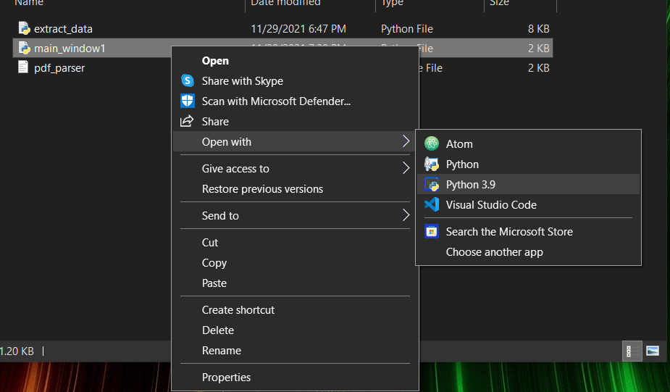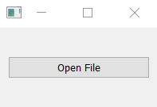

The second option is:

1. Open a terminal/command prompt
2. CD into the directory where “main_window.py” is located
3. Run the command “python3 main_window.py” or “python main_window.py”