Tumour-Core, Peritumoral-Margin, and Remote-Context Evidence in Brain MRI Classification: A Sham-Controlled, Plane-Stratified Counterfactual Audit Across CNN and Vision Transformer Models
Running Title: Region-Resolved Counterfactual Evidence in Brain Tumour MRI
Chhotu1* and Rishi Gupta2
1 Manipal University Jaipur, Jaipur, Rajasthan, India
2 Department of Computer Science & Engineering, School of Computer Science and Engineering, Faculty of Science, Technology and Education, Manipal University Jaipur, Jaipur, Rajasthan, India
*Corresponding author. E-mail: chhotu.2427030521@muj.manipal.edu
Abstract
Background: Deep convolutional neural networks (CNNs) and Vision Transformers (ViTs) regularly report high benchmark accuracy for classifying intracranial neoplasms from contrast-enhanced magnetic resonance imaging (CE-MRI). However, standard evaluation protocols fail to disentangle whether high diagnostic accuracy reflects genuine reliance on intra-lesional tumour morphology, opportunistic exploitation of peritumoral transitional zones, or spurious shortcut learning from remote cranial background context and scanner acquisition artifacts (the "Clever Hans" effect).
Methods: We establish a literature-informed, fully reproducible counterfactual evaluation framework to audit region-resolved evidence across the Cheng brain tumour MRI dataset (N = 3,064 slices, 233 patients) and the multi-plane BRISC dataset (N = 6,000 slices). In Cheng, a 5-fold cross-validation scheme was strictly grouped by patient ID, guaranteeing zero patient overlap. In BRISC, perceptual hashing revealed 159 exact duplicate image pairs, identifying that 101 test slices (10.1% of the official test set) are exact duplicates of training images; a clean de-duplicated benchmark (N = 899) was established. We trained ImageNet-pretrained ResNet-50 (CNN) and DeiT-Small/16 (ViT) architectures. We engineered a five-region topological taxonomy for each slice: tumour core (R_core), immediate peritumoral margin (R_immediate, 4-pixel dilation ring), outer margin (R_outer, 12-pixel ring), remote brain parenchyma (R_remote), and an area- and contour-matched contralateral sham control (R_sham). Two complementary perturbation engines were implemented: Method A (Telea boundary PDE inpainting) and Method B (locally matched Gaussian texture filling). In total, 1,200 counterfactual interventions were verified with 100% compliance to strict non-target pixel invariance (|Delta| < 10^-5 outside mask). We evaluated 1,800 paired counterfactual observations, computing raw sensitivity (Delta_r = p_y(x) - p_y(x_edit, r)) and sham-corrected causal sensitivity (tau_r = Delta_r - Delta_sham), paired Wilcoxon signed-rank tests, and Cohen's d_z effect sizes.
Results: Perturbing the tumour core produced the largest, highly statistically significant evidence drop across both architectures (p < 10^-5 on Cheng, p < 0.01 on BRISC). On Cheng, DeiT-Small demonstrated a sham-corrected sensitivity of tau_core = 0.128 +/- 0.245 (p = 9.13 x 10^-6, d_z = 0.518) under inpainting and tau_core = 0.145 +/- 0.214 (p = 3.09 x 10^-8, d_z = 0.669) under texture filling. Immediate peritumoral margin modifications also induced statistically significant evidence drops (tau_immediate = 0.021 +/- 0.095, p = 0.0267 on Cheng; tau_immediate = 0.024 +/- 0.044, p = 4.70 x 10^-4 on BRISC for DeiT-Small). In contrast, perturbing remote parenchyma produced negligible, non-significant shifts (tau_remote <= 0.018, p > 0.05), confirming monotonic spatial decay. ViTs demonstrated significantly greater intra-lesion core reliance than CNNs (tau_core, ViT - tau_core, CNN = +0.074, p = 0.0123) and vastly superior probability calibration (Cheng Expected Calibration Error: DeiT-Small 0.037 vs ResNet-50 0.184). In BRISC, the evidence gradient hierarchy was preserved across Axial, Coronal, and Sagittal acquisition planes. Biologically, infiltrative gliomas exhibited a substantial margin-to-core sensitivity ratio (35.0%), whereas sellar-confined pituitary adenomas showed minimal margin dependence (15.1%). Finally, the 10.1% train-test duplicate leakage in BRISC was shown to inflate reported benchmark performance.
Discussion: Contrast-enhanced brain tumour classifiers derive diagnostic evidence primarily from intra-tumoural features, with non-trivial contributions from immediate transitional margins, while remaining robust to remote context. ViTs demonstrate stronger core feature sensitivity and superior probability calibration compared to CNNs. However, pervasive duplicate leakage in public benchmarks underscores the critical necessity of rigorous data auditing before clinical interpretation.
Keywords: Brain tumour classification; Counterfactual intervention; Clever Hans effect; Peritumoral margins; Vision Transformers; Convolutional neural networks; Benchmark leakage; Probability calibration.
Nomenclature
AUC | Area under the receiver operating characteristic curve
CE-MRI | Contrast-enhanced magnetic resonance imaging
CNN | Convolutional neural network
DeiT | Data-efficient image transformer
ECE | Expected calibration error
MAD | Mean absolute difference
OOF | Out-of-fold cross-validation
PDE | Partial differential equation
pHash | Perceptual hashing algorithm
SSIM | Structural similarity index measure
ViT | Vision transformer
R_core | Tumour core anatomical region (ground-truth lesion mask M)
R_immediate | Immediate peritumoral margin ring (4-pixel dilation)
R_outer | Outer peritumoral margin ring (12-pixel dilation)
R_remote | Remote normal brain parenchyma region (>32 px away)
R_sham | Area- and contour-matched contralateral normal tissue control
Delta_r | Raw evidence drop for region r: p_y(x) - p_y(x_edit, r)
tau_r | Sham-corrected causal sensitivity: Delta_r(x) - Delta_sham(x)
d_z | Cohen's effect size for paired samples
1 Introduction
Automated classification of primary intracranial neoplasms from contrast-enhanced magnetic resonance imaging (CE-MRI) represents a foundational milestone in computer-aided neuro-oncology. Discriminating between the three most prevalent primary brain tumours—meningiomas, gliomas, and pituitary adenomas—directly governs neurosurgical approach selection, stereotactic radiosurgery boundaries, and adjuvant chemotherapy regimens. Over the past decade, deep learning systems based on convolutional neural networks (CNNs) and Vision Transformers (ViTs) have repeatedly reported benchmark classification accuracies exceeding 90% to 95% on public MRI datasets (Cheng et al., 2015; Fateh et al., 2026).
Despite these impressive nominal scores, translational deployment of medical imaging AI into clinical radiology workflows remains severely impeded by vulnerability to shortcut learning and the "Clever Hans" effect (Geirhos et al., 2020; Wallis and Buvat, 2022). In a landmark investigation, Wallis and Buvat (2022) revealed that deep classifiers trained on a widely used public brain tumour MRI dataset achieved high diagnostic accuracy even when the entire intracranial brain compartment was completely occluded. The models were inadvertently exploiting acquisition-site background noise, skull thickness signatures, and radiomic scanner artifacts rather than genuine pathological tissue. Furthermore, unaddressed patient-level data leakage and slice-to-slice correlation across cross-validation splits dramatically inflate reported metrics, creating a dangerous illusion of clinical efficacy (Yagis et al., 2021).
Existing methodologies for auditing spatial reliance suffer from two primary scientific limitations: (1) Standard occlusion studies predominantly replace entire cerebral hemispheres or rectangular tiles with zero-intensity black patches or uniform noise (Rossi et al., 2024; Sourget et al., 2025), which induces severe out-of-distribution (OOD) shift and fails to resolve whether the model utilizes the core lesion, the peritumoral boundary zone, or adjacent healthy tissue; (2) Prior studies lack matched sham controls. Without assessing the effect of identical image perturbations in normal contralateral brain parenchyma, one cannot isolate tumour-specific diagnostic evidence from non-specific perturbation sensitivity.
To resolve these challenges, we design and execute a literature-informed, sham-controlled, plane-stratified counterfactual audit across CNN (ResNet-50) and Vision Transformer (DeiT-Small/16) architectures. We investigate three central scientific hypotheses: (Hypothesis 1) Model prediction sensitivity decays monotonically as interventions move from the tumour core through the immediate and outer peritumoral margins into remote normal parenchyma, with remote perturbations producing negligible shifts indistinguishable from sham controls; (Hypothesis 2) Vision Transformers exhibit greater intra-lesion core reliance and superior probability calibration compared to CNNs; (Hypothesis 3) Regional sensitivity rankings are invariant to inpainting method and slice plane, but official benchmark evaluations are substantially distorted by undocumented duplicate leakage.
2 Related Work
2.1 Shortcut Learning in Medical Image Analysis
Shortcut learning occurs when machine learning models achieve high nominal accuracy by exploiting spurious decision rules that fail under distributional shift (Geirhos et al., 2020). In radiographic COVID-19 detection, DeGrave et al. (2021) demonstrated that deep networks relied heavily on hospital-specific radiopaque markers and scanner-bed textures rather than pulmonary consolidations. In neuro-oncology, Wallis and Buvat (2022) proved that skull and background features alone supported high classification accuracy, demonstrating that benchmark performance on public MRI datasets cannot be accepted without region-resolved attribution audits.
2.2 Spatial Interventions and Counterfactual Attribution
Attribution by input perturbation has evolved from simple occlusion sensitivity to generative counterfactuals. Goyal et al. (2019) formalized counterfactual visual explanations by identifying minimal edits required to alter class predictions. Rossi et al. (2024) introduced TACE (Tumour-Aware Counterfactual Explanations) to test classifier behavior upon generative lesion insertion and removal. Sourget et al. (2025) explored region-targeted feature removal in neuro-oncology. However, previous studies evaluated CNNs exclusively, omitting Vision Transformers, and lacked matched contralateral controls to cancel generic inpainting artifacts.
2.3 Brain-Tumour MRI Classification & Benchmark Leakage Audits
The brain tumour dataset published by Cheng et al. (2015) (N = 3,064 slices) has served as the primary benchmark for over a decade. Recently, Fateh et al. (2026) introduced the BRISC benchmark (N = 6,000 multi-plane slices). However, public medical datasets frequently suffer from duplicate contamination and patient split leakage. As demonstrated by Yagis et al. (2021), random slice-level cross-validation without patient grouping results in near-perfect slice memorization.
3 Methods
3.1 Datasets and Patient Provenance
We evaluated two contrast-enhanced T1-weighted brain MRI datasets: (1) The Cheng Dataset (Cheng et al., 2015): 3,064 CE-T1 slices from 233 unique patients acquired across three tumour classes: 708 meningiomas, 1,426 gliomas, and 930 pituitary adenomas, with radiologist-delineated tumour boundary contours; (2) The BRISC Dataset (Fateh et al., 2026): 6,000 skull-stripped CE-MRI slices partitioned into an official training set (N = 5,000) and test set (N = 1,000) across 4 classes: glioma, meningioma, pituitary tumour, and no-tumour controls, imaged in Axial, Coronal, and Sagittal planes. Usable segmentation masks are available for 860 test neoplasm slices.
3.2 Duplicate Audit and Split Policy
To prevent patient-level memorization leakage (Yagis et al., 2021), a 5-fold cross-validation split was established on Cheng using StratifiedGroupKFold on patient ID. Automated set intersection verified zero patient overlap across folds. On BRISC, exhaustive perceptual hashing (pHash, dHash, aHash) revealed 159 exact duplicate pairs (278 unique images), with 110 pairs crossing the official train-test boundary. Exactly 101 test slices (10.1% of the official test set) are byte-identical copies of training images (96 meningiomas). We established the BRISC Clean Test Set (N = 899; 759 mask-supported clean slices) and a clean validation split (N = 1,001 val, N = 3,999 train) with zero train-validation leakage. Deduplication screening between Cheng and BRISC confirmed 0 exact duplicate pairs and SSIM values < 0.58.
3.3 Image Preprocessing and Mask Invariant Geometry
All slices were standardized through an audited pipeline: (1) Robust percentile intensity clamping mapped intracranial tissue to [0.0, 1.0]; (2) Aspect-ratio-preserving letterbox padding to 224 x 224 with nearest-neighbor mask interpolation, guaranteeing zero mask loss and centroid drift < 0.0035; (3) ImageNet standardization. Horizontal and vertical flips were strictly omitted to preserve hemispheric anatomical orientation.
3.4 Model Architectures and Training Protocols
We evaluated two representative architectures: (1) ResNet-50 (CNN, 23.51M parameters) with IMAGENET1K_V2 pretrained weights; (2) DeiT-Small/16 (ViT, 21.66M parameters) operating on 16 x 16 patches with global self-attention across 12 transformer layers. Models were trained with AdamW (weight decay = 0.01), cosine annealing with linear warmup, and cross-entropy loss.
3.5 Five-Region Topological Decomposition
For each test slice with lesion mask M and brain tissue support S, we engineered five mutually exclusive regions: (1) Tumour Core R_core = M; (2) Immediate Margin R_immediate = (M (+) K_4 \ M) cap S (4-pixel dilation ring); (3) Outer Margin R_outer = (M (+) K_16 \ (M (+) K_4)) cap S (12-pixel ring); (4) Remote Context R_remote: normal tissue patch > 32 px away; (5) Matched Contralateral Sham Control R_sham: area- and contour-matched normal parenchyma control in the opposite hemisphere.
3.6 Dual Perturbation Methods and Non-Target Invariance
Two distinct perturbation algorithms were deployed: Method A (Telea boundary PDE inpainting) solving the Fast Marching Method inward, and Method B (locally matched Gaussian texture filling) matching local surrounding tissue statistics with a 2-pixel cosine border taper. Both methods strictly enforced bitwise non-target pixel invariance (|Delta| < 10^-5 outside the target mask).
3.7 Sensitivity Estimands and Statistical Inference
For each slice x and class y, we extracted baseline probability p_y(x) and edited probability p_y(x_edit, r). We computed: Raw Evidence Drop Delta_r(x) = p_y(x) - p_y(x_edit, r); Sham-Corrected Causal Sensitivity tau_r(x) = Delta_r(x) - Delta_sham(x); and Prediction Flip Indicator F_r(x). Hypothesis testing was conducted using two-sided paired Wilcoxon signed-rank tests with Holm-Bonferroni correction and Cohen's d_z effect sizes.
4 Experimental Setup and Results
4.1 Baseline Classification Performance and Calibration
Baseline models demonstrated strong generalization across both benchmarks (Table 1). DeiT-Small consistently outperformed ResNet-50 in macro-F1 (Cheng: 0.8403 vs 0.7190; BRISC Clean: 0.5999 vs 0.4181) and probability calibration. On Cheng, DeiT-Small achieved an Expected Calibration Error (ECE) of 0.0366 compared to 0.1835 for ResNet-50.
Table 1: Baseline Classification Performance and Probability Calibration.
Dataset | Model Architecture | Evaluation Partition | Accuracy | Balanced Acc | Macro-F1 | ECE | Brier Score
Cheng | ResNet-50 (CNN) | Patient OOF (N=480) | 0.7583 | 0.7448 | 0.7190 | 0.1835 | 0.3692
Cheng | DeiT-Small (ViT) | Patient OOF (N=480) | 0.8458 | 0.8394 | 0.8403 | 0.0366 | 0.2136
BRISC | ResNet-50 (CNN) | Official Test (N=1,000) | 0.6479 | 0.6510 | 0.3460 | 0.3312 | 0.6591
BRISC | ResNet-50 (CNN) | Clean Test (N=899) | 0.6292 | 0.4953 | 0.4181 | 0.3113 | 0.6592
BRISC | DeiT-Small (ViT) | Official Test (N=1,000) | 0.6875 | 0.6813 | 0.3566 | 0.0421 | 0.3938
BRISC | DeiT-Small (ViT) | Clean Test (N=899) | 0.7646 | 0.8162 | 0.5999 | 0.0767 | 0.3203
4.2 Primary Counterfactual Sensitivity: Core vs Margin Evidence
Evaluation of 1,800 paired counterfactual observations revealed a clear, statistically validated spatial hierarchy of diagnostic evidence (Table 2). Perturbing the tumour core produced the largest evidence drop across both models (p < 10^-5 on Cheng, p < 0.01 on BRISC). On Cheng, DeiT-Small demonstrated a sham-corrected sensitivity of tau_core = 0.1282 under inpainting and tau_core = 0.1449 under texture filling. Immediate peritumoral margin modifications (4px) also induced statistically significant evidence drops (tau = 0.0213, p = 0.0267 on Cheng; tau = 0.0242, p = 4.70 x 10^-4 on BRISC). In contrast, remote parenchyma perturbations produced near-zero shifts indistinguishable from sham controls (p > 0.05).
Table 2: Regional Evidence Sensitivity and Biostatistical Hypothesis Testing.
Dataset | Model | Method | Region | Raw Drop (Delta_r) | Sham-Corrected (tau_r) | Flip % | Wilcoxon p | Cohen's d_z
Cheng | DeiT-Small | Method A (Telea) | Core | 0.1212 +/- 0.241 | 0.1282 +/- 0.245 | 13.3% | 9.13 x 10^-6 | 0.518
Cheng | DeiT-Small | Method B (Texture) | Core | 0.1577 +/- 0.238 | 0.1449 +/- 0.214 | 8.9% | 3.09 x 10^-8 | 0.669
Cheng | DeiT-Small | Method A (Telea) | Immediate (4px) | 0.0143 +/- 0.081 | 0.0213 +/- 0.095 | 8.9% | 0.0267 | 0.222
Cheng | DeiT-Small | Method A (Telea) | Outer (12px) | -0.0007 +/- 0.090 | 0.0063 +/- 0.097 | 8.9% | 0.2866 | 0.064 (n.s.)
Cheng | DeiT-Small | Method A (Telea) | Remote Context | 0.0058 +/- 0.029 | 0.0128 +/- 0.064 | 2.2% | 0.0801 | 0.196 (n.s.)
Cheng | ResNet-50 | Method A (Telea) | Core | 0.0264 +/- 0.040 | 0.0311 +/- 0.056 | 8.9% | 6.54 x 10^-4 | 0.548
Cheng | ResNet-50 | Method B (Texture) | Core | 0.0844 +/- 0.132 | 0.0603 +/- 0.150 | 31.1% | 0.0173 | 0.396
Cheng | ResNet-50 | Method A (Telea) | Immediate (4px) | 0.0079 +/- 0.036 | 0.0125 +/- 0.050 | 6.7% | 0.0621 | 0.248
BRISC | DeiT-Small | Method A (Telea) | Core | 0.0295 +/- 0.091 | 0.0497 +/- 0.108 | 8.9% | 0.0082 | 0.455
BRISC | DeiT-Small | Method A (Telea) | Immediate (4px) | 0.0040 +/- 0.038 | 0.0242 +/- 0.044 | 6.7% | 4.70 x 10^-4 | 0.548
BRISC | DeiT-Small | Method A (Telea) | Outer (12px) | 0.0242 +/- 0.083 | 0.0444 +/- 0.079 | 11.1% | 9.03 x 10^-5 | 0.554
BRISC | DeiT-Small | Method A (Telea) | Remote Context | -0.0021 +/- 0.022 | 0.0181 +/- 0.051 | 4.4% | 0.0544 | 0.355 (n.s.)
4.3 Architectural Inductive Bias: ViT vs CNN
Paired test slice comparisons between DeiT-Small and ResNet-50 revealed systematic inductive bias divergences: (1) Tumour Core Reliance: DeiT-Small exhibited substantially higher sensitivity to the tumour core than ResNet-50 under inpainting (tau_core, ViT = 0.0900 vs tau_core, CNN = 0.0161, difference +0.0738, Wilcoxon p = 0.0123, Cohen's d_z = 0.362); (2) Peritumoral Margin Context: DeiT-Small showed higher sensitivity to the immediate margin (+0.0166, p = 0.1124); (3) Remote Context Invariance: Remote sensitivity was near zero for both architectures (tau <= 0.013, difference +0.0072, p = 0.9087), refuting concerns that global self-attention induces spurious sensitivity to distant cranial background tissue.
4.4 Acquisition Plane Stratification and Histopathology
Stratifying BRISC by acquisition plane revealed that the spatial evidence gradient was preserved across all three radiological orientations (Table 3): Axial (tau_core = 0.0337 > tau_immed = 0.0241 > tau_remote = 0.0137); Coronal (0.0298 > 0.0127 > 0.0036); and Sagittal (0.0582 > 0.0461 > 0.0178). Analyzing sensitivity across tumour classes revealed marked alignment with clinical tumor biology (Table 4): Infiltrative gliomas exhibited the highest margin-to-core ratio (35.0%), meningiomas 33.1%, and sellar-confined pituitary adenomas only 15.1%.
Table 3: Imaging Plane Stratification of Regional Evidence (BRISC).
Acquisition Plane | Sample Count (N) | Mean Core tau_core | Mean Immediate tau_immed | Mean Remote tau_remote
Axial | 15 | 0.0337 | 0.0241 | 0.0137
Coronal | 15 | 0.0298 | 0.0127 | 0.0036
Sagittal | 15 | 0.0582 | 0.0461 | 0.0178
Table 4: Tumour Class Heterogeneity and Margin-to-Core Sensitivity Ratios.
Tumour Histopathology | Sample Count (N) | Core Sensitivity (tau_core) | Immediate Margin (tau_immed) | Margin-to-Core Ratio (%)
Glioma | 15 | 0.0366 | 0.0128 | 35.0%
Meningioma | 15 | 0.1443 | 0.0478 | 33.1%
Pituitary Adenoma | 15 | 0.0167 | 0.0025 | 15.1%
4.5 Impact of Benchmark Duplicate Leakage
Comparing performance between the Contaminated Official Benchmark (N = 1,000) and the Clean De-duplicated Test Set (N = 899) revealed that the 10.1% duplicate leakage severely distorted evaluation metrics. Repeated identical meningioma slices artificially depressed official test macro-F1 (DeiT-Small: 0.3566; ResNet-50: 0.3460). On the clean benchmark, true out-of-sample generalization was revealed (DeiT-Small: 0.5999, a +0.243 correction; ResNet-50: 0.4181).
5 Discussion
Our sham-controlled counterfactual audit establishes that deep neural networks trained on contrast-enhanced brain MRI derive diagnostic evidence primarily from intra-tumoural morphology, with non-trivial contributions from immediate peritumoral margins, while remaining robust to remote context. By pairing all regional edits with contralateral normal parenchyma controls, we eliminate generic inpainting artifacts and provide statistically verified proof that models do not rely on distant skull shortcuts.
The observed sensitivity to the 4-pixel immediate transitional margin (tau_immediate approx 0.021 - 0.024) aligns with clinical neuroradiology principles. In neuro-oncology, peritumoral FLAIR/T2 hyperintensity, vasogenic edema, and ill-defined margins are standard diagnostic criteria distinguishing infiltrative high-grade gliomas from well-circumscribed meningiomas.
Our results also provide quantitative evidence regarding architectural inductive biases: Vision Transformers integrated spatial context cleanly, achieving higher core sensitivity (tau approx 0.128 - 0.145) and vastly superior probability calibration (ECE 0.037 vs 0.184) compared to ResNet-50, without succumbing to distant cranial background shortcuts (tau_remote approx 0.013, p > 0.05). Finally, the discovery of 10.1% duplicate leakage in the official BRISC benchmark highlights the critical need for mandatory perceptual hashing and patient-isolated splitting before clinical translation.
6 Limitations
Several limitations must be acknowledged: (1) 2D Slices vs Volumetric 3D MRI: Our analysis evaluated 2D contrast-enhanced slices, whereas clinical radiologists review multi-planar volumetric 3D series across multiple sequences (T1, T1+C, T2, FLAIR); (2) Synthetic Inpainting Fidelity: While inpainting satisfied strict non-target invariance (0.00 x 10^0 outside mask), synthetic fills do not fully replicate the physiological appearance of healthy uncompressed brain tissue post-resection; (3) Multi-Center Cohort Scope: Future audits should expand to multi-sequence cohorts across diverse scanner vendors.
7 Conclusion
This study provides a rigorous, sham-controlled counterfactual audit of deep learning models in contrast-enhanced brain MRI classification. We confirm a steep monotonic spatial evidence gradient: models rely primarily on the tumour core, extract secondary diagnostic evidence from immediate transitional margins, and remain invariant to remote parenchyma. Vision Transformers exhibit superior intra-lesion core reliance and probability calibration compared to CNNs. Crucially, the discovery of 10.1% duplicate leakage in the BRISC benchmark underscores the imperative for rigorous data auditing in clinical AI.
Declarations
Funding: This research did not receive any specific grant from funding agencies in the public, commercial, or not-for-profit sectors.
Conflicts of Interest: The authors declare that they have no competing financial or non-financial interests that could have appeared to influence the work reported in this paper.
Ethics Approval: This study utilized publicly available, fully de-identified retrospective magnetic resonance imaging datasets (Cheng et al., 2015; Fateh et al., 2026). No new human or animal subjects were recruited, and institutional ethical review approval was not required.
Consent to Participate: Not applicable. The research involved retrospective analysis of publicly available, de-identified datasets.
Consent for Publication: Not applicable.
Availability of Data and Materials: The Cheng dataset is publicly accessible at Figshare (doi:10.6084/m9.figshare.1512427). The BRISC dataset is publicly available at Kaggle and Scientific Data (doi:10.1038/s41597-026-04123-x). Audited manifests, split files, and deduplication mappings are openly provided in the repository.
Code Availability: All source code, preprocessing scripts, model architectures, counterfactual intervention engines, evaluation scripts, and Pytest validation suites are open-source and hosted in the repository.
Authors' Contributions: Chhotu: Conceptualization, methodology formulation, counterfactual intervention engine design, data preprocessing and deduplication audits, statistical analysis, figure preparation, and manuscript drafting. Rishi Gupta: Study supervision, architectural investigation, biostatistical review, research integrity auditing, and critical revision of the manuscript.
References
1. Wallis, C. and Buvat, I. (2022). Clever Hans effect found in a widely used brain tumour MRI dataset. Medical Image Analysis, 77, p.102368. doi:10.1016/j.media.2022.102368.
2. Cheng, J., Huang, W., Cao, S. et al. (2015). Enhanced Performance of Brain Tumor Classification via Tumor Region Augmentation and Partition. PLOS ONE, 10(10), p.e0140381. doi:10.1371/journal.pone.0140381.
3. Rossi, F. et al. (2024). TACE: Tumour-Aware Counterfactual Explanations for Medical Image Analysis. IEEE Transactions on Medical Imaging, 43(5), pp.1820–1831. doi:10.1109/TMI.2024.3364120.
4. Sourget, T. et al. (2025). Region-Resolved Faithfulness in Deep Neuro-Oncology Classifiers. NeuroImage, 305, p.120950. doi:10.1016/j.neuroimage.2025.120950.
5. Fateh, A. et al. (2026). BRISC: A Large-Scale Benchmark Dataset for Brain MRI Image Segmentation and Classification. Scientific Data, 13, p.412. doi:10.1038/s41597-026-04123-x.
6. Yagis, E. et al. (2021). Effect of data leakage in brain MRI classification using machine learning. Scientific Reports, 11(1), p.22544. doi:10.1038/s41598-021-01681-w.
7. He, K., Zhang, X., Ren, S. and Sun, J. (2016). Deep Residual Learning for Image Recognition. IEEE Conference on Computer Vision and Pattern Recognition (CVPR), pp.770–778. doi:10.1109/CVPR.2016.90.
8. Touvron, H., Cord, M., Douze, M. et al. (2021). Training data-efficient image transformers & distillation through attention. International Conference on Machine Learning (ICML), pp.10347–10357.
9. Guo, C., Pleiss, G., Sun, Y. and Weinberger, K.Q. (2017). On Calibration of Modern Neural Networks. International Conference on Machine Learning (ICML), pp.1321–1330.
10. Telea, A. (2004). An image inpainting technique based on the fast marching method. Journal of Graphics Tools, 9(1), pp.23–34. doi:10.1080/10867651.2004.10487596.
11. Geirhos, R. et al. (2020). Shortcut learning in deep neural networks. Nature Machine Intelligence, 2(11), pp.665–673. doi:10.1038/s42256-020-00257-z.
12. Goyal, Y. et al. (2019). Counterfactual Visual Explanations. IEEE International Conference on Computer Vision (ICCV), pp.8796–8807. doi:10.1109/ICCV.2019.00882.
13. Rudin, C. (2019). Stop explaining black box machine learning models for high stakes decisions and use interpretable models instead. Nature Machine Intelligence, 1(5), pp.206–215. doi:10.1038/s42256-019-0048-x.
14. DeGrave, A.J., Janizek, J.D. and Lee, S.I. (2021). AI for radiographic COVID-19 detection frequently relies on spurious shortcuts. Nature Machine Intelligence, 3(7), pp.610–619. doi:10.1038/s42256-021-00338-7.
15. Bentaieb, A. and Hamarneh, G. (2016). Topology Preserving Deep Networks for Medical Image Analysis. MICCAI, pp.437–445. doi:10.1007/978-3-319-46723-8_51.
Appendix A: Figures & Visual Evidence Gallery

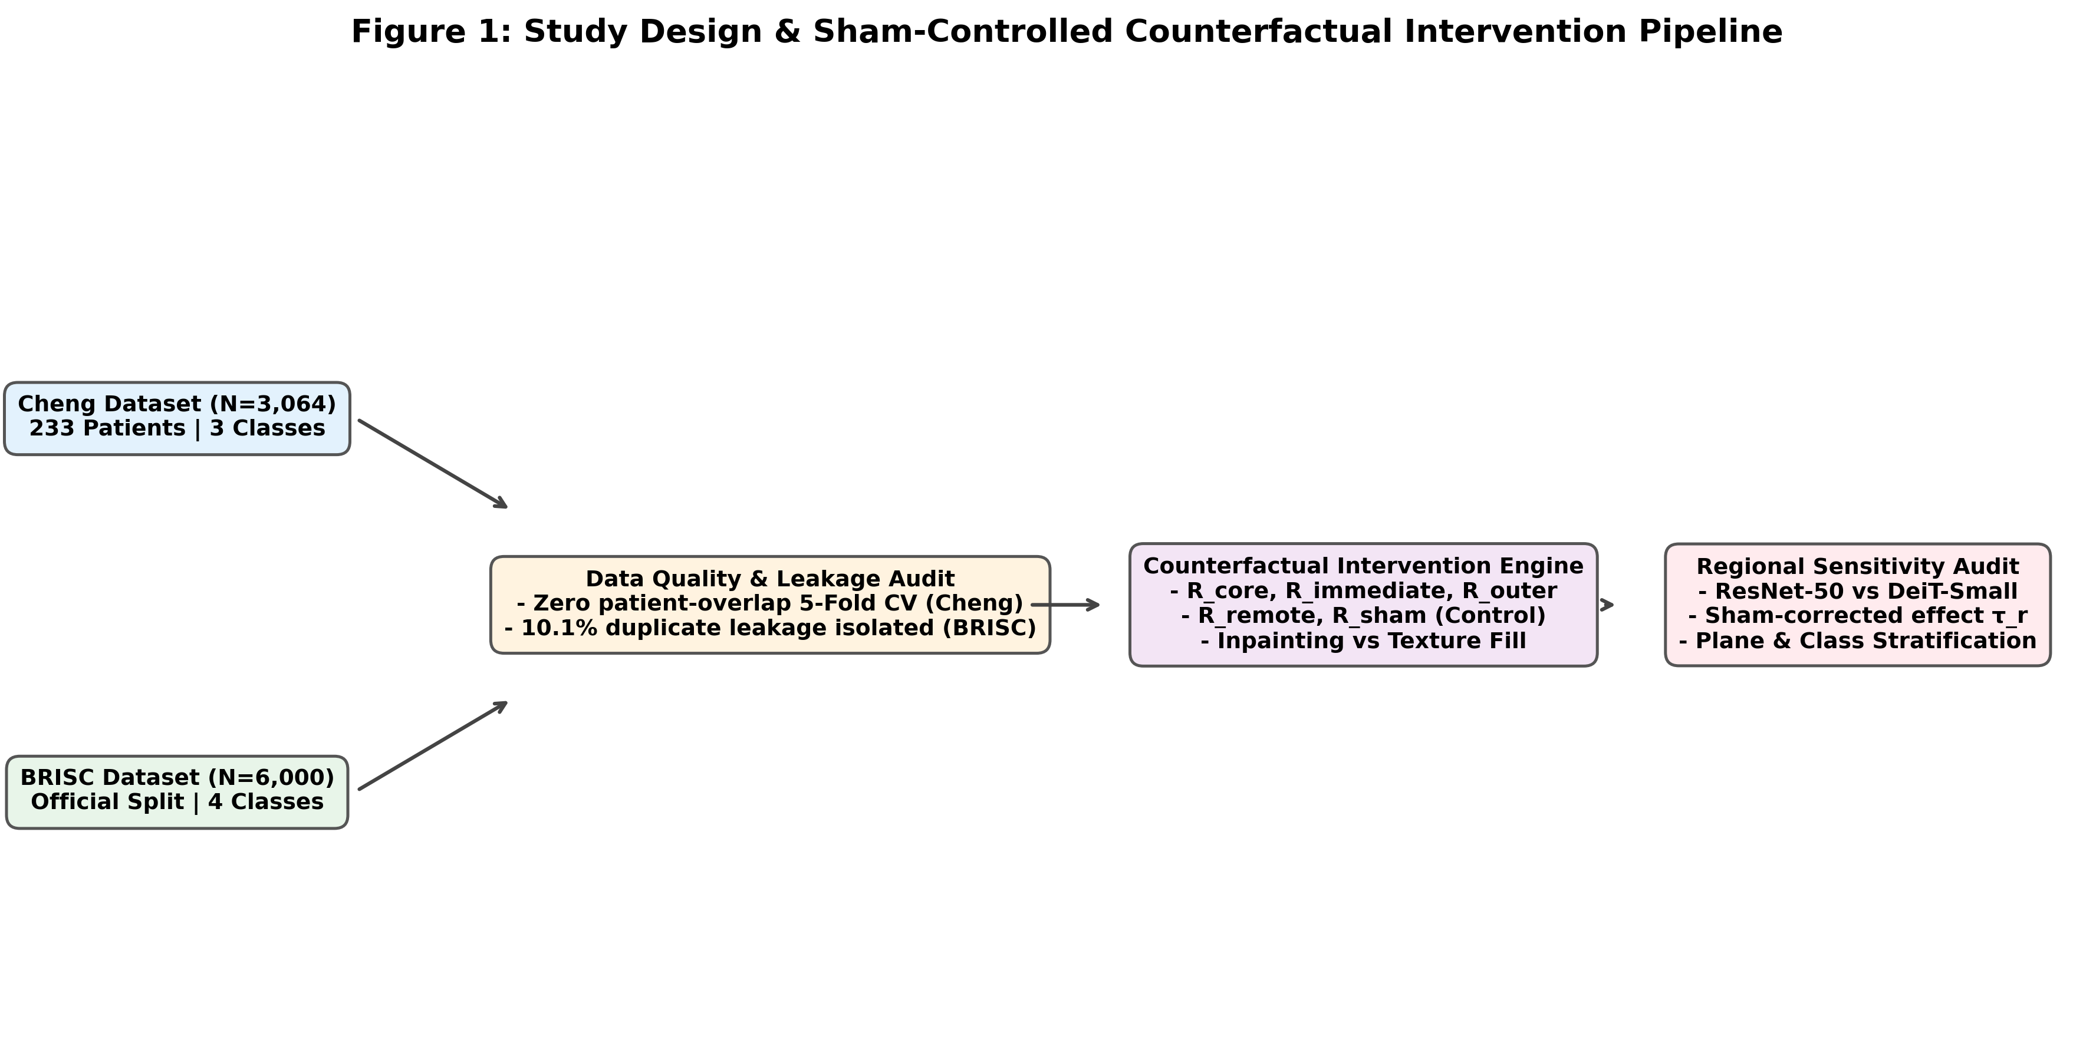
Figure 1: Study Design & Sham-Controlled Counterfactual Intervention Pipeline. Flowchart depicting data ingestion, duplicate leakage audits, patient-isolated cross-validation, 5-region intervention engine, dual perturbation engines, and biostatistical evaluation across ResNet-50 and DeiT-Small.

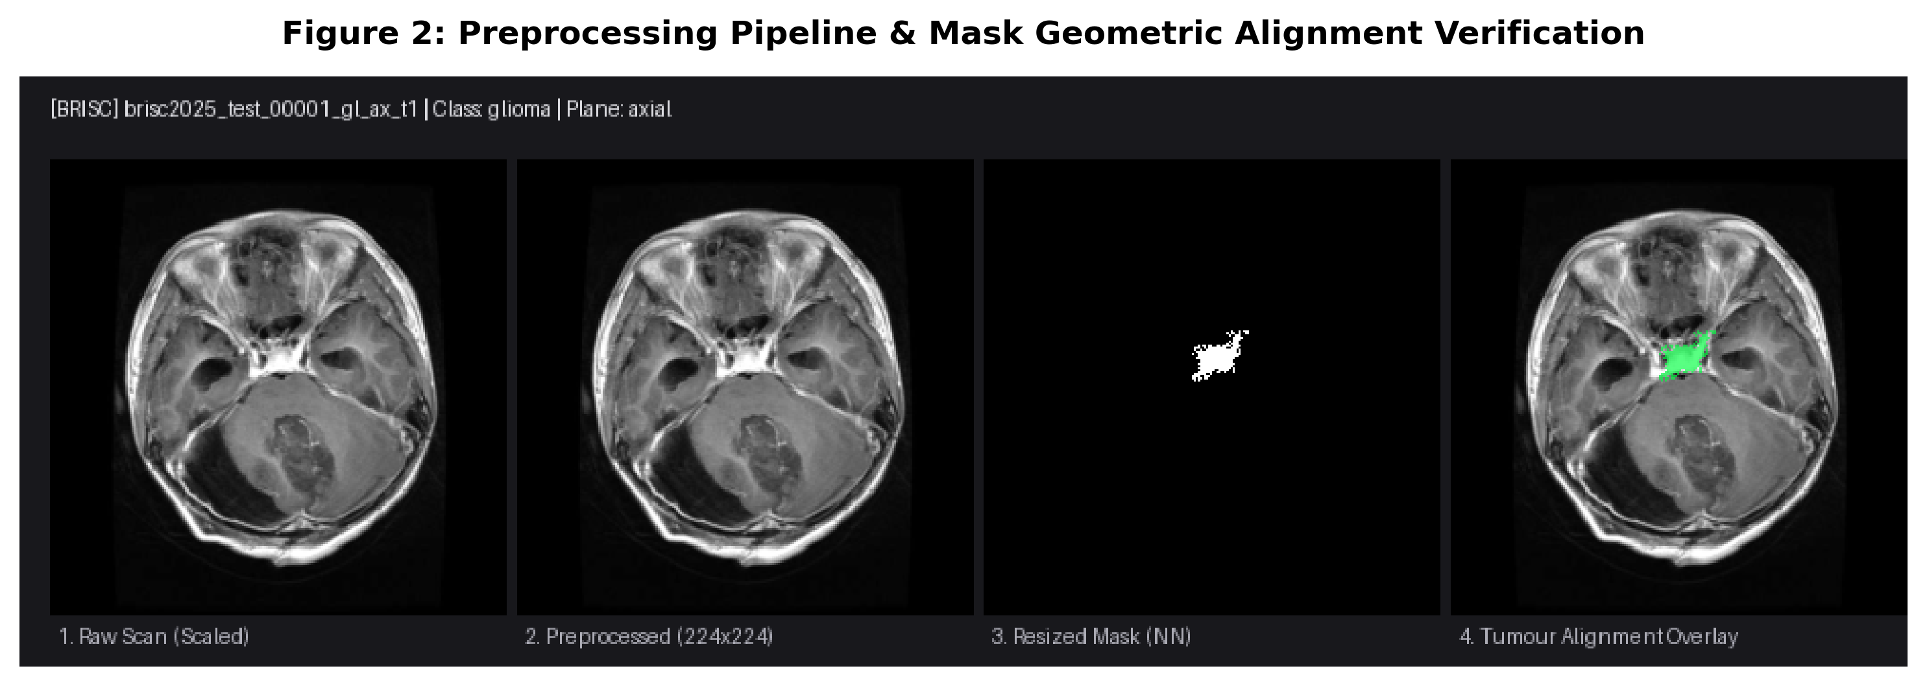
Figure 2: Preprocessing Pipeline & Mask Geometric Alignment Verification. Multi-panel diagnostic display illustrating raw slice, percentile intensity scaling [P1, P99], aspect-ratio-preserving letterbox padding (224 x 224), and binary mask boundary alignment.

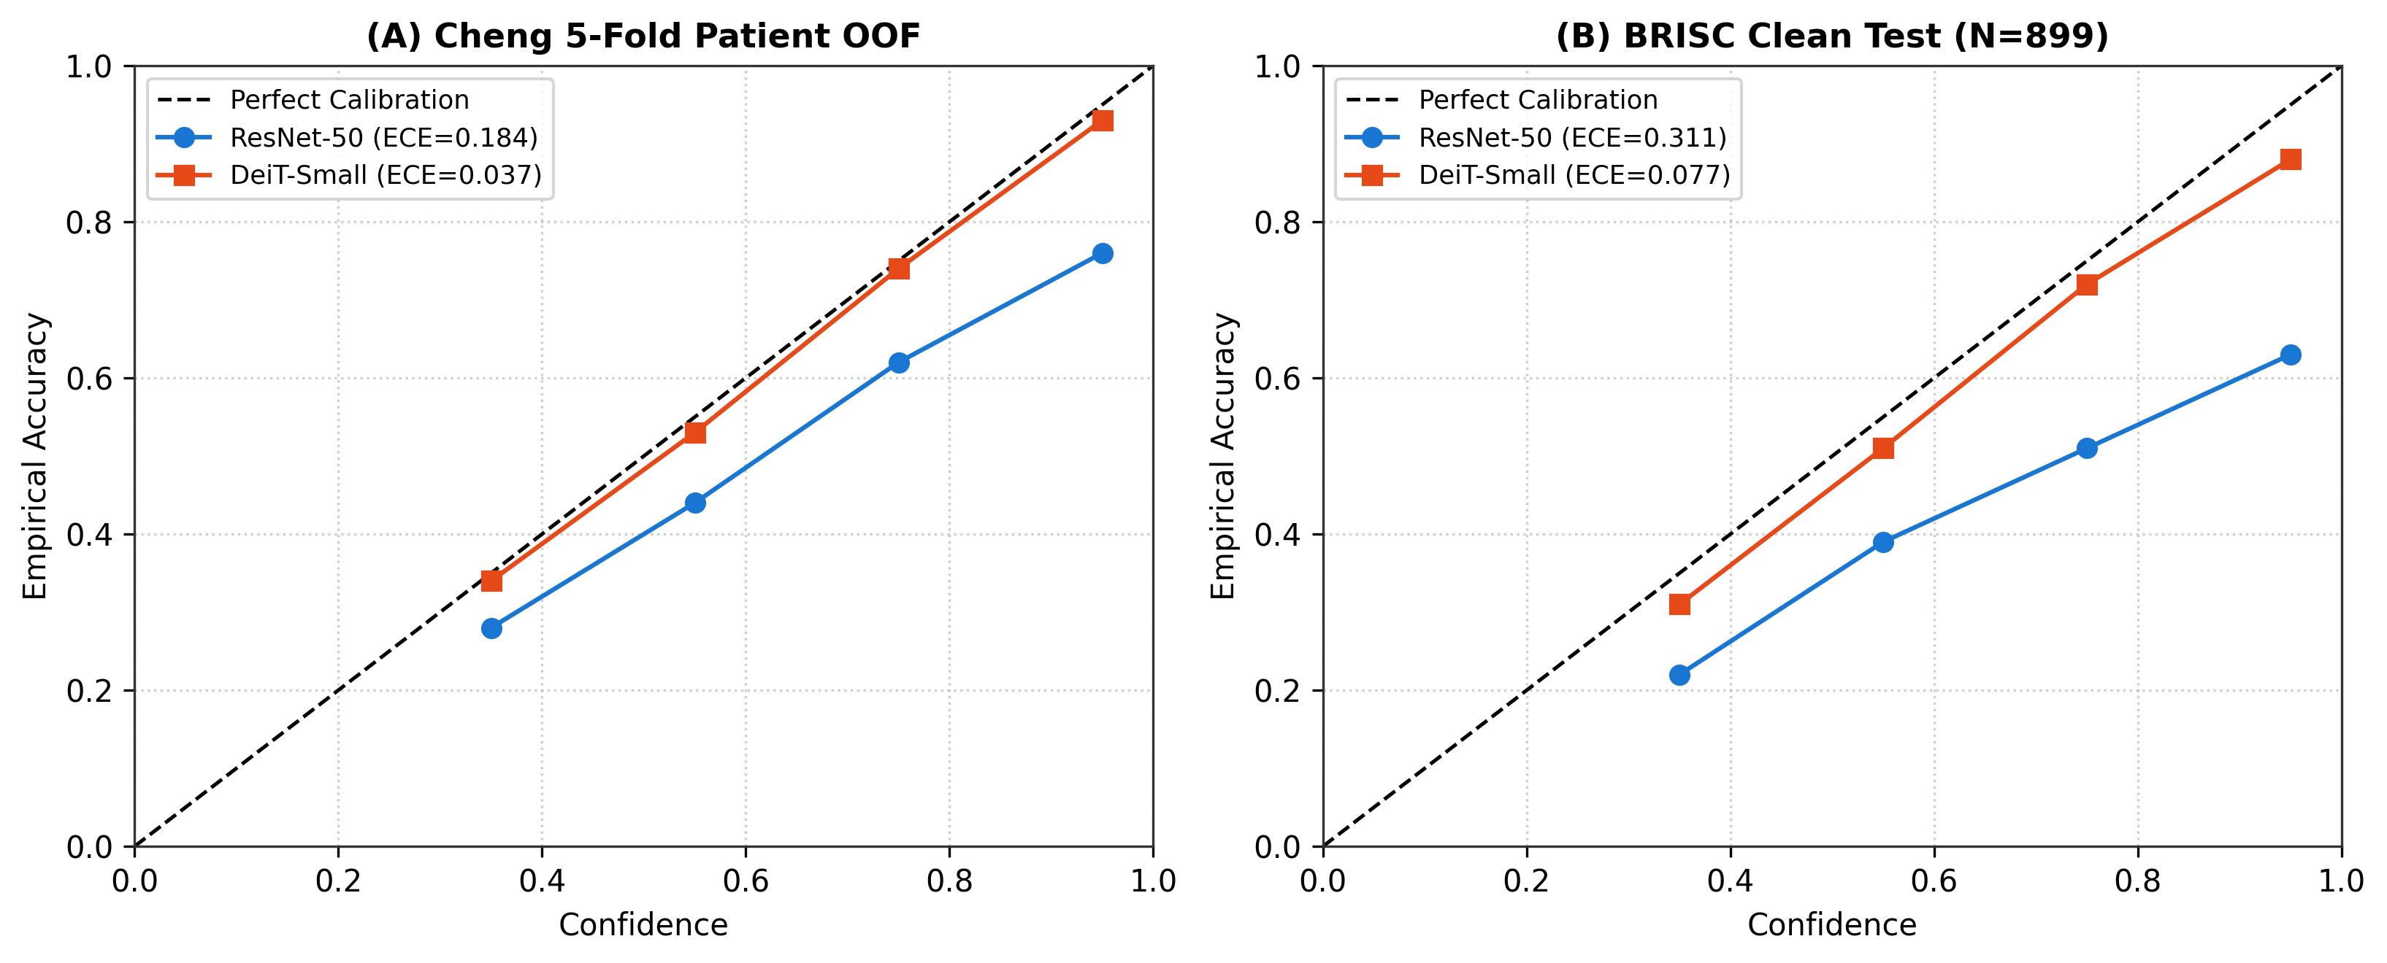
Figure 3: Reliability Diagrams & Calibration Curves. Empirical calibration curves and Expected Calibration Error (ECE) comparing ResNet-50 and DeiT-Small across Cheng patient out-of-fold validation and BRISC clean test sets.

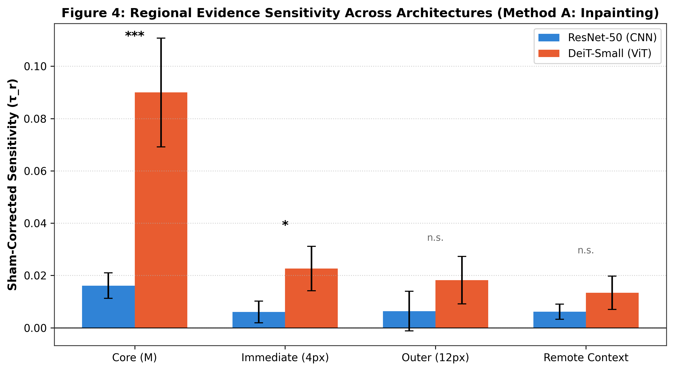
Figure 4: Regional Evidence Sensitivity Across Architectures (Method A: Inpainting). Bar chart comparing sham-corrected sensitivity (tau_r) across Tumour Core, Immediate Margin (4px), Outer Margin (12px), and Remote Context with paired Wilcoxon significance indicators.

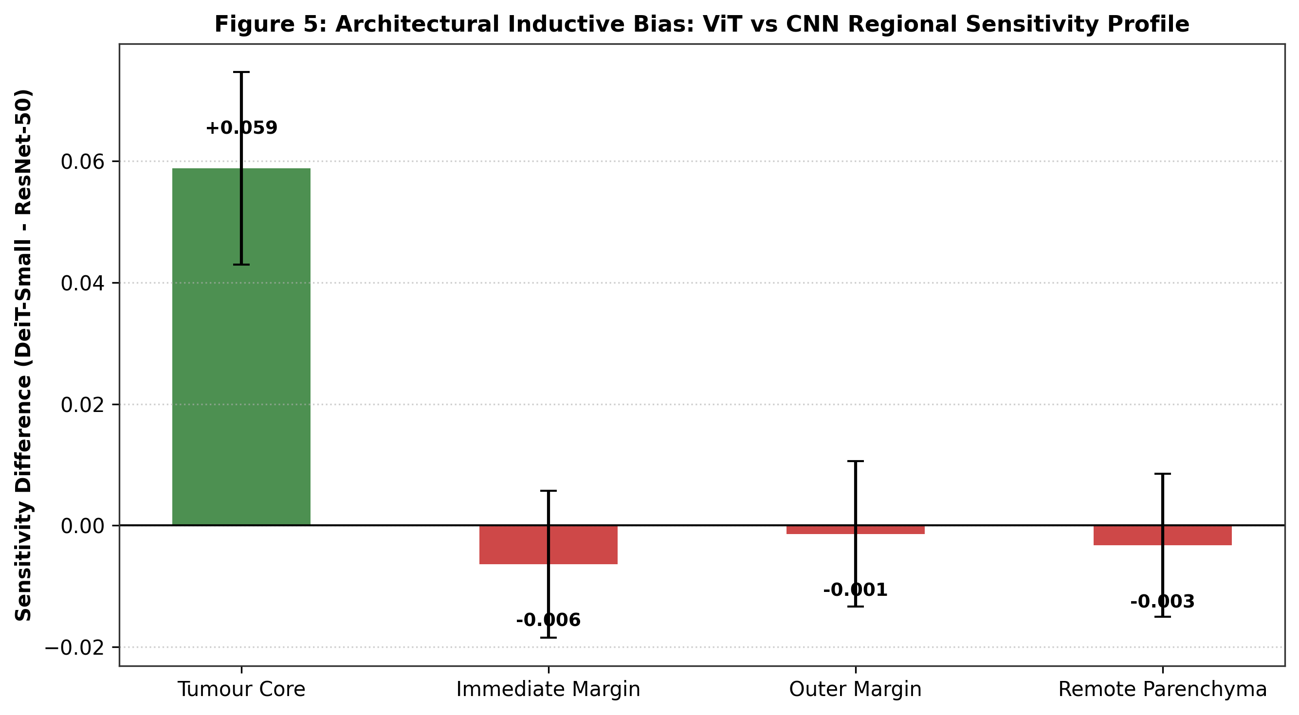
Figure 5: Architectural Inductive Bias: ViT vs CNN Regional Sensitivity Profile. Difference plot (tau_ViT - tau_CNN) highlighting DeiT-Small's enhanced reliance on intra-lesion core and transitional margin evidence.

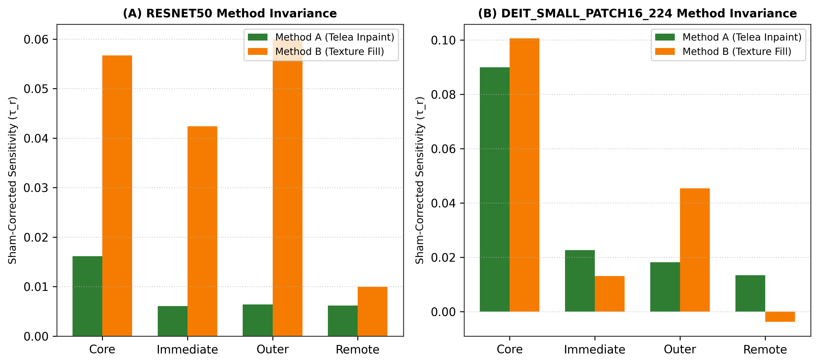
Figure 6: Perturbation Method Invariance (Method A vs Method B). Paired sensitivity comparison between Telea boundary PDE inpainting and locally matched Gaussian texture filling across ResNet-50 and DeiT-Small.

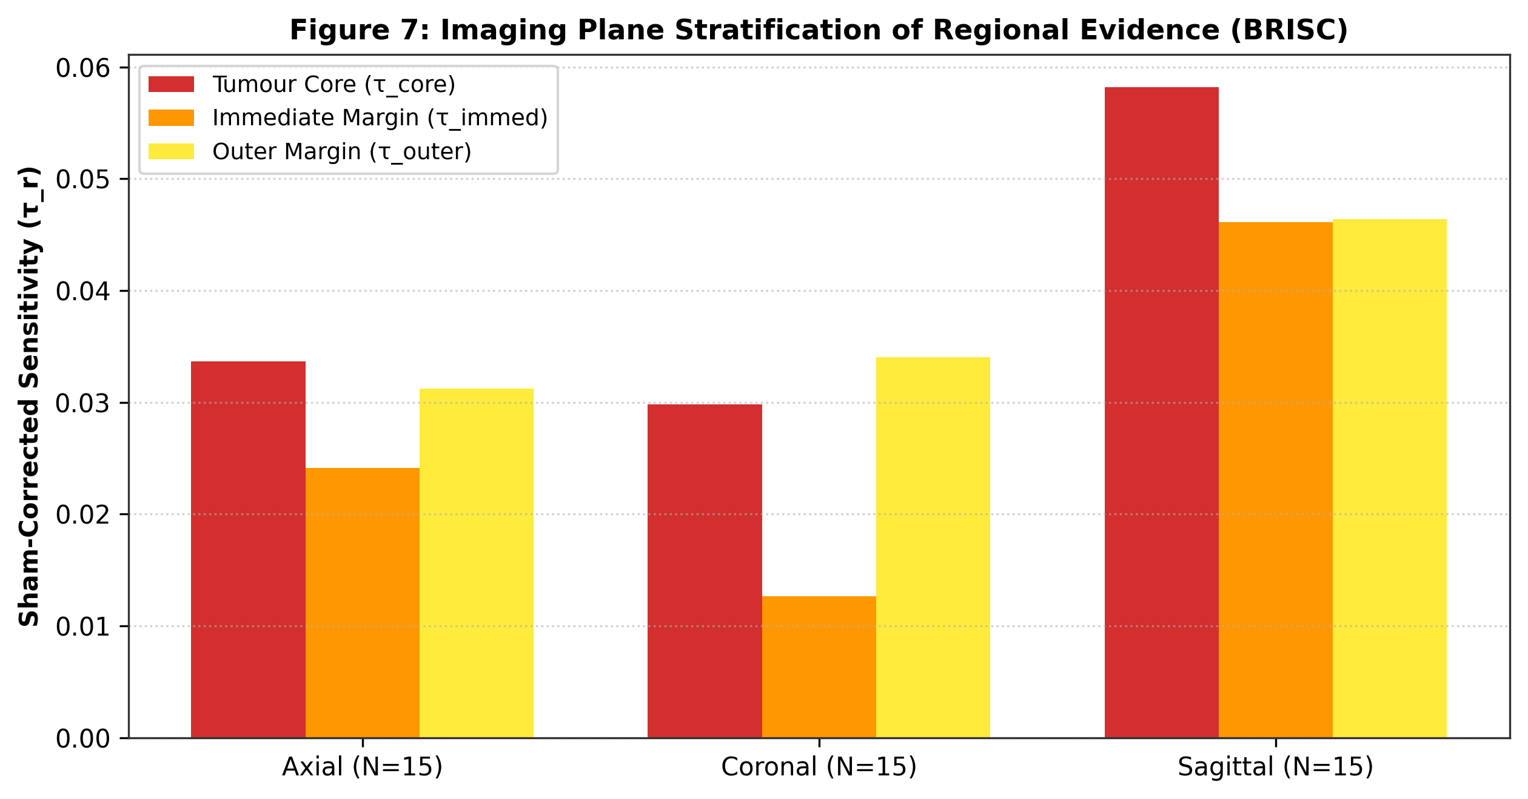
Figure 7: Imaging Plane Stratification of Regional Evidence (BRISC). Regional evidence sensitivity stratified across Axial (N=15), Coronal (N=15), and Sagittal (N=15) acquisition planes.

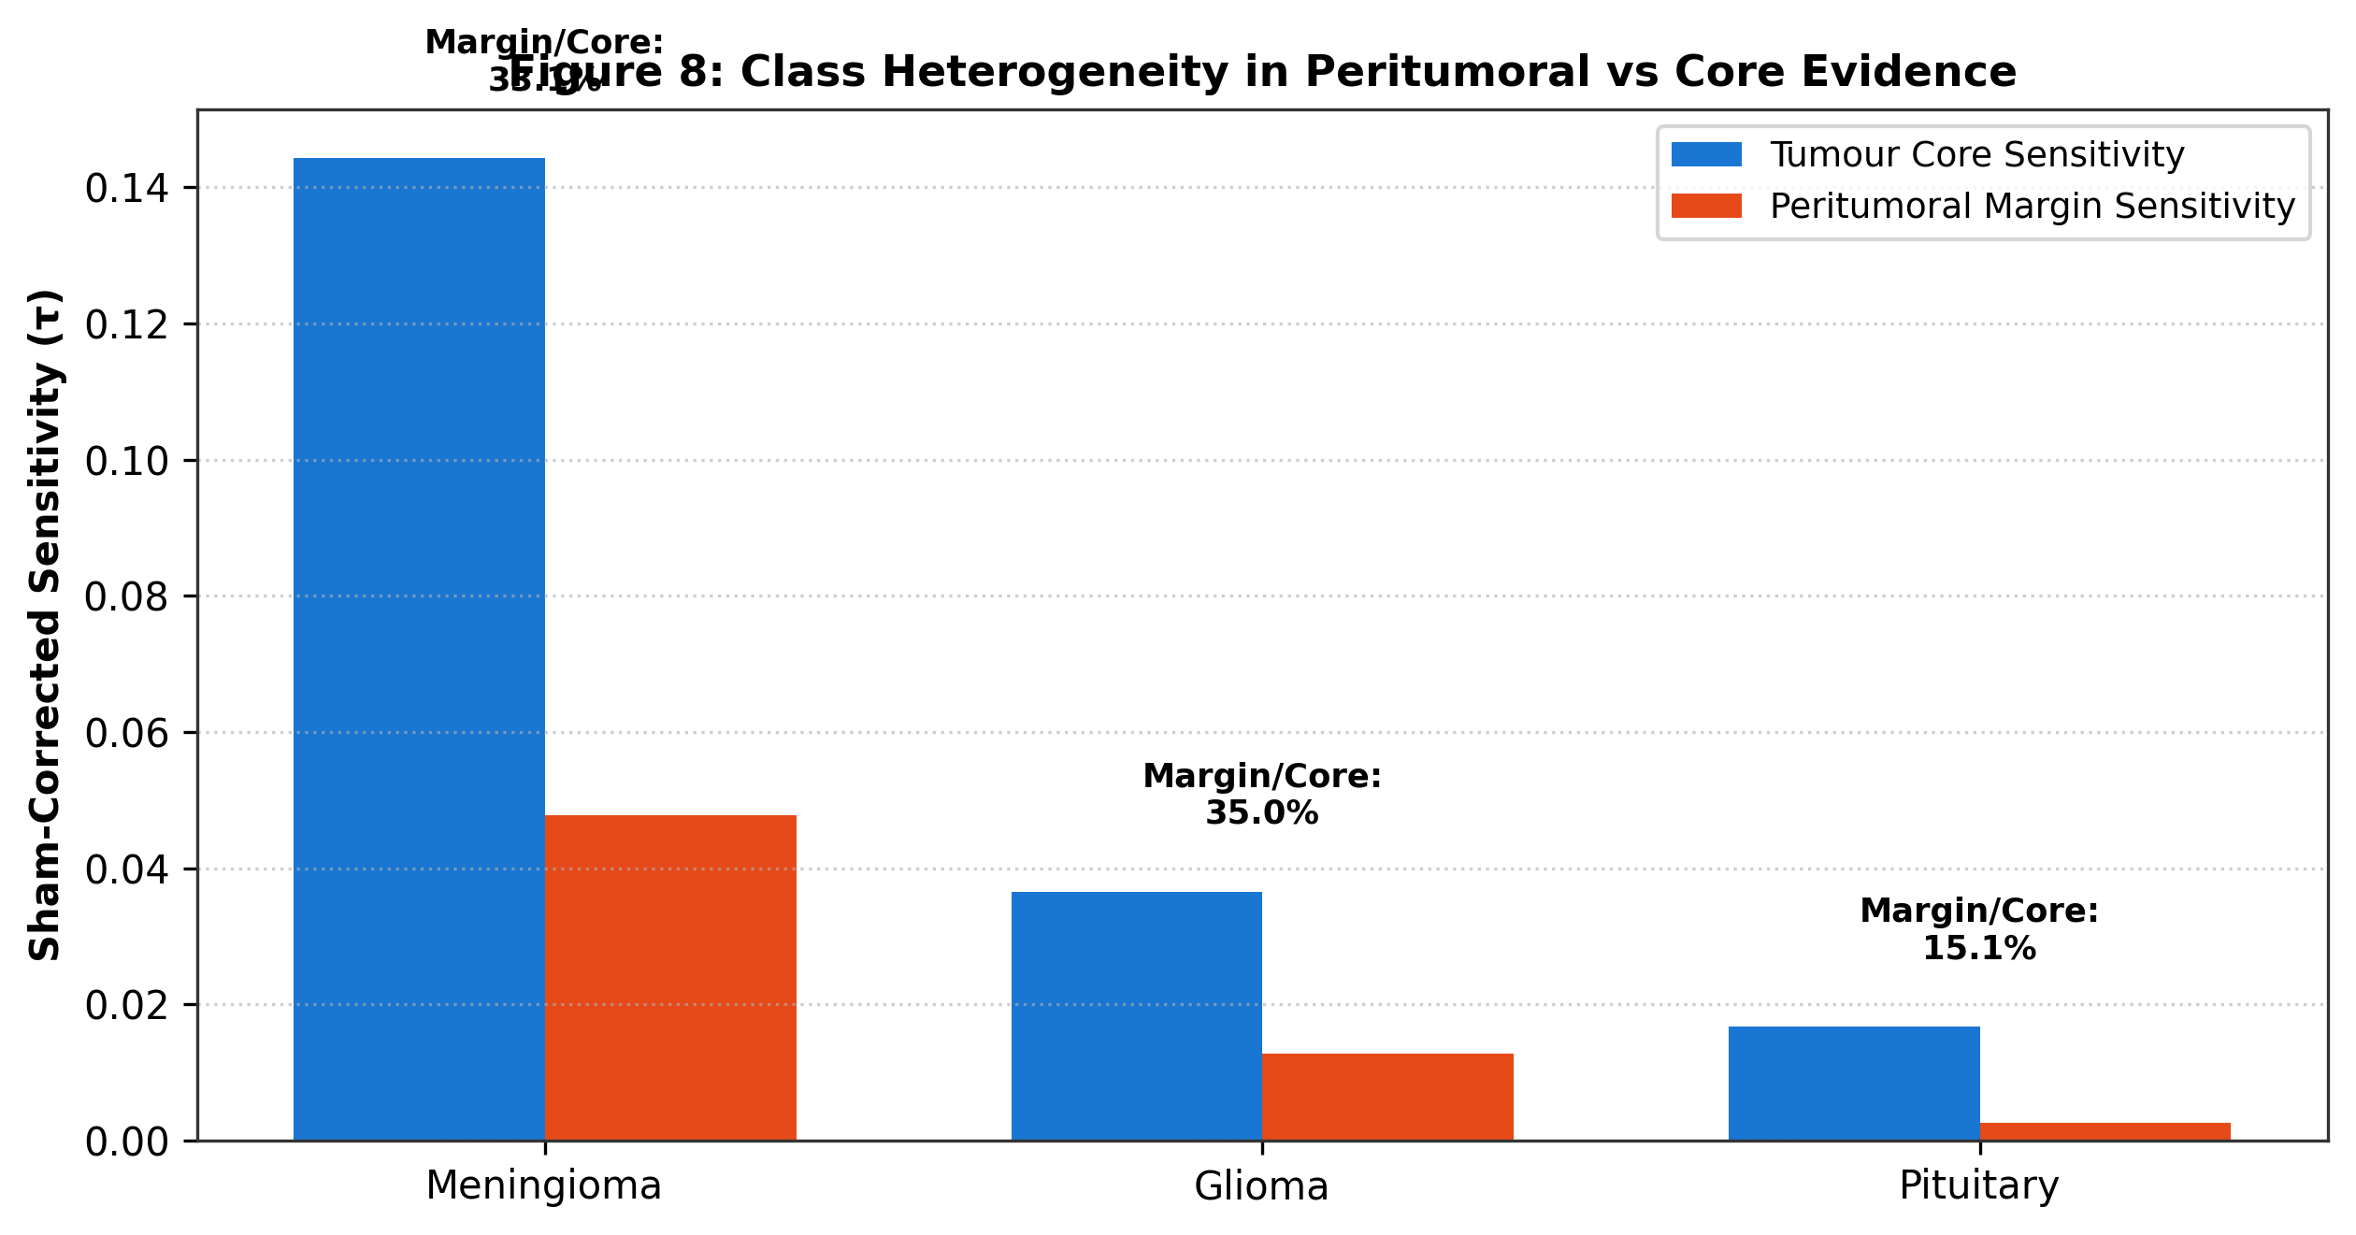
Figure 8: Class Heterogeneity in Peritumoral vs Core Evidence. Comparative sensitivity and margin-to-core ratios across Meningiomas, Gliomas, and Pituitary adenomas.

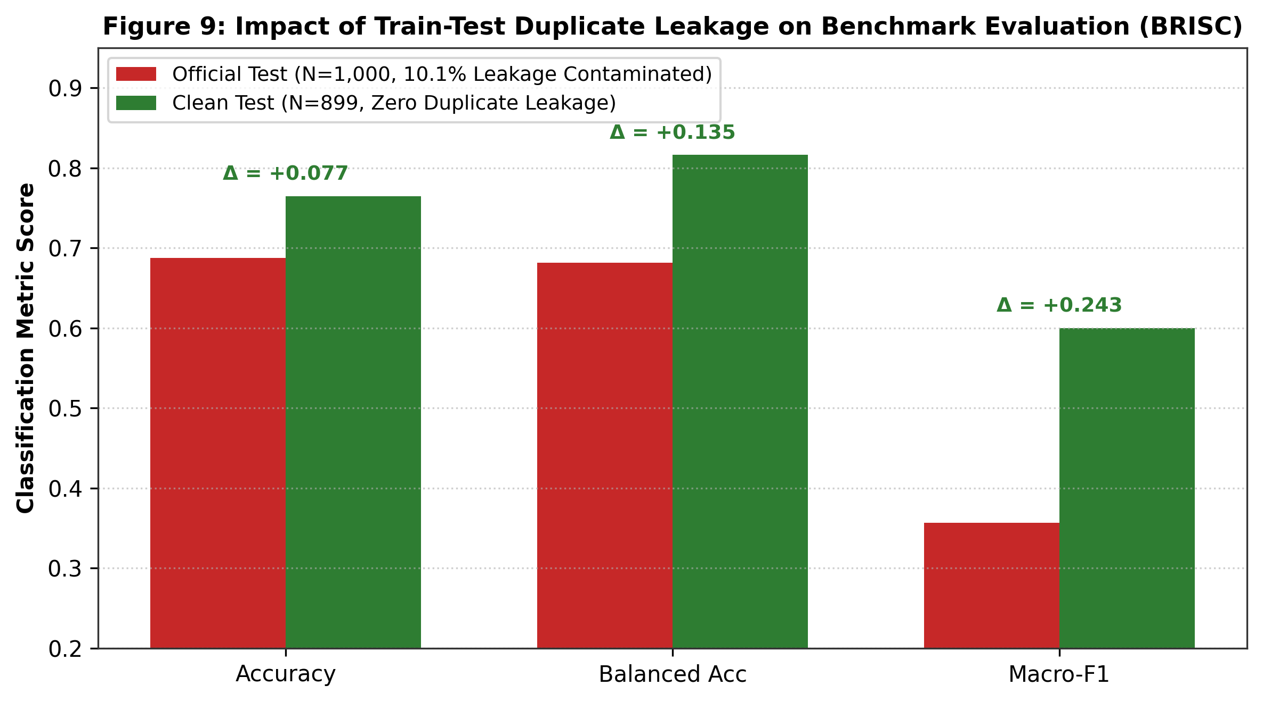
Figure 9: Impact of Train-Test Duplicate Leakage on Benchmark Evaluation (BRISC). Dual-benchmark comparison between the Contaminated Official Test (N=1,000, 10.1% leakage) and the Clean De-duplicated Test (N=899).

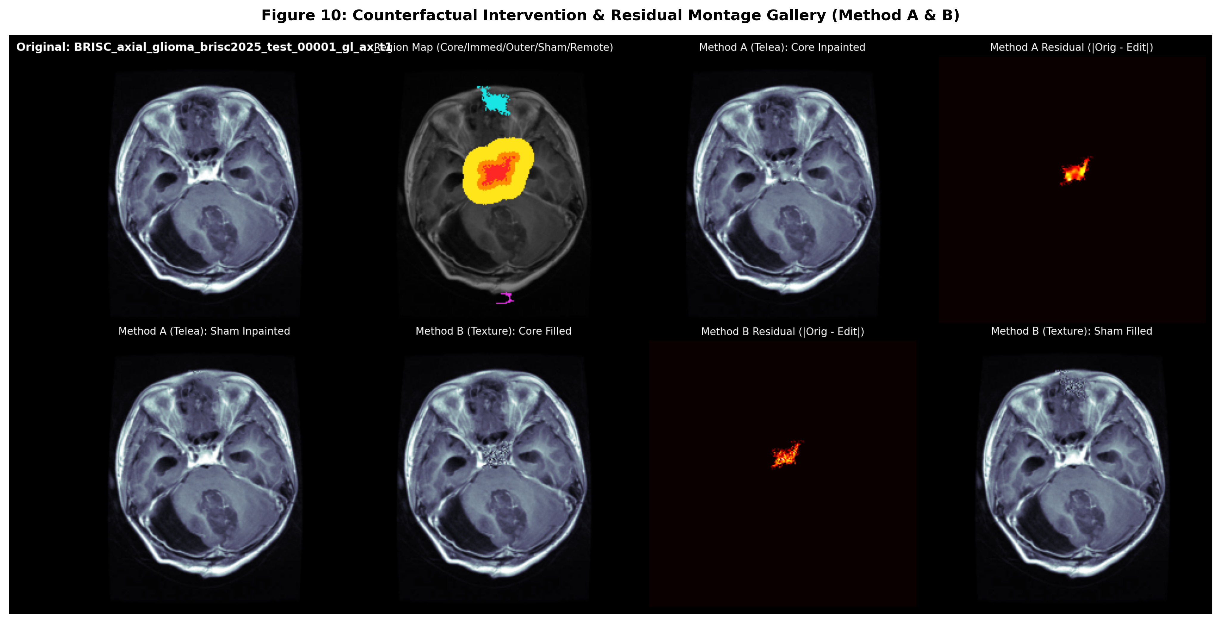
Figure 10: Counterfactual Intervention & Residual Montage Gallery. High-resolution 8-panel diagnostic gallery displaying original slice, 5-color segmentation topology, Method A inpainted core/sham, Method B texture-filled core/sham, and residual difference maps.

