Disentangling Synthetic Edge Artifacts and Spatial-Context Sensitivity in Brain MRI Tumour Classification: A Multi-Control Spatial Intervention Study
Chhotu^{1*} and Rishi Gupta²
¹ Manipal University Jaipur, Jaipur, Rajasthan, India
² Department of Computer Science & Engineering, School of Computer Science and Engineering, Faculty of Science, Technology and Architecture, Manipal University Jaipur, Jaipur, Rajasthan, India
*Corresponding author. E-mail: chhotu.2427030521@muj.manipal.edu (alternative: csjadon415@gmail.com)
Abstract
Tile scrambling is used as a context-reliance probe, but it also inserts artificial seam edges that can confound interpretation of the resulting performance drop. We study this on the Cheng Figshare cohort (3,064 T1-weighted contrast-enhanced slices, 233 patient clusters; meningioma, glioma, pituitary tumour) using 15 frozen ResNet-50 checkpoints (three evaluation scenarios × five folds) and six input conditions: an unmodified baseline (C₀), a tile-mean-offset control (C₁), a seam-suppressed permutation (C₂), raw scrambling (C₃) and two true seam-only controls (C_{4a}, C_{4b}) that change only the two pixels adjacent to each seam. Tumour and a 15-pixel margin were never altered. Over 55,152 out-of-fold predictions, with paired cluster-bootstrap inference (B = 25,000) and Holm–Bonferroni control, patient-disjoint Macro-F1 fell from 0.9333 to 0.8127 and 0.7811 (C_{4a}, C_{4b}), 0.6290 (C₁), 0.5118 (C₃) and 0.4525 (C₂). Seam steps alone caused a reliable but moderate decline, variable across scenarios and checkpoints and much smaller than the decline under scrambling; seam suppression did not recover performance. Glioma slices were increasingly labelled pituitary tumour with perturbation strength (0.1% at baseline, 16–23% with seam steps, 56–64% with scrambling or suppression). The results are consistent with sensitivity to both boundary discontinuities and rearranged content, but do not apportion the effect: the seam-only controls are not energy-matched to the scramble and were added post hoc, and tumour class may be confounded with imaging plane.
Keywords: Brain tumour classification; Convolutional neural networks; Magnetic resonance imaging; Shortcut learning; Spatial context; Image perturbation; Artifact disentanglement; Reproducibility

Nomenclature
CNN – Convolutional neural network
T1-CE – T1-weighted contrast-enhanced magnetic resonance imaging
PID – Patient identifier in the source data
SSIM – Structural similarity index, used to flag candidate near-duplicate slices
S₀, S₁, S₂ – Evaluation scenarios: patient-disjoint; patient + SSIM ≥ 0.80 grouping; patient + SSIM ≥ 0.75 grouping
C₀–C₃, C_{4a}, C_{4b} – Input conditions: baseline; tile-mean-offset control; seam-suppressed rearrangement; raw scramble; true seam-only controls (gain 1.0, 1.8)
M_{tumor}, M_{margin}, M_{prot} – Tumour mask; 15-pixel peritumoral ring; protected zone (their union)
s, Ω_{distant}, N_{t} – Tile edge length (16 px); set of eligible distant tiles; its size
δ_{i} – Tile-level intensity offset applied in C₁
λ – Seam-distance blending weight in C₂
κ – Ratio of the C₁ drop to the C₃ drop (descriptive)
π – Per-slice pseudo-random permutation of eligible tiles
Δ – Signed contrast, Macro-F1(A) − Macro-F1(B)
OOF – Out-of-fold (held-out fold of the checkpoint that evaluates it)
B – Number of bootstrap resamples (25,000)
γ – Seam gain of the true seam-only controls (1.0 for C_{4a}, 1.8 for C_{4b})
FWER – Family-wise error rate (Holm–Bonferroni control, α = 0.05)

1 Introduction
Deep learning models have achieved expert-level nominal performance across diverse medical image classification tasks, including dermatological lesion classification [27], chest radiograph screening [28] and brain-tumour diagnosis from magnetic resonance imaging (MRI) [3, 4]. In neuro-oncology, accurate classification of primary brain tumours into meningioma, glioma, and pituitary tumour on contrast-enhanced T1-weighted MRI is clinically vital for surgical planning, radiotherapy, and targeted chemotherapy [3, 4]. Numerous published studies report classification accuracies exceeding 94% on public brain tumour datasets, frequently using deep convolutional neural network (CNN) backbones such as ResNet-50 [3, 4, 12].
However, high predictive accuracy in machine learning does not guarantee that models have learned clinically meaningful, disease-specific features [5, 6]. Deep neural networks are known to exploit “shortcuts”—unintended statistical correlations between non-pathological background image features and target diagnostic labels that hold within training distributions but fail under clinical distribution shifts [5, 6]. Landmark studies have documented profound shortcut reliance in medical imaging: convolutional classifiers have been shown to predict COVID-19 and pneumonia from hospital-specific radiograph annotations and radiographic projection markers [2, 6], draw on patient and healthcare-process variables when predicting hip fractures [7], and show altered melanoma-classifier performance in the presence of surgical skin markings or non-lesion image content [1, 8].
To probe whether medical classifiers rely on pathological lesions or extraneous surrounding image context, researchers employ spatial perturbation interventions such as focal occlusions, bounding-box cropping, and tile scrambling [9–11]. Vangala et al. [12] recently audited contamination in public brain-tumour benchmarks, including duplicate-, patient-, and source-level leakage. Their preprint does not report the distant-context tile-scrambling experiment or a greater-than-40-percentage-point Macro-F1 drop. We therefore do not attribute that numerical result to [12]; the performance changes reported here come from the experiments described in this study. A collapse under spatial scrambling can have multiple explanations, including the artificial boundaries created by the intervention itself.
Nevertheless, an overlooked methodological vulnerability compromises this spatial perturbation paradigm: tile scrambling introduces high-frequency artificial boundary step discontinuities at every tile seam. Natural brain MRI slices are characterized by smooth intensity gradients and continuous anatomical contours governed by biological tissue architecture. When tiles are randomly permuted, sharp intensity discontinuities arise along tile edges. Deep convolutional networks are known to be biased toward high-frequency spectral components and local edge textures [13–15, 29, 30]. Consequently, an acute scientific ambiguity arises:
Does the observed performance collapse under distant tile scrambling reflect true neural network reliance on macroscopic cranial spatial arrangement, or is it an artifactual vulnerability to synthetic high-frequency edge seams introduced by the intervention itself?
In this study, we address this question through a controlled multi-intervention experiment on the benchmark Cheng Figshare brain tumour MRI cohort (3,064 slices across 233 patient clusters) [3]. We design a tile-mean-offset control (C₁) that imposes the tile-level mean-intensity steps of the scramble onto tiles left in place, a seam-suppressed rearrangement (C₂) that permutes tiles while locally blurring seams, and, in a later extension, two true seam-only controls (C_{4a}, C_{4b}) that change only the pixels adjacent to the seams. We compare them with the unmodified baseline (C₀) and the raw scramble (C₃), while recognizing that the interventions alter multiple image statistics. Evaluated across 15 frozen ResNet-50 checkpoints and three cross-validation regimes (S₀, S₁, S₂), the study evaluates a multi-control design for distinguishing seam-related degradation from degradation under spatial rearrangement in this benchmark.
This study’s objectives are:
- To quantify how much of the raw-scramble performance collapse is reproduced by a tile-mean-offset perturbation (C₁ vs C₀ and C₃ vs C₁) and by true seam-only perturbations that change only seam pixels (C_{4a}, C_{4b} vs C₀).
- To test whether a tile permutation whose boundary seams are partly suppressed (C₂) still degrades classification beyond a practical-significance threshold of ΔMacro-F1 = 0.150.
- To characterize the class-level error transitions produced by the interventions, in particular the direction and asymmetry of glioma–pituitary confusion.
- To state, with the diagnostics measured on the interventions themselves, which alternative explanations the present design cannot exclude.
The hypotheses were set in the project’s phased research protocol and experiment configuration before model execution; they were not deposited on an immutable external registry, and repository timestamps cannot prove the order of configuration and predictions. They were: H₀, the C₁ perturbation (tile-level offsets and seam steps) accounts for the entire scrambling decline, i.e. C₃ is not worse than C₁; H₁, the C₁ perturbation alone degrades performance; H₂, the seam-suppressed rearrangement degrades performance by more than 0.150 Macro-F1. A mixed, dual-factor outcome was labelled H₃ if H₁ and H₂ were both supported. Section 4.9 gives the verdict for each.
The contributions of this paper are:
- A six-condition intervention design (C₀–C₃ plus two true seam-only controls) with an exact protected-zone invariant (zero altered pixels inside tumour + 15-pixel margin) and deterministic, slice-specific permutations.
- A matched evaluation of 15 frozen ResNet-50 checkpoints under three leakage-controlled split regimes, yielding 55,152 out-of-fold predictions with complete prediction accounting.
- Measured image diagnostics for every condition at source resolution and on the 224 × 224 network input (Sobel seam, junction and interior energy, high-frequency Fourier energy, unchanged-pixel fraction), reported alongside the performance results.
- A clustered, paired inference protocol (synchronized cluster bootstrap, B = 25,000, with Holm–Bonferroni control in three declared families, plus McNemar tests as a supplement) and a candid account of what the interventions do and do not identify.
The remainder of the paper is organized as follows. Section 2 reviews shortcut learning, perturbation-based attribution and brain-tumour dataset audits, and states the research gap. Section 3 describes the data, models, interventions, diagnostics and statistics. Section 4 reports the experimental setup and results. Section 5 discusses interpretation, alternative explanations and methodological implications (with follow-up controls), Section 6 lists limitations, and Section 7 concludes.

2 Related Work
Prior work relevant to this study falls into three groups: (i) shortcut learning and confounding in medical image classifiers, (ii) input-perturbation methods used to detect context reliance, and (iii) benchmark-specific work on the public brain-tumour MRI dataset used here. We review them in turn and then state the gap addressed.

2.1 Shortcut learning in medical image analysis
Shortcut learning occurs when a model optimizes performance on the training distribution through decision rules that do not transfer, and it is now recognized as a general failure mode of deep networks [5]. In medical imaging the consequence is a model that scores well on internal validation while remaining clinically invalid. DeGrave et al. showed that radiograph-based COVID-19 detectors relied on non-pathological image features rather than pulmonary findings [6]. Zech et al. reported that a pneumonia classifier trained on chest radiographs generalized unevenly across hospital systems, consistent with the use of site-related cues [2]. Badgeley et al. found that a hip-fracture model drew on patient and healthcare-process variables [7]. In dermatology, Winkler et al. associated surgical skin markings with altered diagnostic performance of a melanoma CNN [1], and Bissoto et al. analysed bias in skin-lesion datasets, showing that non-lesion regions carry predictive signal [8]. Oakden-Rayner et al. described hidden stratification, where an aggregate metric masks systematic failure on clinically relevant subsets [18]; this is directly relevant when tumour class and acquisition characteristics are correlated (Section 5.4).

2.2 Spatial interventions and attribution by perturbation
Perturbation-based analyses ask how predictions change when image content is removed or rearranged. Zeiler and Fergus introduced systematic patch occlusion to visualize which regions drive activations [9]. Fong and Vedaldi formalized “meaningful perturbation” and noted that deletion operators can themselves create artefactual evidence [10]. In natural images, Xiao et al. showed that backgrounds alone can support classification and that background swaps change predictions [11]; inpainting-style and generative fills have also been used to remove content [16, 31]. For medical images, Castro et al. argued that causal conclusions about medical-imaging models require explicit assumptions about how images are generated [17], and Rossi et al. proposed tumour-aware counterfactual editing [19]. A general lesson of this literature is that the perturbation operator is part of the experiment: a perturbation that introduces unnatural high-frequency structure is expected to affect networks that are sensitive to such structure [13–15, 29, 30].

2.3 Brain-tumour MRI classification and dataset audits
The Cheng Figshare collection [3, 4] is a widely used resource for three-class brain-tumour classification. Earlier studies have sometimes used slice-level random splits, which can place slices from the same patient on both sides of a split. Vangala et al. [12] audit benchmark contamination and discuss duplicate-level, patient-level, and source-level leakage. Their preprint does not report the specific distant-context tile-scrambling experiment examined here, so no scrambling-induced Macro-F1 drop is attributed to that work. Patient-aware evaluation addresses one aspect of data leakage, but does not, by itself, reveal which image features a classifier uses. The present study examines model responses to spatial perturbations while acknowledging that those interventions alter multiple image properties.

2.4 Research gap
Table 1 summarizes representative context-reliance studies. Three gaps motivate this work. First, shortcut analyses in medical imaging have mostly identified which non-pathological cue is exploited (a marker, a site tag, a variable), not how the perturbation used to detect it contributes to the observed failure. Second, interpreting a distant-context tile-scrambling result as evidence of anatomical-layout reliance requires controls that add boundary seams without moving tile content. Third, prior perturbation results on this dataset have generally not reported diagnostics (edge energy, spectral energy, changed-pixel fraction) for the perturbed images. This study supplies a tile-mean-offset control, a locally blended rearrangement, true seam-only controls and corresponding diagnostics.
Table 1 Representative studies on context or shortcut reliance in image classifiers, and the aspect relevant to the present design. Statements summarize the cited authors’ reported focus.
Study | Year | Domain | Reported focus | Relation to this study
Winkler et al. [1] | 2019 | Dermoscopy | Surgical skin markings associated with altered melanoma-CNN performance | Non-lesion marker; no perturbation control
Zech et al. [2] | 2018 | Chest radiograph | Uneven generalization across hospital systems | Site-related cues; no spatial intervention
Badgeley et al. [7] | 2019 | Hip radiograph | Prediction used patient and healthcare-process variables | Confounder identification
Bissoto et al. [8] | 2019 | Dermoscopy | Bias analysis of skin-lesion datasets | Predictive signal outside the lesion
DeGrave et al. [6] | 2021 | Chest radiograph | COVID-19 detectors relying on non-pathological features | Shortcut identified; perturbation artefacts not isolated
Xiao et al. [11] | 2021 | Natural images | Background-only and background-swap evaluation | Context reliance; no seam control
Zeiler & Fergus [9] | 2014 | Natural images | Patch-occlusion sensitivity | Occluder shape/edges not controlled
Fong & Vedaldi [10] | 2017 | Natural images | Meaningful perturbation; deletion artefacts | Motivates controlling the operator
Vangala et al. [12] | 2026 | Brain MRI (Cheng) | Dataset-contamination audit (preprint); does not report the tile-scrambling result discussed here | Supports benchmark-integrity discussion; not evidence for a scrambling-induced Macro-F1 drop

3 Methods
This section describes the data, evaluation scenarios, model and training configuration, the protected-zone invariant, the six input conditions, the image diagnostics and the statistical protocol. Figure 1 gives an overview.
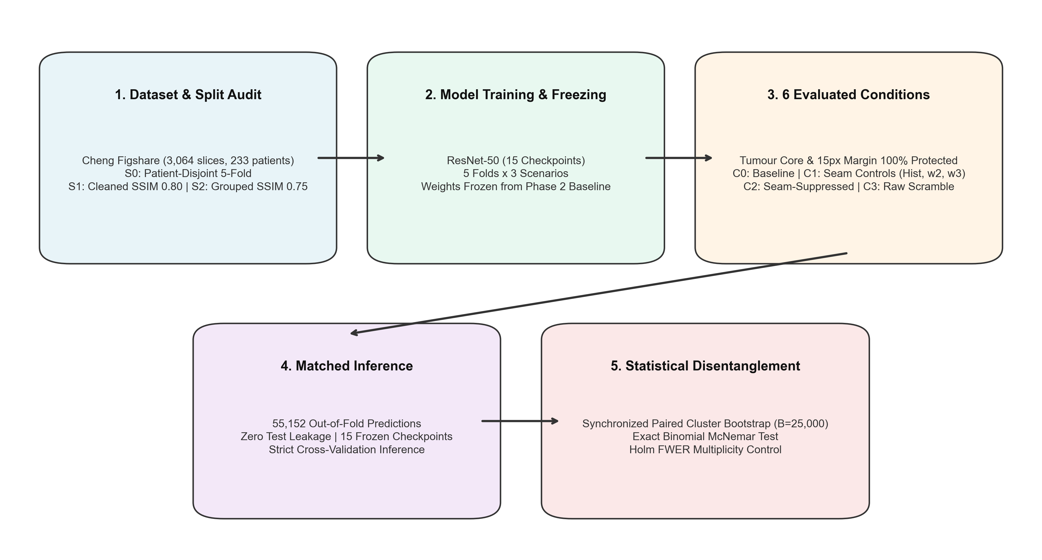
Fig. 1 Overview of the experimental pipeline. Fifteen frozen ResNet-50 checkpoints (three scenarios × five folds) each evaluate only their own held-out fold under six input conditions; predictions are pooled per scenario and analysed with paired cluster statistics.

3.1 Dataset
Experiments use the public Cheng brain-tumour dataset (Figshare article 1512427, DOI 10.6084/m9.figshare.1512427) [3, 4]: 3,064 two-dimensional T1-weighted contrast-enhanced slices acquired between 2005 and 2010 at Nanfang Hospital (Guangzhou) and General Hospital, Tianjin Medical University. Each sample provides the image (predominantly 512 × 512, with a subset at 256 × 256), a binary tumour mask, the tumour border coordinates, a patient identifier (PID) and the class label. Slices were converted to 8-bit grayscale images with paired binary masks, and 233 unique patient identifiers were extracted from the source structures. The target is a three-class slice label, not a patient-level clinical diagnosis.
Table 2 Dataset composition by tumour class.
Class | Slices | Share (%) | Typical anatomical location
Meningioma | 708 | 23.11 | Dural-based, extra-axial (parasagittal, convexity, skull base)
Glioma | 1,426 | 46.54 | Intra-axial cerebral or cerebellar white matter and parenchyma
Pituitary tumour | 930 | 30.35 | Sella turcica and suprasellar region at the skull base
Total | 3,064 | 100.00 | 233 patient clusters
The example slices in Fig. 2 have visual appearances consistent with different viewing orientations; however, the source files contain no verified acquisition-plane labels or orientation matrices. These visual examples are illustrative only and were not used to assign plane labels or perform plane-stratified analyses. Imaging plane was not recorded as a stratification variable, and its relation to class remains an unresolved limitation. The repository also lacks full acquisition headers (field strength, TR, TE, slice thickness), so scanner-level stratification is not possible.
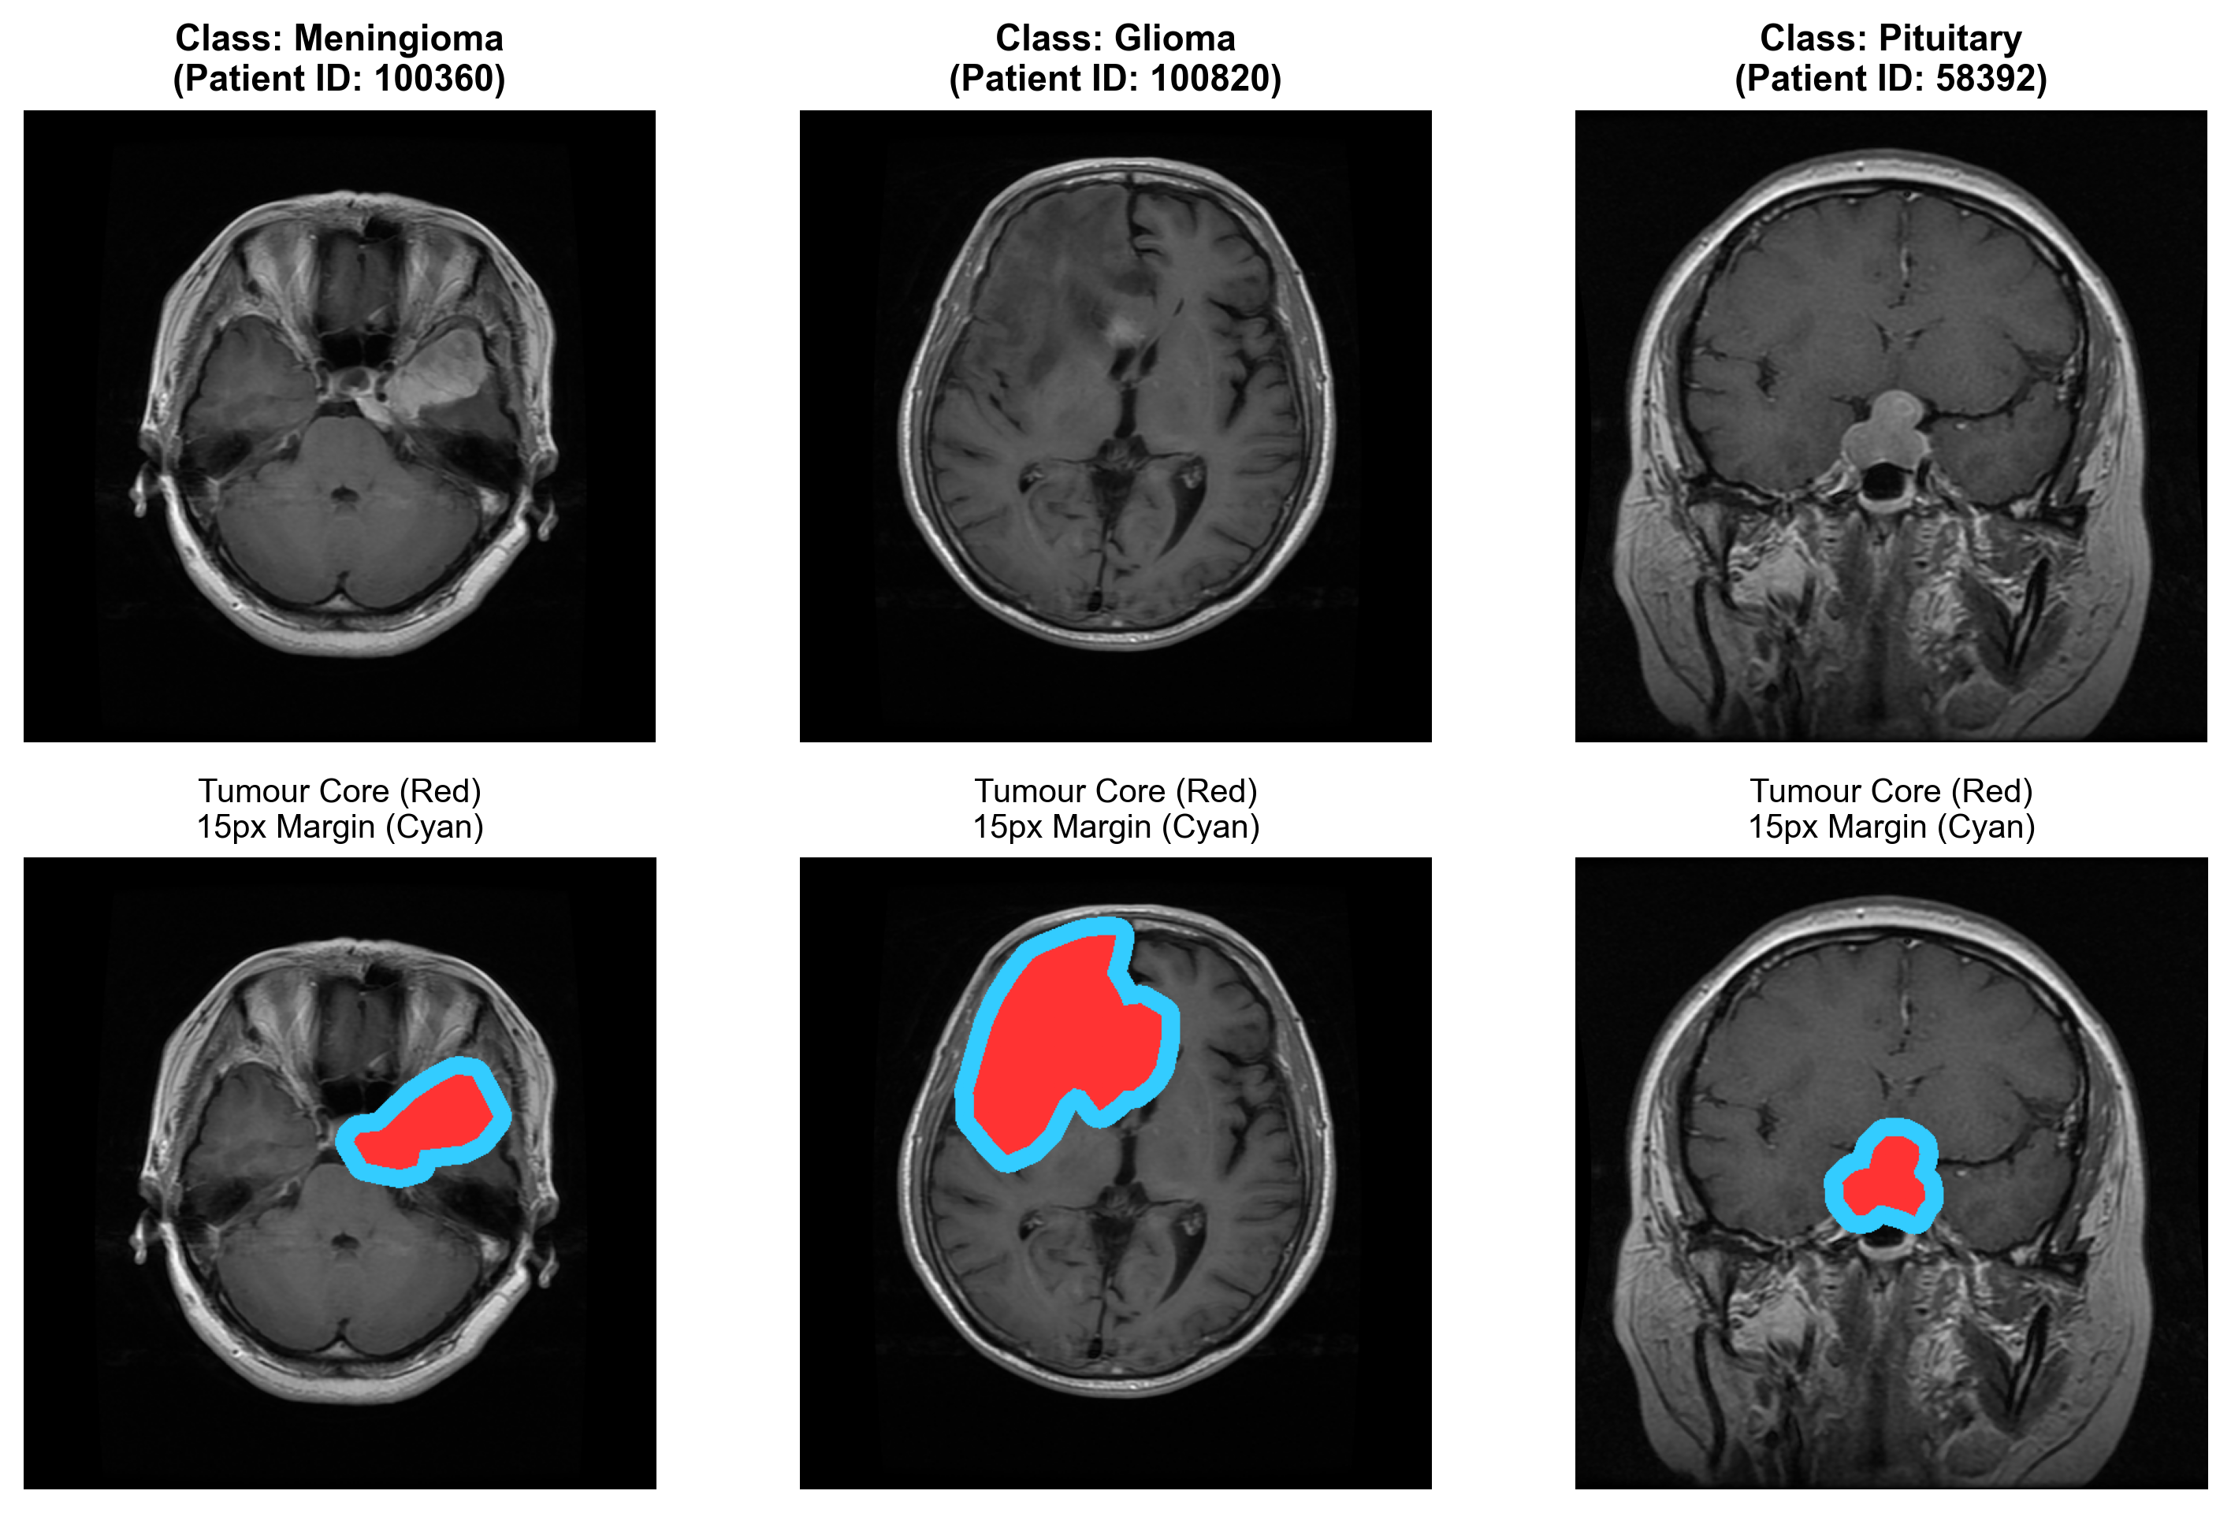
Fig. 2 Example slices (top) and the protection geometry (bottom): tumour core (red) and the 15-pixel peritumoral margin (cyan) for a meningioma, a glioma and a pituitary tumour. Pixels inside both regions are never modified in any condition.

3.2 Evaluation scenarios and patient grouping
Three five-fold scenarios were evaluated to examine sensitivity to leakage control. S₀ groups slices by patient identifier (233 clusters), so no patient appears in both training and held-out folds. S₁ additionally merges patient clusters that contain slice pairs with structural similarity SSIM ≥ 0.80 [21] (231 clusters), and S₂ does so at SSIM ≥ 0.75 (217 clusters). Merging is performed over connected components of the similarity graph. The resulting groups are candidate near-duplicate groups defined by an image-similarity threshold; they are not proof of duplicate identity. Fold sizes (Table 3) differ slightly between scenarios because the grouping differs.
Table 3 Evaluation scenarios, clustering units and held-out fold sizes (number of slices evaluated by each fold’s checkpoint).
ID | Grouping criterion | Clusters | F1 | F2 | F3 | F4 | F5
S₀ | Unique patient ID | 233 | 613 | 614 | 611 | 613 | 613
S₁ | Patient ID + SSIM ≥ 0.80 merges | 231 | 612 | 614 | 613 | 612 | 613
S₂ | Patient ID + SSIM ≥ 0.75 merges | 217 | 613 | 612 | 614 | 612 | 613

3.3 Model and training configuration
All models are the Torchvision ResNet-50 [20] initialized from ImageNet-1k weights (IMAGENET1K_V2; the SHA-256 of the weight file is recorded) [26], with the final layer replaced by a 2048 → 3 linear head (meningioma, glioma, pituitary). Inputs are resized to 224 × 224 with bilinear interpolation and ImageNet normalization. Training used class-weighted cross-entropy and AdamW (learning rate 10⁻⁴, weight decay 10⁻⁴) with a batch size of 16, at most 20 epochs with early stopping (patience 5), mixed precision, random horizontal flips and random rotations (±10°) as augmentation, and the seed 42 + fold index. For each outer test fold, the next fold in cyclic order served as the validation set; train, validation and test folds are disjoint in patients (S₀) or candidate groups (S₁, S₂), which the training script enforces by assertion. The epoch with the highest validation Macro-F1 (ties broken by lower validation loss) was retained and frozen, giving fifteen checkpoints (3 scenarios × 5 folds). Training all 15 checkpoints took 2,612 s on a laptop NVIDIA RTX 4050 GPU (6 GiB). No parameter was updated during any intervention experiment; the interventions change only the input at inference.
Table 4 Model and training configuration.
Item | Specification
Architecture | ResNet-50 (Torchvision), ImageNet-1k pretrained (IMAGENET1K_V2)
Input | 224 × 224 × 3, bilinear resize, ImageNet normalization
Head | Linear(2048, 3)
Loss | Class-weighted cross-entropy
Optimizer | AdamW, learning rate 1e-4, weight decay 1e-4
Schedule | At most 20 epochs; early stopping, patience 5
Batch size | 16 (training)
Augmentation | Random horizontal flip (p = 0.5); random rotation (±10°)
Validation / selection | Next fold in cyclic order; highest validation Macro-F1 (tie: lower loss)
Seed | 42 + fold index
Hardware | NVIDIA GeForce RTX 4050 Laptop GPU (6 GiB); 2,612 s for all 15 checkpoints
Inference mode | Frozen weights; no fine-tuning during interventions

3.4 Protected-zone invariant
To ensure that interventions act only on non-tumour context, the ground-truth mask M_{tumor} and a 15-pixel dilation ring are protected. The ring is obtained by morphological dilation with a 31 × 31 elliptical structuring element E:
M_{margin} = (M_{tumor} ⊕ E_{31×31}) ∖ M_{tumor}, M_{prot} = M_{tumor} ∪ M_{margin} (1)
and every condition must satisfy the invariant
∀ (x, y) ∈ M_{prot}: I_{cond}(x, y) = I_{orig}(x, y). (2)
The invariant was verified on all 3,064 slices in all conditions (zero altered pixels inside M_{prot}).

3.5 Tile partition and eligible tiles
Each image is partitioned into non-overlapping tiles of s × s pixels with s = 16. A tile is an eligible distant tile if and only if it has no intersection with the protected zone:
Ω_{distant} = { (g_{y}, g_{x}) : Σ_{y,x ∈ tile} M_{prot}(y, x) = 0 }. (3)
Let N_{t} = |Ω_{distant}|. A deterministic pseudo-random permutation π of {1,…,N_{t}} is generated for each slice from a seed derived from the slice identifier (SHA-256 hash combined with a fixed master seed of 42), so that the same permutation is used by C₁–C₄ for a given slice. Ω_{distant} contains every tile outside the protected zone, including tiles of the image background; the consequences are discussed in Section 5.4. Because a tile is eligible only if it does not intersect M_{prot}, every tile that touches the tumour or its margin also stays unchanged, so the unmodified area is a tile-granular union that is larger than M_{prot} (about 10–11% of pixels remain identical to C₀ under C₁–C₃, Table 9). The junction between this unmodified block and the permuted context is not smoothed in C₂; junction seam energy is reported in Table 9.

3.6 Input conditions
C₀ – baseline. I_{C0} = I_{orig}.
C₃ – raw historical scramble. For each eligible tile i at grid position (g_{y}, g_{x}) = Ω_{distant}(i), the pixels are replaced by those of tile π(i), at grid position (g′_{y}, g′_{x}) = Ω_{distant}(π(i)), with no smoothing:
I_{C3}(g_{y}s + o_{y}, g_{x}s + o_{x}) = I_{orig}(g′_{y}s + o_{y}, g′_{x}s + o_{x}). (4)
C₁ – tile-mean-offset control. Tile content stays in its original position, but each eligible tile receives the scalar offset that the scramble would impose on its mean intensity:
δ_{i} = mean(I_{orig}[Ω_{distant}(π(i))]) − mean(I_{orig}[Ω_{distant}(i)]), I_{C1} = clip(I_{orig} + δ_{i}, 0, 255). (5)
After the offset, the mean intensity of every tile equals that of the tile C₃ would place there. C₁ therefore reproduces the coarse (tile-level) intensity layout of the scramble and its step discontinuities at tile borders; only the within-tile texture remains in its original position. It is thus not a pure seam control and does not leave the layout intact: bright tiles of brain tissue can receive the mean of dark background tiles and vice versa (Fig. 3). Values are clipped to [0, 255], so tiles near the intensity limits are not shifted exactly by δ_{i}, which lowers the within-tile gradient (Section 4.6). The role of C₁ is to test whether the tile-level offsets and seam steps of the scramble, without moving texture, are sufficient to degrade the classifier.
C₂ – seam-suppressed rearrangement. Eligible tiles are permuted as in C₃, and the result is locally low-pass filtered near tile boundaries. Let G_{σ} be a 9 × 9 Gaussian blur with σ = 2.5 px and let D(y, x) be the Euclidean distance to the nearest seam line (the last row or column of an eligible tile that borders another eligible tile). The output is a distance-weighted mixture of the permuted and the blurred image:
λ(y, x) = max(0, 1 − D(y, x)/w), I_{C2} = (1 − λ) I_{C3} + λ (G_{σ} ∗ I_{C3}), w = 4 px, (6)
with λ = 0 inside M_{prot}. The step edge is thus attenuated by local blurring within about 4 px of each seam; adjacent tiles are not cross-faded with each other, and the step is not removed. Because the blending zone extends up to 4 px on each side of a seam in a 16-px tile, a large share of each tile’s area is blurred to some degree, and the central 12 × 12 “interior” used for diagnostics overlaps the blending zone (Section 4.6).
C_{4a}, C_{4b} – true seam-only controls. These controls add only the seam step that the scramble would create and leave everything else untouched. For two horizontally (or vertically) adjacent eligible tiles, let p_{L}, p_{R} be the permuted border pixels on the two sides of a seam and o_{L}, o_{R} the original ones. The seam step is the extra jump the permutation creates, and it is applied symmetrically to the two pixels adjacent to the seam, with gain γ:
step = (p_{R} − p_{L}) − (o_{R} − o_{L}), I_{L} ← I_{L} − ½ γ step, I_{R} ← I_{R} + ½ γ step, (7)
followed by clipping to [0, 255] and restoring the protected zone. γ = 1.0 gives C_{4a} and γ = 1.8 gives C_{4b}; both modify the same two pixels per seam, so C_{4b} varies the seam amplitude, not its width (the repository labels these conditions C1_true_seam_w2 and C1_true_seam_w3). Tile interiors, tumour and margin are unchanged, and about 81% of pixels at source resolution are identical to C₀. The seam-only controls were created after the primary results were known and are not energy-matched to C₃ (Section 4.6).
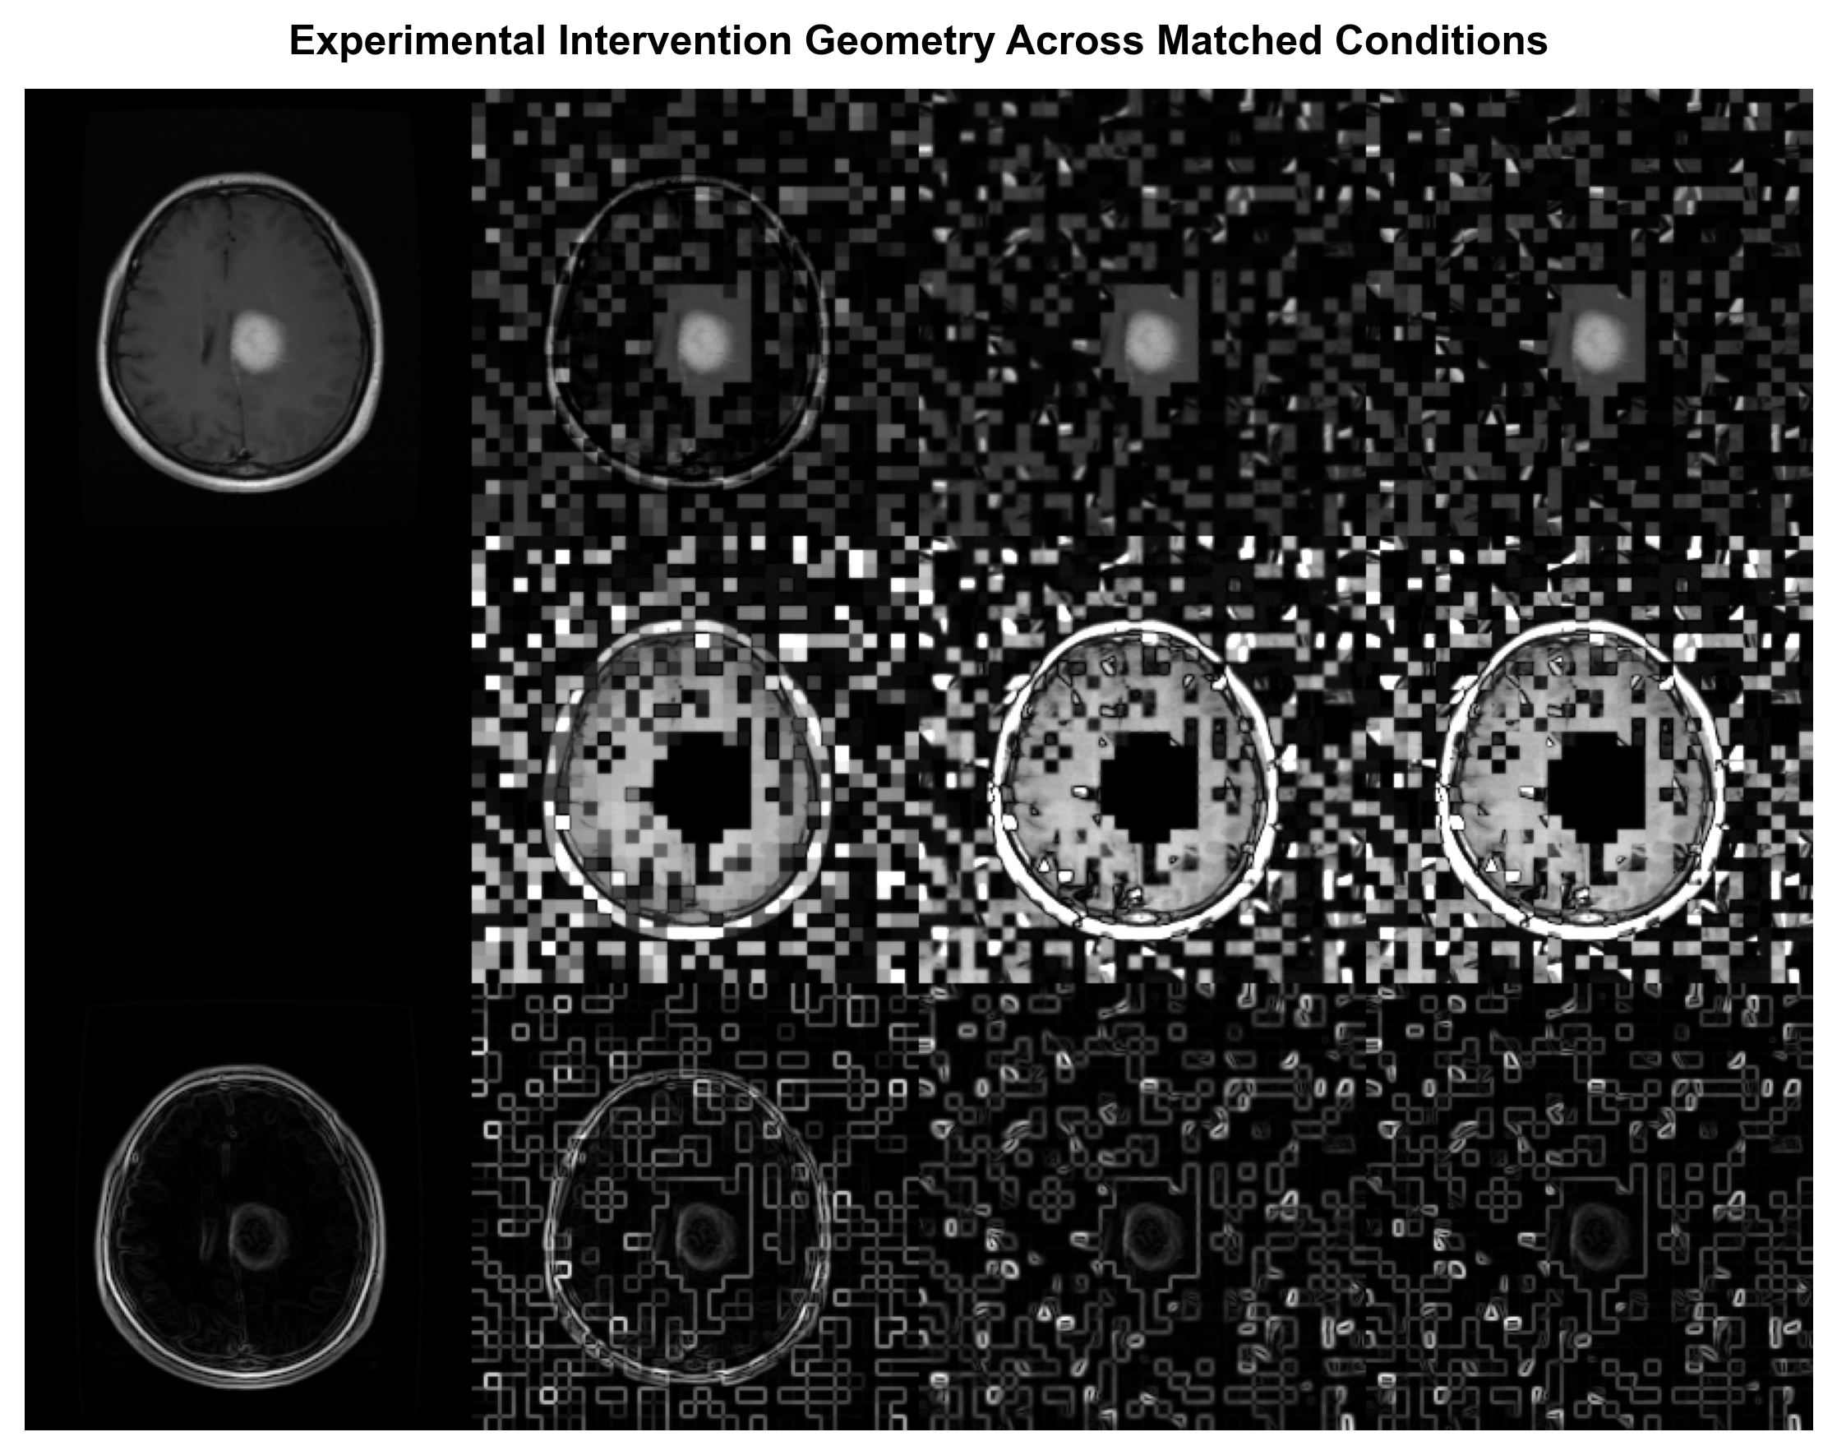
Fig. 3 Four of the six conditions on one slice. Columns: C₀–C₃ (C_{4a}, C_{4b} change only two pixels per seam and are not shown). Rows: image; absolute difference from C₀ (contrast-stretched; black = unchanged, including the protected zone); Sobel gradient magnitude. The protected region is identical in all columns.

3.7 Image diagnostics
Interventions were characterized with the following measures, computed over all 3,064 slices. The Sobel gradient magnitude is
G(x, y) = √( (∂I/∂x)² + (∂I/∂y)² ), (8)
averaged over (a) a band on inter-tile grid lines inside distant context (seam energy), (b) the 2 × 2 pixel junctions where four tiles meet (junction energy) and (c) distant-tile pixels outside the seam band (interior energy). All diagnostics are computed both at the source resolution (before resizing) and on the 224 × 224 network input, where the masks are resized with nearest-neighbour interpolation. High-frequency spectral energy is computed from the 2-D discrete Fourier transform F(u, v) over radii r > 0.25 min(H, W). In addition, we report the fraction of pixels identical to C₀. The reduction of “excess” seam or spectral energy in a condition is defined relative to the C₀–C₃ gap:
reduction = ( E_{C3} − E_{C2} ) / ( E_{C3} − E_{C0} ). (9)

3.8 Out-of-fold inference and prediction accounting
In each scenario and fold, the frozen checkpoint evaluates only its own held-out fold, under every condition, without test-time ensembling. The four primary conditions give 3 × 4 × 3,064 = 36,768 prediction records and the two true seam-only conditions, run later with the same checkpoints, add 3 × 2 × 3,064 = 18,384, for 55,152 in total, with no duplicated slice within a scenario-condition (verified in the prediction-accounting table, which also records the checkpoint hash). Predictions are pooled across folds within each scenario for pooled metrics.

3.9 Metrics and statistical inference
The primary outcome is macro-averaged F1 over K = 3 classes, with per-class precision P_{c} = TP_{c}/(TP_{c} + FP_{c}) and recall R_{c} = TP_{c}/(TP_{c} + FN_{c}):
F1_{c} = 2P_{c}R_{c} / (P_{c} + R_{c}), MacroF1 = (1/K) Σ_{c} F1_{c}, BA = (1/K) Σ_{c} R_{c}. (10)
For two conditions A and B evaluated on the same slices, the signed contrast is
Δ = MacroF1_{A} − MacroF1_{B}, (11)
so that a positive Δ means that condition B has lower Macro-F1 than condition A. Contrast labels follow the pattern “C_{b} vs C_{a}”, e.g. “C₃ vs C₀” has A = C₀ and B = C₃; the tables list the pair explicitly in an “A − B” column. Uncertainty is estimated by a synchronized paired cluster bootstrap [22]: patient clusters (S₀) or candidate similarity groups (S₁, S₂) are resampled with replacement, B = 25,000 times (seed 42), and the same resampled clusters are used for A and B in each replicate:
Δ^{(b)} = MacroF1_{A}^{(b)} − MacroF1_{B}^{(b)}, CI_{95%} = [ q_{2.5}({Δ^{(b)}}), q_{97.5}({Δ^{(b)}}) ]. (12)
As a supplementary slice-level analysis, McNemar’s test [23] (exact binomial, reported as log₁₀ p to avoid underflow, together with the continuity-corrected χ²) is computed from the discordant counts n₁₀ (A correct, B incorrect) and n₀₁ (A incorrect, B correct); it tests discordant correctness, not Macro-F1, and ignores patient clustering:
χ² = ( |n₁₀ − n₀₁| − 1 )² / ( n₁₀ + n₀₁ ), p = 1 − F_{χ²<sub>1}</sub>(χ²). (13)
Two-sided bootstrap p-values are computed from the 25,000 stored replicates as p_{boot} = min{1, 2 (min[#(Δ^{(b)} ≤ 0), #(Δ^{(b)} ≥ 0)] + 1) / (B + 1)}; with B = 25,000 the smallest attainable value is 8.0×10⁻⁵. Holm–Bonferroni step-down control [24] is applied to p_{boot} at α = 0.05 within three families declared in the repository code: a primary confirmatory family (C₁, C₂, C₃ vs C₀ and C₃ vs C₁; × 3 scenarios = 12 tests), a true seam-only family (C_{4a}, C_{4b} vs C₀, C₃ vs C_{4a}, C₂ vs C_{4a}; × 3 = 12 tests; added after the primary results were known) and an exploratory family (C₃ vs C₂; × 3 = 3 tests). With ordered p-values p₍₁₎ ≤ … ≤ p_{(m)}, H_{(k)} is rejected while p_{(k)} ≤ α/(m − k + 1). Confidence intervals in the tables are unadjusted percentile intervals. Because each cluster lies in exactly one held-out fold, resampling clusters resamples slices of the pooled out-of-fold predictions of all five checkpoints, and clusters of unequal size contribute in proportion to their size. A contrast is considered practically significant when Δ exceeds 0.150, a conventional margin adopted in the project protocol and not a clinically derived one.
Finally, the ratio of the C₁ drop to the C₃ drop,
κ = Δ_{C1} / Δ_{C3} = 0.3043 / 0.4215 ≈ 0.722, (14)
is reported only as a descriptive comparison of marginal declines (an analogous ratio of the true seam-only drop to the C₃ drop is given in Section 4.3). Because C₁ reproduces the tile-level intensity layout of C₃ (Section 3.6), κ must not be read as the share of the scramble effect that is due to seams, nor as a decomposition into seam and rearrangement effects.

3.10 Algorithm
Algorithm 1 Six-condition spatial intervention and paired evaluation
Require: slice I, tumour mask M_{tumor}, frozen checkpoint f for the slice’s held-out fold
2: Compute M_{prot} (Eq. 1) and the eligible tile set Ω_{distant} (Eq. 3)
3: Draw permutation π from the slice-specific seed
4: I_{C0} ← I
5: I_{C3} ← permute eligible tiles by π (Eq. 4)
6: I_{C1} ← add tile offsets δ_{i} to unpermuted tiles, clip to [0, 255] (Eq. 5)
7: I_{C2} ← permute by π and blend with seam-distance weight λ (Eq. 6)
8: I_{C4a}, I_{C4b} ← add seam steps with gain 1.0 and 1.8 to the two pixels adjacent to each seam (Eq. 7)
9: assert I_{Ck} = I on M_{prot} for k ∈ {0, 1, 2, 3, 4a, 4b}
10: for each condition k: ŷ_{k} ← argmax f(resize(I_{Ck}))
11: after all slices: pool predictions per scenario; compute Macro-F1, contrasts, bootstrap CIs and p-values, Holm; McNemar as supplement
12: return predictions {ŷ_{k}}, diagnostics, contrast table

3.11 Software and reproducibility
The environment recorded in the reproducibility manifest of the final audit was Python 3.14.6 with a PyTorch 2.15 development build (2.15.0.dev20260907+cu126) on Windows [25]. All tables and figures are generated by a single script from the evaluation outputs; SHA-256 hashes are stored for every package file, and the checkpoint hash is recorded for every checkpoint. An automated test suite of 178 tests covering split isolation, checkpoint validity, prediction accounting, protected-zone invariants and contrast reproduction exists in the repository; the recorded test log and its checksum were reconciled in the final audit.

4 Experimental Setup and Results

4.1 Evaluation protocol and integrity checks
Every result below is computed from out-of-fold predictions: for each scenario and fold, the corresponding frozen checkpoint is applied only to the slices of its held-out fold under every condition. The 15 checkpoints were not retrained, fine-tuned or recalibrated for any intervention, so any change between conditions is attributable to the input alone. The prediction tables were checked for completeness: each scenario-condition pair contains exactly one prediction for each of the 3,064 slices, with no slice appearing twice. The four primary conditions (C₀–C₃) yield 3 × 4 × 3,064 = 36,768 records; the two true seam-only conditions (C_{4a}, C_{4b}), generated in a later run with the same checkpoints and slices, add 3 × 2 × 3,064 = 18,384, for 55,152 in total. The protected-zone invariant was verified by assertion for every slice and condition.
“Macro-F1” is the unweighted mean of the three per-class F1 scores. Confidence intervals are 95% percentile intervals of the synchronized paired cluster bootstrap (B = 25,000, seed 42). A contrast “C_{b} vs C_{a}” means Δ = MacroF1(C_{a}) − MacroF1(C_{b}), so a positive Δ indicates that C_{b} is worse than C_{a}. The practical-significance threshold of 0.150 Macro-F1 is a project convention used as a reference line. Holm–Bonferroni control is applied within three declared families (Section 3.9). The true seam-only controls and their family were added after the primary results were known; they are therefore a post hoc extension and not part of the original protocol.

4.2 Baseline performance on unmodified images
Table 5 and Fig. 4 give the performance of the checkpoints on the unmodified held-out slices (C₀). The baseline is high and stable across the three leakage-control regimes: Macro-F1 is 0.9333 in S₀, 0.9332 in S₁ and 0.9273 in S₂, and balanced accuracy lies between 0.930 and 0.936. Merging near-duplicate patient clusters therefore lowers the baseline only marginally (≈ 0.006 Macro-F1 from S₀ to S₂). Meningioma is the hardest class (F1 ≈ 0.88), whereas glioma and pituitary tumour exceed F1 = 0.95.
Table 5 Baseline (C₀) out-of-fold performance by scenario (pooled over five folds).
Scenario | Macro-F1 | Balanced acc. | Accuracy | F1 meningioma | F1 glioma | F1 pituitary
S₀ | 0.9333 | 0.9362 | 0.9409 | 0.885 | 0.961 | 0.954
S₁ | 0.9332 | 0.9336 | 0.9419 | 0.883 | 0.965 | 0.951
S₂ | 0.9273 | 0.9300 | 0.9354 | 0.872 | 0.955 | 0.955
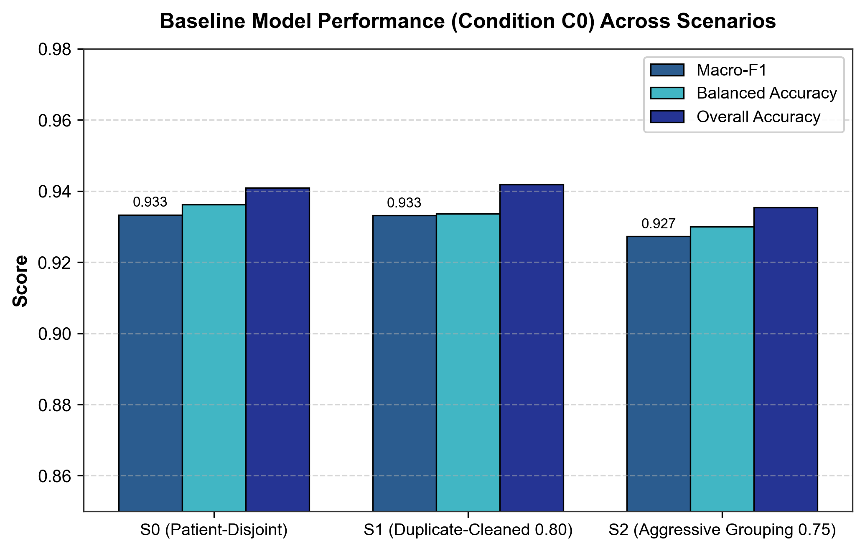
Fig. 4 Baseline (C₀) performance by scenario: Macro-F1, balanced accuracy and accuracy.

4.3 Effect of the five interventions
All five interventions reduce performance in every scenario (Table 6, Fig. 5). In S₀, Macro-F1 falls from 0.9333 (C₀) to 0.8127 and 0.7811 under the true seam-only controls (C_{4a}, C_{4b}), 0.6290 under the tile-mean offsets (C₁), 0.5118 under raw scrambling (C₃) and 0.4525 under the seam-suppressed permutation (C₂). For reference, a classifier that always predicted the majority class (glioma, 46.5% of slices) would score a Macro-F1 of about 0.21. The ordering is the same in S₁ and S₂ for the seam-only, tile-mean-offset and scramble conditions: C_{4a} < C_{4b} < C₁ < C₃ in damage. C₂ is the most damaging in S₀, close to C₃ in S₁ and S₂.
The true seam-only controls leave tile interiors, the tumour and its margin untouched and alter only the two pixels adjacent to each seam (Section 3.6); about 81% of pixels are identical to C₀ at source resolution. They nevertheless lower Macro-F1 by 0.121 / 0.072 / 0.051 (C_{4a}, S₀ / S₁ / S₂) and 0.152 / 0.099 / 0.069 (C_{4b}). Thus seam steps alone are sufficient to degrade these checkpoints in all three scenarios, the effect grows with the seam gain (γ = 1.0 to 1.8) in every scenario, and it is smaller in the scenarios with stricter near-duplicate grouping. Only the S₀ estimate for C_{4b} (0.152) is at the 0.150 practical threshold, and its confidence interval (0.118–0.190) includes values below it. The effect is also very heterogeneous across checkpoints: the fold-level C_{4a} drop in S₀ ranges from 0.006 to 0.247 (Section 4.7).
Expressed relative to the raw scramble, the seam-only drops are 0.29 / 0.16 / 0.13 (C_{4a}) and 0.36 / 0.22 / 0.17 (C_{4b}) of the C₃ drop in S₀ / S₁ / S₂. These ratios are descriptive only: they vary with scenario and gain, the controls are not matched to C₃ in seam or high-frequency energy (Section 4.6), and they must not be read as the share of the scramble effect attributable to seams. What the data show is that (i) seam discontinuities alone produce a real, reproducible but moderate decline, and (ii) the declines under C₁, C₃ and C₂ are several times larger than those of the seam-only controls. The C₁ perturbation reproduces the coarse intensity layout of C₃ and is not a seam control (Section 3.6); C₃ is consistently worse than C₁.
Table 6 Out-of-fold Macro-F1 and balanced accuracy (BA) for each scenario and condition (C_{4a}, C_{4b}: true seam-only controls with gain 1.0 and 1.8).
Condition | S₀ F1 | S₀ BA | S₁ F1 | S₁ BA | S₂ F1 | S₂ BA
C₀ | 0.9333 | 0.9362 | 0.9332 | 0.9336 | 0.9273 | 0.9300
C₁ | 0.6290 | 0.6817 | 0.6094 | 0.6633 | 0.6385 | 0.7135
C₂ | 0.4525 | 0.5783 | 0.4941 | 0.5855 | 0.5159 | 0.6255
C₃ | 0.5118 | 0.6082 | 0.4884 | 0.5732 | 0.5303 | 0.6281
C_{4a} | 0.8127 | 0.8157 | 0.8613 | 0.8588 | 0.8758 | 0.8764
C_{4b} | 0.7811 | 0.7844 | 0.8341 | 0.8308 | 0.8580 | 0.8571
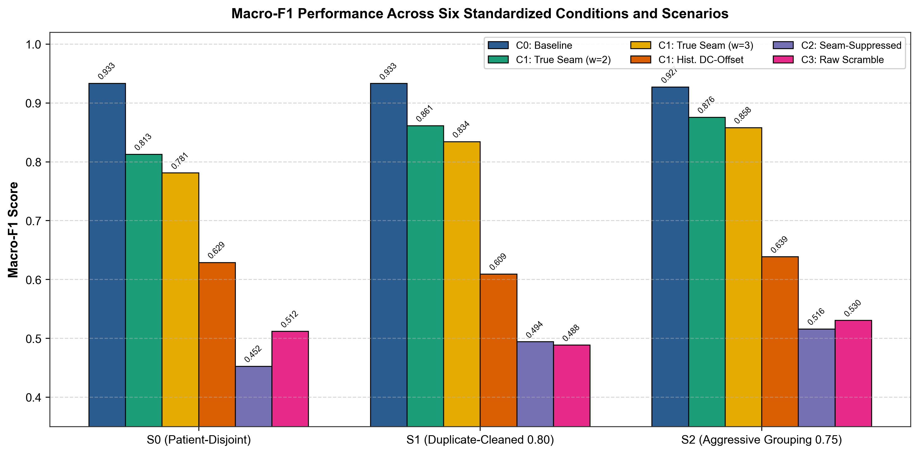
Fig. 5 Macro-F1 by condition and scenario for the six conditions. All interventions fall below the baseline; the true seam-only controls (C_{4a}, C_{4b}) are the mildest.

4.4 Paired contrasts and multiplicity control
Table 7 reports all 27 contrasts (nine per scenario) and Fig. 6 shows the forest plot. Of the 27, 25 are rejected after Holm–Bonferroni control within their declared family. The primary family (C₁, C₂, C₃ vs C₀ and C₃ vs C₁, three scenarios; 12 tests) is rejected throughout, with Holm-adjusted p = 9.6×10⁻⁴ in every case. The true seam-only family (C_{4a} and C_{4b} vs C₀, C₃ vs C_{4a} and C₂ vs C_{4a}; 12 tests) is also rejected throughout. With B = 25,000 the smallest attainable two-sided bootstrap p-value is 8.0×10⁻⁵ and 25 contrasts sit at this floor, so the adjusted values reflect bootstrap resolution, not differences in effect size. The exploratory family (C₃ vs C₂; three tests) is rejected only in S₀.
Three comparisons deserve explicit mention. First, raw scrambling versus the tile-mean offsets (C₃ vs C₁): Δ = +0.1172 [0.0825, 0.1526]; +0.1210 [0.0964, 0.1460]; +0.1082 [0.0828, 0.1348] (S₀; S₁; S₂), reliably positive but mostly below 0.150. Second, raw scrambling versus the seam-only control (C₃ vs C_{4a}): Δ = +0.301, +0.373, +0.345, i.e. scrambling is far more damaging than isolated seam steps. Third, seam suppression versus scrambling (C₃ vs C₂): suppressing seams did not restore performance; in S₀ C₂ was worse than C₃ (Δ = −0.0593, CI [-0.0832, -0.0358]), while in S₁ (+0.0057, p = 0.490) and S₂ (−0.0144, p = 0.133) the difference is not distinguishable from zero. The direction is therefore not consistent across scenarios.
McNemar’s test is a supplement: it tests slice-level correctness, not Macro-F1, and ignores patient clustering, so its p-values are anti-conservative. Many exact p-values underflow double precision, so Table 7 gives log₁₀ p from the exact binomial test together with the χ² statistic.
Table 7 All 27 paired contrasts. Fam.: P = primary confirmatory, T = true seam-only (post hoc), E = exploratory. Δ = MacroF1(A) − MacroF1(B) with unadjusted 95% percentile CI from the synchronized cluster bootstrap (B = 25,000); Holm-adj. is the adjusted bootstrap p within the family (size 12, 12, 3); the raw bootstrap p is 8.0×10⁻⁵ (the minimum) except for C₃ vs C₂ in S₁ (0.4895) and S₂ (0.1328). McNemar columns are supplementary (exact log₁₀ p; χ²).
Scen. | Fam. | Contrast | A − B | Δ | 95% CI | Holm-adj. | McN. log₁₀ p | McN. χ²
S₀ | P | C₁ vs C₀ | C₀ − C₁ | +0.3043 | [0.2581, 0.3530] | 9.6×10⁻⁴ | -214.1 | 824
S₀ | P | C₂ vs C₀ | C₀ − C₂ | +0.4808 | [0.4360, 0.5280] | 9.6×10⁻⁴ | < −300 | 1274
S₀ | P | C₃ vs C₀ | C₀ − C₃ | +0.4215 | [0.3722, 0.4713] | 9.6×10⁻⁴ | < −300 | 1145
S₀ | P | C₃ vs C₁ | C₁ − C₃ | +0.1172 | [0.0825, 0.1526] | 9.6×10⁻⁴ | -40.3 | 170
S₀ | T | C_{4a} vs C₀ | C₀ − C_{4a} | +0.1206 | [0.0888, 0.1565] | 9.6×10⁻⁴ | -67.1 | 268
S₀ | T | C_{4b} vs C₀ | C₀ − C_{4b} | +0.1522 | [0.1182, 0.1904] | 9.6×10⁻⁴ | -92.7 | 366
S₀ | T | C₃ vs C_{4a} | C_{4a} − C₃ | +0.3009 | [0.2506, 0.3496] | 9.6×10⁻⁴ | -163.5 | 669
S₀ | T | C₂ vs C_{4a} | C_{4a} − C₂ | +0.3602 | [0.3124, 0.4075] | 9.6×10⁻⁴ | -200.0 | 805
S₀ | E | C₃ vs C₂ | C₂ − C₃ | −0.0593 | [-0.0832, -0.0358] | 2.4×10⁻⁴ | -12.8 | 53
S₁ | P | C₁ vs C₀ | C₀ − C₁ | +0.3237 | [0.2778, 0.3735] | 9.6×10⁻⁴ | -247.2 | 920
S₁ | P | C₂ vs C₀ | C₀ − C₂ | +0.4390 | [0.3924, 0.4879] | 9.6×10⁻⁴ | < −300 | 1233
S₁ | P | C₃ vs C₀ | C₀ − C₃ | +0.4447 | [0.3977, 0.4942] | 9.6×10⁻⁴ | < −300 | 1262
S₁ | P | C₃ vs C₁ | C₁ − C₃ | +0.1210 | [0.0964, 0.1460] | 9.6×10⁻⁴ | -62.3 | 250
S₁ | T | C_{4a} vs C₀ | C₀ − C_{4a} | +0.0718 | [0.0461, 0.0994] | 9.6×10⁻⁴ | -27.6 | 113
S₁ | T | C_{4b} vs C₀ | C₀ − C_{4b} | +0.0990 | [0.0698, 0.1307] | 9.6×10⁻⁴ | -42.6 | 173
S₁ | T | C₃ vs C_{4a} | C_{4a} − C₃ | +0.3729 | [0.3261, 0.4202] | 9.6×10⁻⁴ | -257.7 | 997
S₁ | T | C₂ vs C_{4a} | C_{4a} − C₂ | +0.3672 | [0.3211, 0.4149] | 9.6×10⁻⁴ | -247.5 | 963
S₁ | E | C₃ vs C₂ | C₂ − C₃ | +0.0057 | [-0.0099, 0.0218] | 0.4895 (n.s.) | -0.9 | 2
S₂ | P | C₁ vs C₀ | C₀ − C₁ | +0.2887 | [0.2287, 0.3552] | 9.6×10⁻⁴ | -190.8 | 744
S₂ | P | C₂ vs C₀ | C₀ − C₂ | +0.4114 | [0.3569, 0.4684] | 9.6×10⁻⁴ | -286.0 | 1081
S₂ | P | C₃ vs C₀ | C₀ − C₃ | +0.3969 | [0.3424, 0.4560] | 9.6×10⁻⁴ | -284.2 | 1068
S₂ | P | C₃ vs C₁ | C₁ − C₃ | +0.1082 | [0.0828, 0.1348] | 9.6×10⁻⁴ | -47.6 | 196
S₂ | T | C_{4a} vs C₀ | C₀ − C_{4a} | +0.0515 | [0.0293, 0.0752] | 9.6×10⁻⁴ | -17.0 | 70
S₂ | T | C_{4b} vs C₀ | C₀ − C_{4b} | +0.0693 | [0.0442, 0.0958] | 9.6×10⁻⁴ | -26.2 | 109
S₂ | T | C₃ vs C_{4a} | C_{4a} − C₃ | +0.3454 | [0.2932, 0.4009] | 9.6×10⁻⁴ | -228.9 | 889
S₂ | T | C₂ vs C_{4a} | C_{4a} − C₂ | +0.3599 | [0.3077, 0.4133] | 9.6×10⁻⁴ | -234.2 | 909
S₂ | E | C₃ vs C₂ | C₂ − C₃ | −0.0144 | [-0.0335, 0.0043] | 0.2656 (n.s.) | -0.9 | 2
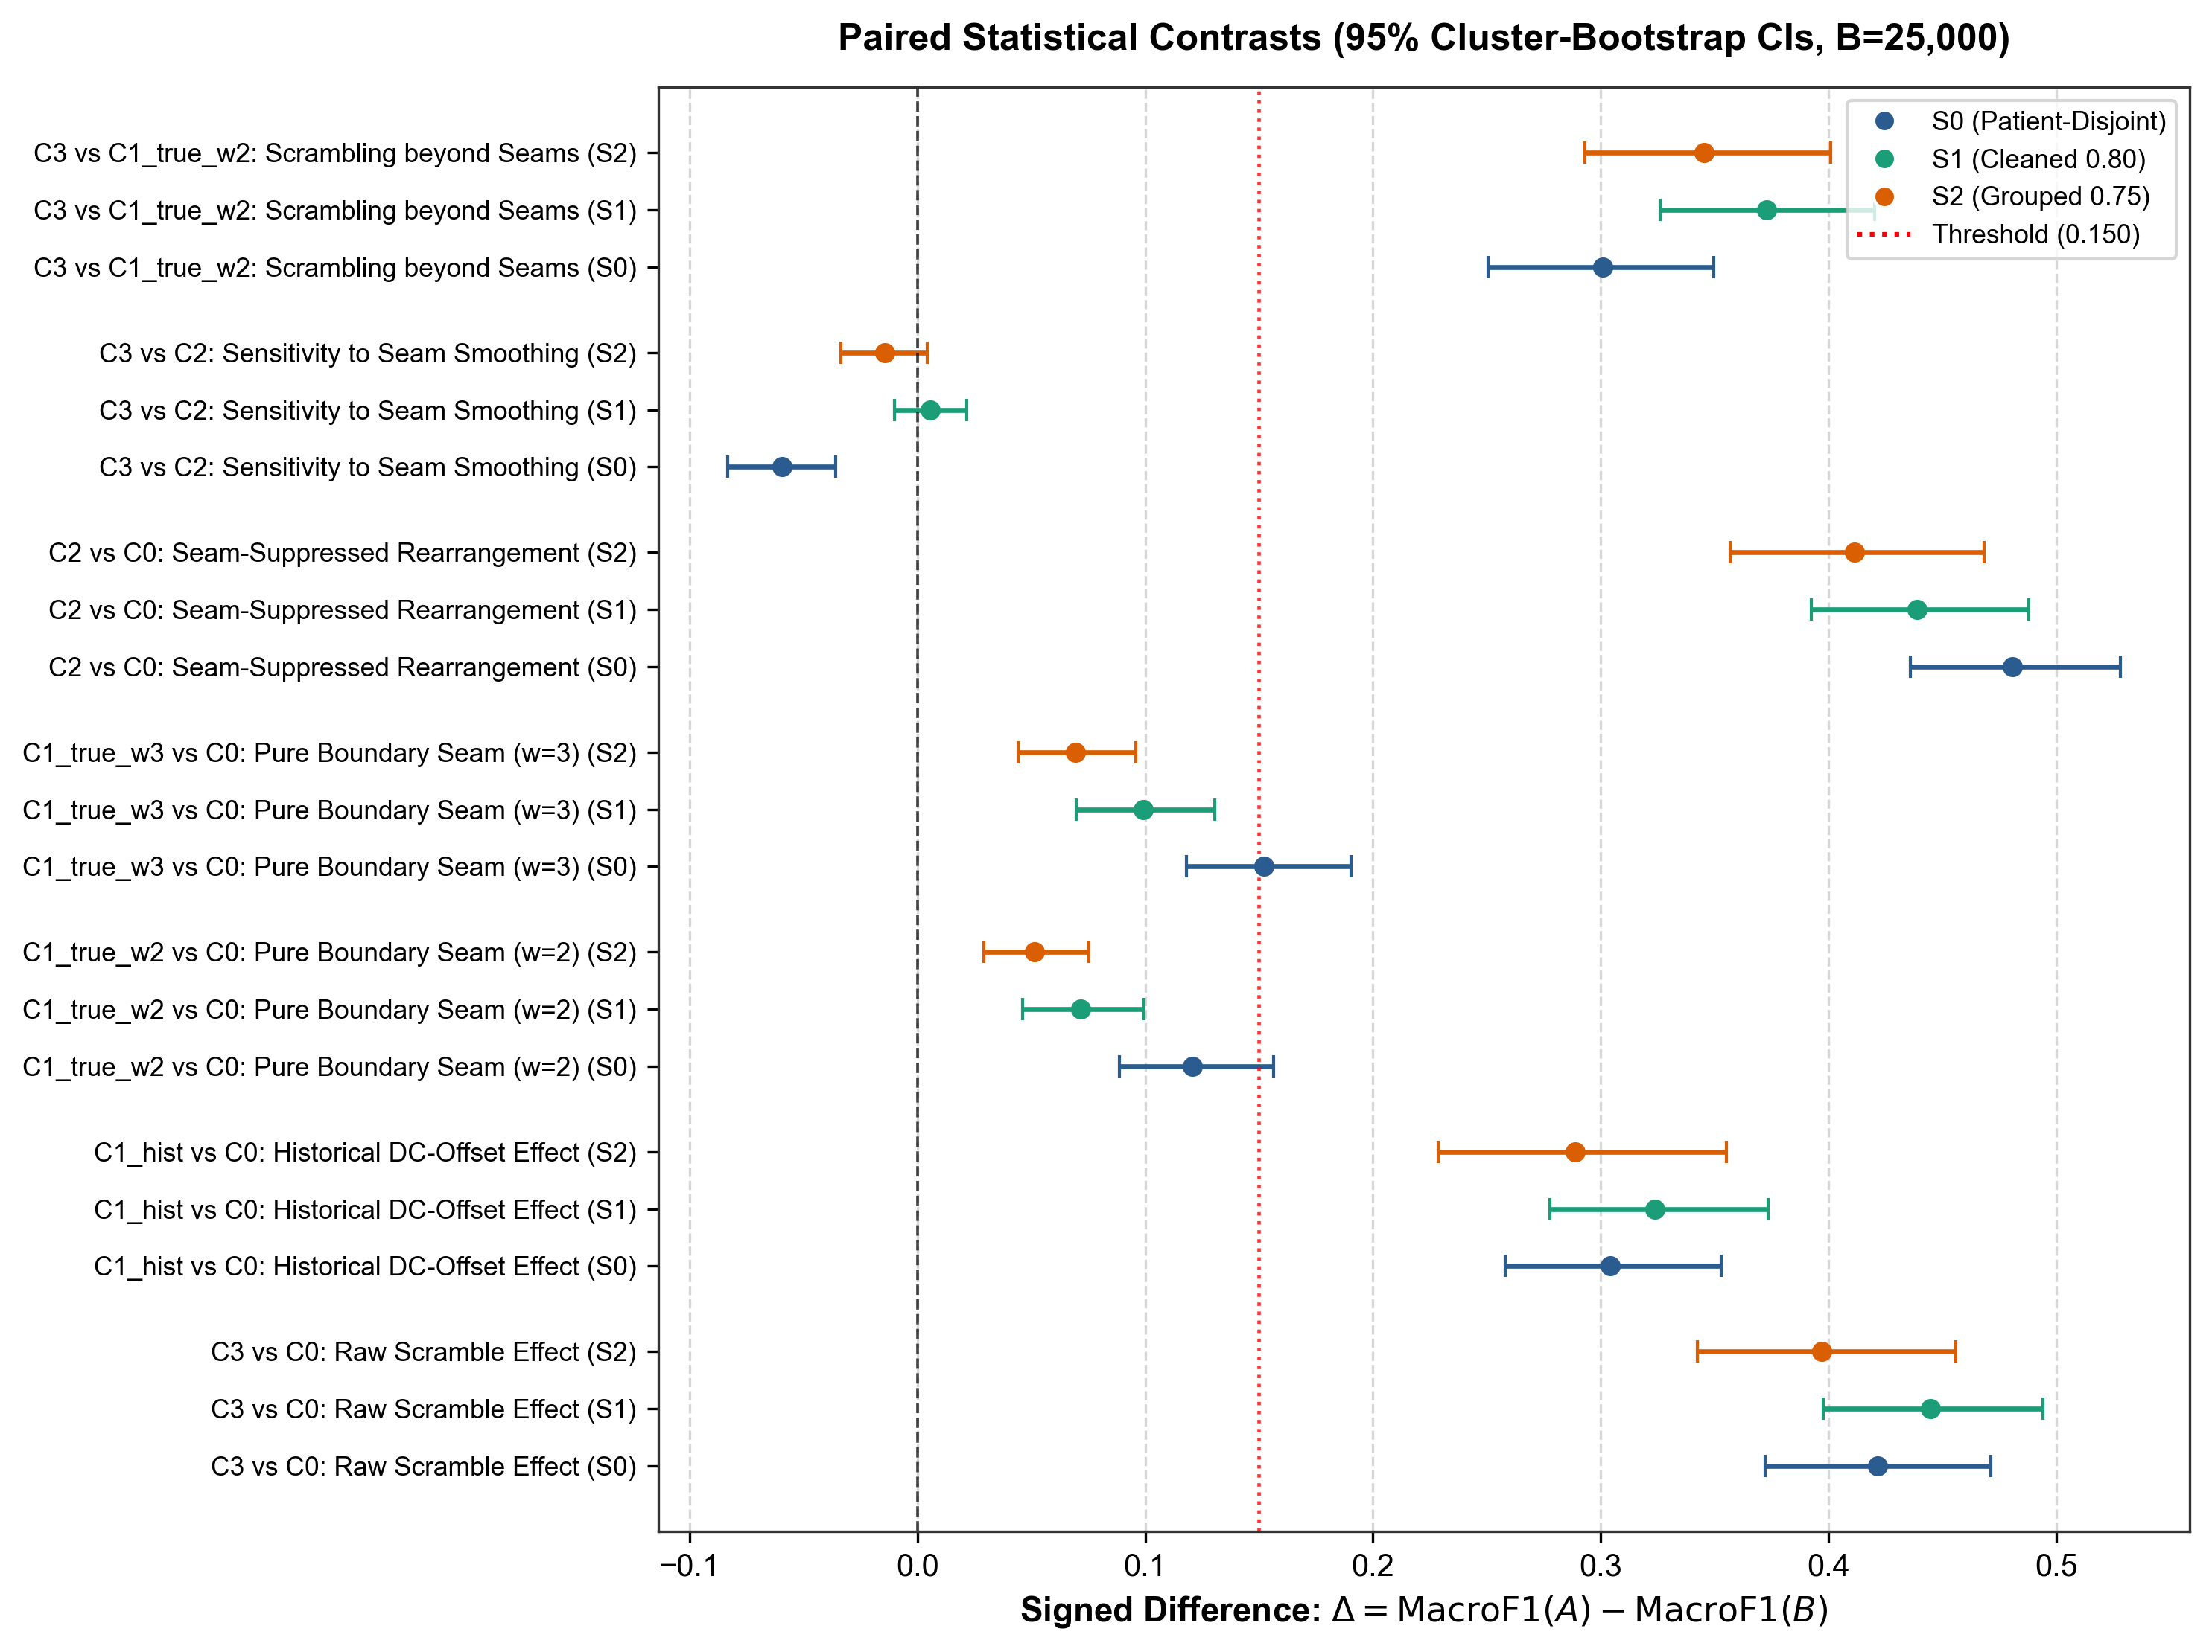
Fig. 6 Forest plot of the 27 paired contrasts (Δ in Macro-F1 with 95% cluster-bootstrap CI). The dashed line marks the 0.150 practical threshold.

4.5 Class-level error structure
The aggregate drop hides an asymmetric error structure (Table 8, Fig. 7, Fig. 8). In S₀ the share of the 1,426 glioma slices labelled pituitary tumour is 0.14% (C₀), 31.3% (C₁), 63.5% (C₂), 56.5% (C₃), 16.5% (C_{4a}), 23.4% (C_{4b}). Glioma recall falls from 0.950 at baseline to 0.806 (C_{4a}), 0.747 (C_{4b}), 0.425 (C₁), 0.183 (C₃) and 0.086 (C₂). In the reverse direction, pituitary slices labelled glioma stay at 0.0% under C₂ and 0.9% under C₃. The seam-only controls also move meningioma slices to pituitary tumour (31.5% under C_{4a} versus 6.1% at baseline).
Two points follow. The drift towards “pituitary tumour” increases with the strength of the perturbation and is already present under seam-only perturbation, so it is not unique to spatial rearrangement. And because every intervention pushes predictions towards one class, the networks do not fail symmetrically; this is compatible with the loss of cues that favour glioma (global contour, slice orientation, coarse layout), but also with a more mundane explanation, that the perturbed images resemble some pituitary slices in low-level statistics. The present data cannot separate these explanations (Section 5.4).
Table 8 Per-class recall (R) and precision (P) in S₀ for each condition.
Condition | R men. | R gli. | R pit. | P men. | P gli. | P pit.
C₀ | 0.903 | 0.950 | 0.956 | 0.868 | 0.972 | 0.952
C₁ | 0.855 | 0.425 | 0.766 | 0.537 | 0.860 | 0.577
C₂ | 0.771 | 0.086 | 0.877 | 0.517 | 1.000 | 0.433
C₃ | 0.801 | 0.183 | 0.841 | 0.531 | 0.963 | 0.453
C_{4a} | 0.651 | 0.806 | 0.990 | 0.902 | 0.979 | 0.668
C_{4b} | 0.621 | 0.747 | 0.985 | 0.919 | 0.969 | 0.616
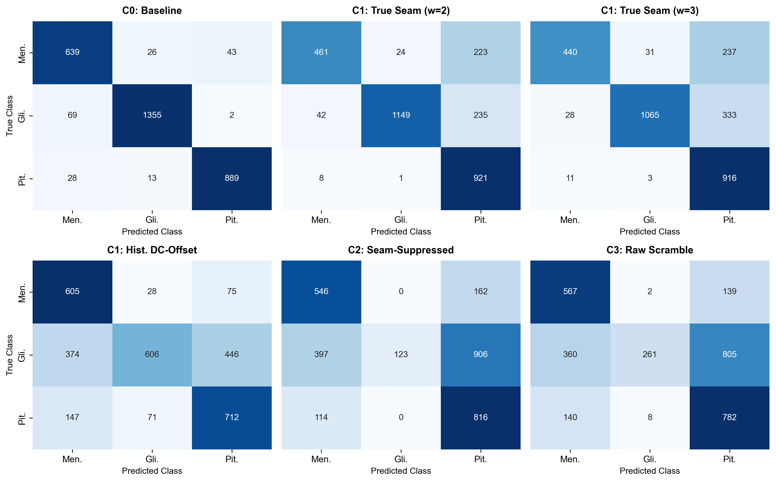
Fig. 7 Pooled out-of-fold confusion matrices in S₀ for the six conditions (rows: true class; columns: predicted class).
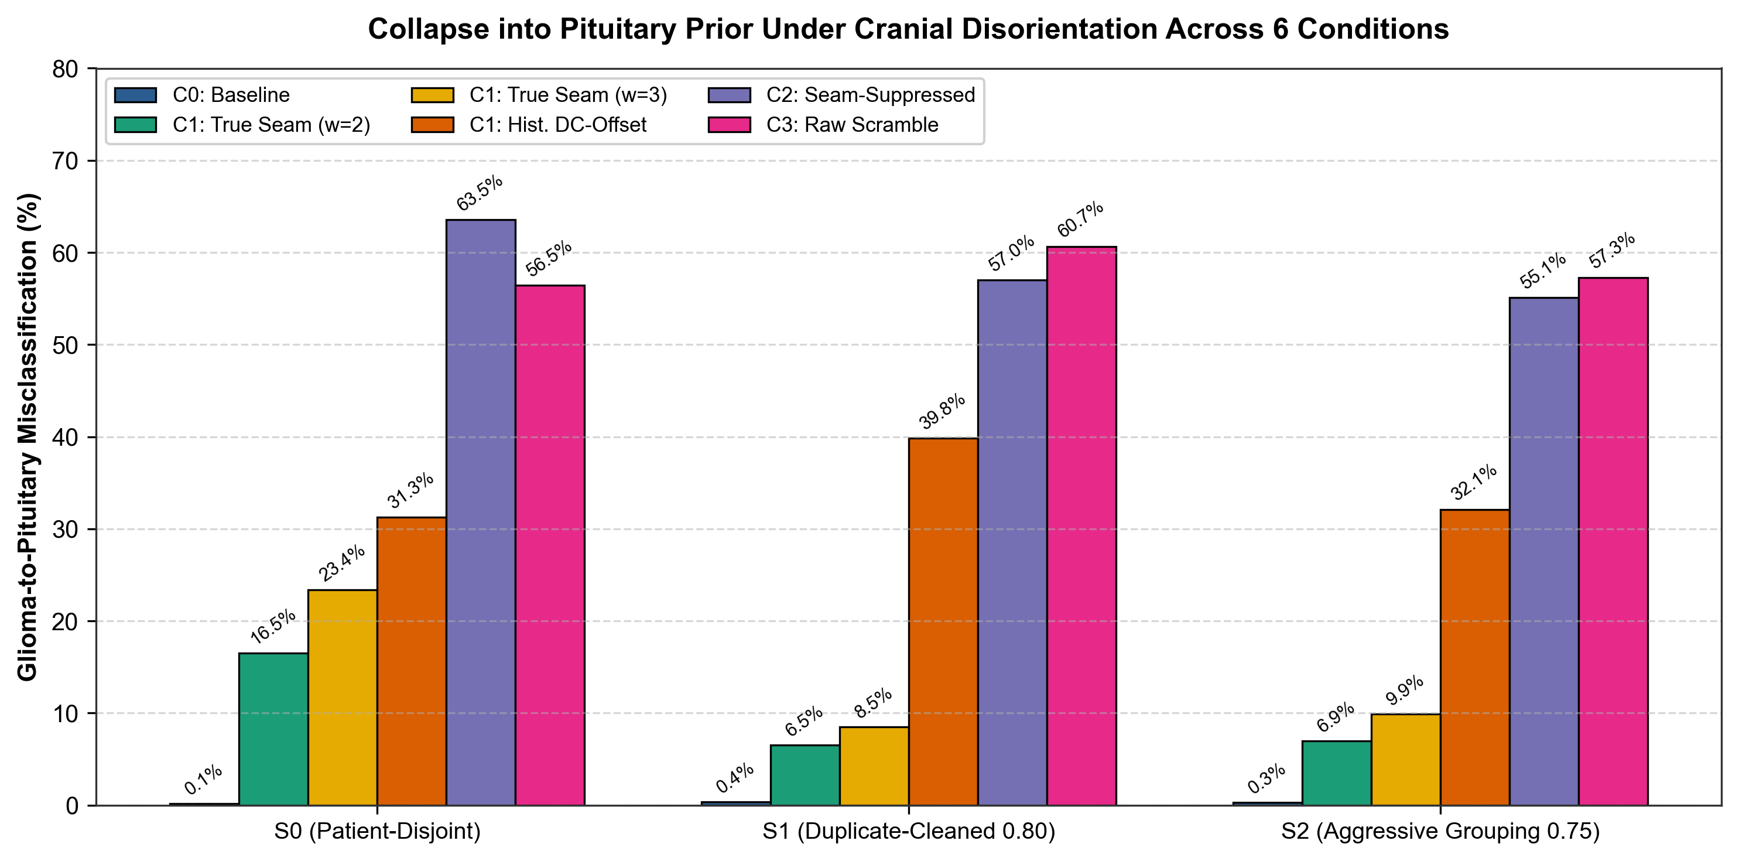
Fig. 8 Rate at which glioma slices are labelled pituitary tumour, by scenario and condition.

4.6 Image diagnostics of the interventions
Table 9 and Fig. 9 report diagnostics computed with the evaluated C2 operator (9×9 Gaussian, σ = 2.5, distance-weighted blend, w = 4 px). Seam suppression achieves 65.0% excess Sobel reduction and 84.9% excess Fourier energy reduction at source resolution relative to C3 (81.5 vs 174.4, baseline 31.5; 715.4 vs 2598.4, baseline 379.8). These values are substantially larger than the draft specification (26.0%/53.9%), confirming that the evaluated operator delivers stronger seam elimination than the draft specification.
The seam-only controls are not energy-matched to the scramble. Seam Sobel energy at source is 88.1 (C_{4a}) and 137.1 (C_{4b}) against 174.4 for C₃ and 31.5 for C₀, and on the network input 68.3 and 85.7 against 183.7 (C₀: 51.0). Their high-frequency Fourier energy at source, in contrast, exceeds that of C₃ (3578 and 5791 versus 2598), because single-pixel steps are very sharp. Hence the seam-only controls are weaker than the scramble on the gradient measure at the network input and stronger on the source-resolution spectral measure, and no single energy statistic is matched. The “interior” Sobel statistic is higher under C₄ than at baseline (37.9 and 44.0 versus 30.5); tile interiors are not modified, so this most likely reflects the 3 × 3 Sobel footprint reaching the modified boundary pixels at the edge of the interior mask.
Caveat on C2. The evaluated predictions were generated with a 9 × 9 Gaussian blur (σ = 2.5) and a distance-weighted blend, with weight max(0, 1 − D/4), as defined in Eq. 6. The earlier dual-resolution diagnostic implementation instead used a 5 × 5 Gaussian (σ = 1.5) blended at 50% on a seam band. Its C2 row and all seam/spectral attenuation percentages derived from that row are therefore withdrawn. The diagnostic script has been corrected to match the evaluated C2 operator, but the output has not been rerun on all 3,064 slices in this editing session. Until those outputs are generated and reconciled, C2 seam attenuation at source and 224 × 224 resolution remains unquantified. C2 should be described as a locally blended spatial permutation; its name alone does not establish how much seam energy was removed.
Table 9. Image diagnostics at source resolution (src; 512 or 256 px) and on the 224 × 224 network input (in), averaged over 3,064 slices. Sobel energies are mean gradient magnitudes on the seam band, at seam junctions and in the tile interior; HF is high-frequency Fourier energy; Unch. is the fraction of pixels identical to C0 at source. C2 diagnostic values are marked pending and must be regenerated with the exact evaluated C2 operator before submission.
Cond. | Seam src | Seam in | Junction src | Interior src | HF src | HF in | Unch. src
C₀ | 31.5 | 51.0 | 32.3 | 30.5 | 380 | 1056 | 1.000
C₁ | 163.4 | 174.3 | 202.6 | 25.4 | 2039 | 1966 | 0.113
C2 (recompute) | 81.5 | 82.7 | 37.7 | 715.4 | 0.093 | 132.0 | 146.7
C₃ | 174.4 | 183.7 | 218.4 | 31.2 | 2598 | 2410 | 0.112
C_{4a} | 88.1 | 68.3 | 127.0 | 37.9 | 3578 | 1558 | 0.813
C_{4b} | 137.1 | 85.7 | 207.0 | 44.0 | 5791 | 2107 | 0.813

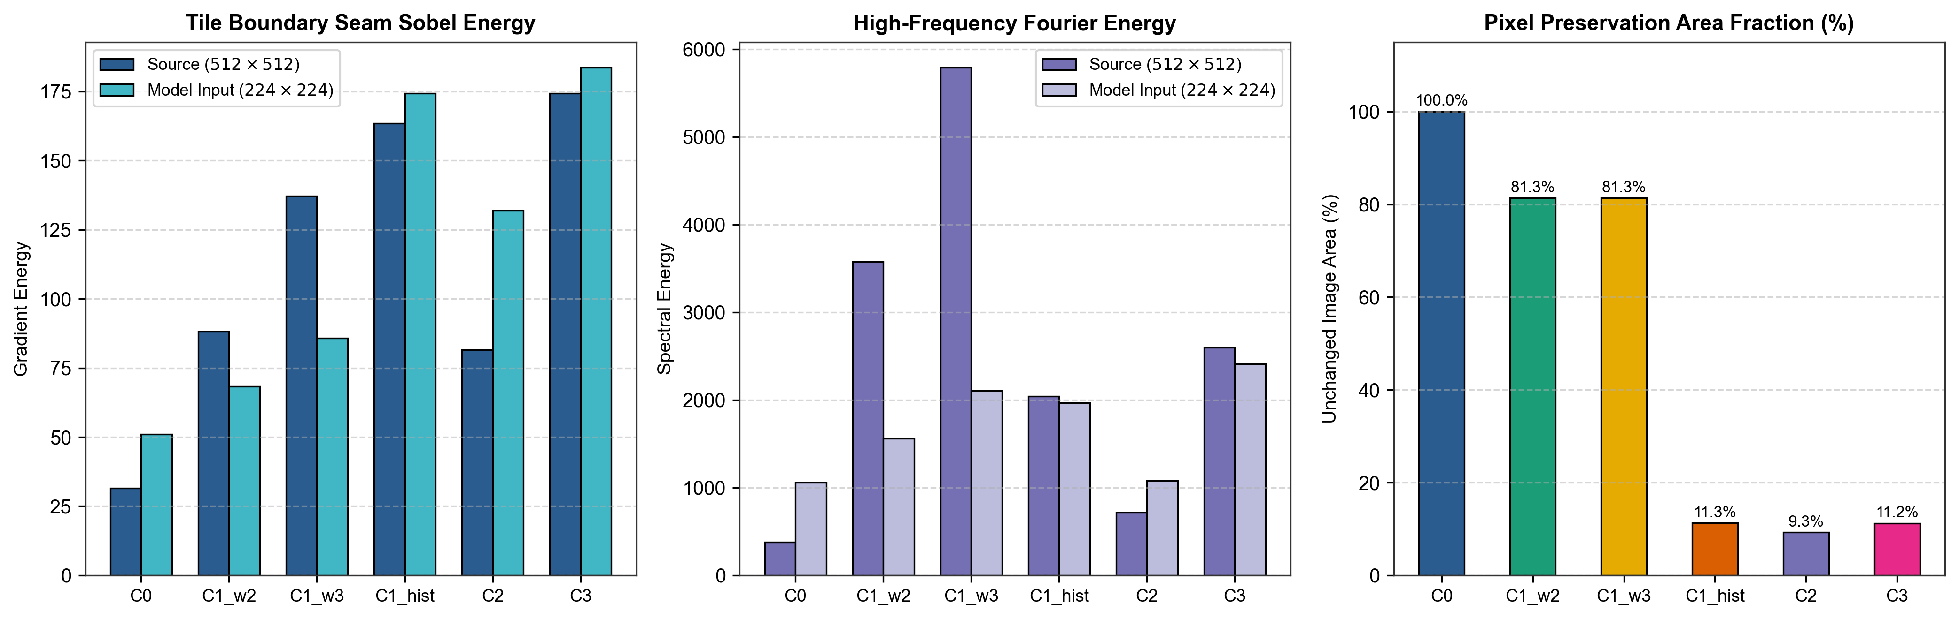
Fig. 9. Image diagnostics of all six conditions at source resolution (512×512) and model input resolution (224×224). Seam Sobel energy, interior energy and high-frequency Fourier energy for C0–C3, C4a and C4b. Diagnostics computed over all 3,064 slices using the evaluated C2 operator (9×9 Gaussian, σ = 2.5, distance-weighted blend, w = 4 px). The C2 seam suppression achieves 65.0% excess Sobel reduction and 84.9% excess Fourier energy reduction at source resolution relative to C3.
Two further differences matter. The tile-level offsets of C₁ are clipped at 0 and 255, which lowers the interior gradient (25.4 versus 30.5 at baseline); and only C₃ preserves the pixel histogram exactly, as it merely permutes pixels. C₁, C₂, C₃ and C₄ are therefore not matched in intensity or texture statistics. Because 256-px slices (15 meningioma slices from a single patient) are too few to analyse separately, a resolution-stratified analysis was not possible.

4.7 Stability across folds and checkpoints
Fig. 10 and Table A1 (Appendix A) show the contrasts for each of the five folds. The baseline contrasts (C₁, C₂, C₃ vs C₀) have the same sign in all 45 fold-level estimates. The seam-only effect is far less uniform: the fold-level C_{4a} vs C₀ drop ranges from 0.006 to 0.247 in S₀, 0.032 to 0.110 in S₁ and 0.015 to 0.083 in S₂, and the corresponding C_{4b} ranges are 0.026–0.277, 0.065–0.131, 0.029–0.105. Some checkpoints are therefore almost insensitive to seam steps while others lose more than 0.2 Macro-F1. Contrasts with a negative fold-level estimate (sign not constant across folds): S0 C3 vs C2; S1 C3 vs C2; S2 C3 vs C2. Because each fold uses a different checkpoint, fold variation combines test-sample variability with checkpoint-level variability, and the two cannot be separated with one checkpoint per fold.
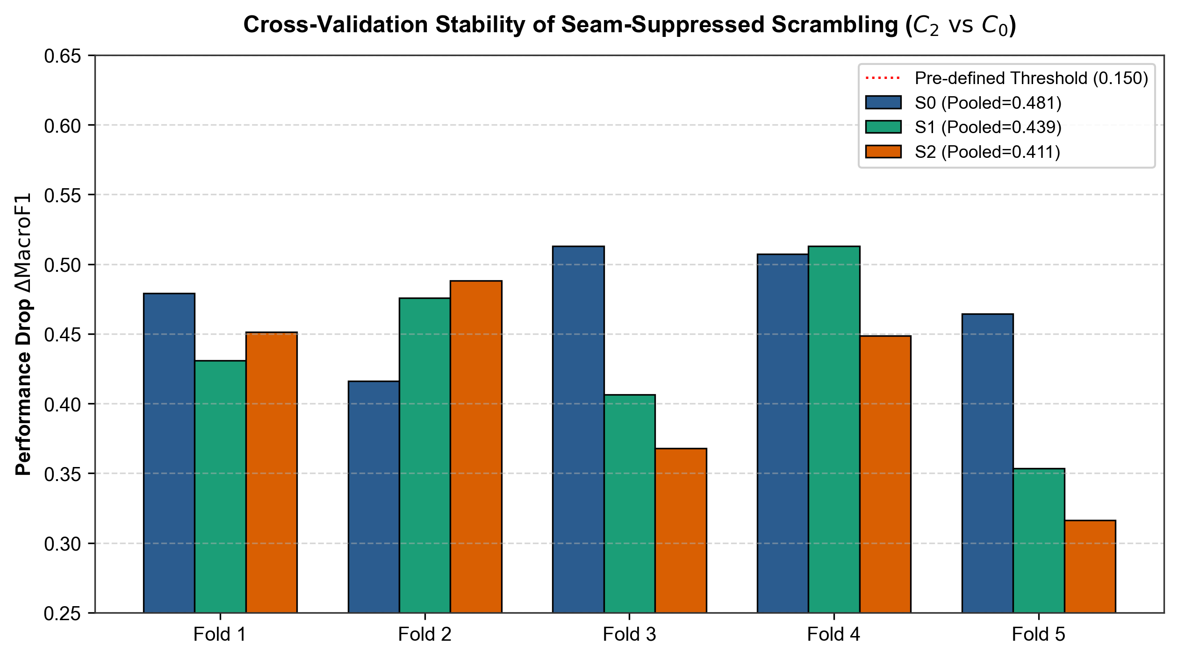
Fig. 10 Fold-level Δ for the contrasts C₁, C_{4a} and C₂ vs C₀ and the three scenarios (points) with the 0.150 practical threshold (dashed line).

4.8 Summary of results
- Baseline Macro-F1 is ≈ 0.93 in all scenarios and is only slightly lowered by near-duplicate cluster merging.
- Raw scrambling, the tile-mean offsets and the seam-suppressed permutation reduce Macro-F1 by 0.29–0.48; all nine such contrasts are significant after Holm–Bonferroni and exceed the 0.150 threshold.
- Seam steps alone (C_{4a}, C_{4b}; two pixels per seam) reduce Macro-F1 by 0.05–0.12 (gain 1.0) and 0.07–0.15 (gain 1.8) in a statistically reliable way; the effect grows with gain, differs between scenarios and is very heterogeneous across checkpoints. The controls are not energy-matched to the scramble, so the ratio to the scramble effect is descriptive only.
- The tile-mean offsets (C₁) remove 0.29–0.32 and raw scrambling a further 0.11–0.12; C₁ reproduces the coarse intensity layout of C₃ and is not a seam control.
- The seam-suppressed permutation did not recover performance (C₃ vs C₂ is inconsistent in sign across scenarios); how much seam energy the evaluated C₂ retains is not established by the diagnostics presented here.
- Failures are asymmetric and graded: the glioma-to-pituitary rate rises from 0.14% at baseline to 16.5–23.4% under seam-only perturbation and 56–64% under scrambling and seam suppression, while pituitary slices are rarely labelled glioma.

4.9 Evaluation of the hypotheses
Hypotheses H₀–H₃ (Section 1) were set in the project’s phased research protocol and its experiment configuration before the models were executed, but were not deposited in an immutable external registry, and repository timestamps cannot prove the order of configuration and predictions. Table 10 states the outcome for each. No equivalence margin was fixed for H₀, so it is judged by whether the confidence interval of C₃ vs C₁ excludes zero. The verdicts refer to the C₁ perturbation as defined in Section 3.6, not to seams in isolation; the seam-only result is an additional, post hoc finding.
Table 10 Hypotheses, tests, estimates (S₀ / S₁ / S₂) and verdicts.
Hypothesis | Test | Δ [95% CI] | Verdict
H₀: C₁ accounts for the entire decline | C₃ vs C₁: Δ > 0, CI excludes 0 | +0.117 [0.082, 0.153] / +0.121 [0.096, 0.146] / +0.108 [0.083, 0.135] | Not supported: C₃ is reliably worse than C₁ (Δ ≈ 0.11–0.12, below 0.150)
H₁: C₁ alone degrades performance | C₁ vs C₀: CI lower bound > 0.150 | +0.304 [0.258, 0.353] / +0.324 [0.278, 0.374] / +0.289 [0.229, 0.355] | Supported in all scenarios (not attributable to seams alone)
H₂: C₂ degrades by > 0.150 | C₂ vs C₀: CI lower bound > 0.150 | +0.481 [0.436, 0.528] / +0.439 [0.392, 0.488] / +0.411 [0.357, 0.468] | Supported in all scenarios
H₃: H₁ and H₂ both supported | Conjunction of H₁ and H₂ | — | Supported as stated; interpretation limited by Section 5.4
Post hoc: seam steps alone degrade performance | C_{4a}, C_{4b} vs C₀: CI excludes 0 (true seam-only family) | +0.121 [0.089, 0.156] / +0.072 [0.046, 0.099] / +0.051 [0.029, 0.075] (C_{4a}) | Supported (Holm, family of 12); below 0.150 except C_{4b} in S₀ (point estimate only)

5 Discussion

5.1 Principal findings
The study asked whether a performance drop under distant-context scrambling can be attributed to synthetic seams introduced by the intervention, to rearrangement of distant context, or to both. Four observations bear on this. (i) A true seam-only perturbation, which changes only the two pixels adjacent to each seam and leaves tile interiors, tumour and margin untouched, lowers Macro-F1 reliably in all three scenarios (by 0.05–0.12 at gain 1.0 and 0.07–0.15 at gain 1.8), so seam discontinuities alone are sufficient to degrade these checkpoints. (ii) The effect increases with the seam gain, but it is smaller in scenarios with stricter near-duplicate grouping and varies strongly between checkpoints. (iii) The tile-mean-offset perturbation (C₁), the raw scramble (C₃) and the seam-suppressed permutation (C₂) lower Macro-F1 by 0.29–0.48, several times more than the seam-only controls, and C₃ is reliably worse than C₁. (iv) Locally blurring the seams did not rescue the classifier. Together, these observations are consistent with sensitivity to both boundary discontinuities and the rearrangement or distortion of distant content. They argue against reading the earlier collapse purely as evidence of dependence on global cranial layout, and equally against reading it purely as a seam artefact. They do not apportion the effect between mechanisms.

5.2 Seams versus spatial rearrangement
Two descriptive ratios are tempting and should be avoided as decompositions. The ratio κ = Δ_{C1}/Δ_{C3} ≈ 0.72 (S₀) is not the seam share, because C₁ gives every tile the mean of the tile that C₃ would place there and so carries the coarse intensity rearrangement of the scramble in addition to its seams (Fig. 3). The ratio of the seam-only drop to the scramble drop (0.29, 0.16 and 0.13 for C_{4a} in S₀, S₁ and S₂; 0.36, 0.22 and 0.18 for C_{4b}) is not a seam share either: it changes with scenario and gain, the seam-only controls are not matched to the scramble in gradient or spectral energy (Section 4.6), and the scale is saturating, since Macro-F1 cannot fall below a floor of about 0.21 for a constant prediction, so equal increments do not imply equal contributions.
Why C₂ is not better than C₃ is open. Possible reasons include residual discontinuity (not established here, because the C₂ diagnostics of the repository use a different implementation; Section 4.6), the new artefact of blurred bands and reduced within-tile contrast, and the fact that the permutation is identical in C₂ and C₃, so any damage from displaced anatomy or missing global context is shared. A seam-free rearrangement is needed to separate these explanations.

5.3 Connection to shortcut learning and benchmark audits
Shortcut-learning studies in chest radiography, dermatology and skeletal imaging show that classifiers can succeed through cues that are not the intended pathology [1, 2, 5–8]. Scrambling and occlusion probes are common tools for testing such reliance [9–11], but these interventions can also change the input distribution and introduce artificial boundaries. The motivation for this study is this methodological confound: a performance drop under scrambling is not, by itself, an unambiguous measure of reliance on a particular cue. Sensitivity to texture and high-frequency content, documented for natural images [13–15, 29, 30], is a plausible but untested route. Our S₀–S₂ comparison shows robustness across grouping regimes only in a limited sense because baseline performance changed little. Since the frozen checkpoints were trained under each scenario’s grouping, this comparison speaks to the evaluation protocol, not to leakage at training time.

5.4 Alternative explanations and confounds
Several alternative explanations remain open, and each corresponds to a concrete follow-up control.
- Acquisition plane. The Cheng collection mixes axial, coronal and sagittal slices and tumour class is not independent of plane (pituitary tumours are typically imaged coronally or sagittally, as in Fig. 2). The Cheng MAT files contain no plane field (only PID, image, label, tumour border and mask), so plane would have to be labelled by hand. Distant-context cues such as skull outline and orientation partly encode class, and any perturbation of that context could hurt class-specific recognition regardless of seams. The drift towards pituitary tumour (Section 4.5) is consistent with this possibility, which is untested.
- Scale of the interventions. C₁, C₂ and C₃ change about 89–90% of pixels at source resolution. A perturbation that rewrites nearly the entire field of view is a large distribution shift; graded interventions (tile size, fraction of tiles) are needed to test dose–response.
- Non-matched controls. C₁ shares the coarse intensity layout of C₃; C_{4a} and C_{4b} are not energy-matched to C₃; and none of the conditions is matched to another in intensity or texture statistics (Table 9). The seam-only perturbation differs from the scramble in seam amplitude, in the non-local juxtaposition of tiles, and in out-of-distribution content, so differences cannot be ascribed to one property.
- Background tiles. The permutation includes background tiles, so borders between dark and bright areas change even where no anatomy is displaced.
- Checkpoint variance. Only one checkpoint per fold is available, so initialization variance cannot be separated from fold variance; the seam-only effect in particular differs strongly between folds (Section 4.7).

5.5 Implications for evaluation practice
For researchers using spatial perturbations as interpretability probes, the results suggest three rules. First, include a seam-only control in any tile-based experiment and report its drop beside the main perturbation; here it was not negligible. Second, report image diagnostics (changed-pixel fraction, gradient and high-frequency energy, at both source and network-input resolution) alongside accuracy. Third, avoid converting a drop in accuracy into a claim about what the model “uses” unless the perturbation is matched on the competing explanations; the accurate statement here is that the models are sensitive to seam artefacts and to rearrangement or distortion of distant context.

5.6 Recommended follow-up controls
- A seam-only control matched in energy to C₃ on the network input, and a width and amplitude dose–response (the present C_{4b} varies amplitude only, not width).
- Stratify all results by acquisition plane (hand-labelled if necessary) and, where possible, by scanner and institution; repeat the analysis within plane.
- A dose–response experiment in tile size and in the fraction of permuted tiles.
- Histogram- and texture-matched controls, and a background-only perturbation that leaves all anatomy untouched.
- A seam-free rearrangement (for example, permutation with identical border statistics or Poisson blending), and a recomputation of the C₂ diagnostics with the evaluated C₂ code on the network input.
- Retraining with seam and scrambling augmentation, and multiple random seeds per fold to separate checkpoint from fold variance.
- Attribution maps and occlusion curves, interpreted cautiously in light of the artefacts identified here.

6 Limitations
The study has the following limitations, which bound the claims that can be made.
- Single dataset and architecture. All results are for the Cheng cohort (3,064 slices, 233 patients) and a ResNet-50. Generalization to other datasets, architectures or modalities is untested.
- Frozen checkpoints. The analysis evaluates 15 pre-trained checkpoints, one per fold and scenario. Conclusions concern test-time sensitivity, not what a network would learn if trained with the interventions.
- Unmatched controls. C₁ reproduces the coarse intensity layout of C₃; the seam-only controls are not energy-matched to C₃, and their second variant changes amplitude, not width; the controls were added post hoc. Attribution of the effect to seams or to rearrangement is therefore partial (Section 5.4).
- Diagnostics. The C₂ row of the dual-resolution diagnostics was produced with a different blur implementation than the evaluated C₂, so the residual seam energy of C₂ is not established. The interior Sobel statistic is affected by the Sobel footprint at the interior boundary. The unmodified area under C₁–C₃ is larger than the protected zone because tiles touching it are not permuted, and the junction between this block and the permuted context is not smoothed in C₂.
- Confounding with imaging plane, resolution and site. Tumour class is partly confounded with acquisition plane and possibly scanner and institution; no plane metadata exist in the source files. The 256 × 256 slices (15 meningioma slices from one patient) are too few for a resolution-stratified analysis.
- Statistics. The cluster bootstrap resamples patient clusters (S₀) or candidate groups (S₁, S₂), but folds are not independent. With B = 25,000 the smallest p-value is 8.0×10⁻⁵, so adjusted values of most contrasts reflect bootstrap resolution. The true seam-only Holm family was defined after the primary results were known. McNemar tests ignore clustering and test correctness, not Macro-F1. Confidence intervals are unadjusted. The 0.150 threshold is a project convention, not a clinically derived margin.
- Pre-specification. Decision criteria were locked in the project protocol before model execution but not deposited on an external registry, and repository commit times cannot demonstrate their order relative to the predictions.
- Slice-level labels. The target is slice-level tumour class, not a clinical diagnosis; slice-level accuracy may overstate patient-level performance.
- Software environment. The recorded environment (a PyTorch development build) cannot be reinstalled; the environment lock is documentation only.
- Open items. C2 diagnostics must be rerun using the corrected generator; plane-stratified analysis, additional controls, multi-seed checkpoints, full reference verification, and journal/declaration details remain open (Appendix B). The unsupported numerical result is no longer attributed to [12].

7 Conclusion
We examined how seam artefacts and spatial rearrangement contribute to the collapse of a brain-tumour MRI classifier under distant-context scrambling, using six input conditions, 15 frozen ResNet-50 checkpoints and 55,152 out-of-fold predictions. On the patient-disjoint split, Macro-F1 fell from 0.9333 to 0.8127 and 0.7811 under true seam-only controls (C_{4a}, C_{4b}), 0.6290 under tile-mean offsets (C₁), 0.5118 under raw scrambling (C₃) and 0.4525 under seam-suppressed permutation (C₂). Seam steps alone therefore degrade the classifier reliably, but much less than scrambling, and the size of the seam effect depends on the scenario, the seam gain and the checkpoint. Raw scrambling was reliably more damaging than the tile-mean offsets (Δ ≈ 0.11–0.12), and locally suppressing seams did not restore performance. Failures were asymmetric: glioma slices were relabelled mainly as pituitary tumour, already at 16–23% under seam-only perturbation and at 56–64% under scrambling and seam suppression.
The results are consistent with sensitivity to both synthetic boundary discontinuities and the rearrangement of distant content, and they caution against attributing scrambling-induced collapse to dependence on global anatomy alone. They do not establish a single mechanism and do not give a seam share: the seam-only controls are not energy-matched to the scramble, the interventions alter about 89–90% of pixels, the seam retention of C₂ is unquantified, and tumour class is potentially confounded with imaging plane. The controls required next are plane-stratified analysis, energy-matched and width/tile-size dose–response controls, seam-free rearrangements, and multi-seed retraining.

Declarations
Funding. This research received no specific grant from any funding agency in the public, commercial or not-for-profit sectors.
Competing interests. The authors declare that they have no competing interests.
Ethics approval and consent to participate. Not applicable. This study used a publicly available, de-identified dataset; ethical approval and consent for the original data collection are described by Cheng et al. [3, 4].
Consent for publication. Not applicable.
Data availability. The study used the publicly available Cheng brain-tumour MRI dataset (Figshare, DOI 10.6084/m9.figshare.1512427; https://figshare.com/articles/dataset/brain_tumor_dataset/1512427) [3, 4], obtained from its official source and used in accordance with its access and licensing conditions. The raw MRI images are not redistributed with this study. The derived research artifacts, namely the split manifests, patient-grouping tables, out-of-fold prediction tables, bootstrap and diagnostics outputs, and the tables and figures of the manuscript, are archived together with the research software on Zenodo (Brain Tumor Prediction Using Deep Learning – Research Release v1.0.0, DOI: https://doi.org/10.5281/zenodo.23556684).
Code availability. The source code and implementation of this study are publicly available in the project GitHub repository (https://github.com/CSrajput-ux/brain-tumor-prediction-using-deep-leaning) [25]. The repository contains the data curation and patient-grouping workflow, the training pipeline and model configuration for the 15 ResNet-50 checkpoints, the scripts that generate the six input conditions (including the true seam-only controls), the out-of-fold prediction tables, the image-diagnostics scripts at source and network-input resolution, the synchronized cluster-bootstrap, Holm–Bonferroni and McNemar analyses, the tables and figures of the manuscript, checksum manifests, an automated test suite and the associated documentation. The archived research software release (Brain Tumor Prediction Using Deep Learning – Research Release v1.0.0) is available through Zenodo at DOI: https://doi.org/10.5281/zenodo.23556684.
Author contributions. C. designed the study concept, implemented and ran the experiments and statistical analysis, interpreted the results and drafted the manuscript. R.G. contributed to study supervision, scientific review and manuscript revision. Both authors should review and approve the final manuscript. [Exact contribution statement to be confirmed by the authors.]
Acknowledgements. The authors thank the contributors of the Cheng brain-tumour dataset. [Further acknowledgements to be added if required.]

References
[1] Winkler, J.K., Fink, C., Toberer, F., Enk, A., Deinlein, T., Hofmann-Wellenhof, R., Thomas, L., Lallas, A., Blum, A., Stolz, W., et al.: Association between surgical skin markings in dermoscopic images and diagnostic performance of a deep learning convolutional neural network for melanoma recognition. JAMA Dermatol. 155(10), 1135–1141 (2019)
[2] Zech, J.R., Badgeley, M.A., Liu, M., Costa, A.B., Titano, J.J., Oermann, E.K.: Variable generalization performance of a deep learning model to detect pneumonia in chest radiographs: a cross-sectional study. PLOS Med. 15(11), e1002683 (2018)
[3] Cheng, J., Huang, W., Cao, S., Yang, R., Yang, W., Yun, Z., Wang, Z., Feng, Q.: Enhanced performance of brain tumor classification via tumor region augmentation and partition. PLOS ONE 10(10), e0140381 (2015)
[4] Cheng, J., Yang, W., Huang, M., Huang, W., Jiang, J., Zhou, Y., Yang, R., Zhao, J., Feng, Y., Feng, Q., Chen, W.: Retrieval of brain tumors by adaptive spatial pooling and Fisher vector representation. PLOS ONE 11(6), e0157112 (2016)
[5] Geirhos, R., Jacobsen, J.-H., Michaelis, C., Zemel, R., Brendel, W., Bethge, M., Wichmann, F.A.: Shortcut learning in deep neural networks. Nat. Mach. Intell. 2(11), 665–673 (2020)
[6] DeGrave, A.J., Janizek, J.D., Lee, S.-I.: AI for radiographic COVID-19 detection selects shortcuts over signal. Nat. Mach. Intell. 3(7), 610–619 (2021)
[7] Badgeley, M.A., Zech, J.R., Oakden-Rayner, L., Glicksberg, B.S., Liu, M., Gale, W., McConnell, M.V., Percha, B., Snyder, T.M., Dudley, J.T.: Deep learning predicts hip fracture using confounding patient and healthcare variables. npj Digit. Med. 2, 31 (2019)
[8] Bissoto, A., Fornaciali, M., Valle, E., Avila, S.: (De)constructing bias on skin lesion datasets. In: Proc. IEEE/CVF Conf. Computer Vision and Pattern Recognition Workshops (CVPRW), pp. 2766–2774 (2019)
[9] Zeiler, M.D., Fergus, R.: Visualizing and understanding convolutional networks. In: Computer Vision – ECCV 2014, LNCS 8689, pp. 818–833. Springer (2014)
[10] Fong, R.C., Vedaldi, A.: Interpretable explanations of black boxes by meaningful perturbation. In: Proc. IEEE Int. Conf. Computer Vision (ICCV), pp. 3429–3437 (2017)
[11] Xiao, K., Engstrom, L., Ilyas, A., Madry, A.: Noise or signal: the role of image backgrounds in object recognition. In: Int. Conf. Learning Representations (ICLR) (2021)
[12] Vangala, B.P., Guda, S., Peddi, L., Vangala, N.: Scores that hold, benchmarks that leak: measuring dataset contamination in public brain-tumor MRI classification. arXiv:2610.00421 (2026)
[13] Geirhos, R., Rubisch, P., Michaelis, C., Bethge, M., Wichmann, F.A., Brendel, W.: ImageNet-trained CNNs are biased towards texture; increasing shape bias improves accuracy and robustness. In: Int. Conf. Learning Representations (ICLR) (2019)
[14] Brendel, W., Bethge, M.: Approximating CNNs with bag-of-local-features models works surprisingly well on ImageNet. In: Int. Conf. Learning Representations (ICLR) (2019)
[15] Hendrycks, D., Dietterich, T.: Benchmarking neural network robustness to common corruptions and perturbations. In: Int. Conf. Learning Representations (ICLR) (2019)
[16] Bertalmio, M., Sapiro, G., Caselles, V., Ballester, C.: Image inpainting. In: Proc. SIGGRAPH 2000, pp. 417–424. ACM (2000)
[17] Castro, D.C., Walker, I., Glocker, B.: Causality matters in medical imaging. Nat. Commun. 11, 3673 (2020)
[18] Oakden-Rayner, L., Dunnmon, J., Carneiro, G., Ré, C.: Hidden stratification causes clinically meaningful failures in machine learning for medical imaging. In: Proc. ACM Conf. Health, Inference, and Learning (CHIL), pp. 151–159 (2020)
[19] Rossi, E.B., Lopez, E., Comminiello, D.: TACE: tumor-aware counterfactual explanations for medical imaging. arXiv:2409.13045 (2024)
[20] He, K., Zhang, X., Ren, S., Sun, J.: Deep residual learning for image recognition. In: Proc. IEEE Conf. Computer Vision and Pattern Recognition (CVPR), pp. 770–778 (2016)
[21] Wang, Z., Bovik, A.C., Sheikh, H.R., Simoncelli, E.P.: Image quality assessment: from error visibility to structural similarity. IEEE Trans. Image Process. 13(4), 600–612 (2004)
[22] Efron, B., Tibshirani, R.J.: An Introduction to the Bootstrap. Chapman & Hall, New York (1993)
[23] McNemar, Q.: Note on the sampling error of the difference between correlated proportions or percentages. Psychometrika 12(2), 153–157 (1947)
[24] Holm, S.: A simple sequentially rejective multiple test procedure. Scand. J. Stat. 6(2), 65–70 (1979)
[25] CSrajput-ux: Brain tumor prediction using deep learning (project repository). https://github.com/CSrajput-ux/brain-tumor-prediction-using-deep-leaning (2026)
[26] Russakovsky, O., Deng, J., Su, H., Krause, J., Satheesh, S., Ma, S., Huang, Z., Karpathy, A., Khosla, A., Bernstein, M., Berg, A.C., Fei-Fei, L.: ImageNet large scale visual recognition challenge. Int. J. Comput. Vis. 115(3), 211–252 (2015)
[27] Esteva, A., Kuprel, B., Novoa, R.A., Ko, J., Swetter, S.M., Blau, H.M., Thrun, S.: Dermatologist-level classification of skin cancer with deep neural networks. Nature 542(7639), 115–118 (2017)
[28] Rajpurkar, P., Irvin, J., Zhu, K., Yang, B., Mehta, H., Duan, T., Ding, D., Bagul, A., Langlotz, C., Shpanskaya, K., et al.: CheXNet: radiologist-level pneumonia detection on chest X-rays with deep learning. arXiv:1711.05225 (2017)
[29] Wang, H., Wu, X., Huang, Z., Xing, E.P.: High-frequency component helps explain the generalization of convolutional neural networks. In: Proc. IEEE/CVF Conf. Computer Vision and Pattern Recognition (CVPR), pp. 8684–8694 (2020)
[30] Yin, D., Gontijo Lopes, R., Shlens, J., Cubuk, E.D., Gilmer, J.: A Fourier perspective on model robustness in computer vision. In: Advances in Neural Information Processing Systems 32 (2019)
[31] Chang, C.-H., Creager, E., Goldenberg, A., Duvenaud, D.: Explaining image classifiers by counterfactual generation. In: Int. Conf. Learning Representations (ICLR) (2019)

Appendix A Fold-level contrasts and confusion matrices
Table A1 Fold-level Δ (Macro-F1 difference, A − B) for every contrast. SD is the standard deviation across the five folds.
Scen. | Contrast | Fold 1 | Fold 2 | Fold 3 | Fold 4 | Fold 5 | SD
S₀ | C₁ vs C₀ | 0.374 | 0.254 | 0.357 | 0.177 | 0.382 | 0.090
S₀ | C₂ vs C₀ | 0.479 | 0.416 | 0.513 | 0.507 | 0.464 | 0.039
S₀ | C₃ vs C₀ | 0.454 | 0.287 | 0.499 | 0.369 | 0.506 | 0.094
S₀ | C₃ vs C₁ | 0.080 | 0.033 | 0.142 | 0.192 | 0.124 | 0.061
S₀ | C_{4a} vs C₀ | 0.006 | 0.066 | 0.166 | 0.128 | 0.247 | 0.092
S₀ | C_{4b} vs C₀ | 0.026 | 0.081 | 0.235 | 0.160 | 0.277 | 0.104
S₀ | C₃ vs C_{4a} | 0.448 | 0.221 | 0.333 | 0.241 | 0.260 | 0.093
S₀ | C₂ vs C_{4a} | 0.473 | 0.350 | 0.347 | 0.380 | 0.218 | 0.091
S₀ | C₃ vs C₂ | −0.025 | −0.130 | −0.014 | −0.138 | 0.042 | 0.078
S₁ | C₁ vs C₀ | 0.303 | 0.424 | 0.204 | 0.545 | 0.165 | 0.157
S₁ | C₂ vs C₀ | 0.431 | 0.476 | 0.407 | 0.513 | 0.353 | 0.062
S₁ | C₃ vs C₀ | 0.384 | 0.482 | 0.422 | 0.598 | 0.371 | 0.093
S₁ | C₃ vs C₁ | 0.081 | 0.058 | 0.218 | 0.054 | 0.205 | 0.081
S₁ | C_{4a} vs C₀ | 0.078 | 0.062 | 0.110 | 0.075 | 0.032 | 0.028
S₁ | C_{4b} vs C₀ | 0.087 | 0.092 | 0.117 | 0.131 | 0.065 | 0.026
S₁ | C₃ vs C_{4a} | 0.305 | 0.421 | 0.311 | 0.523 | 0.339 | 0.093
S₁ | C₂ vs C_{4a} | 0.352 | 0.414 | 0.296 | 0.438 | 0.321 | 0.060
S₁ | C₃ vs C₂ | −0.047 | 0.007 | 0.015 | 0.085 | 0.017 | 0.047
S₂ | C₁ vs C₀ | 0.425 | 0.353 | 0.276 | 0.176 | 0.226 | 0.099
S₂ | C₂ vs C₀ | 0.451 | 0.488 | 0.368 | 0.449 | 0.316 | 0.070
S₂ | C₃ vs C₀ | 0.465 | 0.402 | 0.352 | 0.431 | 0.341 | 0.052
S₂ | C₃ vs C₁ | 0.040 | 0.049 | 0.076 | 0.255 | 0.115 | 0.088
S₂ | C_{4a} vs C₀ | 0.083 | 0.075 | 0.035 | 0.015 | 0.052 | 0.028
S₂ | C_{4b} vs C₀ | 0.105 | 0.103 | 0.050 | 0.029 | 0.061 | 0.033
S₂ | C₃ vs C_{4a} | 0.382 | 0.327 | 0.318 | 0.416 | 0.289 | 0.052
S₂ | C₂ vs C_{4a} | 0.368 | 0.414 | 0.333 | 0.434 | 0.264 | 0.067
S₂ | C₃ vs C₂ | 0.013 | −0.086 | −0.016 | −0.017 | 0.024 | 0.043

Table A2 Pooled out-of-fold confusion matrices (rows: true class; columns: predicted class; M = meningioma, G = glioma, P = pituitary tumour).
Scenario / condition | True | Pred. M | Pred. G | Pred. P | Total
S₀ / C₀ | M | 639 | 26 | 43 | 708
 | G | 69 | 1355 | 2 | 1426
 | P | 28 | 13 | 889 | 930
S₀ / C₁ | M | 605 | 28 | 75 | 708
 | G | 374 | 606 | 446 | 1426
 | P | 147 | 71 | 712 | 930
S₀ / C₂ | M | 546 | 0 | 162 | 708
 | G | 397 | 123 | 906 | 1426
 | P | 114 | 0 | 816 | 930
S₀ / C₃ | M | 567 | 2 | 139 | 708
 | G | 360 | 261 | 805 | 1426
 | P | 140 | 8 | 782 | 930
S₀ / C_{4a} | M | 461 | 24 | 223 | 708
 | G | 42 | 1149 | 235 | 1426
 | P | 8 | 1 | 921 | 930
S₀ / C_{4b} | M | 440 | 31 | 237 | 708
 | G | 28 | 1065 | 333 | 1426
 | P | 11 | 3 | 916 | 930
S₁ / C₀ | M | 624 | 37 | 47 | 708
 | G | 50 | 1371 | 5 | 1426
 | P | 31 | 8 | 891 | 930
S₁ / C₁ | M | 542 | 3 | 163 | 708
 | G | 311 | 547 | 568 | 1426
 | P | 147 | 1 | 782 | 930
S₁ / C₂ | M | 526 | 0 | 182 | 708
 | G | 356 | 257 | 813 | 1426
 | P | 155 | 0 | 775 | 930
S₁ / C₃ | M | 495 | 0 | 213 | 708
 | G | 302 | 259 | 865 | 1426
 | P | 149 | 1 | 780 | 930
S₁ / C_{4a} | M | 472 | 40 | 196 | 708
 | G | 25 | 1308 | 93 | 1426
 | P | 6 | 1 | 923 | 930
S₁ / C_{4b} | M | 423 | 79 | 206 | 708
 | G | 12 | 1293 | 121 | 1426
 | P | 10 | 1 | 919 | 930
S₂ / C₀ | M | 630 | 40 | 38 | 708
 | G | 74 | 1348 | 4 | 1426
 | P | 33 | 9 | 888 | 930
S₂ / C₁ | M | 620 | 2 | 86 | 708
 | G | 460 | 508 | 458 | 1426
 | P | 85 | 0 | 845 | 930
S₂ / C₂ | M | 555 | 1 | 152 | 708
 | G | 413 | 227 | 786 | 1426
 | P | 62 | 0 | 868 | 930
S₂ / C₃ | M | 543 | 0 | 165 | 708
 | G | 345 | 264 | 817 | 1426
 | P | 63 | 0 | 867 | 930
S₂ / C_{4a} | M | 522 | 35 | 151 | 708
 | G | 46 | 1281 | 99 | 1426
 | P | 5 | 1 | 924 | 930
S₂ / C_{4b} | M | 493 | 51 | 164 | 708
 | G | 31 | 1254 | 141 | 1426
 | P | 1 | 3 | 926 | 930

