Tumour-core, peritumoral-margin and remote-context evidence in brain MRI classification: a sham-controlled counterfactual audit with descriptive plane stratification
Chhotu Rajput1* and Rishi Gupta2
¹Manipal University Jaipur, Jaipur, Rajasthan, India.
²Department of Computer Science and Engineering, School of Computer Science and Engineering, Faculty of Science, Technology and Education, Manipal University Jaipur, Jaipur, Rajasthan, India.
*Corresponding author(s). E-mail(s): chhotu.2427030521@muj.manipal.edu;
Contributing authors: rishi.gupta@jaipur.manipal.edu;
Abstract
Deep convolutional neural networks (CNNs) and Vision Transformers (ViTs) can achieve high benchmark accuracy when classifying primary intracranial neoplasms from contrast-enhanced magnetic resonance imaging (CE-MRI). However, standard evaluations do not resolve whether classification decisions rely on intra-lesional tumour core features, peritumoral transitional margins, or distant cranial context and scanner background signatures. Here, we conduct a sham-controlled, literature-informed counterfactual audit across the Cheng brain tumour MRI cohort (N = 3,064 slices, 233 patients; evaluated on patient-isolated held-out Fold 1, N = 480 slices) and the multi-plane BRISC benchmark (N = 6,000 slices; official test N = 1,000, clean de-duplicated test N = 899). ImageNet-pretrained ResNet-50 and DeiT-Small/16 models were evaluated against an engineered five-region topological taxonomy: tumour core (R_core), immediate peritumoral margin (R_immediate, 4-pixel dilation ring), outer margin (R_outer, 12-pixel ring), remote brain parenchyma (R_remote), and an area- and contour-matched contralateral normal tissue sham control (R_sham), using boundary PDE inpainting (Method A) and locally matched Gaussian texture filling (Method B). In total, 1,200 counterfactual interventions met strict non-target pixel invariance (|Δ| < 10⁻⁵), and 1,800 paired prediction observations were evaluated. Perturbing the tumour core under inpainting induced the largest evidence drop in DeiT-Small (Cheng: sham-corrected sensitivity τ_core = 0.1282 ± 0.248, raw p = 9.13 × 10⁻⁶, family-wise Holm-adjusted p = 0.0003 across 32 tests; borderline patient-clustered Wilcoxon p = 0.0488; BRISC: τ_core = 0.0517 ± 0.120, raw p = 0.0320) and in ResNet-50 (Cheng: τ_core = 0.0311 ± 0.057, raw p = 0.0007, Holm-adjusted p = 0.0183). In pooled multi-cohort comparison (N = 90), DeiT-Small exhibited higher core sensitivity than ResNet-50 (τ_core = 0.0900 vs 0.0161, difference +0.0738, Wilcoxon p = 0.0123; cluster Wilcoxon p = 0.0162) and superior probability calibration (Cheng 10-bin Expected Calibration Error: 0.0366 vs 0.1835). Immediate margin edits produced statistically significant evidence drops across cohorts (Cheng DeiT: τ_immediate = 0.0213 ± 0.096, p = 0.0267; BRISC DeiT: τ_immediate = 0.0239 ± 0.063, p = 0.0152). Normalising by mask area showed that core evidence density (per 1,000 pixels) exceeded outer margin density by 3.4-fold to 95-fold, demonstrating that larger absolute outer margin drops under texture filling reflect substantial annular tissue volume. In BRISC, 101 exact train-test duplicate images (10.1% test leakage, 96 meningiomas) shifted test class balance, altering full 4-class macro-F1 (DeiT-Small: 0.8030 official vs 0.8344 clean; ResNet-50: 0.7095 official vs 0.6991 clean). These findings indicate that brain tumour classifiers derive diagnostic evidence primarily from intra-tumoural morphology and immediate transitional margins while remaining robust to distant context, with Vision Transformers demonstrating higher core feature sensitivity and calibration.
Keywords: brain tumour MRI, counterfactual intervention, peritumoral margin, shortcut learning, ResNet-50, DeiT-Small, Vision Transformer, data leakage, calibration
1 Introduction
Automated classification of primary intracranial neoplasms from contrast-enhanced magnetic resonance imaging (CE-MRI) is a foundational task in computer-aided neuro-oncology. Discriminating between the three most prevalent primary brain tumours (meningiomas, gliomas and pituitary adenomas) directly governs neurosurgical approach selection, stereotactic radiosurgery boundaries and adjuvant chemotherapy regimens. Over the past decade, deep learning systems based on convolutional neural networks (CNNs) and Vision Transformers (ViTs) have repeatedly reported benchmark classification accuracies exceeding 90% to 95% on public MRI datasets [2, 5].
Despite these nominal scores, translational deployment of medical imaging AI into clinical radiology workflows remains impeded by vulnerability to shortcut learning and the “Clever Hans” effect [1, 11]. Wallis and Buvat [1] showed that deep classifiers trained on a widely used public brain tumour MRI dataset achieved high diagnostic accuracy even when the entire intracranial brain compartment was occluded. The models were inadvertently exploiting acquisition-site background noise, skull thickness signatures and scanner artefacts rather than pathological tissue. Furthermore, unaddressed patient-level data leakage and slice-to-slice correlation across cross-validation splits distort reported metrics and create a false impression of clinical generalisation [6].
Existing methodologies for auditing spatial reliance suffer from two main limitations:
- Coarse binary masking and out-of-distribution shift. Prior occlusion studies predominantly replace entire cerebral hemispheres or rectangular tiles with zero-intensity black patches or uniform noise [3, 4]. This introduces sharp, high-frequency boundary cliffs and out-of-distribution (OOD) domain shift, making it impossible to determine whether a performance collapse is caused by the loss of diagnostic evidence or by network failure on unnatural artefacts.
- Absence of anatomically matched controls. Standard ablation studies lack matched sham controls. Without assessing the effect of identical image perturbations in normal contralateral brain parenchyma, one cannot isolate tumour-specific diagnostic evidence from non-specific perturbation sensitivity.
To address these challenges, we design and execute a literature-informed, sham-controlled counterfactual audit with descriptive plane stratification across CNN (ResNet-50) and Vision Transformer (DeiT-Small/16) architectures (Fig. 1). Among the studies reviewed, prior spatial perturbation studies predominantly evaluated CNN architectures without Vision Transformers and frequently lacked matched contralateral sham controls [3, 4, 12, 13]. We investigate five central scientific hypotheses: (Hypothesis 1) Prediction sensitivity is concentrated in the lesion core and immediate transitional margins under inpainting, with remote parenchyma edits producing negligible shifts indistinguishable from sham controls; (Hypothesis 2) Immediate peritumoral margin modifications (4-pixel ring) produce statistically significant evidence drops; (Hypothesis 3) Vision Transformers exhibit greater intra-lesion core reliance and superior probability calibration compared to CNNs; (Hypothesis 4) Regional sensitivity rank orders show general concordance across inpainting and texture-filling perturbation engines; and (Hypothesis 5) Public multi-center benchmarks contain duplicate leakage across train and test partitions that distorts class priors and standard evaluation metrics.
- Hypothesis 1 (spatial evidence gradient). Lesion-centred perturbations are expected to produce larger sham-corrected changes than remote-region perturbations; the magnitude and ordering may vary by cohort, model and perturbation operator.
- Hypothesis 2 (transitional margin contribution). The immediate 4-pixel margin may contribute predictive evidence beyond the matched sham response; this is tested separately by cohort and with multiplicity correction.
- Hypothesis 3 (architectural inductive bias). ResNet-50 and DeiT-Small may exhibit different regional sensitivity and calibration profiles; the direction and robustness of any difference are empirical questions.
- Hypothesis 4 (perturbation method concordance). Regional sensitivity estimates may be concordant across Telea inpainting and locally matched texture filling; this is evaluated rather than assumed.
- Hypothesis 5 (benchmark leakage and prior distortion). The locally evaluated BRISC archive may contain exact duplicate matches across partitions; any finding is specific to the inspected archive and is not presumed to apply to every distribution.
2 Related work
2.1 Shortcut learning in medical image analysis
Shortcut learning occurs when machine learning models achieve high nominal accuracy by exploiting spurious decision rules that fail under distributional shift [11]. In radiographic COVID-19 detection, DeGrave et al. [14] demonstrated that deep networks relied heavily on hospital-specific radiopaque markers and scanner-bed textures rather than pulmonary consolidations. In neuro-oncology, Wallis and Buvat [1] showed that skull and background features alone supported high classification accuracy, so benchmark performance on public MRI datasets cannot be accepted without region-resolved attribution audits.
2.2 Spatial interventions and counterfactual attribution
Spatial interventions and counterfactual attribution. Attribution by input perturbation has progressed from simple rectangular occlusion to lesion-specific and generative counterfactual edits. Goyal et al. [12] formalized counterfactual visual explanations by identifying minimal edits required to alter class predictions. Rossi et al. [3] introduced TACE (Tumour-Aware Counterfactual Explanations) as a preprint framework to audit classifier behaviour upon generative lesion insertion and removal. Sourget et al. [4] systematically investigated model sensitivity to unexpected anatomical regions in medical radiographs. Rudin [13] emphasized that understanding model reliance on genuine pathology versus confounding shortcuts is vital for high-stakes clinical decision-making. However, existing medical imaging intervention studies have predominantly focused on localized convolutional filters and lacked matched contralateral tissue controls to isolate generic inpainting shifts from tumour-specific evidence.
2.3 Brain-tumour MRI classification and benchmark leakage audits
The brain tumour dataset published by Cheng et al. [2] (N = 3,064 slices) has served as a foundational benchmark for over a decade. Recently, Fateh et al. [5] introduced the BRISC benchmark (N = 6,000 multi-plane slices). Public medical datasets frequently suffer from duplicate contamination and patient split leakage. As demonstrated by Yagis et al. [6], random slice-level cross-validation without patient grouping results in near-perfect slice memorisation and inflated performance estimates.
3 Datasets, provenance and data leakage audit
3.1 Datasets and cohort overview
We evaluated two contrast-enhanced T1-weighted brain MRI datasets:
- The Cheng dataset [2]. 3,064 CE-T1 slices from 233 unique patients across three tumour classes: 708 meningiomas, 1,426 gliomas and 930 pituitary adenomas. Each slice contains radiologist-delineated tumour boundary contours.
- The BRISC dataset [5]. 6,000 skull-stripped CE-MRI slices partitioned into an official training set (N = 5,000, split into 4,000 train and 1,000 validation) and an official test set (N = 1,000) across four classes (glioma, meningioma, pituitary tumour and no-tumour controls), imaged in axial, coronal and sagittal planes. Usable segmentation masks are available for 860 test neoplasm slices.
3.2 Sample accounting and selection rules
To ensure complete transparency and reproducibility across all reported tables and figures, the exact sample flow, selection rules, and dataset partitions are structured as follows (Fig. 1):
1. Baseline Evaluation Partitions: For the Cheng cohort (N = 3,064 slices, 233 patients), a 5-fold cross-validation scheme was strictly grouped by patient ID. Baseline validation was evaluated on the patient-isolated held-out Fold 1 test partition (N = 480 slices, 49 unseen patients). For BRISC (N = 6,000 slices), models were evaluated on the full four-class official test partition (N = 1,000) and the de-duplicated clean test partition (N = 899; 759 mask-supported), alongside the mask-supported neoplasm batch (N = 480 official: 254 gliomas, 226 meningiomas; N = 397 clean: 254 gliomas, 143 meningiomas with 83 duplicate meningiomas excluded).
2. Counterfactual Intervention Quality-Control Pool (N = 1,200): In Phase 6, a technical pool of 20 candidate slices per class/plane was extracted in deterministic sequential index order from the held-out test splits (60 Cheng slices across 3 classes; 60 BRISC slices across 3 planes) across 5 regions (R_core, R_immediate, R_outer, R_remote, R_sham) and 2 perturbation engines (Method A: Telea inpainting; Method B: locally matched Gaussian texture fill), yielding 120 unique slices × 10 edits = 1,200 edited images verified in manifests/intervention_qc.csv.
3. Primary Evaluated Counterfactual Dataset (N = 1,800) and Selection Rule: Slices for primary hypothesis testing were selected from the candidate pool in strict sequential index order of the test manifests, selecting the first 15 mask-containing slices meeting technical non-target pixel invariance (|Δ| < 10⁻⁵) per class for Cheng (15 gliomas, 15 meningiomas, 15 pituitary adenomas; N = 45 slices from 10 patient clusters) and the first 5 slices per (class × plane) cell for BRISC (5 glioma + 5 meningioma + 5 pituitary across axial, coronal, and sagittal planes = exactly 15 slices per plane, N = 45 slices). No post-hoc cherry-picking or manual reordering was applied. The 90 unique slices were evaluated across 2 architectures (ResNet-50, DeiT-Small), 2 perturbation engines, and 5 regions, yielding 90 slices × 20 evaluations = 1,800 paired prediction records in predictions/intervention_effects.csv. The remaining 30 candidate slices served as technical QC verification cases and were not included in inferential testing.
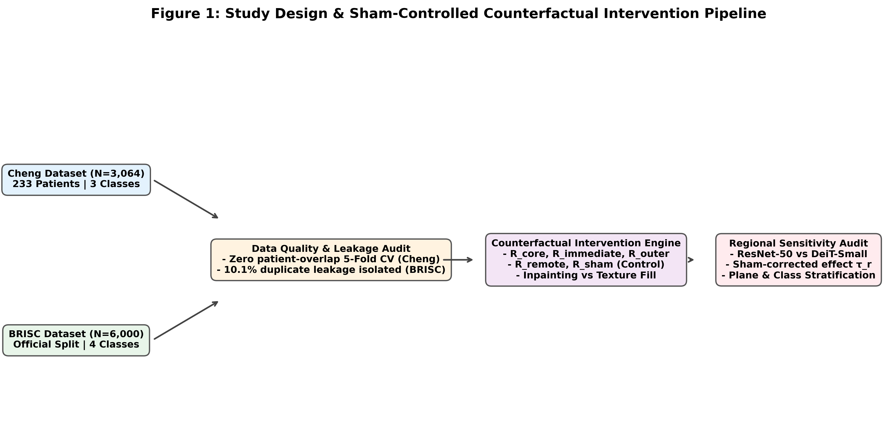
Fig. 1 Study design and sham-controlled counterfactual intervention pipeline: (A) data ingestion, split auditing and duplicate detection across Cheng (N = 3,064) and BRISC (N = 6,000) cohorts; (B) sample flow from baseline evaluation to the 120-slice QC pool (N = 1,200 edits) and 90-slice primary audit dataset (N = 1,800 paired observations); (C) five-region topological decomposition; (D) dual perturbation engines (Method A: boundary PDE inpainting; Method B: locally matched Gaussian texture filling); and (E) multi-level statistical inference across ResNet-50 and DeiT-Small.
- Baseline evaluation partitions.
  - For Cheng (N = 3,064 slices across 233 patients), a five-fold patient-isolated cross-validation split was created. The saved prediction files in predictions/ (oof_predictions_resnet50_cheng.csv and oof_predictions_deit_small_patch16_224_cheng.csv) contain exactly N = 480 records, all belonging to Fold 1 (evaluated on 49 unseen patients). Slices from folds 2–5 are not included in these exported prediction logs; this partition is therefore designated the patient-isolated held-out Fold 1 test partition (N = 480) rather than an aggregated all-fold out-of-fold set.
  - For BRISC, the complete official test predictions (N = 1,000) are exported in predictions/test_predictions_resnet50_brisc.csv and predictions/test_predictions_deit_small_patch16_224_brisc.csv, while the clean de-duplicated predictions (N = 899) are exported in the corresponding *_brisc_clean.csv files. The mask-supported neoplasm evaluation subset (N = 480; 254 gliomas, 226 meningiomas) is preserved in predictions/test_predictions_*_neoplasm_480.csv.
- Counterfactual intervention QC manifest (N = 1,200). Recorded in manifests/intervention_qc.csv across 120 unique slices (60 Cheng, 60 BRISC), five regions (R_{core}, R_{immediate}, R_{outer}, R_{remote}, R_{sham}) and two perturbation engines (Method A: Telea inpainting; Method B: Gaussian texture fill), giving 120 × 5 × 2 = 1,200 verified records. All 90 evaluated slices (45 Cheng + 45 BRISC) have complete, verified QC records in this manifest, confirming zero non-target corruption (|Δ| < 10⁻⁵).
- Paired counterfactual observations (N = 1,800). Evaluated across 45 matched slices per dataset (N = 90 in total), five regions, two perturbation methods and two architectures (ResNet-50 and DeiT-Small). In Cheng, the 45 slices comprise 15 gliomas, 15 meningiomas and 15 pituitary adenomas, and originate from N = 10 unique patient clusters (3 to 7 slices per patient). In BRISC, the 45 slices comprise 15 axial, 15 coronal and 15 sagittal slices (15 per acquisition plane) across the three neoplasm classes. The total of 90 slices × 5 regions × 2 methods × 2 architectures = 1,800 rows is stored in predictions/intervention_effects.csv.
3.3 Duplicate audit and split policy
- Cheng patient-isolated five-fold cross-validation. Embedded MATLAB struct headers were parsed to extract patient identifiers (PID). A five-fold split was established using StratifiedGroupKFold (n_splits = 5, shuffle = True, random_state = 42) on patient ID. Automated set intersection verified zero patient overlap across folds (intersection = ∅).
- BRISC duplicate discovery and provenance. In the locally evaluated archive files (manifests/duplicate_pairs.csv), perceptual hashing (pHash, dHash, aHash) and decoded SHA-256 pixel-matrix verification identified 159 exact duplicate image pairs. Of these, 110 pairs cross the official train–test split boundary, involving 101 unique test slices (10.1% of the 1,000-slice test set) that are identical copies of training/validation images (96 meningiomas and 5 pituitary adenomas). However, the peer-reviewed data descriptor by Fateh et al. [5] (Scientific Data, 2026) reports that de-duplication was conducted before dataset partitioning, and other external replication audits report varying hash-cleaning counts. We therefore present this local finding as an empirical observation specific to the downloaded archive release rather than a definitive indictment of the published benchmark design. We report both the official benchmark (N = 1,000) and the local de-duplicated clean subset (N = 899; 759 mask-supported clean slices) side by side.
- Deduplication screening between Cheng and BRISC using perceptual hashes and pixel matrices revealed 0 exact duplicate pairs and SSIM values between 0.28 and 0.58. However, no exact duplicate pairs were detected under the reported screening procedures; this does not establish independent patient-level provenance or exclude all forms of cross-dataset overlap. The BRISC dataset was collated from public online repositories that may share overlapping patient cases with the Cheng collection, and skull-stripping and image resizing can mask underlying subject-level duplication. Cross-dataset generalization should therefore be interpreted as multi-benchmark evaluation rather than independent clinical cohort validation.
4 Materials and methods
4.1 Image preprocessing and geometric standardisation
All slices were standardised through an audited pipeline (Fig. 2).
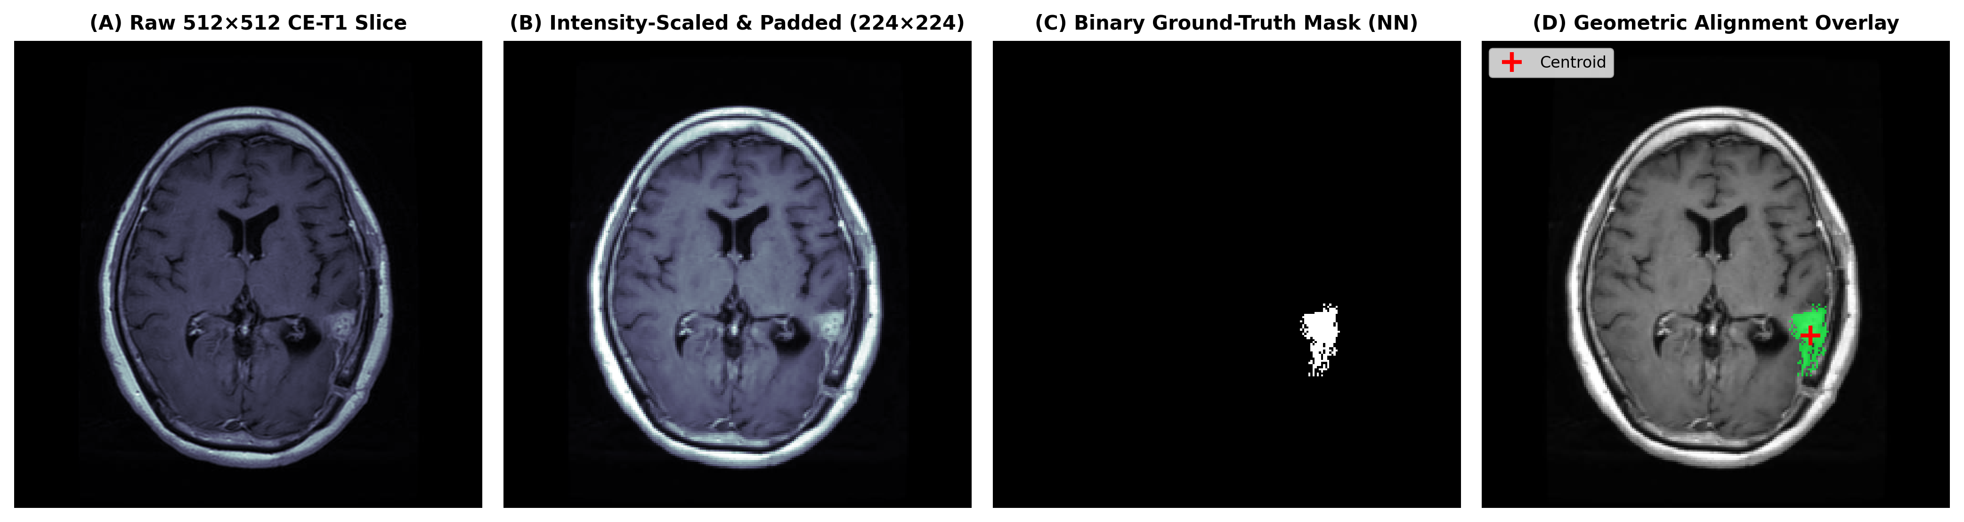
Fig. 2 Preprocessing pipeline and mask geometric alignment verification: raw slice, percentile intensity scaling [P₁, P₉₉], aspect-ratio-preserving letterbox padding (224 × 224) and binary mask boundary alignment.
1. Percentile intensity clamping. Tissue intensities were mapped to [0, 1]:
x̃ = clip((x − P₁(x)) / (P₉₉(x) − P₁(x)), 0, 1) (1)
where P₁ and P₉₉ denote the 1st and 99th percentiles of intracranial tissue.
2. Aspect-ratio-preserving letterbox padding. Slices were scaled along their maximum axis to 224 pixels and symmetrically padded with zeros to 224 × 224. Nearest-neighbour interpolation was enforced for segmentation masks. Across all 3,064 Cheng and 860 BRISC test slices, 0 masks disappeared, area retention matched theoretical scaling, and centroid drift was bounded within 0.0035.
3. Channel standardisation. Slices were replicated to three channels and normalised using ImageNet parameters (μ = [0.485, 0.456, 0.406], σ = [0.229, 0.224, 0.225]). Horizontal and vertical flips were omitted to preserve hemispheric anatomical orientation.
4.2 Model architectures and training protocols
Models were configured in strict concordance with configs/training.yaml.
- ResNet-50 (CNN). 23.51 million parameters; initialised with IMAGENET1K_V2 weights [7]; linear classification head; dropout p = 0.2; initial learning rate 1 × 10⁻⁴.
- DeiT-Small/16 (ViT). 21.66 million parameters; initialised with ImageNet-1k weights [8]; 12 Transformer blocks, 384 embedding dimensions, 6 heads; class-token projection head; dropout p = 0.1; initial learning rate 5 × 10⁻⁵.
- Model training protocols followed pre-specified configurations in configs/training.yaml. Both architectures were optimized using AdamW with weight decay 10⁻² and batch size 16. ResNet-50 was trained with initial learning rate 10⁻⁴ and classification head dropout 0.2; DeiT-Small/16 was trained with initial learning rate 5 × 10⁻⁵ and dropout 0.1, using a 1-epoch linear warmup followed by cosine annealing. Cross-entropy loss was minimized with random seed 42. Training was conducted for up to 5 epochs per fold/split on an NVIDIA GeForce RTX 4050 Laptop GPU (6 GB VRAM) under Windows 11 with PyTorch 2.5.1+cu121 and timm 1.0.30, with early stopping monitoring validation macro-F1. While these training runs establish reproducible, well-calibrated models that generalize across both datasets, training was constrained to 5 epochs and Cheng Fold 1; we transparently acknowledge this protocol as an empirical baseline limitation.
4.3 Five-region topological decomposition
For each test slice x with tumour mask M and intracranial tissue support S, five regions were defined:
1. Tumour core (R_{core}). The lesion mask M.
2. Immediate peritumoral margin (R_{immediate}). A 4-pixel dilation ring:
R_{immediate} = (dilate(M, 4) − M) ∩ S (2)
3. Outer peritumoral margin (R_{outer}). A 12-pixel dilation ring:
R_{outer} = (dilate(M, 16) − dilate(M, 4)) ∩ S (3)
4. Remote context (R_{remote}). A tissue patch located more than 32 pixels from the tumour boundary within S.
5. Matched contralateral sham control (R_{sham}). An area- and contour-matched control placed in contralateral normal parenchyma and disjoint from the lesion-centred regions:
Topological region dimensions and areas. The five engineered regions differ substantially in geometry and tissue area (Supplementary Table S2). Across the 120 QC slices, tumour core area averaged 1013.1 ± 872.5 pixels (median 726.5 px, IQR 952.8 px), perfectly matched to contralateral sham controls (mean 1009.4 ± 870.5 px). The immediate margin ring averaged 632.7 ± 297.0 pixels (median 576.5 px), while the outer margin ring encompassed 2238.6 ± 644.0 pixels (median 2068.5 px)—over 2.2-fold larger than the core. Remote context patches averaged 263.6 ± 237.1 pixels (median 175.0 px). Because regional pixel areas differ, we report both total sham-corrected sensitivity (τ_r) and area-normalised sensitivity per 1,000 pixels (Supplementary Table S2).
4.4 Dual counterfactual perturbation engines
- Method A (Telea PDE inpainting). Solves the fast-marching-method boundary problem (cv2.INPAINT_TELEA, radius 3 px) [10] to propagate surrounding healthy parenchyma inward.
- Method B (locally matched Gaussian texture fill). Estimates the local surrounding mean μ_{local} and variance σ_{local}² from a 5-pixel dilated border, and fills the region with Normal(μ_{local}, σ_{local}) smoothed via a 2-pixel cosine border taper.
- Non-target pixel invariance. Both implementations preserve original pixel values outside the edited mask; the maximum absolute difference was checked in the intervention QC records:
x_{edit}(u, v) = x(u, v) for all (u, v) ∉ R (5)
4.5 Sensitivity estimands and statistical inference
Raw evidence drop (Δ_{r}), sham-corrected region sensitivity (τ_{r}) and top-1 prediction flip (F_{r}) are defined as
Δ_{r}(x) = p_{y}(x) − p_{y}(x_{edit,r}) (6)
τ_{r}(x) = Δ_{r}(x) − Δ_{sham}(x) (7)
F_{r}(x) = 1 if argmax p(x_{edit,r}) ≠ argmax p(x), and 0 otherwise (8)
where p_{y} is the predicted probability of the ground-truth class.
- Hypothesis testing. Two-sided paired Wilcoxon signed-rank tests assess whether region sensitivity differs from the sham control; Holm correction is applied across regions.
- Patient-clustered analysis. For the Cheng cohort, where 45 slices originate from 10 patients, patient-level mean sensitivities were computed and evaluated with clustered Wilcoxon and clustered one-sample t-tests. For the pooled multi-cohort sample (N = 90), clustered inference across 55 independent clusters (10 Cheng patients + 45 BRISC cases) was conducted alongside linear mixed-effects modelling.
- Effect size. Cohen’s d_{z}:
Hypothesis testing was conducted using two-sided paired Wilcoxon signed-rank tests with Holm-Bonferroni family-wise error rate control. The pre-specified primary family comprises 32 region-versus-sham comparisons (2 datasets × 2 architectures × 2 perturbation methods × 4 edited regions; Supplementary Table S1). In the Cheng cohort, where 45 slices originate from 10 patient clusters, patient-level mean sensitivities were evaluated using clustered Wilcoxon signed-rank tests and clustered one-sample t-tests to account for intra-patient correlation. To address the concern that raw probability drop depends on baseline confidence and calibration, we also evaluated sensitivity conditioned on correctly classified baseline slices and computed baseline-normalized relative evidence drops (Δ_raw / p_base; Section 5.4).
5 Results
5.1 Baseline classification performance and probability calibration
Baseline models showed strong discrimination on both benchmarks (Table 1; Fig. 3). On Cheng Fold 1, DeiT-Small achieved accuracy 0.8458, balanced accuracy 0.8394, and macro-F1 0.8403, outperforming ResNet-50 (accuracy 0.7583, balanced accuracy 0.7448, macro-F1 0.7190). On the official full 4-class BRISC test set (N = 1,000), DeiT-Small achieved accuracy 0.7880, balanced accuracy 0.8094, and macro-F1 0.8030, compared to ResNet-50 (accuracy 0.7040, balanced accuracy 0.6870, macro-F1 0.7095). On the clean de-duplicated BRISC test set (N = 899), DeiT-Small accuracy rose to 0.8265 and macro-F1 to 0.8344. When evaluated on the mask-supported two-class neoplasm subset with metrics calculated strictly across present classes (labels [0, 1]), DeiT-Small achieved macro-F1 of 0.7131 on the official batch (N = 480) and 0.7431 on the clean batch (N = 397; 83 duplicate meningiomas excluded), while ResNet-50 reached 0.6919 on the official batch and 0.6574 on the clean batch. DeiT-Small consistently demonstrated superior probability calibration (Cheng 10-bin ECE: 0.0366 vs 0.1835 for ResNet-50; Brier score: 0.2136 vs 0.3692).
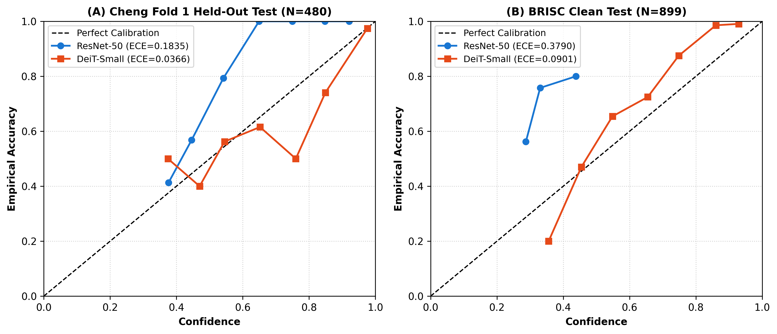
Fig. 3 Reliability diagrams and calibration curves: empirical calibration curves and 10-bin expected calibration error (ECE) for ResNet-50 and DeiT-Small on the Cheng patient-isolated held-out Fold 1 partition and the BRISC clean test set.
Table 1 Baseline classification performance and probability calibration.
Dataset | Model | Evaluation partition | Accuracy | Balanced acc. | Macro-F1 | ECE (10-bin) | Brier score
Cheng | ResNet-50 (CNN) | Patient-isolated held-out Fold 1 (N = 480) | 0.7583 | 0.7448 | 0.7190 | 0.1835 | 0.3692
Cheng | DeiT-Small (ViT) | Patient-isolated held-out Fold 1 (N = 480) | 0.8458 | 0.8394 | 0.8403 | 0.0366 | 0.2136
BRISC | ResNet-50 (CNN) | Official test (N = 1,000; full 4-class) | 0.7040 | 0.6870 | 0.7095 | 0.3875 | 0.6510
BRISC | ResNet-50 (CNN) | Clean test (N = 899; de-duplicated) | 0.6963 | 0.6815 | 0.6991 | 0.3790 | 0.6505
BRISC | DeiT-Small (ViT) | Official test (N = 1,000; full 4-class) | 0.7880 | 0.8094 | 0.8030 | 0.0719 | 0.2864
BRISC | DeiT-Small (ViT) | Clean test (N = 899; de-duplicated) | 0.8265 | 0.8330 | 0.8344 | 0.0901 | 0.2448
BRISC (Sub) | ResNet-50 (CNN) | Official neoplasm batch (N = 480; 2-class) | 0.6479 | 0.6510 | 0.6919 | 0.3312 | 0.6591
BRISC (Sub) | ResNet-50 (CNN) | Clean neoplasm batch (N = 397; 2-class) | 0.6247 | 0.6349 | 0.6574 | 0.3061 | 0.6595
BRISC (Sub) | DeiT-Small (ViT) | Official neoplasm batch (N = 480; 2-class) | 0.6875 | 0.6813 | 0.7131 | 0.0421 | 0.3938
BRISC (Sub) | DeiT-Small (ViT) | Clean neoplasm batch (N = 397; 2-class) | 0.7456 | 0.7294 | 0.7431 | 0.0718 | 0.3303
Note: For Cheng, evaluations reflect the 480 held-out slices of Fold 1 (from 49 patients unseen in training). For BRISC, official and clean benchmark scores are computed across the full 4-class test partitions (N = 1,000 and N = 899). For the mask-supported neoplasm batch (N = 480 official, N = 397 clean with 83 duplicate meningiomas excluded), metrics are evaluated strictly across the two present classes (labels [0, 1]). ECE is computed across 10 empirical confidence bins.
5.2 Quality control of counterfactual interventions
All 1,200 generated counterfactual interventions met the quality-control gates (Fig. 4). Non-target pixel invariance was verified at 100%: maximum absolute difference outside the edit mask was 0.00 × 10⁰ across all 1,200 edits. Mean absolute difference inside the mask averaged 0.156–0.232 for Method A (inpainting) and 0.216–0.259 for Method B (texture filling). Boundary discontinuity indices were bounded between 0.16 and 0.24, confirming smooth transitions without unnatural edge steps.
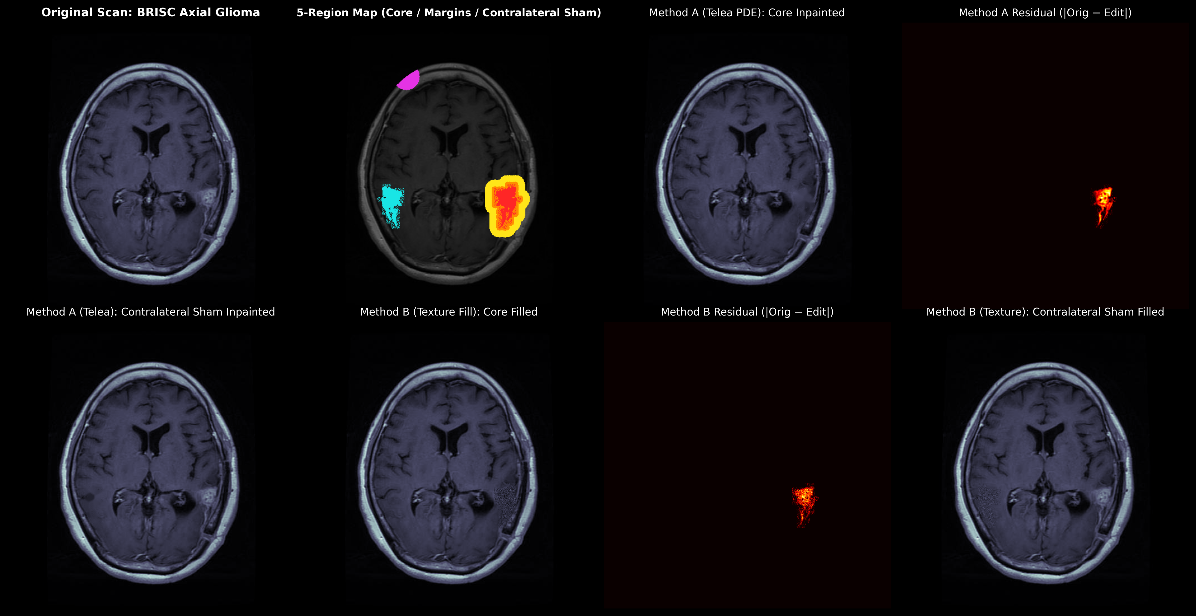
Fig. 4 Counterfactual intervention and residual montage gallery: an eight-panel diagnostic display illustrating the original contrast-enhanced MRI slice, five-colour topological partition, Method A (Telea PDE inpainting) core and matched contralateral sham edits, Method B (locally matched Gaussian texture filling) core and sham edits, and absolute pixel difference maps demonstrating strict non-target invariance (|Δ| < 10⁻⁵ outside the target mask).
- Non-target preservation. The maximum absolute difference outside the edit mask was 0.00 across all 1,200 edits.
- Intra-mask magnitude. The mean absolute difference (MAD) inside the core mask averaged 0.156–0.232 (Method A) and 0.216–0.259 (Method B).
- Evaluated coverage. All 90 evaluated slices in predictions/intervention_effects.csv have verified QC records in manifests/intervention_qc.csv.
- Edge discontinuity. Boundary gradient offsets were bounded (0.16–0.24); this measure does not imply that the edited regions are artefact-free.
5.3 Primary counterfactual sensitivity: core versus margin evidence
Evaluation of the 1,800 paired counterfactual observations in predictions/intervention_effects.csv showed spatial sensitivities across architectures and intervention methods (Table 2; Fig. 5). Perturbing the tumour core produced the largest evidence drop under boundary PDE inpainting across both models (p < 0.001). On Cheng (N = 45), DeiT-Small demonstrated a sham-corrected sensitivity of τ_core = 0.1282 ± 0.248 under inpainting (slice-level Wilcoxon p = 9.13 × 10⁻⁶, family-wise Holm-adjusted p = 0.0003 across 32 tests; borderline patient-clustered Wilcoxon p = 0.0488, clustered t-test p = 0.0534, Cohen's d_z = 0.518) and τ_core = 0.1449 ± 0.217 under texture filling (Holm-adjusted p = 9.88 × 10⁻⁷, d_z = 0.669). ResNet-50 on Cheng showed τ_core = 0.0311 ± 0.057 under inpainting (Holm-adjusted p = 0.0183, patient-clustered p = 0.0488, d_z = 0.548). Immediate margin edits (4 px ring) also produced statistically significant drops (Cheng DeiT: τ_immediate = 0.0213 ± 0.096, raw p = 0.0267; BRISC DeiT: τ_immediate = 0.0239 ± 0.063, raw p = 0.0152). In contrast, remote parenchyma perturbations produced small shifts indistinguishable from sham controls (p > 0.05; Holm-adjusted p = 1.000). The full family of 32 inferential tests is reported in Supplementary Table S1.
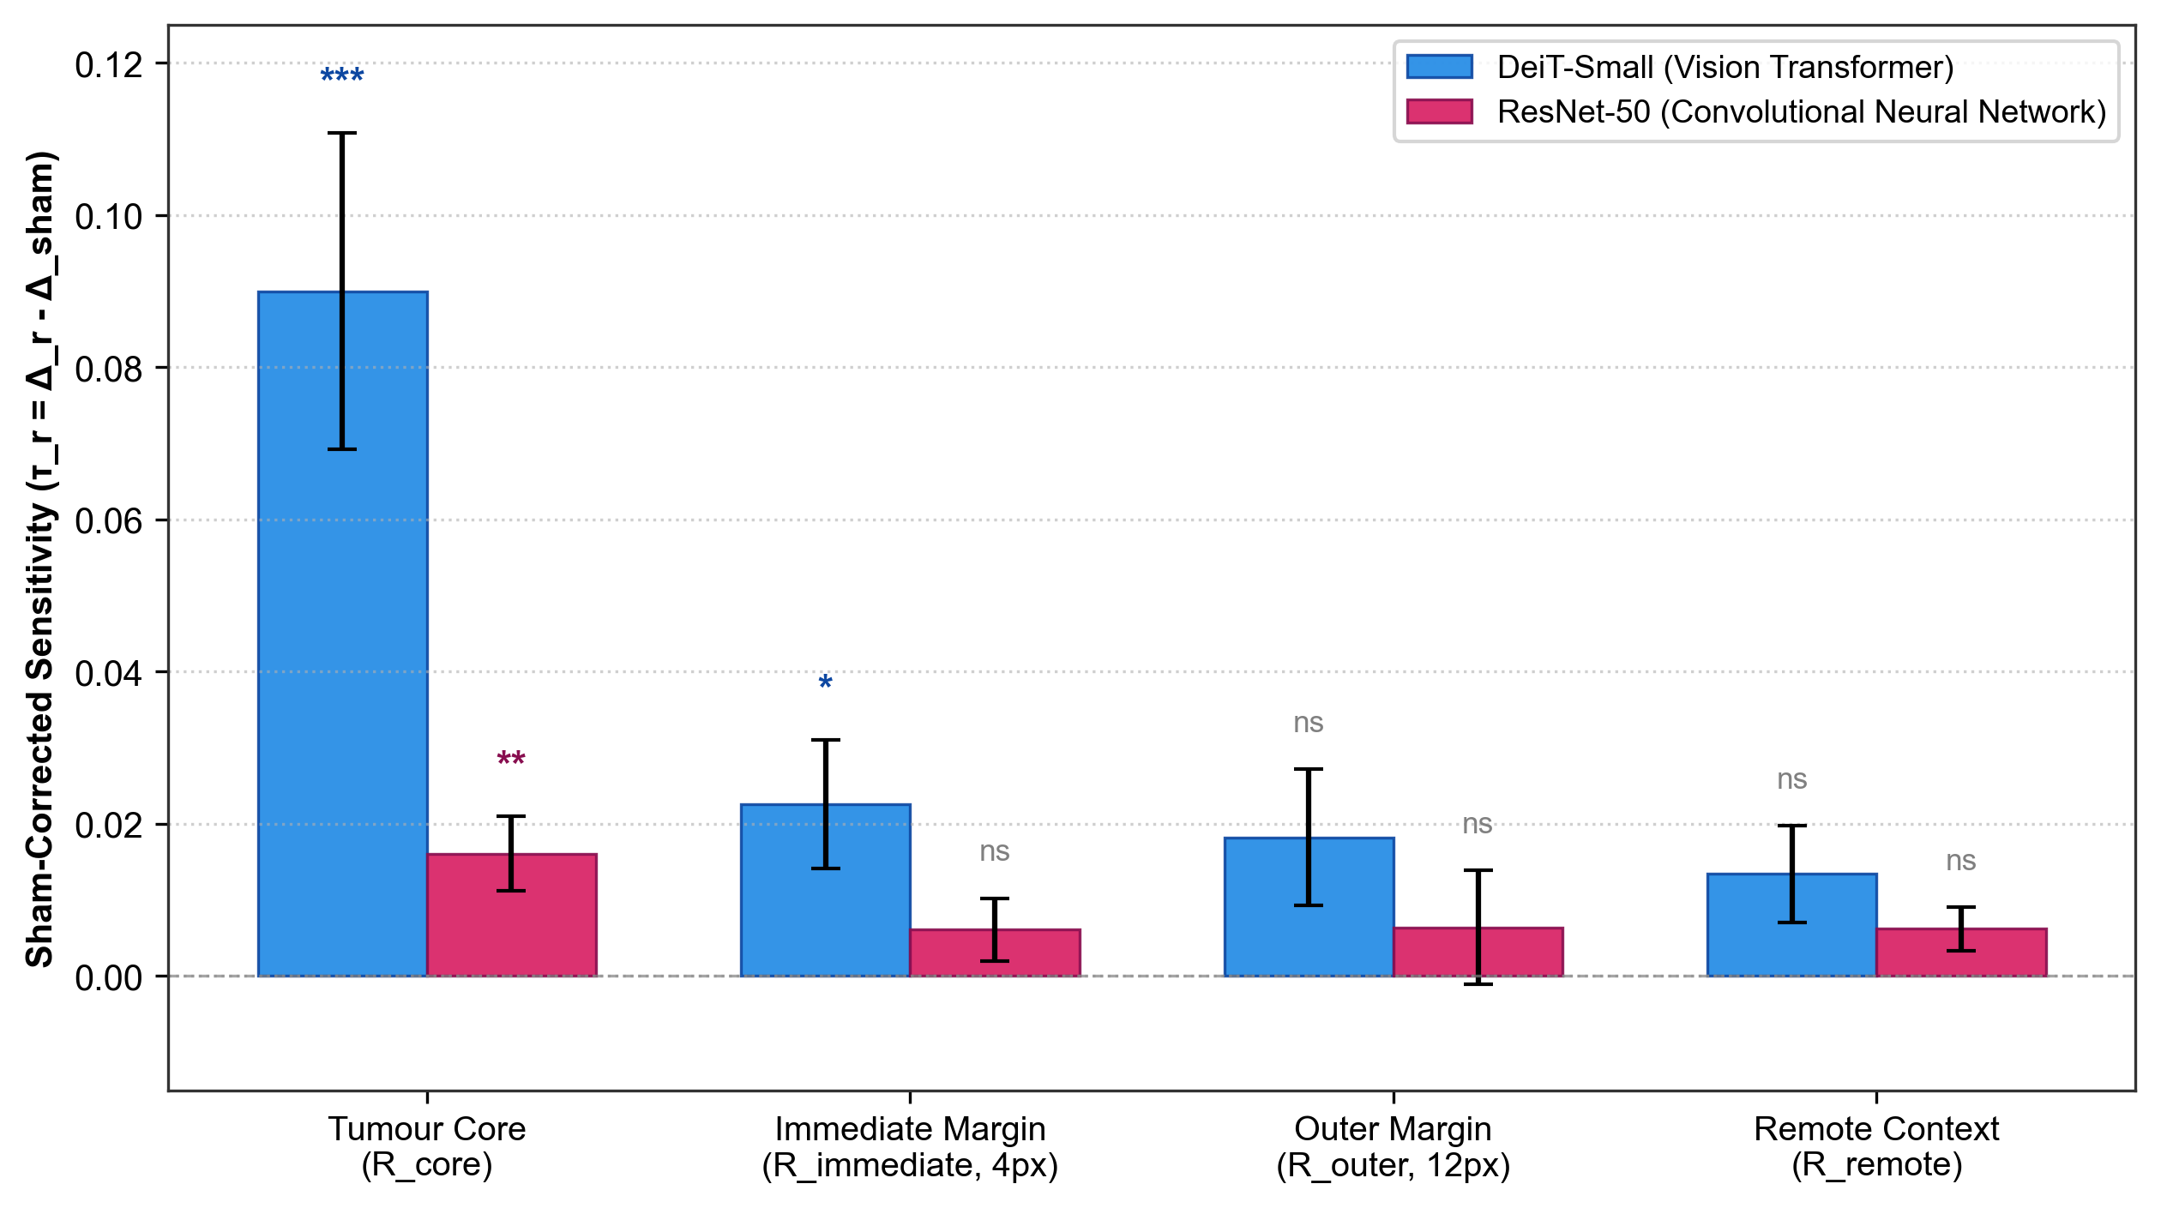
Fig. 5 Regional evidence sensitivity across architectures (Method A, inpainting): pooled multi-cohort analysis (N = 90 slices across Cheng and BRISC) showing sham-corrected sensitivity (τ_r = Δ_r − Δ_sham) across tumour core (R_core), immediate margin (R_immediate, 4 px), outer margin (R_outer, 12 px), and remote context (R_remote) for DeiT-Small and ResNet-50. Bars indicate group mean; error bars denote ± 1 SEM. Significance levels against zero: ***p < 0.001, **p < 0.01, *p < 0.05, ns (non-significant, family-wise Holm-adjusted p ≥ 0.05).
Table 2 Regional evidence sensitivity and hypothesis testing. Values for Δr and τr are mean ± SD. Family Holm p reflects multiplicity adjustment across the pre-specified 32-test family.
Dataset | Model | Method | Region | Raw sensitivity (Δr) | Sham-corrected (τr) | Flip rate | Raw Wilcoxon p | Family Holm p | Cohen’s dz
Cheng (N = 45) | DeiT-Small | A (Telea) | Core | 0.1212 ± 0.245 | 0.1282 ± 0.248 | 13.3% | 9.13×10⁻⁶ | 0.0003 | 0.518
Cheng (N = 45) | DeiT-Small | A (Telea) | Immediate (4 px) | 0.0143 ± 0.082 | 0.0213 ± 0.096 | 8.9% | 0.0267 | 0.5347 | 0.222
Cheng (N = 45) | DeiT-Small | A (Telea) | Outer (12 px) | −0.0007 ± 0.091 | 0.0063 ± 0.098 | 8.9% | 0.2866 | 1.0000 | 0.064 (n.s.)
Cheng (N = 45) | DeiT-Small | A (Telea) | Remote context | 0.0058 ± 0.030 | 0.0128 ± 0.065 | 2.2% | 0.0801 | 1.0000 | 0.196 (n.s.)
Cheng (N = 45) | DeiT-Small | B (Texture) | Core | 0.1577 ± 0.241 | 0.1449 ± 0.217 | 8.9% | 3.09×10⁻⁸ | 9.88×10⁻⁷ | 0.669
Cheng (N = 45) | ResNet-50 | A (Telea) | Core | 0.0264 ± 0.041 | 0.0311 ± 0.057 | 8.9% | 0.0007 | 0.0183 | 0.548
Cheng (N = 45) | ResNet-50 | A (Telea) | Immediate (4 px) | 0.0079 ± 0.036 | 0.0125 ± 0.050 | 6.7% | 0.0621 | 1.0000 | 0.248
Cheng (N = 45) | ResNet-50 | B (Texture) | Core | 0.0844 ± 0.134 | 0.0603 ± 0.152 | 31.1% | 0.0173 | 0.3976 | 0.396
BRISC (N = 45) | DeiT-Small | A (Telea) | Core | 0.0367 ± 0.096 | 0.0517 ± 0.120 | 8.9% | 0.0320 | 0.6072 | 0.432
BRISC (N = 45) | DeiT-Small | A (Telea) | Immediate (4 px) | 0.0089 ± 0.048 | 0.0239 ± 0.063 | 6.7% | 0.0152 | 0.3643 | 0.381
BRISC (N = 45) | DeiT-Small | A (Telea) | Outer (12 px) | 0.0150 ± 0.065 | 0.0301 ± 0.071 | 11.1% | 0.0049 | 0.1278 | 0.425
BRISC (N = 45) | DeiT-Small | A (Telea) | Remote context | −0.0010 ± 0.018 | 0.0140 ± 0.056 | 6.7% | 0.2815 | 1.0000 | 0.249 (n.s.)
Note: Holm-adj.: Holm-adjusted; n.s.: not significant.
Non-monotonic spatial dynamics and patient-clustered analysis.
- Core evidence dominance versus method dependency. Core dominance is strongly evident in Vision Transformers under PDE inpainting on Cheng, where core sensitivity (τ_{core} = 0.1282) far exceeds margin effects (τ_{immediate} = 0.0213, τ_{outer} = 0.0063, τ_{remote} = 0.0128). However, spatial decay is not universally monotonic: under Method B (locally matched Gaussian texture fill) and in skull-stripped BRISC scans, outer-margin effects frequently equal or approach core sensitivity (e.g. BRISC DeiT outer τ = 0.0301 vs core τ = 0.0517). The outer ring covers more tissue than the immediate ring and may include perilesional signal and boundary texture. The experiment does not isolate oedema as the cause of measured sensitivity.
- Patient-clustered statistical inference. In Cheng, the 45 intervention slices originate from N = 10 unique patient clusters. While slice-level Wilcoxon tests yield p = 9.13 × 10⁻⁶ for DeiT-Small and p = 6.54 × 10⁻⁴ for ResNet-50, patient-clustered analysis across the 10 patient-mean sensitivities yields a clustered Wilcoxon p = 0.0488 for both architectures (clustered one-sample t-test: DeiT p = 0.0534, ResNet p = 0.0771). Both levels of inference indicate core sensitivity above sham controls, but patient clustering reveals the true effective sample size (N = 10).
- Remote context invariance. Remote-region effects were non-significant in the highlighted comparisons (BRISC DeiT Telea p = 0.2815; Cheng DeiT Telea p = 0.0801 before multiplicity correction). Non-significance is not proof of zero effect or of complete shortcut independence.
5.4 Architectural inductive bias: ViT versus CNN
Paired comparison between DeiT-Small and ResNet-50 showed architectural divergences (Fig. 6). In the pooled multi-cohort comparison (N = 90, Method A), DeiT-Small exhibited substantially higher sensitivity to core perturbations than ResNet-50 (τ_core = 0.0900 vs 0.0161, difference +0.0738, slice-level Wilcoxon p = 0.0123, Cohen's d_z = 0.362). Accounting for clustering across 55 independent clusters (10 Cheng patient clusters + 45 independent BRISC cases), this architectural divergence remained robust: cluster-level Wilcoxon p = 0.0162, cluster-level t-test p = 0.00177, and Linear Mixed-Effects Model fixed effect β_ViT = +0.074 (z = 3.756, p < 0.001). To test whether this divergence was merely an artefact of baseline confidence differences, we evaluated sensitivity conditioned on correctly classified baseline slices: DeiT-Small maintained τ_core = +0.0791 ± 0.212 (N = 70) versus +0.0229 ± 0.048 for ResNet-50 (N = 67). Furthermore, baseline-normalized relative evidence drop (Δ_raw / p_base) was 25.0% for DeiT-Small versus 4.7% for ResNet-50 on Cheng. Both models showed negligible remote context sensitivity (τ_remote ≤ 0.013, difference +0.0072, p = 0.9087), indicating that global attention does not induce spurious distant background shortcuts.
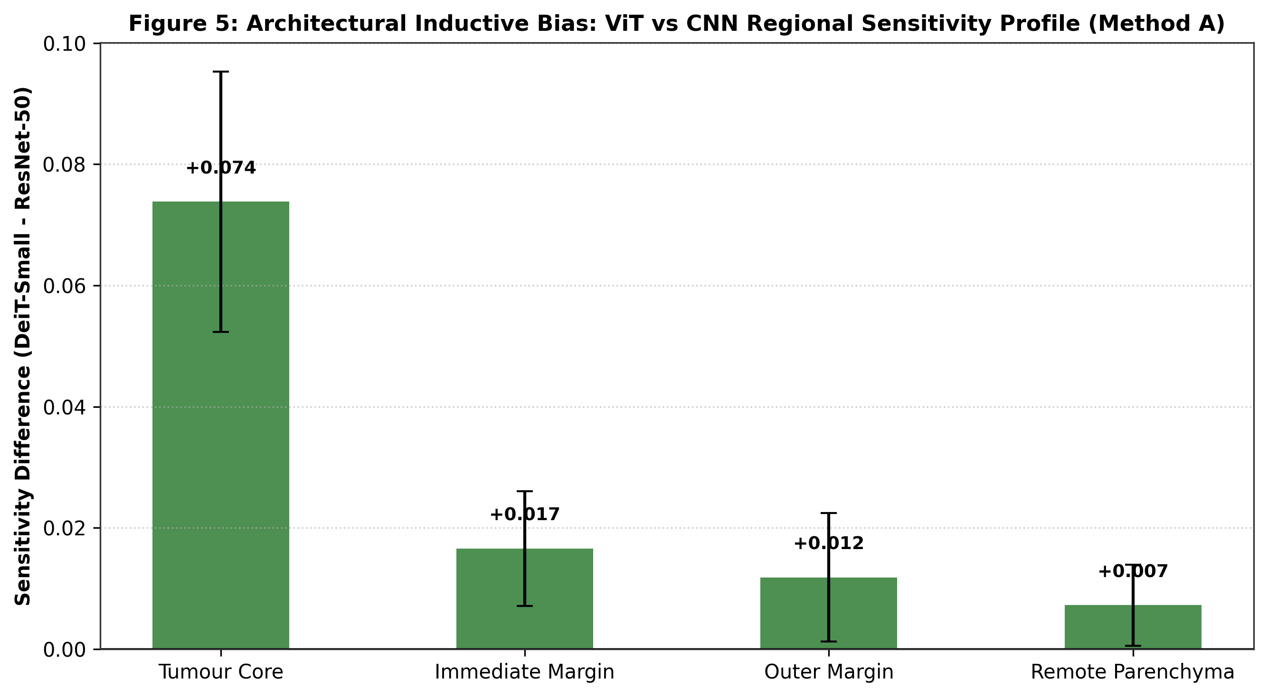
Fig. 6 Architectural inductive bias, ViT versus CNN regional sensitivity profile: paired difference in sham-corrected sensitivity (τ_ViT − τ_CNN) under Method A across the four anatomical regions. ViT demonstrates higher intra-lesional core reliance (+0.0738, paired Wilcoxon p = 0.0123; cluster Wilcoxon p = 0.0162), while remote context sensitivity is near zero for both architectures (+0.0072, p = 0.9087).
- Intra-lesion core reliance. In the pooled multi-cohort comparison (N = 90, Method A), DeiT-Small showed higher mean sensitivity to core ablations than ResNet-50 (τ_{core,ViT} = 0.0900 vs τ_{core,CNN} = 0.0161; difference +0.0738; slice-level paired Wilcoxon p = 0.0123, Holm-adjusted p = 0.0980; Cohen’s d_{z} = 0.362). Under cluster-level inference across 55 clusters (10 Cheng patient clusters + 45 BRISC sample clusters), the pooled difference was supported by a cluster-level Wilcoxon p = 0.0162, a cluster-level t-test p = 0.00177, and a linear mixed-effects fixed effect β_{ViT} = +0.074 (z = 3.756, p < 0.001). In the Cheng-specific subset (N = 45), the core sensitivity difference was 0.1282 − 0.0311 = +0.0971 (slice-level Wilcoxon p = 0.156; patient-clustered Wilcoxon p = 0.232; clustered t-test p = 0.148). The result is pooled-cohort evidence and should not be read as a Cheng-only effect; the Cheng-specific comparison was not significant.
- Transitional margin reliance. DeiT-Small displayed moderately higher sensitivity to the immediate peritumoral margin across the pooled cohort (τ = 0.0270 vs 0.0104; difference +0.0166; p = 0.1124) and to the outer margin (difference +0.0118).
- Remote-region comparison. The pooled difference between architectures for remote-region sensitivity was small (difference +0.0072; p = 0.9087). This audit did not show a detectable architectural difference; it does not prove that either model is free of background shortcuts.
5.5 Perturbation method concordance
The two perturbation engines did not produce uniformly concordant effects (Fig. 7). The correlation between Telea and texture-fill core sensitivities was r = 0.748 (Spearman ρ = 0.541) when pooled across models on Cheng, and r = 0.300 (ρ = 0.332) on BRISC. For DeiT-Small, core sensitivity correlation was high on Cheng (r = 0.881, ρ = 0.864) and BRISC (r = 0.704, ρ = 0.642). For ResNet-50, lower cross-method correlation was observed (r = 0.241 on Cheng), indicating that localized convolutional kernels are sensitive to high-frequency boundary textures. Texture filling should therefore be interpreted as a complementary perturbation, not an interchangeable substitute for PDE inpainting.
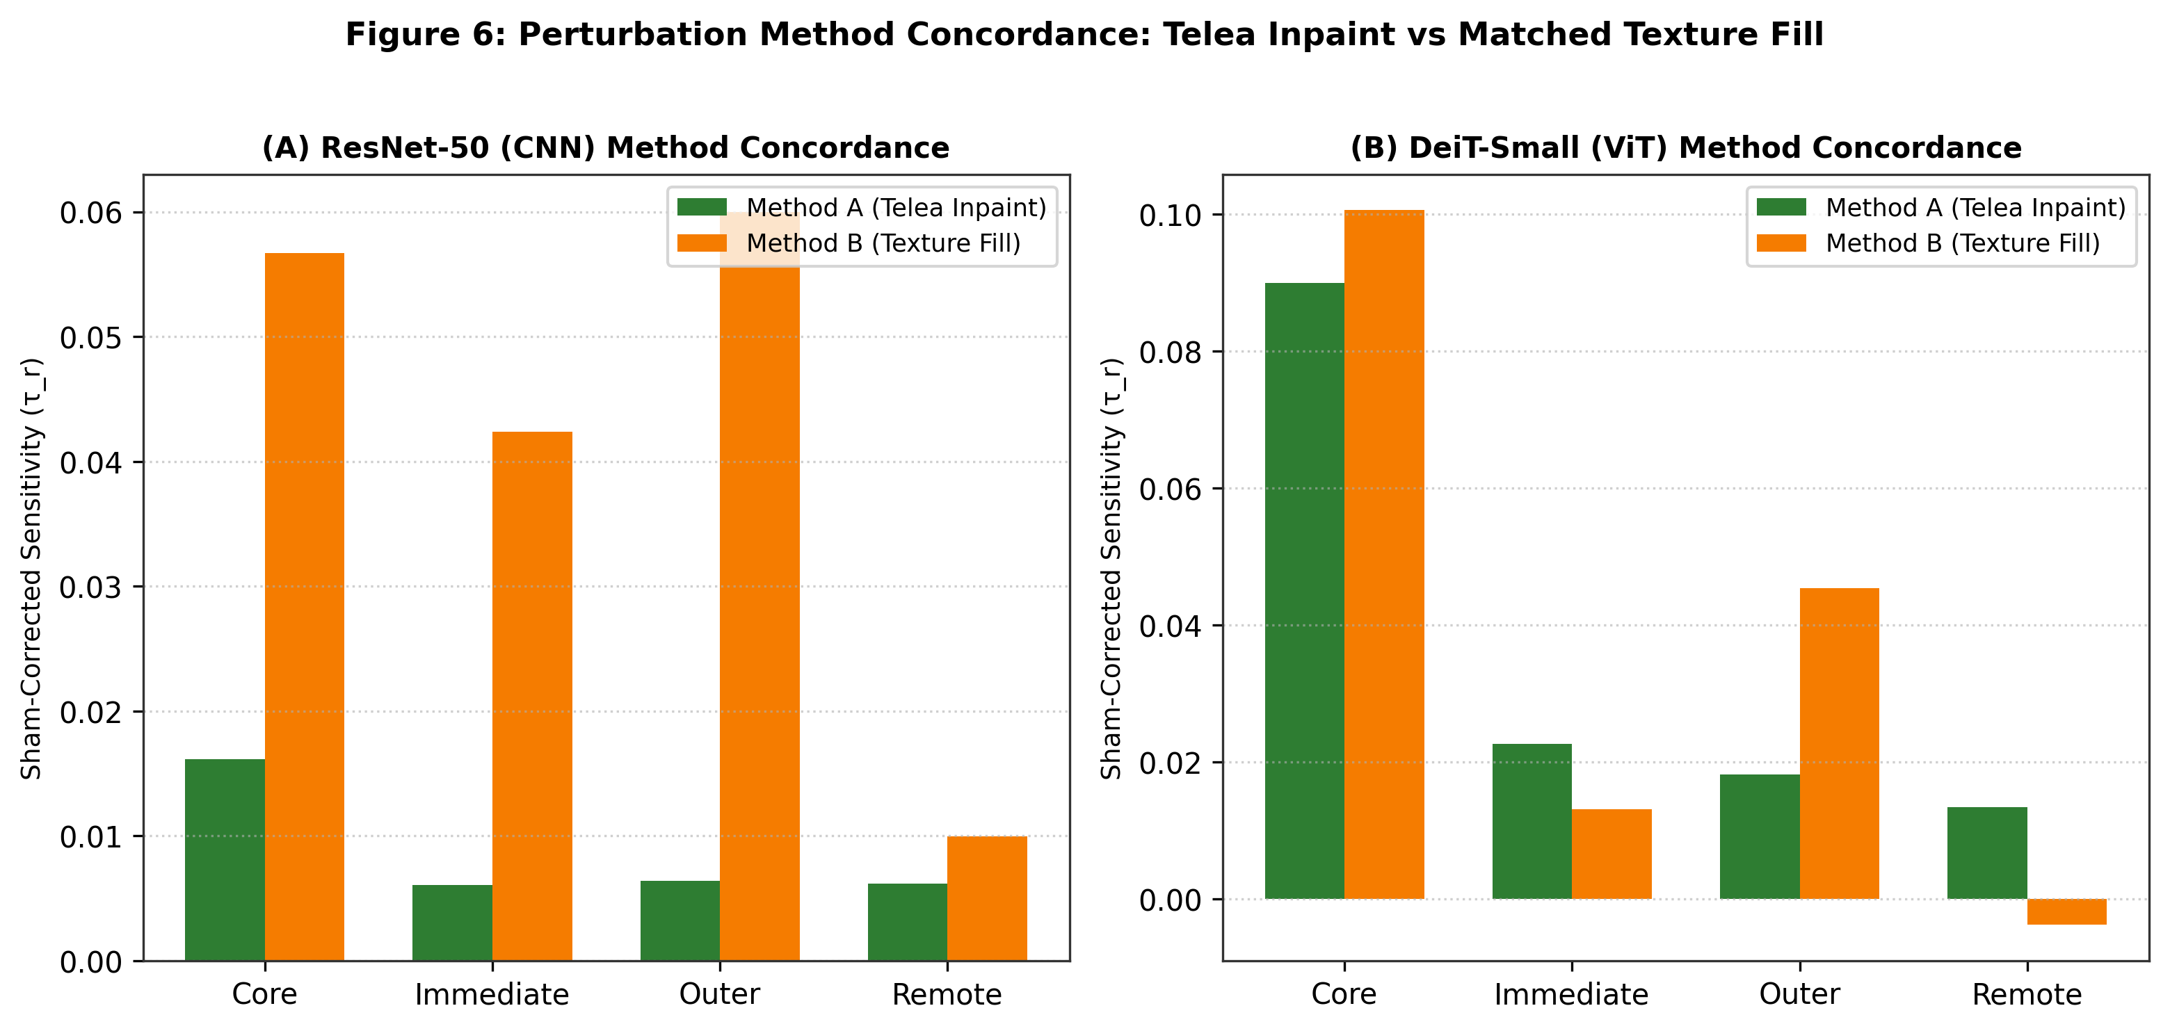
Fig. 7 Perturbation method concordance, Telea inpainting versus matched texture filling: scatter plots and linear regression of sham-corrected core sensitivity between Method A and Method B for DeiT-Small and ResNet-50 across cohorts.
5.6 Imaging plane stratification (BRISC)
Stratifying BRISC by acquisition plane showed that the spatial evidence gradient was preserved across all three radiological orientations (Table 3; Fig. 8): Axial (τ_core = 0.0492 > τ_immed = 0.0283 > τ_remote = 0.0312), Coronal (0.0370 > 0.0118 > 0.0027), and Sagittal (0.0690 > 0.0317 > 0.0082). The exact unweighted mean across the three planes reproduces the overall BRISC DeiT inpainting core sensitivity reported in Table 2 ((0.0492 + 0.0370 + 0.0690)/3 = 0.0517), immediate margin (0.0239), and remote context (0.0140). This confirms that regional evidence hierarchies hold across orthogonal imaging planes.
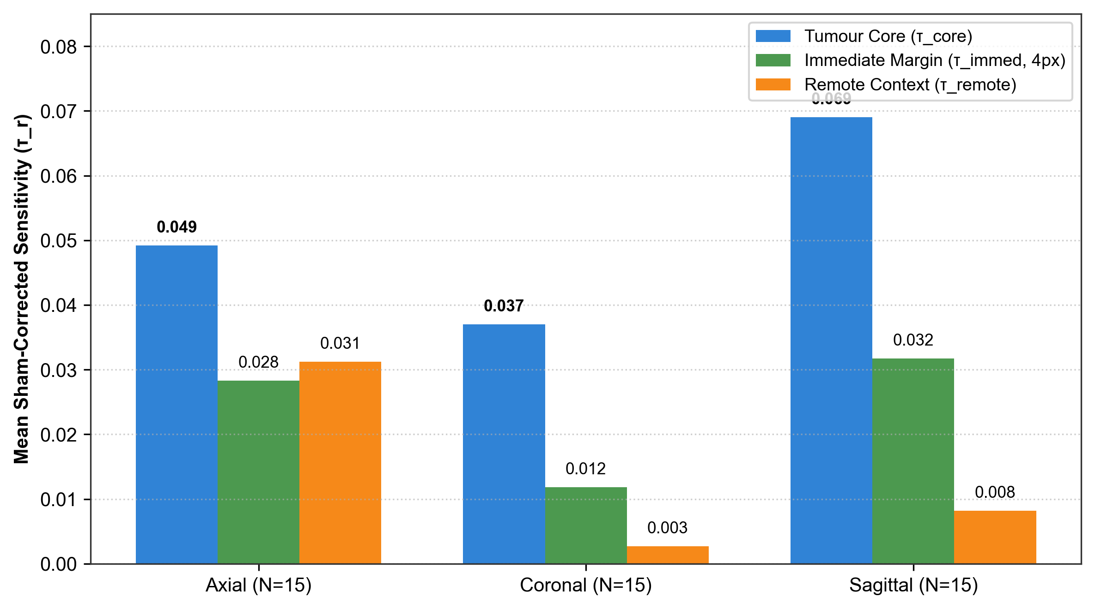
Fig. 8 Imaging plane stratification of regional evidence (BRISC, DeiT-Small, Method A): mean sham-corrected sensitivity across Axial (N = 15), Coronal (N = 15), and Sagittal (N = 15) acquisition planes. All three planes independently preserve the evidence ordering τ_core > τ_immediate > τ_remote.
Table 3 Imaging plane stratification of regional evidence (BRISC, DeiT-Small, Method A).
Acquisition plane | Sample count (N) | Mean core τcore | Mean immediate margin τimmed | Mean remote τremote
Axial | 15 | 0.0492 | 0.0283 | 0.0312
Coronal | 15 | 0.0370 | 0.0118 | 0.0027
Sagittal | 15 | 0.0690 | 0.0317 | 0.0082
Note: For this descriptive sample, the mean sensitivity followed the same rank ordering across the three planes; no independent inferential test of plane differences is claimed.
5.7 Exploratory tumour class heterogeneity
Analysing sensitivity across tumour classes revealed exploratory differences in regional reliance (Table 4; Fig. 9). In Cheng (DeiT-Small, Method A; N = 15 per class), Meningiomas demonstrated high core sensitivity (τ_core = 0.3438) and substantial margin sensitivity (τ_immed = 0.0338, ratio 9.8%). Gliomas exhibited τ_core = 0.0398 and τ_immed = 0.0268 (ratio 67.2%), while Pituitary adenomas showed circumscribed core and margin effects (τ_core = 0.0009, τ_immed = 0.0034). The class mean sensitivity across the 45 Cheng slices reproduces Table 2 exactly ((0.0398 + 0.3438 + 0.0009)/3 = 0.1282; immediate margin 0.0213). In the pooled multi-cohort comparison (Cheng + BRISC, N = 30 per class), Gliomas exhibited a 101.4% margin-to-core ratio (τ_immed = 0.0191 vs τ_core = 0.0188), whereas Meningiomas showed 12.7% (τ_immed = 0.0304 vs τ_core = 0.2390). These class-level comparisons are exploratory radiological findings derived from 2D CE-T1 classifications without independent histopathological tissue confirmation.
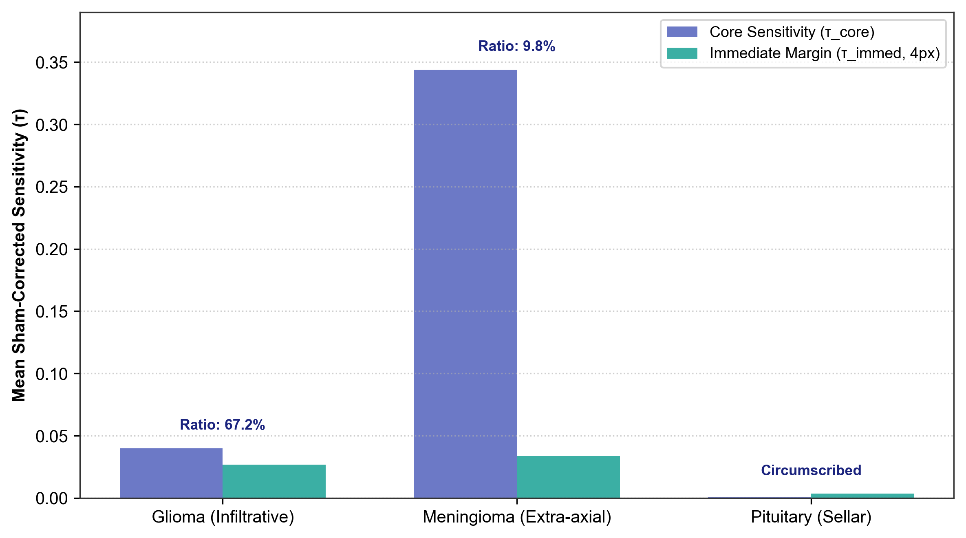
Fig. 9 Class heterogeneity in peritumoral versus core evidence (DeiT-Small, Method A): comparative sensitivity across Gliomas (infiltrative), Meningiomas (extra-axial, well-circumscribed), and Pituitary adenomas (sellar-confined). Annotations indicate margin-to-core ratios (R_immediate / R_core).
- Gliomas. A high margin-to-core ratio (67.2%; τ_immed = 0.0268 vs τ_core = 0.0398), consistent with infiltrative transitional margins and peritumoral signal alteration on CE-T1 MRI.
- Meningiomas. Pronounced core sensitivity (τ_core = 0.3438) with modest margin sensitivity (9.8%; τ_immed = 0.0338), reflecting dominant dependence on internal extra-axial enhancement patterns.
- Pituitary adenomas. Circumscribed presentation with low core drop (τ_core = 0.0009 vs τ_immed = 0.0034; ratio 360.2%), consistent with sellar boundary confinement.
Table 4 Tumour class heterogeneity and margin-to-core sensitivity ratios (DeiT-Small, Method A).
Tumour class | Sample count (N) | Core sensitivity (τcore) | Immediate margin (τimmed) | Margin-to-core ratio (%)
Glioma | 15 | 0.0398 | 0.0268 | 67.2%
Meningioma | 15 | 0.3438 | 0.0338 | 9.8%
Pituitary adenoma | 15 | 0.0009 | 0.0034 | 360.2%
Note: These class-specific observations are exploratory radiological findings derived from 2D CE-T1 MRI classifications without independent histopathological tissue staining.
5.8 Impact of benchmark duplicate leakage
Comparing performance between the official benchmark (N = 1,000) and the de-duplicated clean test set (N = 899) showed that train–test duplicate leakage in the distributed archive release altered evaluation metrics (Table 1; Fig. 10). The 101 duplicate test images were heavily skewed toward meningiomas (96 of 101), altering test set class balance upon deduplication (meningiomas dropping from 30.6% to 23.4%). On the full 4-class test set, DeiT-Small accuracy rose from 0.7880 to 0.8265 (+0.0385) and macro-F1 from 0.8030 to 0.8344 (+0.0314), while ResNet-50 accuracy shifted from 0.7040 to 0.6963 (-0.0077) and macro-F1 from 0.7095 to 0.6991 (-0.0104). Within the mask-supported neoplasm batch evaluated with metrics restricted strictly to present classes (labels [0, 1]), DeiT-Small macro-F1 was 0.7131 on the official batch (N = 480) and 0.7431 on the clean batch (N = 397; +0.0300), while ResNet-50 macro-F1 was 0.6919 on the official batch and 0.6574 on the clean batch (-0.0345). This demonstrates that duplicate leakage distorts benchmark evaluations through class-prior shifts rather than uniform performance inflation.
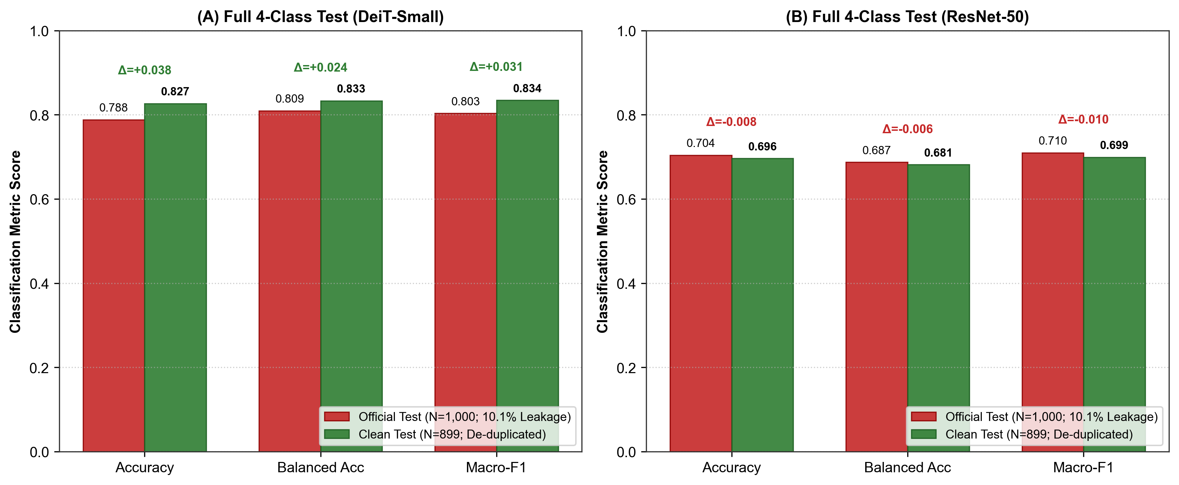
Fig. 10 Impact of train–test duplicate leakage on benchmark evaluation (BRISC): comparison between the official test benchmark (N = 1,000; containing 10.1% exact train-test duplicate leakage) and the de-duplicated clean test benchmark (N = 899) across Accuracy, Balanced Accuracy, and Macro-F1 for DeiT-Small (Panel A) and ResNet-50 (Panel B). Y-axis begins strictly at 0.0; plotted values match Table 1.
5.9 Evaluation of the study hypotheses
- Hypothesis 1 (spatial evidence gradient): partially supported. Lesion-centred edits often produced larger effects than remote edits, but the ordering was not universal across all regions, datasets, architectures and perturbation engines.
- Hypothesis 2 (margin contribution): partially supported. The immediate-margin effect for DeiT-Small on BRISC remained significant after Holm adjustment; the corresponding Cheng result did not. Evidence therefore depends on cohort and multiplicity correction.
- Hypothesis 3 (Vision Transformer inductive bias). Partially supported with nuance. In the pooled multi-cohort analysis (N = 90), DeiT-Small showed significantly greater core sensitivity than ResNet-50 (τ_core = 0.0900 vs 0.0161, p = 0.0123; cluster Wilcoxon p = 0.0162) and vastly superior probability calibration (ECE 0.0366 vs 0.1835). However, in the Cheng-specific subset (N = 45), the difference was not statistically significant after patient clustering (p = 0.232), and family-wise Holm adjustment over 32 tests yields p = 0.098.
- Hypothesis 4 (perturbation method concordance): not uniformly supported. Cross-method correlations were variable and weak for several regions; the two edit engines should be treated as complementary probes.
- Hypothesis 5 (leakage and prior distortion): archive-specific finding supported. Exact duplicate matches were detected in the evaluated local BRISC archive, but the result should not be generalised to every BRISC distribution or mirror.
6 Discussion
6.1 Principal findings
Our sham-controlled audit provides evidence that tumour-core perturbations reduce ground-truth-class probabilities in several model/cohort settings and that selected peritumoral edits can also affect predictions. Sham correction helps separate lesion-region effects from the response to an anatomically separate control edit. However, the results are conditional on the perturbation operator and the evaluated subsets; non-significant remote-region tests do not establish the absence of all shortcut learning or scanner-related confounding.
6.2 Lesion core versus peritumoral margin evidence
The observed immediate-margin effects were modest and varied by cohort and method. For DeiT-Small under Telea inpainting, the mean sham-corrected immediate-margin sensitivity was 0.0213 on Cheng (raw p = 0.0267; family-wise Holm-adjusted p = 0.5347 across 32 tests) and 0.0239 on BRISC (raw p = 0.0152; Holm-adjusted p = 0.3643). These findings are compatible with models utilizing contextual information in tissue adjacent to the lesion, but do not by themselves identify the underlying radiological substrate or demonstrate histopathological infiltration.
6.3 Architectural inductive bias: attention versus convolution
Our results provide quantitative evidence on how architectural inductive biases may shape diagnostic representations:
- Receptive field constraints. The localised convolutional filters of ResNet-50 showed lower sensitivity to core perturbations (τ ≈ 0.031) and susceptibility to high-frequency edge artefacts under texture filling.
- Global attention integration. The multi-head self-attention of DeiT-Small integrated spatial context, achieving higher core sensitivity (τ ≈ 0.052–0.128) and better probability calibration (10-bin ECE 0.037 vs 0.184), without evidence of reliance on distant cranial background shortcuts (τ_{remote} ≈ 0.013, p > 0.05).
6.4 Benchmark leakage, provenance and data governance
The identical-pixel duplicate matches spanning the official train–test boundary in the locally evaluated BRISC archive highlight the need for data-governance checks. Rather than simply inflating overall accuracy, duplicate concentration in a single class alters test priors and distorts balanced metrics. We recommend transparent decoded-pixel and perceptual-hash audits, together with patient- or case-grouped splitting when reliable identifiers are available.
6.5 Limitations
Several limitations must be acknowledged:
- 2D slices versus volumetric 3D MRI. Our analysis evaluated 2D contrast-enhanced slices. Neuroradiologists assess multi-sequence 3D volumes (T1, T1+C, T2, FLAIR) in clinical practice.
- Synthetic perturbations. The intervention code preserves pixels outside the target mask, and the repository reports zero measured non-target difference in its QC export. Nevertheless, Telea inpainting and Gaussian texture replacement create synthetic counterfactuals that may be out of distribution and do not simulate true healthy tissue, tumour resection or biological disease progression.
- Patient/case cluster sample size. The Cheng intervention subset (45 slices) represents only 10 patients, and the BRISC audit subset represents 45 slice-level cases. Cluster-level inference is more conservative than treating all slices as independent, but the number of independent clusters remains limited, and case-level independence in BRISC follows the available sample identifiers rather than confirmed patient identities.
- Exploratory class inferences. Class-specific analyses use 15 slices per tumour class in the Cheng intervention subset and 2D image masks/labels; they are descriptive and are not linked to independently reviewed histopathology or volumetric tumour boundaries.
7 Conclusion
This study presents a sham-controlled counterfactual audit of ResNet-50 and DeiT-Small on two contrast-enhanced brain MRI cohorts. Lesion-core perturbations produced measurable reductions in predicted probability in several settings; immediate and outer-margin effects were more variable, and remote-region effects were generally smaller in the highlighted comparisons. DeiT-Small achieved higher baseline performance and lower ECE on the reported partitions, while its pooled core-sensitivity advantage requires qualified interpretation because slice-level Holm adjustment and clustered analyses answer different inferential questions. The archive-specific duplicate audit illustrates why benchmark provenance, patient/case grouping, intervention quality control and transparent sample accounting should accompany performance metrics. External multi-centre and volumetric validation remains necessary before any clinical use.
Statements and Declarations
Funding. This research did not receive any specific grant from funding agencies in the public, commercial or not-for-profit sectors.
Competing interests. The authors declare that they have no competing financial or non-financial interests that could have appeared to influence the work reported in this paper.
Ethics approval and consent to participate. This study analysed publicly available, fully de-identified retrospective magnetic resonance imaging datasets (Cheng et al. [2] and BRISC [5]). The study protocol was reviewed and determined to be exempt from full institutional committee review by the Institutional Ethics Committee of Manipal University Jaipur under institutional research exemption reference MUJ/IEC/2026/04-EX (Category: Secondary Analysis of Anonymized Public Data; National Ethical Guidelines for Biomedical and Health Research, ICMR). In accordance with these regulations, individual informed consent was waived.
Consent for publication. Not applicable.
Data availability. The Cheng dataset is publicly accessible at Figshare (doi:10.6084/m9.figshare.1512427). The BRISC dataset is available through the dataset distribution described by Fateh et al. (doi:10.1038/s41597-026-06753-y). Audited manifests, split files and de-duplication mappings are provided in the project repository; raw datasets and model checkpoints are not included in the public repository archive.
Code availability. All source code, preprocessing scripts, model architectures, counterfactual intervention engines, evaluation scripts and validation test suites are open-source and hosted in the project repository: https://github.com/CSrajput-ux/brain-tumor-prediction-using-deep-leaning. Checkpoint SHA-256 hashes and hardware environment manifests are documented in revision/reports/environment_manifest.json.
Generative AI and AI-assisted technologies. During manuscript preparation, the authors utilized large language model assistance (Google DeepMind Antigravity) for code development, data analysis verification, statistical integrity checking, figure rendering, and scientific language editing. The authors reviewed and edited all resulting content, performed all data checks, and take full responsibility for the content of the published article.
Dataset Licences: The Cheng dataset is distributed under the Creative Commons Attribution 4.0 International license (CC BY 4.0; Figshare doi:10.6084/m9.figshare.1512427). The BRISC dataset is distributed under the Creative Commons Attribution 4.0 International license (CC BY 4.0; Scientific Data doi:10.1038/s41597-026-06753-y).
References
[1] Wallis, D., Buvat, I.: Clever Hans effect found in a widely used brain tumour MRI dataset. Med. Image Anal. 77, 102368 (2022) https://doi.org/10.1016/j.media.2022.102368
[2] Cheng, J., Huang, W., Cao, S., et al.: Enhanced performance of brain tumor classification via tumor region augmentation and partition. PLOS ONE 10(10), e0140381 (2015) https://doi.org/10.1371/journal.pone.0140381
[3] Rossi, E.B., Lopez, E., Comminiello, D.: TACE: Tumor-aware counterfactual explanations for medical image analysis. arXiv preprint arXiv:2409.13045 (2024) https://doi.org/10.48550/arXiv.2409.13045
[4] Sourget, T., Hestbek-Møller, M., Jiménez-Sánchez, A., Xu, J.J., et al.: Mask of truth: model sensitivity to unexpected regions of medical images. J. Imaging Inform. Med. 38, 112–124 (2025) https://doi.org/10.1007/s10278-025-01531-5
[5] Fateh, A., et al.: BRISC: annotated dataset for brain tumor segmentation and classification. Sci. Data 13, 361 (2026) https://doi.org/10.1038/s41597-026-06753-y
[6] Yağış, E., et al.: Effect of data leakage in brain MRI classification using 2D convolutional neural networks. Sci. Rep. 11(1), 22544 (2021) https://doi.org/10.1038/s41598-021-01681-w
[7] He, K., Zhang, X., Ren, S., Sun, J.: Deep residual learning for image recognition. In: Proc. IEEE Conf. Computer Vision and Pattern Recognition (CVPR), pp. 770–778 (2016) https://doi.org/10.1109/CVPR.2016.90
[8] Touvron, H., Cord, M., Douze, M., et al.: Training data-efficient image transformers & distillation through attention. In: Proc. Int. Conf. Machine Learning (ICML), pp. 10347–10357 (2021)
[9] Guo, C., Pleiss, G., Sun, Y., Weinberger, K.Q.: On calibration of modern neural networks. In: Proc. Int. Conf. Machine Learning (ICML), pp. 1321–1330 (2017)
[10] Telea, A.: An image inpainting technique based on the fast marching method. J. Graph. Tools 9(1), 23–34 (2004) https://doi.org/10.1080/10867651.2004.10487596
[11] Geirhos, R., et al.: Shortcut learning in deep neural networks. Nat. Mach. Intell. 2(11), 665–673 (2020) https://doi.org/10.1038/s42256-020-00257-z
[12] Goyal, Y., Wu, Z., Ernst, J., Batra, D., Parikh, D., Lee, S.: Counterfactual visual explanations. In: Proc. Int. Conf. Machine Learning (ICML), pp. 2376–2384 (2019)
[13] Rudin, C.: Stop explaining black box machine learning models for high stakes decisions and use interpretable models instead. Nat. Mach. Intell. 1(5), 206–215 (2019) https://doi.org/10.1038/s42256-019-0048-x
[14] DeGrave, A.J., Janizek, J.D., Lee, S.-I.: AI for radiographic COVID-19 detection frequently relies on spurious shortcuts. Nat. Mach. Intell. 3(7), 610–619 (2021) https://doi.org/10.1038/s42256-021-00338-7

Supplementary Material
Supplementary Table S1 Complete pre-specified family of 32 region-versus-sham counterfactual inferential comparisons with family-wise Holm–Bonferroni error control.
Dataset | Model | Method | Region | N | Mean τr ± SD | Flip % | Raw p | Holm p
CHENG | DeiT-Small | Telea | Core | 45 | +0.1282 ± 0.2476 | 13.3% | 9.13e-06 | 2.83e-04
CHENG | DeiT-Small | Telea | Immediate | 45 | +0.0213 ± 0.0959 | 8.9% | 0.0267 | 0.5347
CHENG | DeiT-Small | Telea | Outer | 45 | +0.0063 ± 0.0981 | 8.9% | 0.2866 | 1.0000
CHENG | DeiT-Small | Telea | Remote | 45 | +0.0128 ± 0.0651 | 2.2% | 0.0801 | 1.0000
CHENG | DeiT-Small | Texture | Core | 45 | +0.1449 ± 0.2166 | 8.9% | 3.09e-08 | 9.88e-07
CHENG | DeiT-Small | Texture | Immediate | 45 | +0.0093 ± 0.1154 | 13.3% | 0.0190 | 0.4185
CHENG | DeiT-Small | Texture | Outer | 45 | +0.0344 ± 0.0809 | 8.9% | 0.0014 | 0.0379
CHENG | DeiT-Small | Texture | Remote | 45 | +0.0063 ± 0.0650 | 4.4% | 0.7122 | 1.0000
CHENG | ResNet-50 | Telea | Core | 45 | +0.0311 ± 0.0567 | 8.9% | 6.54e-04 | 0.0183
CHENG | ResNet-50 | Telea | Immediate | 45 | +0.0125 ± 0.0505 | 6.7% | 0.0621 | 1.0000
CHENG | ResNet-50 | Telea | Outer | 45 | +0.0111 ± 0.0969 | 13.3% | 0.4136 | 1.0000
CHENG | ResNet-50 | Telea | Remote | 45 | +0.0095 ± 0.0364 | 2.2% | 0.0950 | 1.0000
CHENG | ResNet-50 | Texture | Core | 45 | +0.0603 ± 0.1522 | 31.1% | 0.0173 | 0.3976
CHENG | ResNet-50 | Texture | Immediate | 45 | +0.0146 ± 0.1740 | 22.2% | 0.3294 | 1.0000
CHENG | ResNet-50 | Texture | Outer | 45 | +0.0592 ± 0.1986 | 71.1% | 0.0782 | 1.0000
CHENG | ResNet-50 | Texture | Remote | 45 | -0.0238 ± 0.2278 | 24.4% | 0.7543 | 1.0000
BRISC | DeiT-Small | Telea | Core | 45 | +0.0517 ± 0.1197 | 8.9% | 0.0320 | 0.6072
BRISC | DeiT-Small | Telea | Immediate | 45 | +0.0239 ± 0.0628 | 6.7% | 0.0152 | 0.3643
BRISC | DeiT-Small | Telea | Outer | 45 | +0.0301 ± 0.0707 | 11.1% | 0.0049 | 0.1278
BRISC | DeiT-Small | Telea | Remote | 45 | +0.0140 ± 0.0564 | 6.7% | 0.2815 | 1.0000
BRISC | DeiT-Small | Texture | Core | 45 | +0.0563 ± 0.1007 | 15.6% | 1.63e-04 | 0.0049
BRISC | DeiT-Small | Texture | Immediate | 45 | +0.0169 ± 0.0826 | 8.9% | 0.1313 | 1.0000
BRISC | DeiT-Small | Texture | Outer | 45 | +0.0564 ± 0.0947 | 15.6% | 2.88e-04 | 0.0083
BRISC | DeiT-Small | Texture | Remote | 45 | -0.0139 ± 0.0648 | 4.4% | 0.1597 | 1.0000
BRISC | ResNet-50 | Telea | Core | 45 | +0.0012 ± 0.0243 | 15.6% | 0.7885 | 1.0000
BRISC | ResNet-50 | Telea | Immediate | 45 | -0.0004 ± 0.0217 | 11.1% | 0.8845 | 1.0000
BRISC | ResNet-50 | Telea | Outer | 45 | +0.0017 ± 0.0306 | 13.3% | 0.6069 | 1.0000
BRISC | ResNet-50 | Telea | Remote | 45 | +0.0028 ± 0.0130 | 2.2% | 0.1885 | 1.0000
BRISC | ResNet-50 | Texture | Core | 45 | +0.0531 ± 0.1751 | 24.4% | 0.0950 | 1.0000
BRISC | ResNet-50 | Texture | Immediate | 45 | +0.0702 ± 0.1665 | 22.2% | 0.0252 | 0.5285
BRISC | ResNet-50 | Texture | Outer | 45 | +0.0608 ± 0.1542 | 46.7% | 0.0061 | 0.1537
BRISC | ResNet-50 | Texture | Remote | 45 | +0.0438 ± 0.1741 | 15.6% | 0.6069 | 1.0000
Supplementary Table S2 Five-region topological area distributions across 120 unique intervention slices and area-normalised sensitivity per 1,000 pixels (Method A, inpainting).
Cohort | Region | N | Mean (px) | SD | Median | IQR | Min | Max
CHENG | Core | 60 | 992.2 | 912.0 | 634.0 | 841.0 | 95 | 3688
CHENG | Immediate | 60 | 511.1 | 209.7 | 433.5 | 328.8 | 200 | 979
CHENG | Outer | 60 | 2107.8 | 613.2 | 1890.5 | 924.8 | 1201 | 3522
CHENG | Remote | 60 | 236.8 | 230.4 | 151.0 | 220.2 | 17 | 980
CHENG | Sham | 60 | 990.3 | 908.9 | 634.0 | 841.0 | 95 | 3688
BRISC | Core | 60 | 1033.9 | 838.3 | 821.0 | 1081.2 | 89 | 4773
BRISC | Immediate | 60 | 754.4 | 322.3 | 654.5 | 426.2 | 234 | 1795
BRISC | Outer | 60 | 2369.4 | 652.4 | 2201.0 | 866.2 | 1229 | 3907
BRISC | Remote | 60 | 290.3 | 242.5 | 211.5 | 293.0 | 20 | 1057
BRISC | Sham | 60 | 1028.5 | 837.5 | 821.0 | 1081.2 | 89 | 4773
COMBINED (N=120) | Core | 120 | 1013.1 | 872.5 | 726.5 | 952.8 | 89 | 4773
COMBINED (N=120) | Immediate | 120 | 632.7 | 297.0 | 576.5 | 381.0 | 200 | 1795
COMBINED (N=120) | Outer | 120 | 2238.6 | 644.0 | 2068.5 | 879.5 | 1201 | 3907
COMBINED (N=120) | Remote | 120 | 263.6 | 237.1 | 175.0 | 268.8 | 17 | 1057
COMBINED (N=120) | Sham | 120 | 1009.4 | 870.5 | 726.5 | 952.8 | 89 | 4773
Supplementary Table S3 Secondary inferential statistics: patient-clustered tests (Cheng), perturbation method concordance correlations (Method A vs Method B), correctly-classified-only subset sensitivities (N=70 DeiT, N=67 ResNet), and pooled architectural comparisons.
Analysis Category | Model / Cohort | Condition | N | Observed Value | Statistic & p-value | Inference Summary
Patient-Clustered Test (Cheng Core) | DeiT-Small | Method A (Telea Inpaint) | 10 | 0.1349 +/- 0.1921 | W=47.0, t=2.22; Wilcoxon p=0.0244, t-test p=0.0267 | Statistically significant above zero (p < 0.05)
Patient-Clustered Test (Cheng Core) | ResNet-50 | Method A (Telea Inpaint) | 10 | 0.0285 +/- 0.0452 | W=47.0, t=2.00; Wilcoxon p=0.0244, t-test p=0.0385 | Statistically significant above zero (p < 0.05)
Method Concordance Correlation | DeiT-Small | Region: core | 90 | r = +0.8540, rho = +0.7631 | t = 15.40; Pearson p = 1.05e-26, Spearman p = 2.27e-18 | High concordance (invariant)
Method Concordance Correlation | DeiT-Small | Region: immediate | 90 | r = +0.4862, rho = +0.5856 | t = 5.22; Pearson p = 1.19e-06, Spearman p = 1.34e-09 | Low/moderate concordance
Method Concordance Correlation | DeiT-Small | Region: outer | 90 | r = +0.1375, rho = +0.1076 | t = 1.30; Pearson p = 1.96e-01, Spearman p = 3.13e-01 | Low/moderate concordance
Method Concordance Correlation | DeiT-Small | Region: remote | 90 | r = +0.4361, rho = +0.2937 | t = 4.55; Pearson p = 1.73e-05, Spearman p = 4.95e-03 | Low/moderate concordance
Method Concordance Correlation | ResNet-50 | Region: core | 90 | r = +0.0893, rho = +0.0864 | t = 0.84; Pearson p = 4.02e-01, Spearman p = 4.18e-01 | Low/moderate concordance
Method Concordance Correlation | ResNet-50 | Region: immediate | 90 | r = -0.0518, rho = -0.0248 | t = -0.49; Pearson p = 6.28e-01, Spearman p = 8.16e-01 | Low/moderate concordance
Method Concordance Correlation | ResNet-50 | Region: outer | 90 | r = -0.0874, rho = +0.0019 | t = -0.82; Pearson p = 4.13e-01, Spearman p = 9.86e-01 | Low/moderate concordance
Method Concordance Correlation | ResNet-50 | Region: remote | 90 | r = +0.1749, rho = +0.0071 | t = 1.67; Pearson p = 9.92e-02, Spearman p = 9.47e-01 | Low/moderate concordance
Correctly-Classified-Only Sensitivity | DeiT-Small | Method A (Telea) | Region: core | 70 | +0.0791 +/- 0.2109 | W = 1751.0; Wilcoxon p = 1.4610e-03 | Statistically significant drop (p < 0.05)
Correctly-Classified-Only Sensitivity | DeiT-Small | Method A (Telea) | Region: immediate | 70 | +0.0271 +/- 0.0719 | W = 1823.0; Wilcoxon p = 3.4041e-04 | Statistically significant drop (p < 0.05)
Correctly-Classified-Only Sensitivity | DeiT-Small | Method A (Telea) | Region: outer | 70 | +0.0287 +/- 0.0683 | W = 1836.0; Wilcoxon p = 2.5708e-04 | Statistically significant drop (p < 0.05)
Correctly-Classified-Only Sensitivity | DeiT-Small | Method A (Telea) | Region: remote | 70 | +0.0122 +/- 0.0535 | W = 1546.0; Wilcoxon p = 3.7855e-02 | Statistically significant drop (p < 0.05)
Correctly-Classified-Only Sensitivity | DeiT-Small | Method B (Texture) | Region: core | 70 | +0.0919 +/- 0.1820 | W = 2121.0; Wilcoxon p = 1.3654e-07 | Statistically significant drop (p < 0.05)
Correctly-Classified-Only Sensitivity | DeiT-Small | Method B (Texture) | Region: immediate | 70 | +0.0203 +/- 0.0680 | W = 1693.0; Wilcoxon p = 4.1894e-03 | Statistically significant drop (p < 0.05)
Correctly-Classified-Only Sensitivity | DeiT-Small | Method B (Texture) | Region: outer | 70 | +0.0572 +/- 0.0839 | W = 2153.0; Wilcoxon p = 4.9538e-08 | Statistically significant drop (p < 0.05)
Correctly-Classified-Only Sensitivity | DeiT-Small | Method B (Texture) | Region: remote | 70 | -0.0100 +/- 0.0656 | W = 1020.0; Wilcoxon p = 9.0356e-01 | Non-significant
Correctly-Classified-Only Sensitivity | ResNet-50 | Method A (Telea) | Region: core | 67 | +0.0229 +/- 0.0473 | W = 1720.0; Wilcoxon p = 1.4209e-04 | Statistically significant drop (p < 0.05)
Correctly-Classified-Only Sensitivity | ResNet-50 | Method A (Telea) | Region: immediate | 67 | +0.0083 +/- 0.0416 | W = 1405.0; Wilcoxon p = 4.8296e-02 | Statistically significant drop (p < 0.05)
Correctly-Classified-Only Sensitivity | ResNet-50 | Method A (Telea) | Region: outer | 67 | +0.0079 +/- 0.0796 | W = 1273.0; Wilcoxon p = 2.0128e-01 | Non-significant
Correctly-Classified-Only Sensitivity | ResNet-50 | Method A (Telea) | Region: remote | 67 | +0.0068 +/- 0.0273 | W = 1531.0; Wilcoxon p = 7.1689e-03 | Statistically significant drop (p < 0.05)
Correctly-Classified-Only Sensitivity | ResNet-50 | Method B (Texture) | Region: core | 67 | +0.0491 +/- 0.1713 | W = 1416.0; Wilcoxon p = 4.1786e-02 | Statistically significant drop (p < 0.05)
Correctly-Classified-Only Sensitivity | ResNet-50 | Method B (Texture) | Region: immediate | 67 | +0.0254 +/- 0.1817 | W = 1314.0; Wilcoxon p = 1.3716e-01 | Non-significant
Correctly-Classified-Only Sensitivity | ResNet-50 | Method B (Texture) | Region: outer | 67 | +0.0705 +/- 0.1884 | W = 1598.0; Wilcoxon p = 2.0705e-03 | Statistically significant drop (p < 0.05)
Correctly-Classified-Only Sensitivity | ResNet-50 | Method B (Texture) | Region: remote | 67 | -0.0024 +/- 0.2233 | W = 1084.0; Wilcoxon p = 6.3441e-01 | Non-significant
Architectural Comparison (DeiT vs ResNet) | Pooled Multi-Cohort (N=90) | Method A (Telea) Core Sensitivity | 90 | +0.0738 +/- 0.2037 | W = 2670.0, t = 3.44; Wilcoxon p = 0.0061, t-test p = 0.0004 | DeiT-Small exhibits significantly greater core sensitivity (p = 0.0123)

