  - NETWORKING PORTFOLIO

Cisco Packet Tracer
Network configuration, routing & troubleshooting
Hands-on academic lab work | Computer Networks | Network & Data Link layers
A practical record of designing small networks, configuring inter-LAN communication, studying packet behaviour and investigating connectivity in Cisco Packet Tracer.

Portfolio at a glance
TOOLS | Cisco Packet Tracer; device CLI; Simulation Mode
SKILLS | IP addressing, routing, RIPv2, DHCP, ICMP, ARP, MAC address learning
APPROACH | Build topology → configure devices → test connectivity → inspect behaviour
SCOPE | Educational lab environments, not production network deployments
Screenshots throughout this report are preserved from my original lab document. They illustrate the experiments and observations described.

1 | Extending a LAN
TASK | Added a device to an existing LAN and configured IP address, subnet mask and default gateway.
EVIDENCE | Expanded topology, router interface configuration and command prompt output.
I tested whether the new device could communicate through the router. This exercise connected the roles of addressing and gateways with practical network expansion.
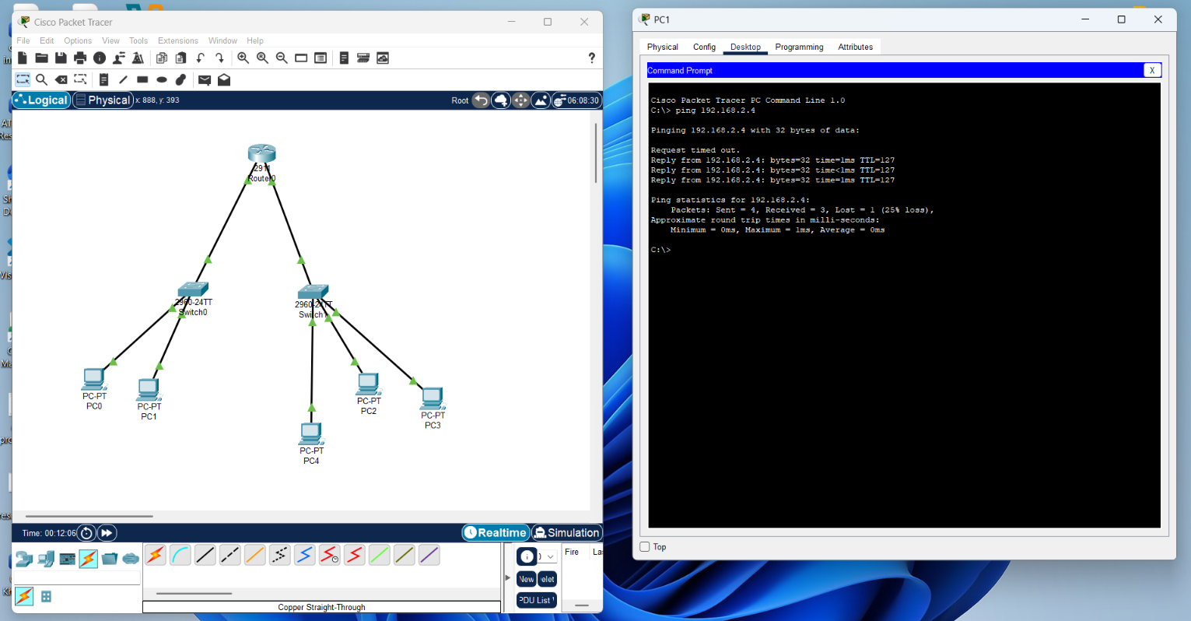
Figure 1 · Extended topology and ping testing
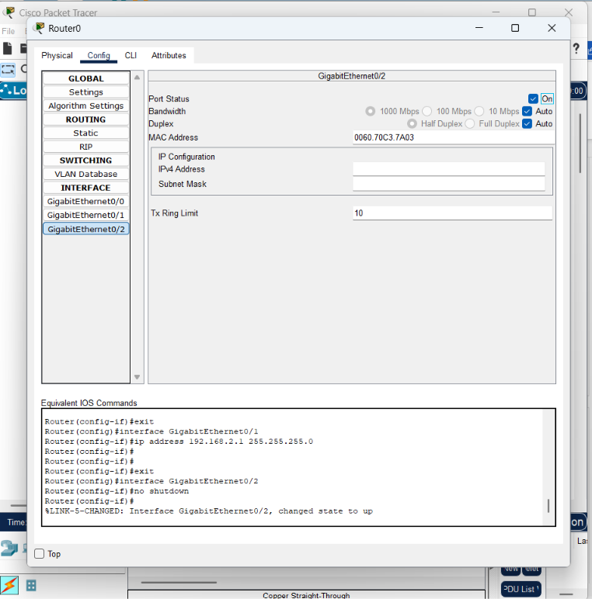
Figure 2 · Router interface configuration
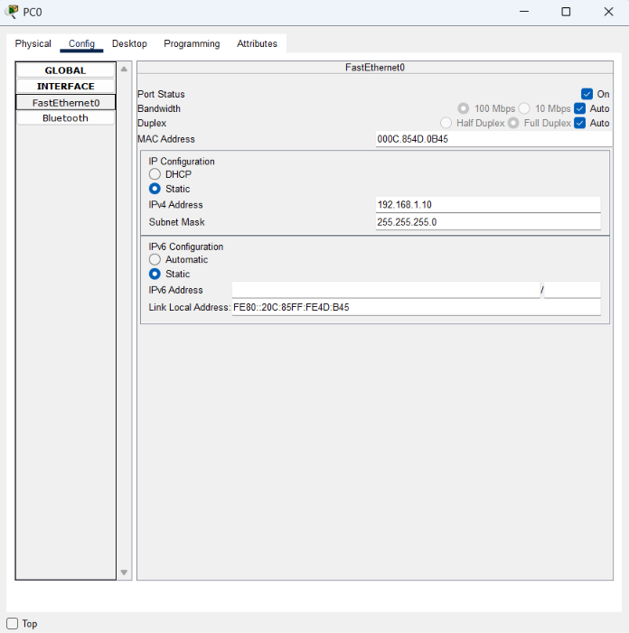
Figure 3 · Device IP config.

2 | Static routing and connectivity tests
TASK | Connected three LANs through three routers and switches, with routers linked through the middle router.
EVIDENCE | Topology and ping tests, including both successful and unsuccessful outcomes.
I configured addressing and explored how static routing affects reachability between networks. The visible tests included failures or unreachable responses, so this section records troubleshooting as well as connectivity.
My main learning was that a connected topology alone is not sufficient: routers need appropriate routes, and devices need valid addressing and gateways for traffic to reach a remote LAN.
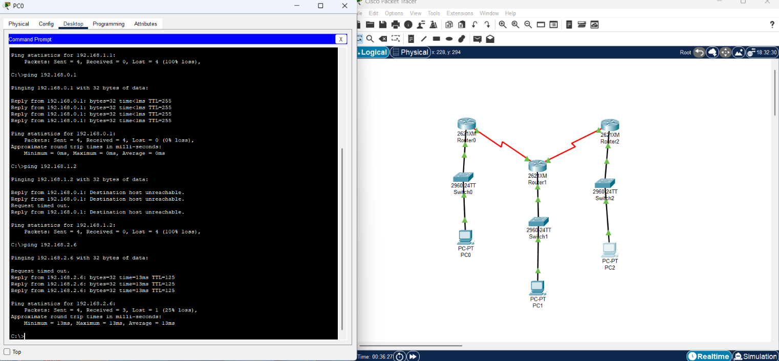
Figure 4 · Three-router topology with ping results

3 | Dynamic routing with RIPv2
TASK | Configured RIP version 2 to exchange routes between routers.
EVIDENCE | Router connectivity tests and Packet Tracer Simulation Mode.
In this activity I compared dynamic routing with static routes. After a network connection changed, RIPv2 was used to learn an alternative route without manually rewriting every static route.
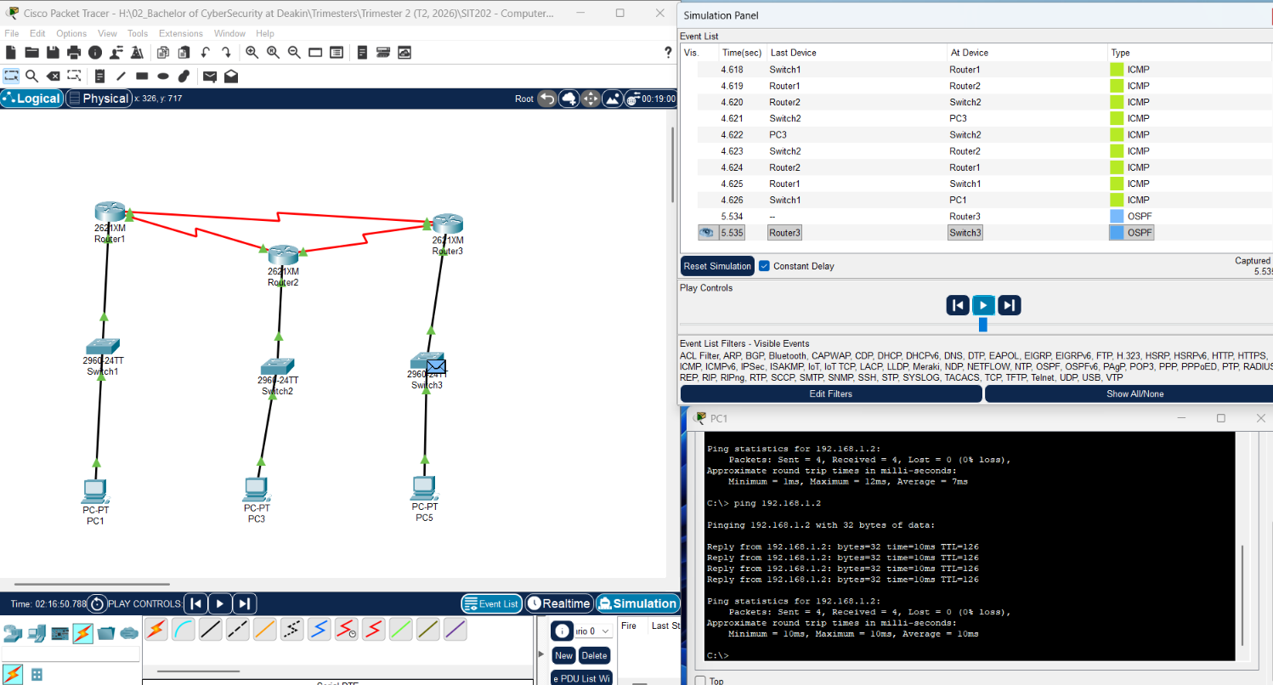
Figure 5 · Dynamic routing topology and simulation results

4 | DHCP across three LANs
TASK | Built three LANs (192.168.1.0/24, 192.168.2.0/24 and 192.168.3.0/24) with a router and a DHCP server.
EVIDENCE | DHCP pool configuration, host addressing, ping tests and Simulation Mode.
I used a static address for the DHCP server and separate pools for the LANs. The router acted as the default gateway and ip helper-address relayed requests from LANs without the server. I examined the DHCP Discover, Offer, Request and Acknowledgement sequence.
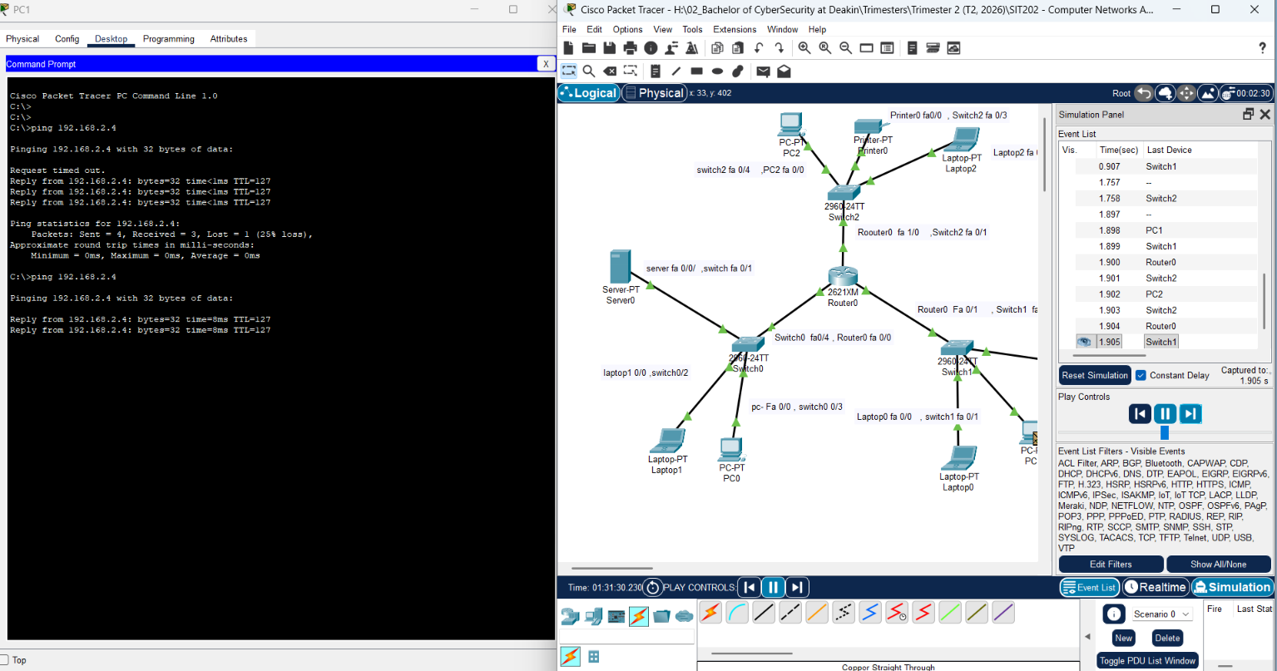
Figure 6 · DHCP multi-LAN topology and packet observations

5 | ICMP and packet inspection
TASK | Sent test packets across LANs and inspected ICMP details in Simulation Mode.
EVIDENCE | Simple PDU, packet detail windows and connectivity-related screenshots.
I reviewed the source and destination addresses, TTL and ICMP type/code fields. Echo Request uses Type 8, Code 0; Echo Reply uses Type 0, Code 0. I also explored traceroute and how changing TTL values can reveal network hops.
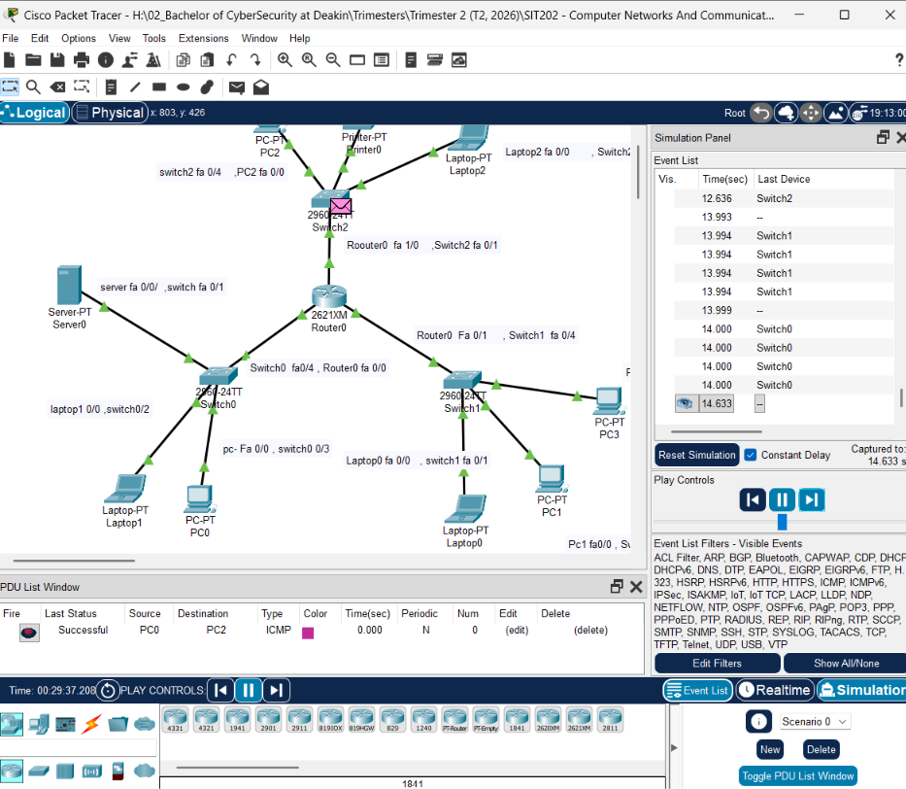
Figure 7 · ICMP connectivity and simulation view
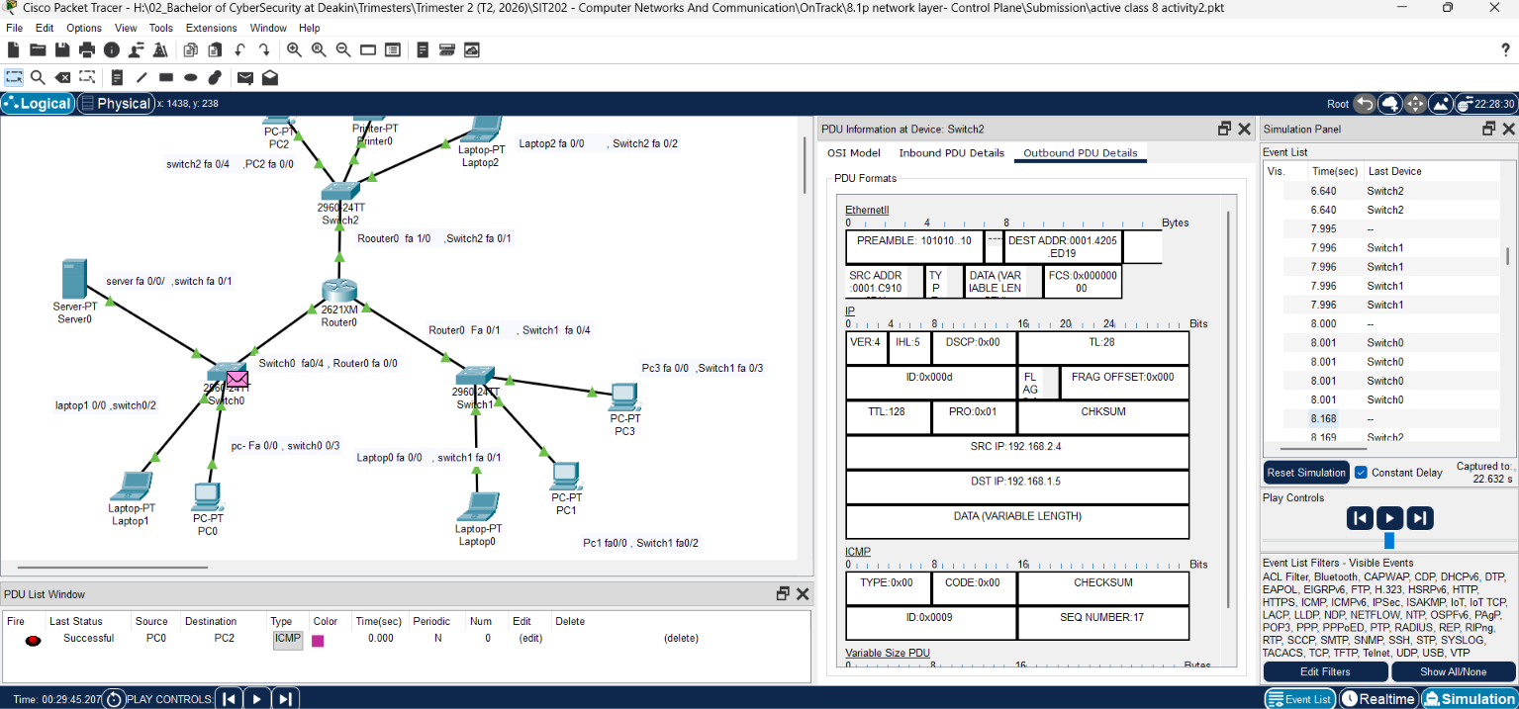
Figure 8 · Packet details
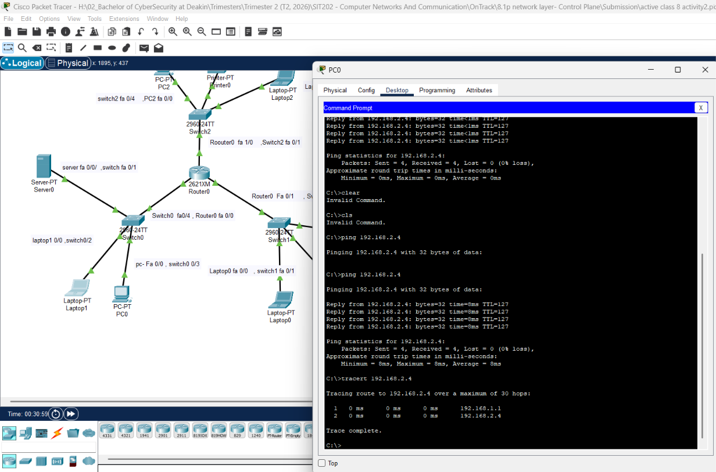

6 | ARP address resolution
TASK | Observed ARP requests, replies and changes in ARP caches after network communication.
EVIDENCE | Topology, terminal displays, host configuration and simulation screenshots.
On the same LAN, ARP helps a device find the destination MAC address; for a remote LAN, the host resolves the default gateway MAC address. I compared cached entries before and after communication.
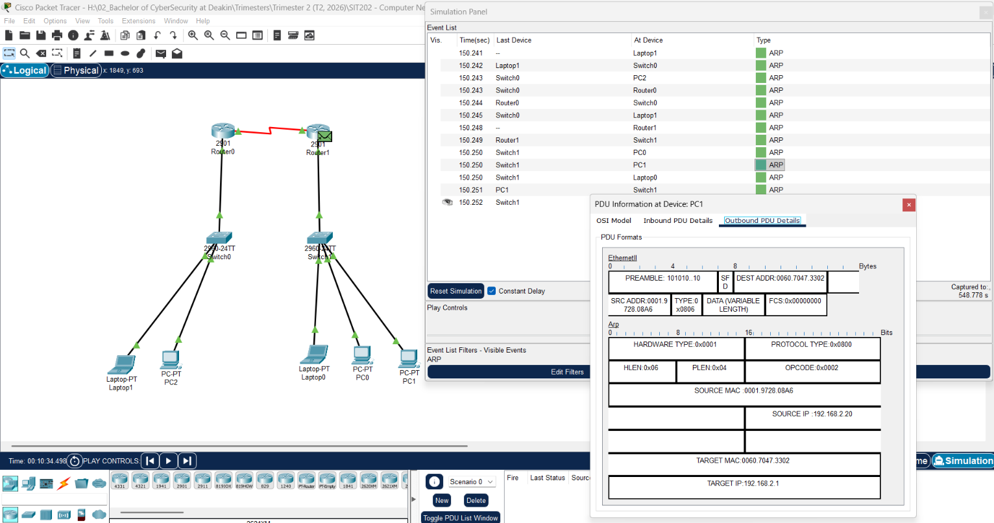
Figure 10 · ARP-related command-line testing
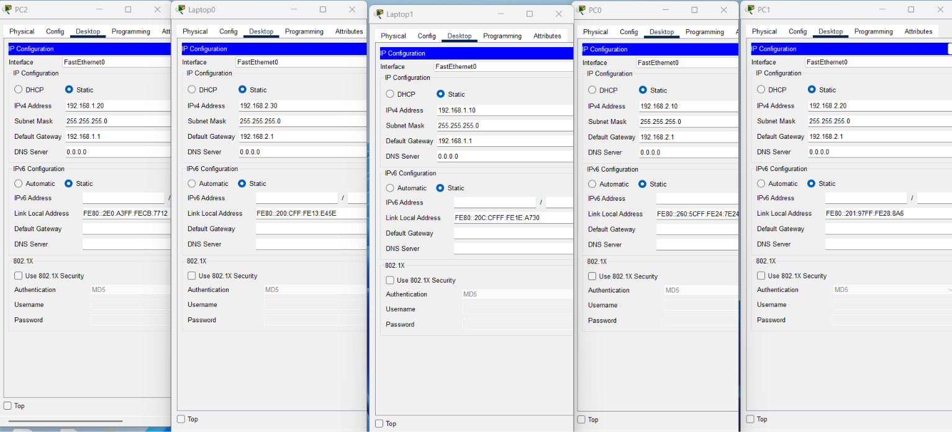
Figure 11 · Configurations
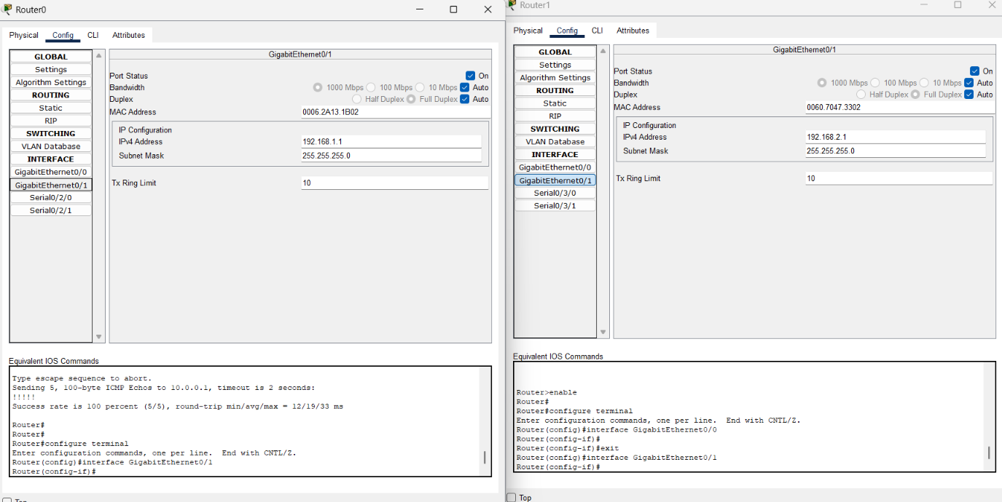
Figure 12 · Config.
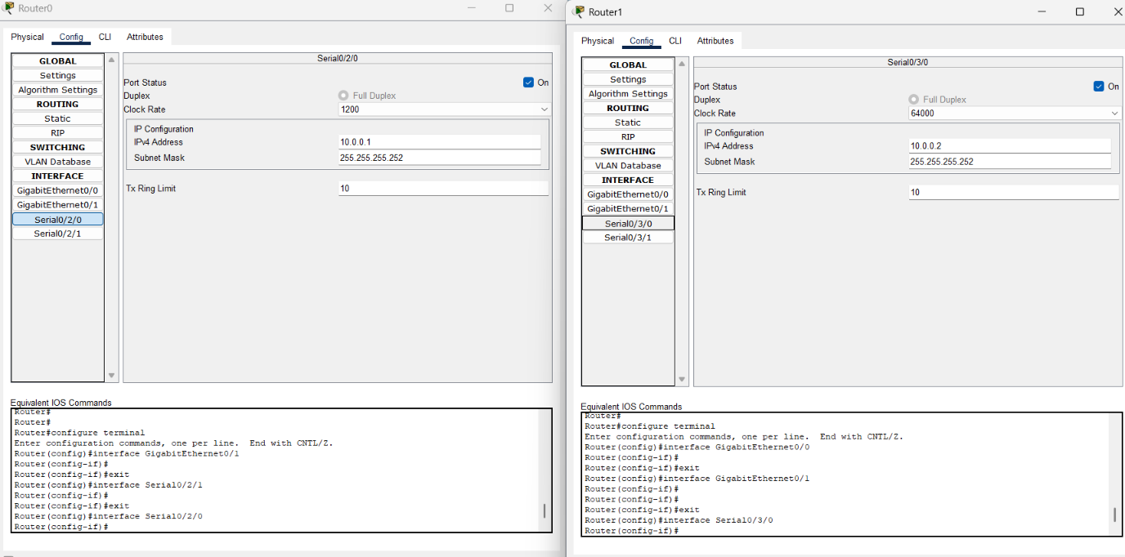
Figure 13 · Config.
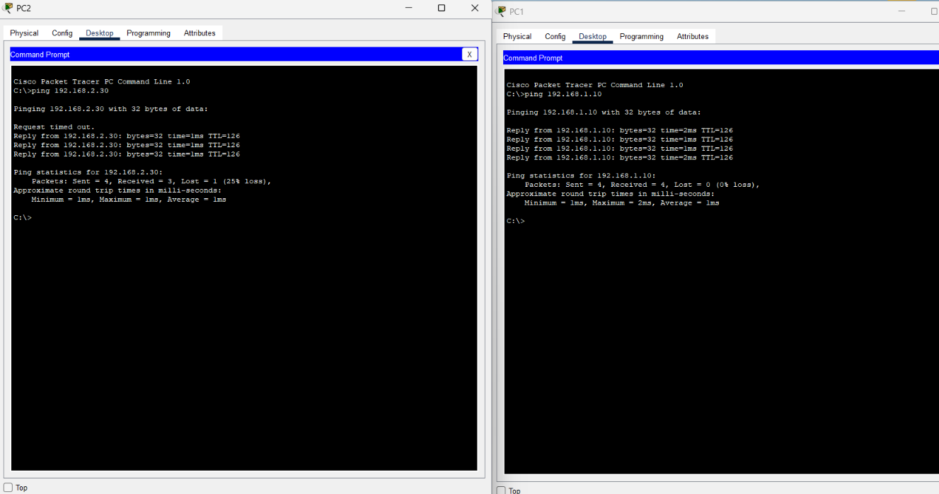
Figure 14 · Ping Testing
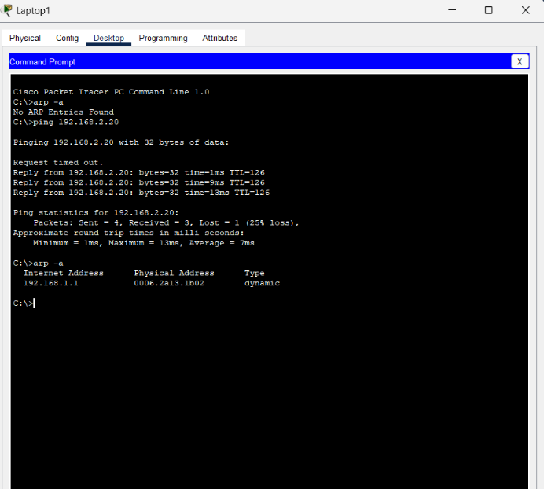
Figure 15 · Arp table checking

7 | Switch MAC learning and DHCP
TASK | Used a switch MAC address table, endpoint ARP caches and a DHCP-enabled network to observe learned entries.
EVIDENCE | Switch command-line output, device tests and host addressing views.
A switch learns source MAC addresses and associates them with incoming ports. I compared this with ARP tables, which map IP addresses to MAC addresses. After clearing MAC table entries and generating network traffic, new entries appeared.
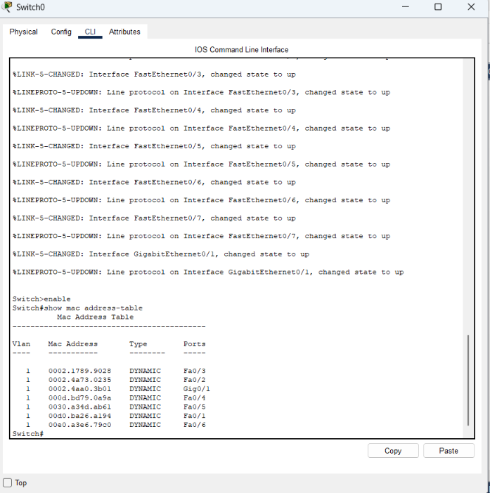
Figure 16 · Mac address table checking in Switch
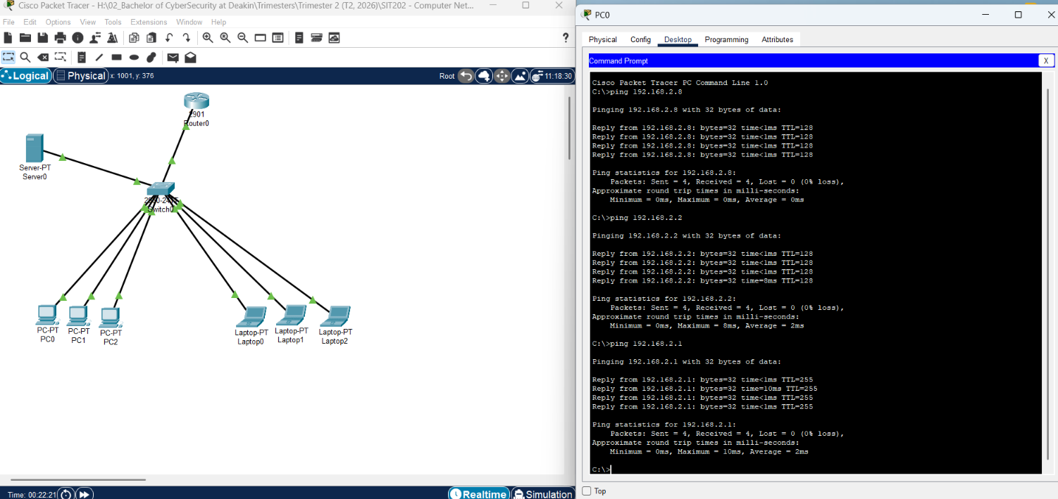
Figure 17 · ARP cache example
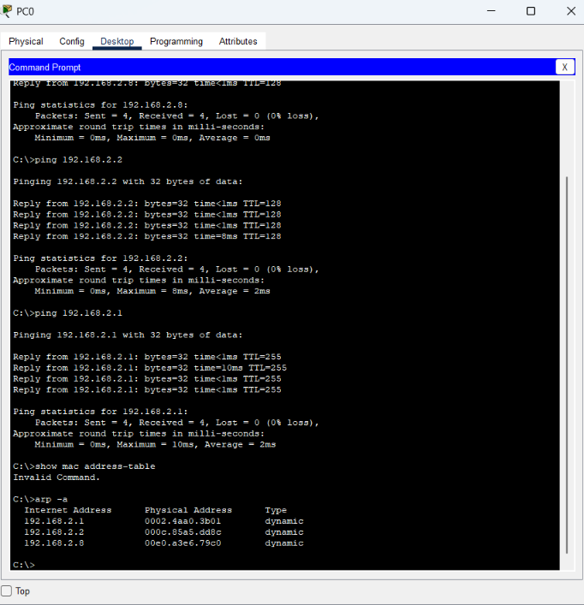
Figure 18 · PC0 MAC address table
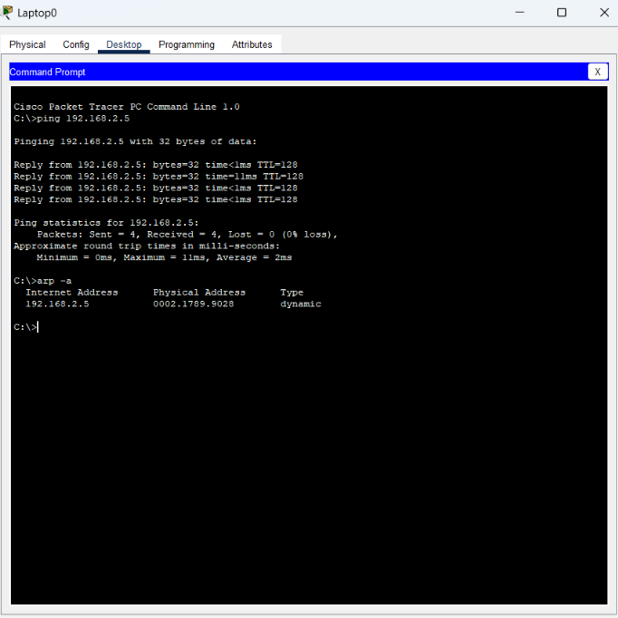
Figure 19 · ARP table tests/ checking
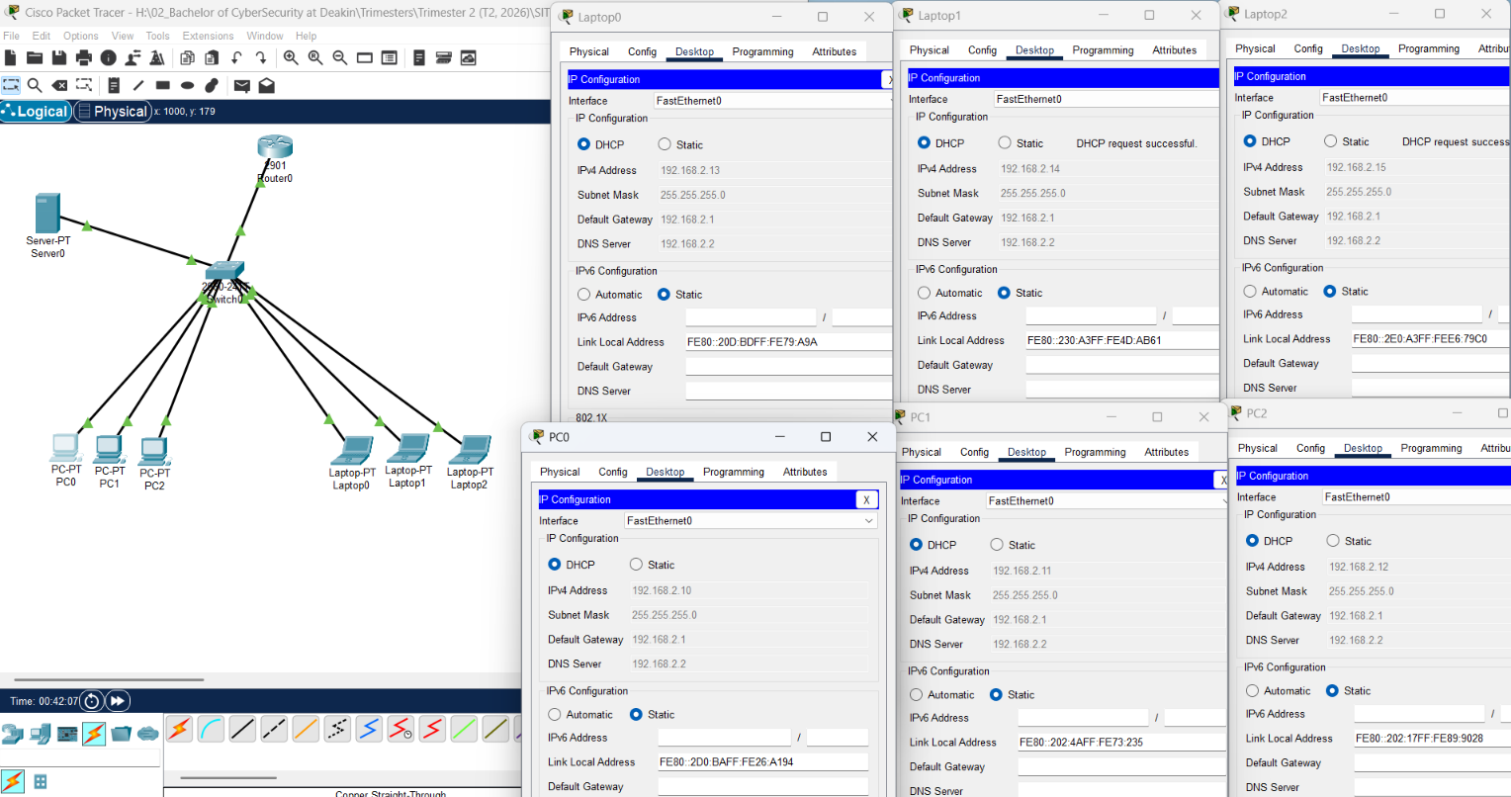
Figure 20 · DHCP-related device config.
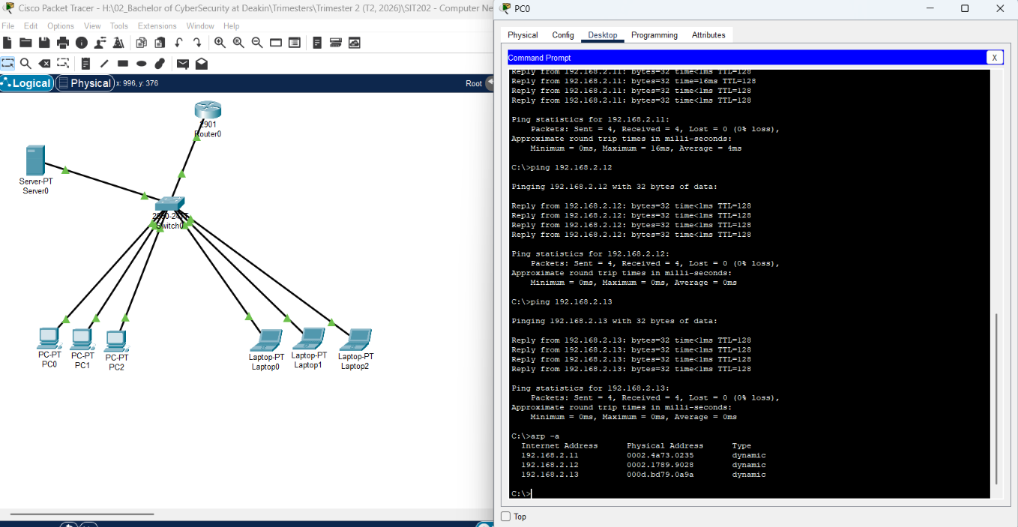
Figure 21 · DHCP-enabled ARP table checking
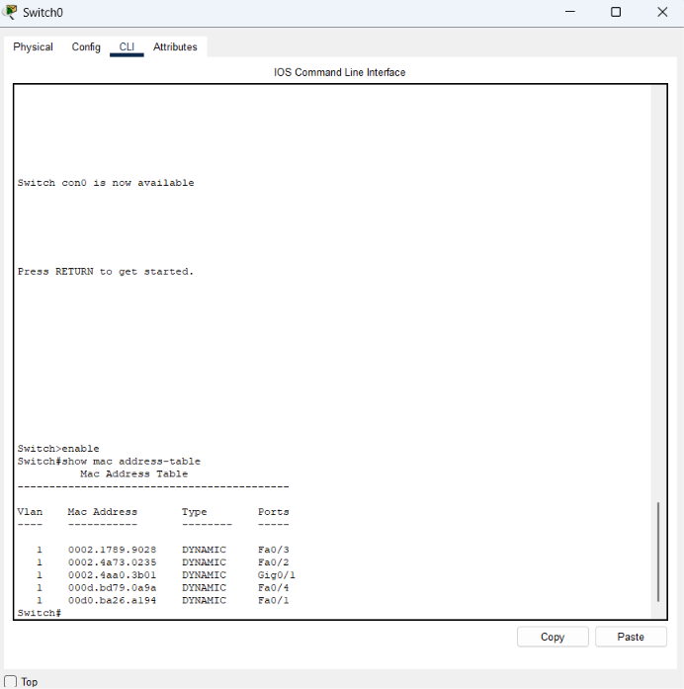
Figure 22 · Switch MAC table after communication

Key takeaways
These labs strengthened my understanding of the relationship between IP addressing routing and Layer 2 forwarding. I practiced checking connectivity with ping, using Simulation Mode to inspect network traffic and comparing expected behaviour with results shown on screen.

