ECE2210 – Nick Troiano – ntroian – 08/30/2026
HW0
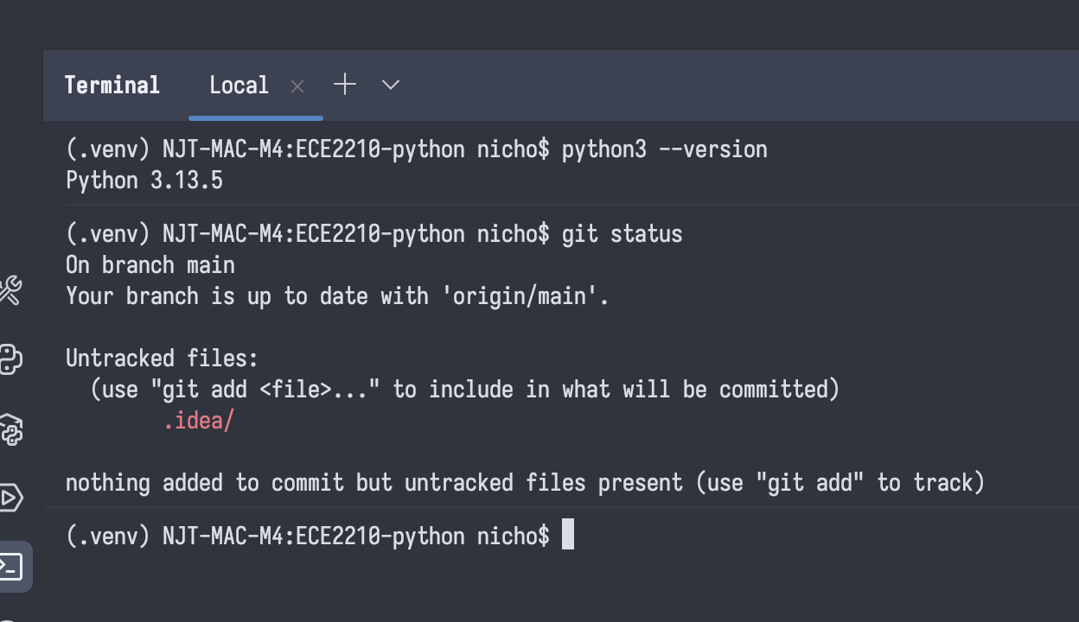
https://github.com/CT-42210/ece2210-python/settings

I had no extraneous issues setting up my directories, Python virtual environment, and git repository (cloud backup). I have been programming for 8 years, so I am fairly confident in my ability to succeed in this class and am excited to see where it takes me!

