HW1 – Nick Troiano – ntroian – ECE2210
Screenshot 1 – Problem 1:
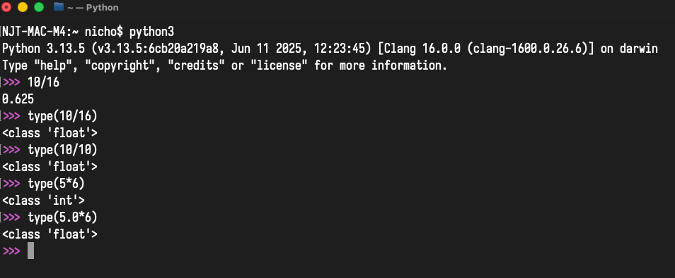
Screenshot 2 – Problems 2-5:
