ĐẠI HỌC CẦN THƠ
TRƯỜNG CÔNG NGHỆ THÔNG TIN VÀ TRUYỀN THÔNG


BÁO CÁO THỰC HÀNH TIN HỌC VĂN PHÒNG
HỌC PHẦN: NỀN TẢNG CÔNG NGHỆ SỐ (CT005)
Giảng viên hướng dẫn: Lê Huỳnh Quốc Bảo
Sinh viên thực hiện: Sầm Ngọc Diễm Quỳnh
Mã số sinh viên: B2605301
Lớp học phần: CT005_D03
MỤC LỤC

Bài thực hành 2: Microsoft Word và Google Docs 2
Bài thực hành số 1 - Trộn thư dữ liệu từ Excel 2
Bài thực hành số 2 - Tạo mục lục 2
Bài thực hành số 3 - Google Docs 2
Bài thực hành 3: Microsoft Excel và Google Sheets 3
Bài thực hành số 1 - Excel 3
Bài thực hành số 2 - Google Spreadsheet 3
Bài thực hành 4: Microsoft Powerpoint 4
Bài thực hành số 1 4
Bài thực hành số 2 4
Bài thực hành 5: Tạo, quản lý và chia sẻ nội dung số 5

Bài thực hành 2: Microsoft Word và Google Docs

Bài thực hành số 1 - Trộn thư dữ liệu từ Excel
Mrs Mary Collins
10 Bally Rd
Sydney
Australia
Dear Participant
As you may be aware, we have been running a variety of courses at the college ranging from 1 week to 12 weeks. We are now happy to inform you that we are introducing several 2-day courses, which will be held both at weekends and mid-week to suit the varying needs of potential students.
Please find enclosed an application form and a program schedule. We look forward to your participation.
Yours truly,
Course Director

Mr Tom Thompson
15 Bondi Rd
Sydney
Australia
Dear Participant
As you may be aware, we have been running a variety of courses at the college ranging from 1 week to 12 weeks. We are now happy to inform you that we are introducing several 2-day courses, which will be held both at weekends and mid-week to suit the varying needs of potential students.
Please find enclosed an application form and a program schedule. We look forward to your participation.
Yours truly,
Course Director

Ms Roberta Reynolds
85 Lombard Street
New York
America
Dear Participant
As you may be aware, we have been running a variety of courses at the college ranging from 1 week to 12 weeks. We are now happy to inform you that we are introducing several 2-day courses, which will be held both at weekends and mid-week to suit the varying needs of potential students.
Please find enclosed an application form and a program schedule. We look forward to your participation.
Yours truly,
Course Director

Mr Tâm Nguyen Minh
115 Trần Hưng Đạo
CanTho
VietNam
Dear Participant
As you may be aware, we have been running a variety of courses at the college ranging from 1 week to 12 weeks. We are now happy to inform you that we are introducing several 2-day courses, which will be held both at weekends and mid-week to suit the varying needs of potential students.
Please find enclosed an application form and a program schedule. We look forward to your participation.
Yours truly,
Course Director

Ms George Stephens
34 George Street
Sydney
Australia
Dear Participant
As you may be aware, we have been running a variety of courses at the college ranging from 1 week to 12 weeks. We are now happy to inform you that we are introducing several 2-day courses, which will be held both at weekends and mid-week to suit the varying needs of potential students.
Please find enclosed an application form and a program schedule. We look forward to your participation.
Yours truly,
Course Director

Mr Frank Hunter
23 Mullins Rd
Geelong
Australia
Dear Participant
As you may be aware, we have been running a variety of courses at the college ranging from 1 week to 12 weeks. We are now happy to inform you that we are introducing several 2-day courses, which will be held both at weekends and mid-week to suit the varying needs of potential students.
Please find enclosed an application form and a program schedule. We look forward to your participation.
Yours truly,
Course Director

Mrs Hang Le Thanh
14 Le Duan
Ha Noi
VietNam
Dear Participant
As you may be aware, we have been running a variety of courses at the college ranging from 1 week to 12 weeks. We are now happy to inform you that we are introducing several 2-day courses, which will be held both at weekends and mid-week to suit the varying needs of potential students.
Please find enclosed an application form and a program schedule. We look forward to your participation.
Yours truly,
Course Director

Bài thực hành số 2 - Tạo mục lục
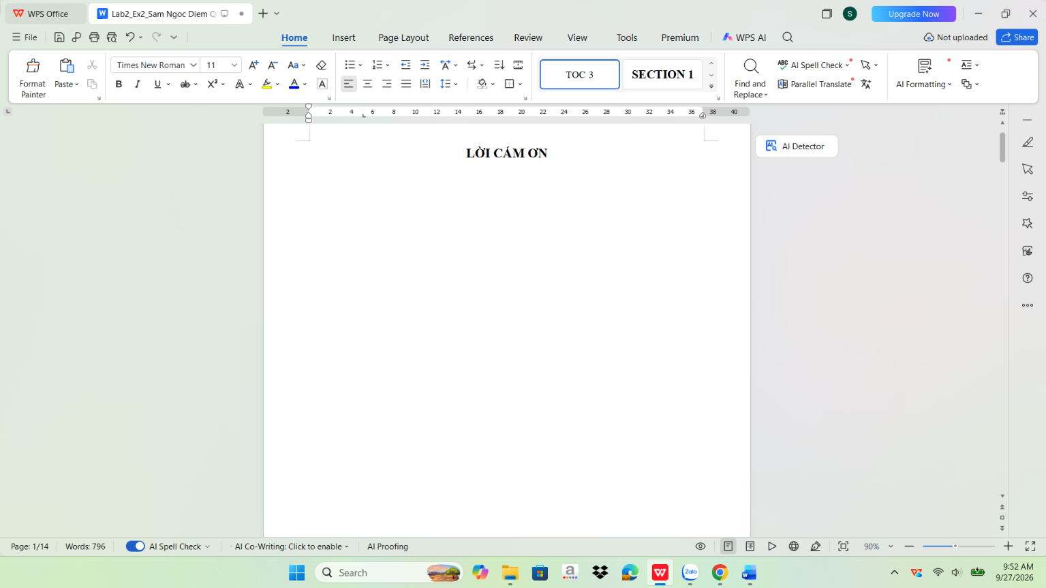
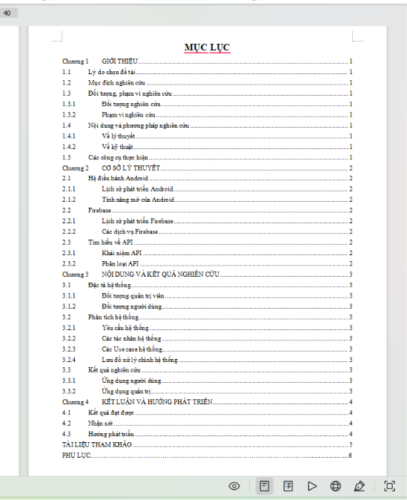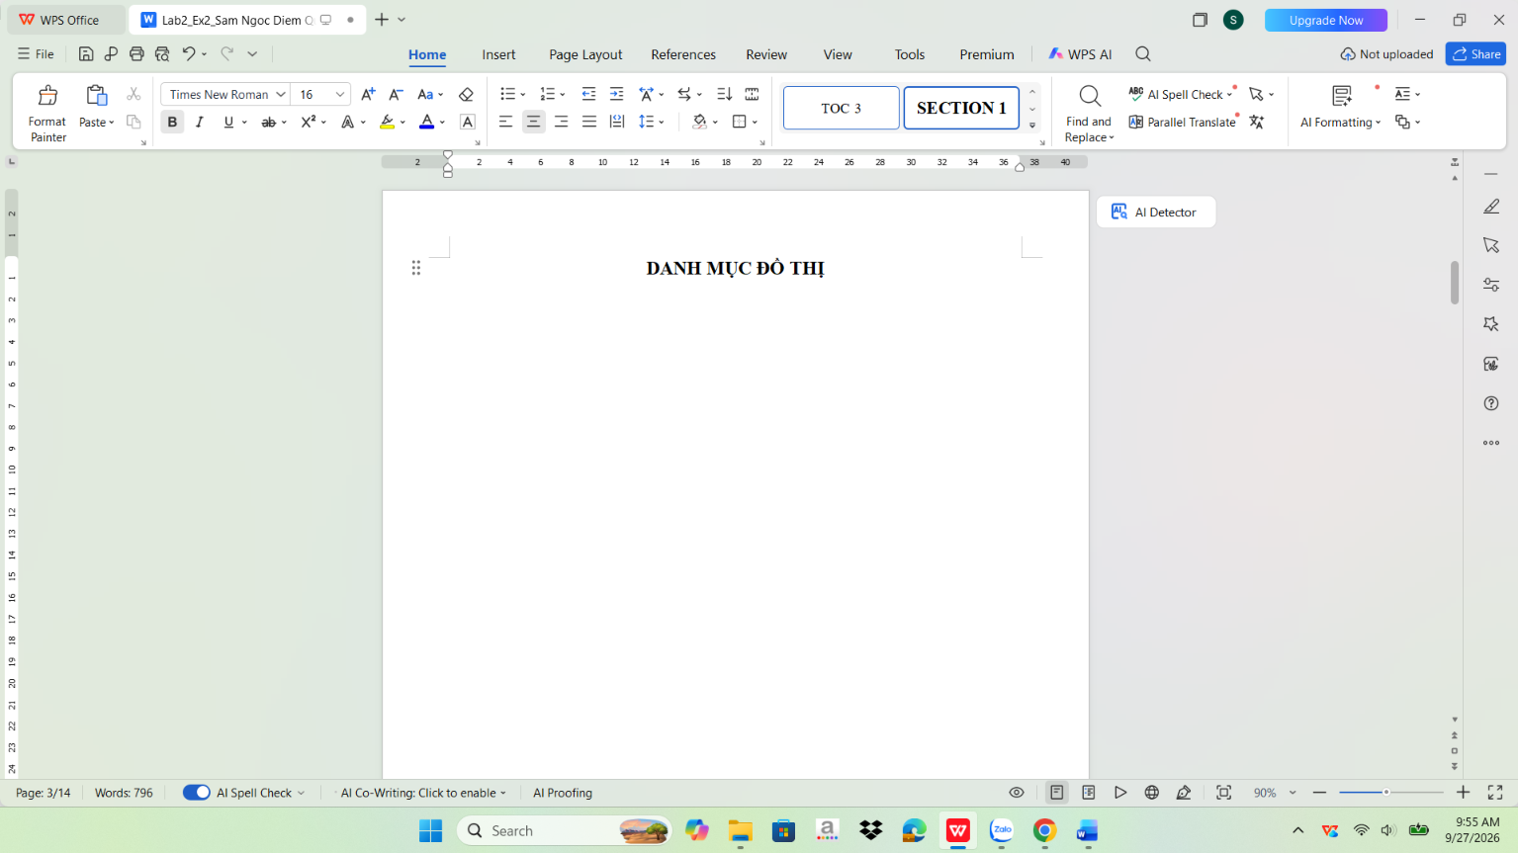
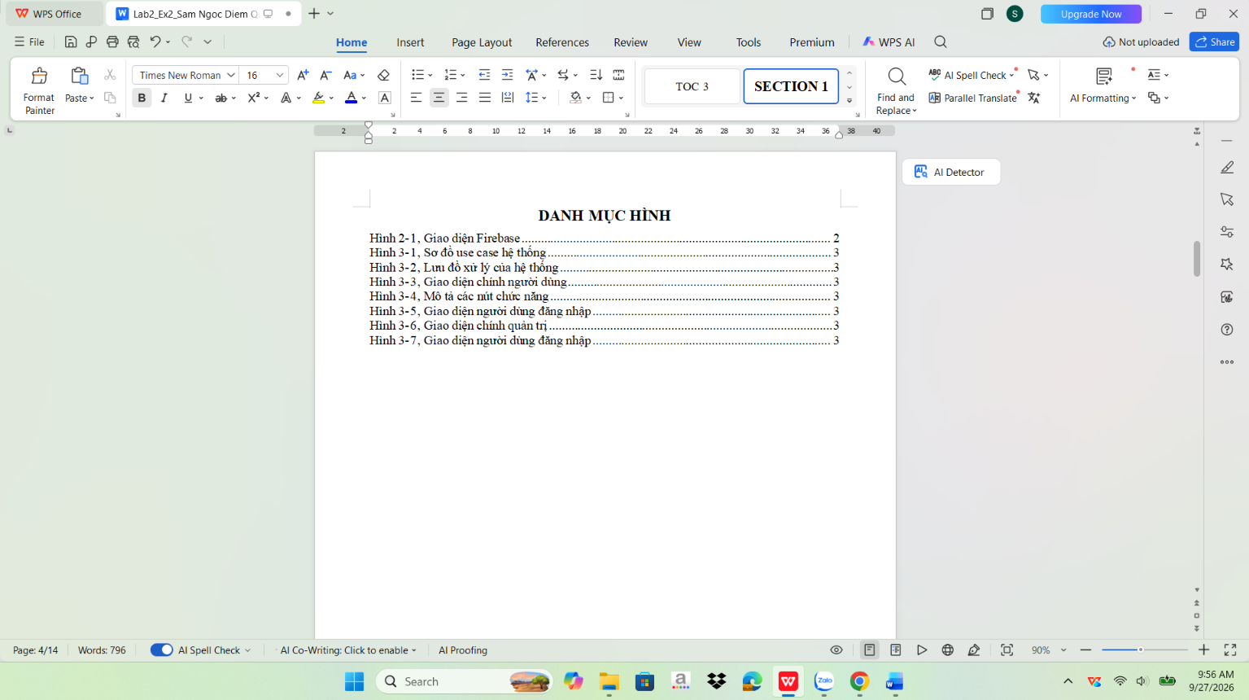
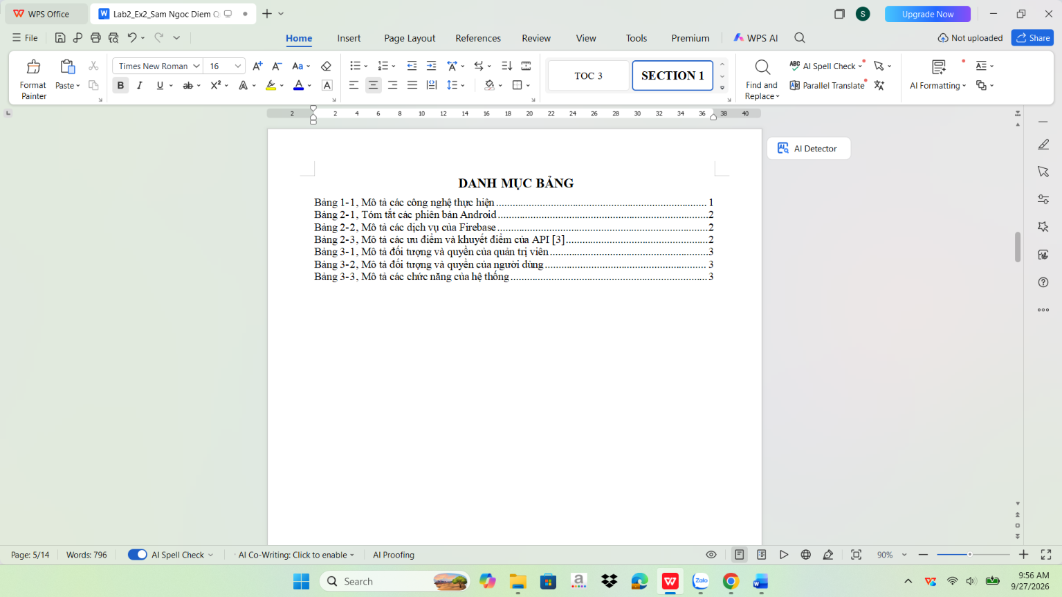
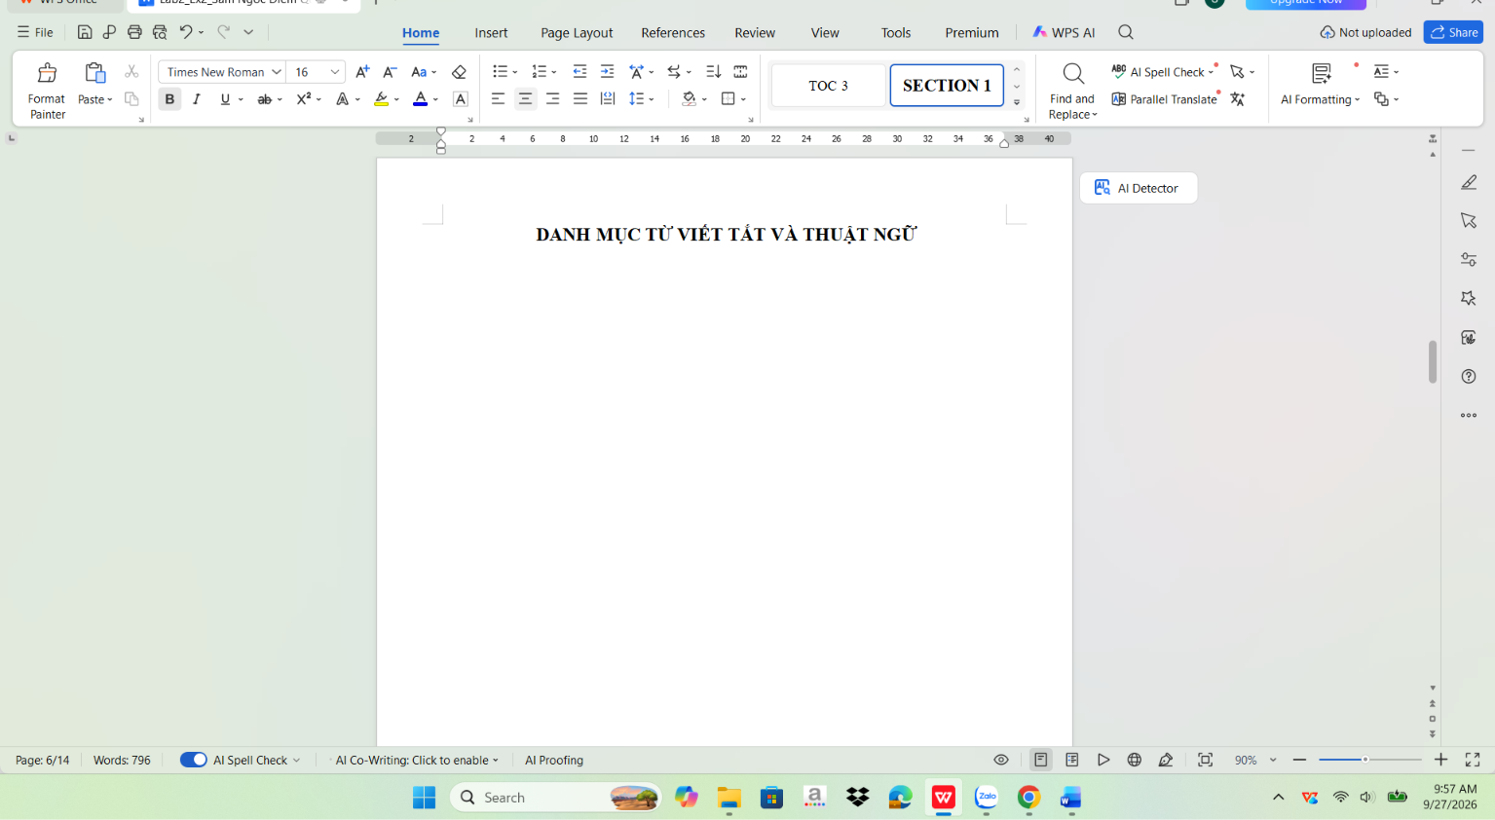
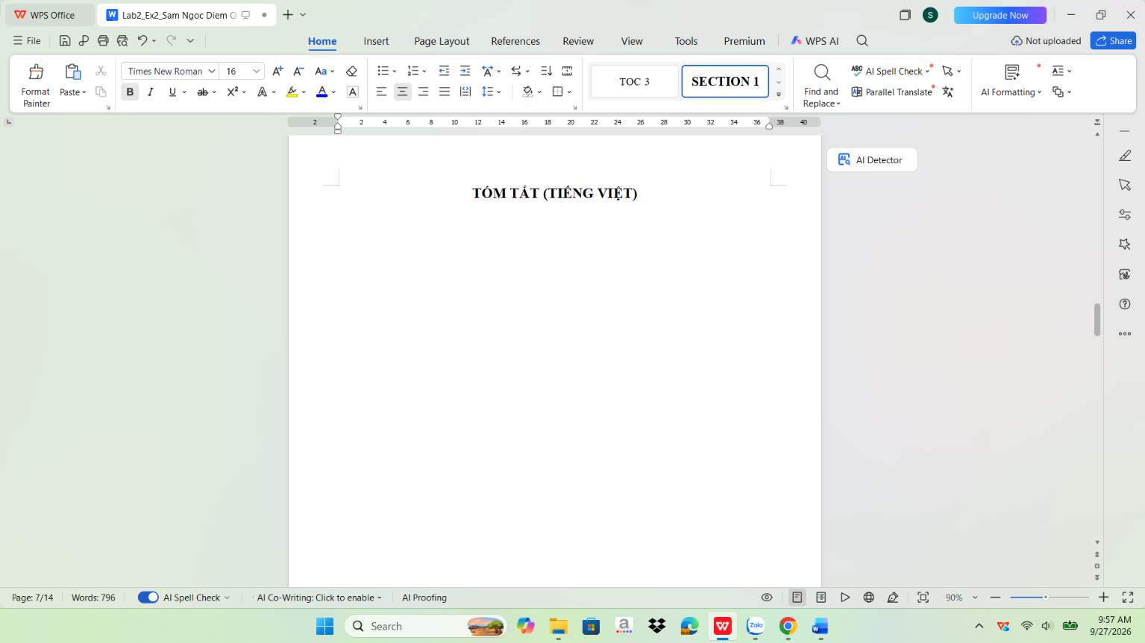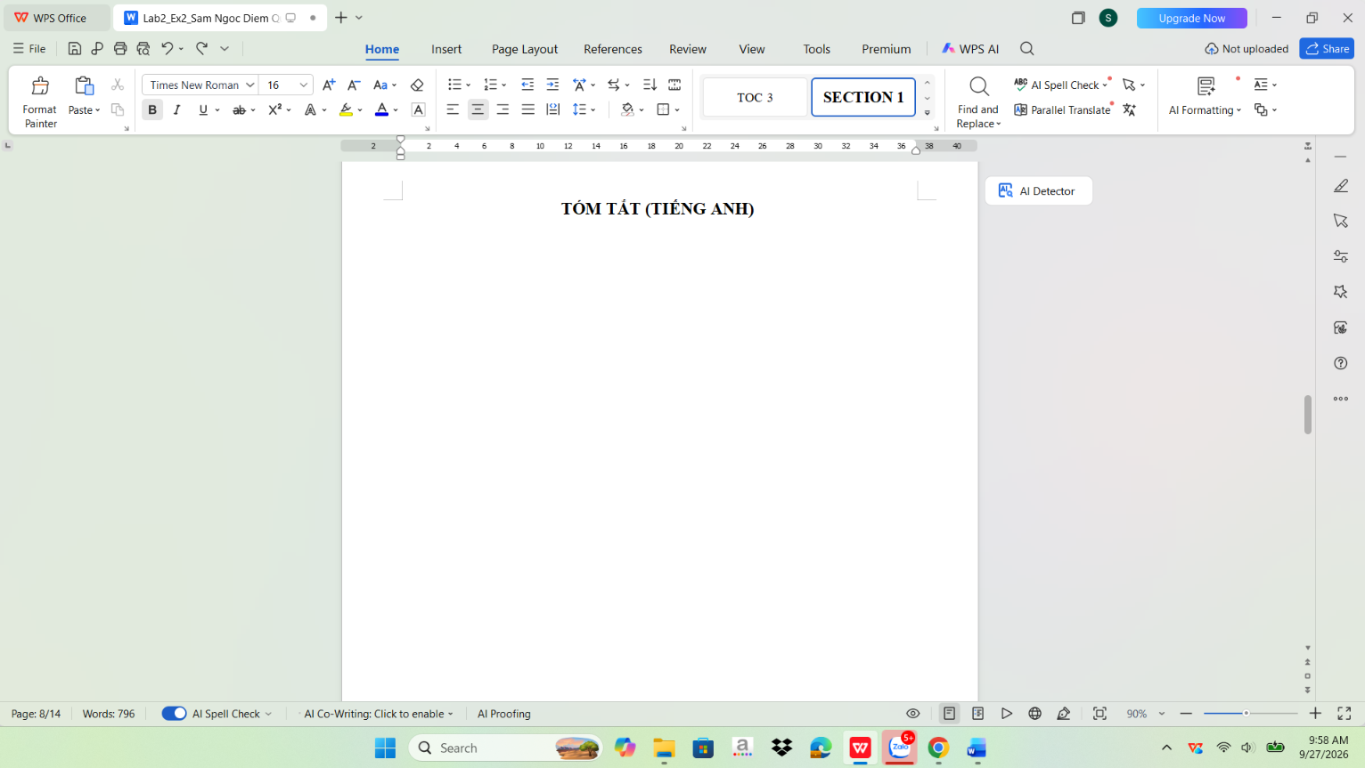
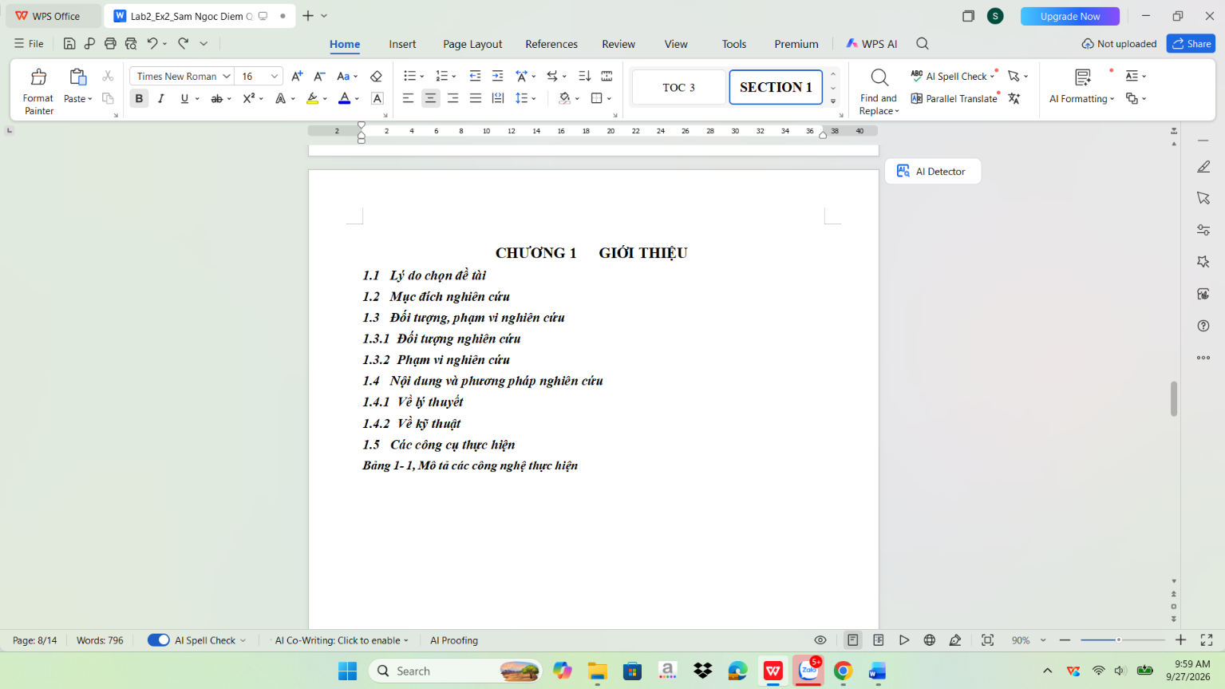
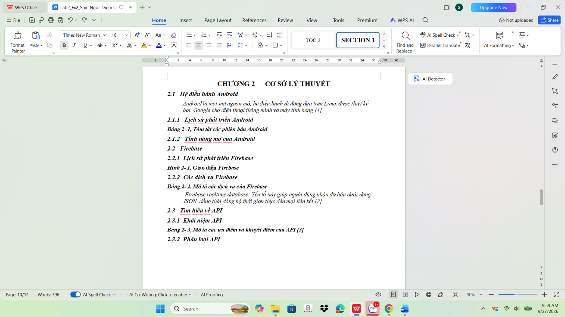
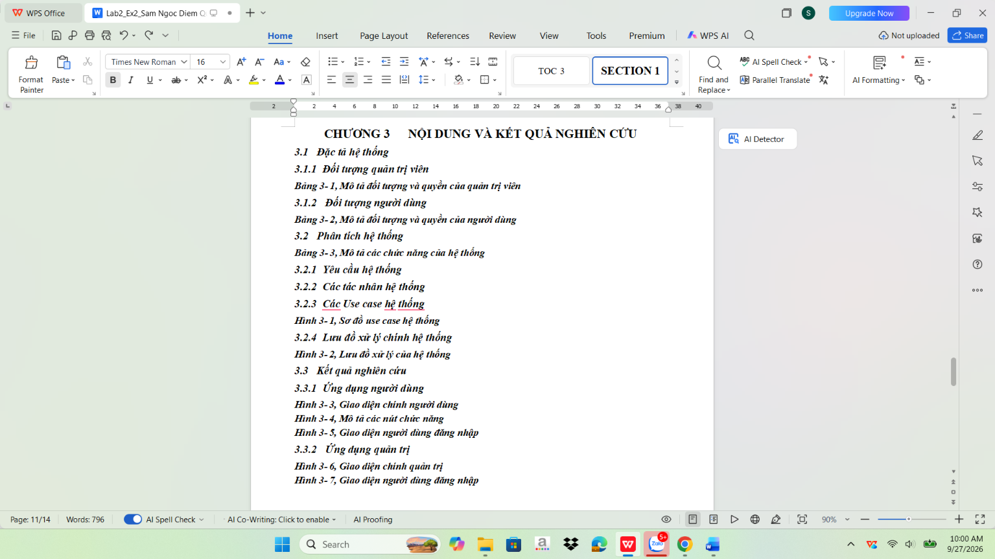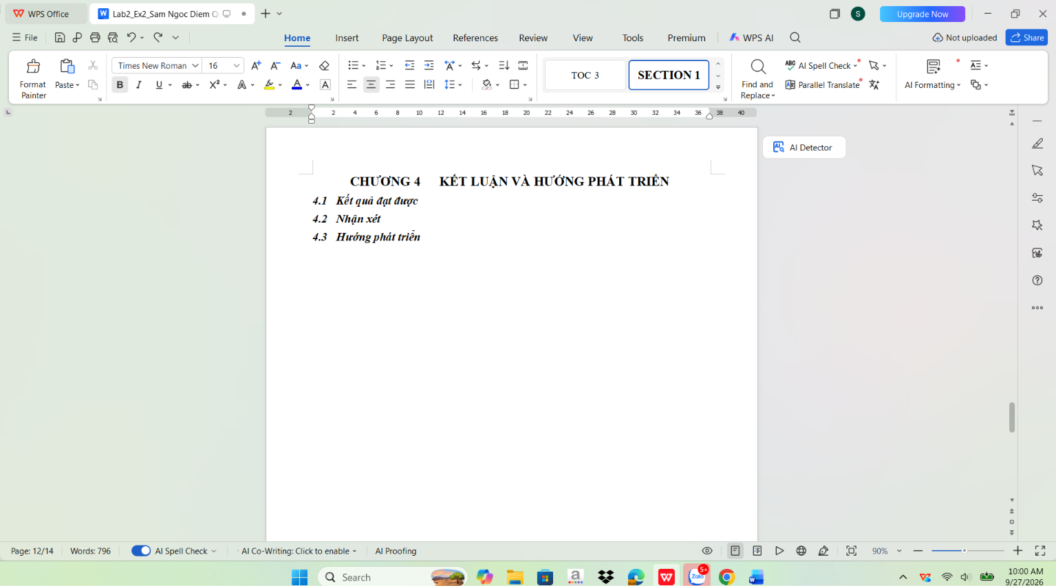
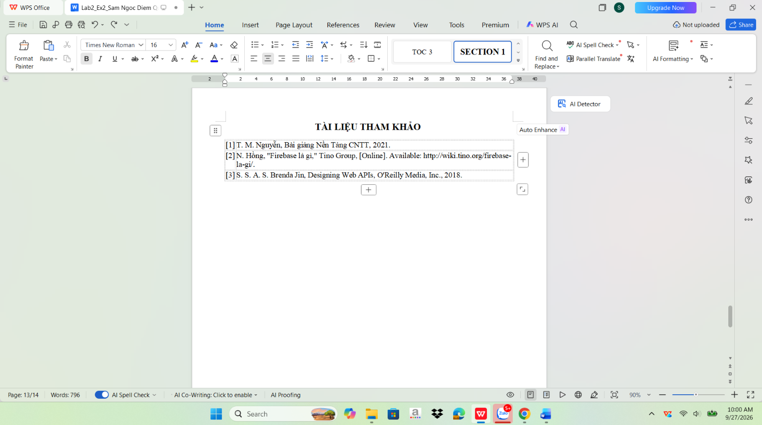
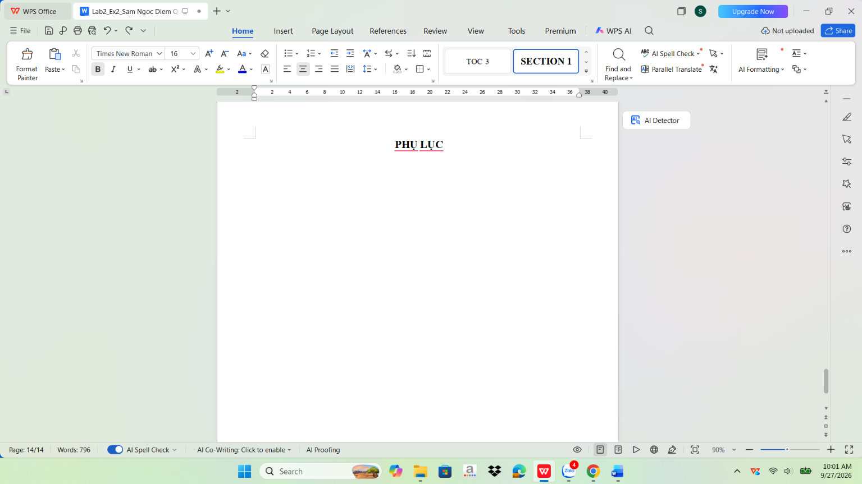

Bài thực hành số 3 - Google Docs
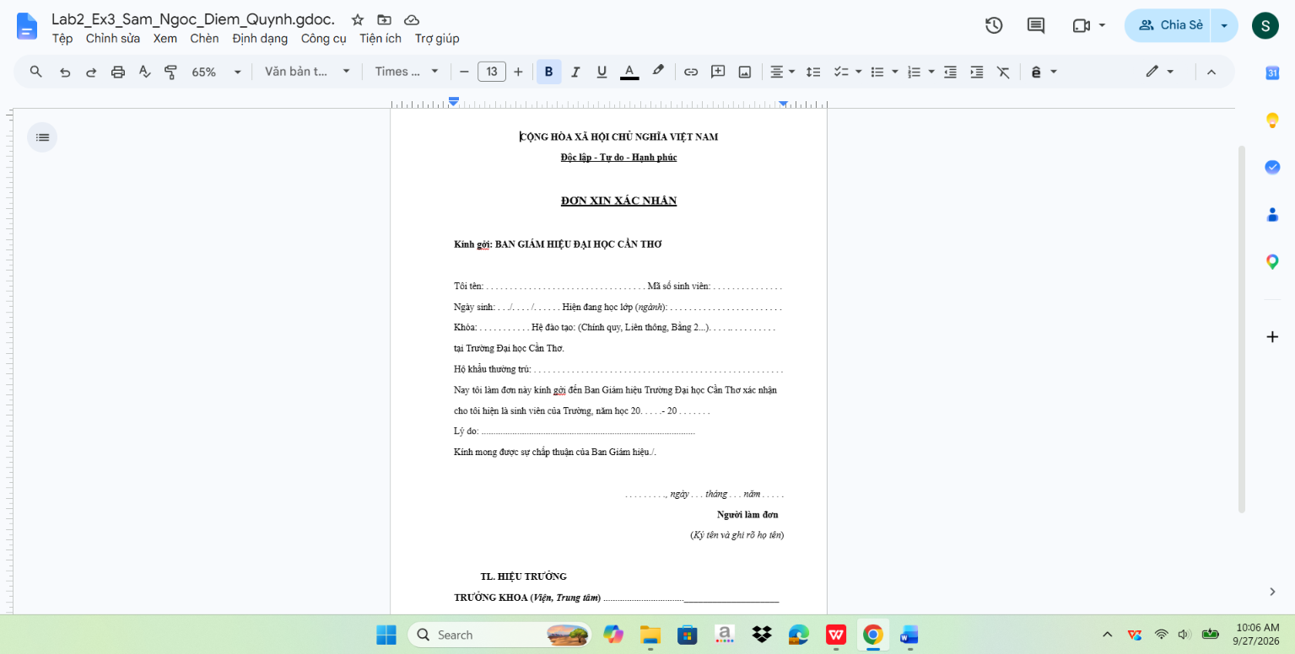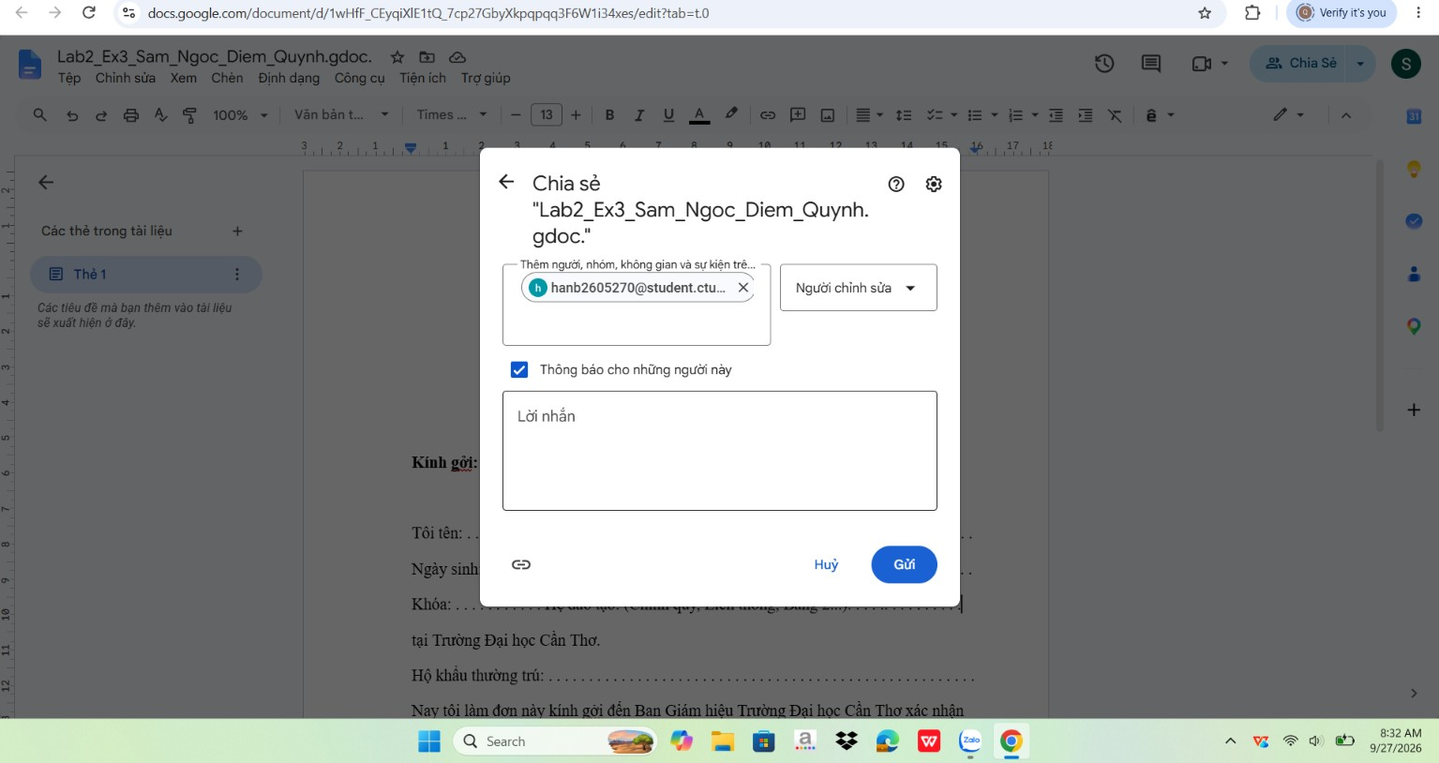
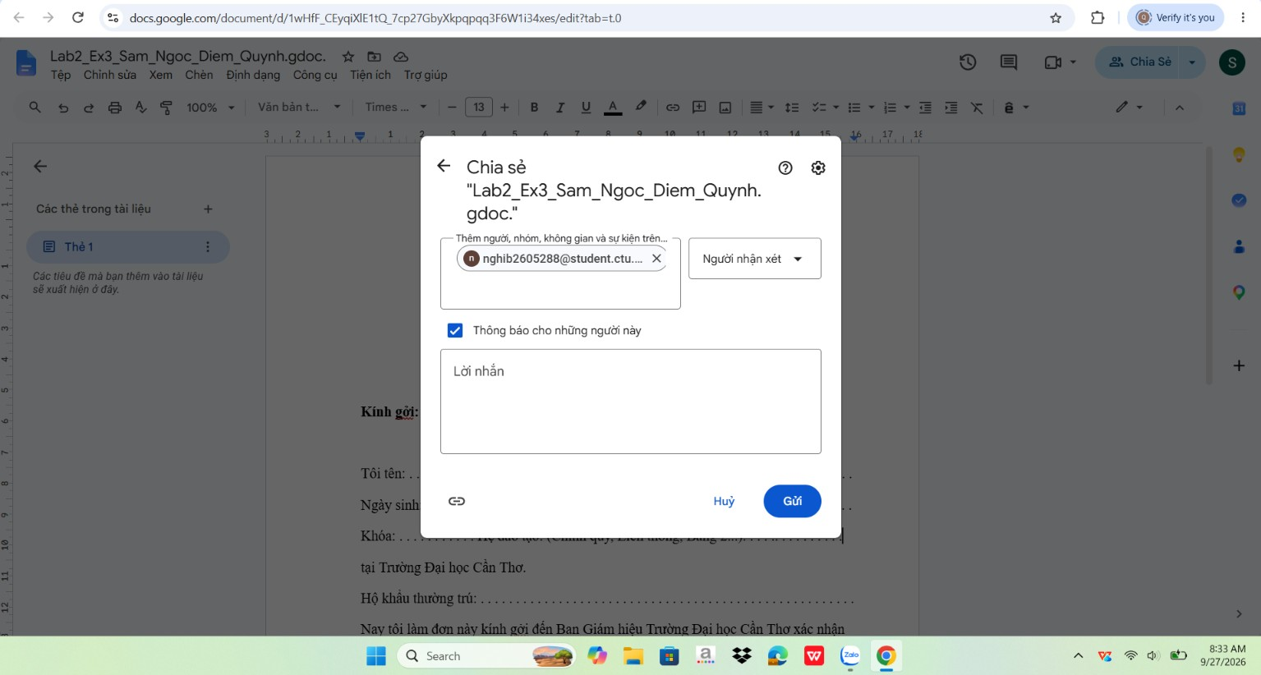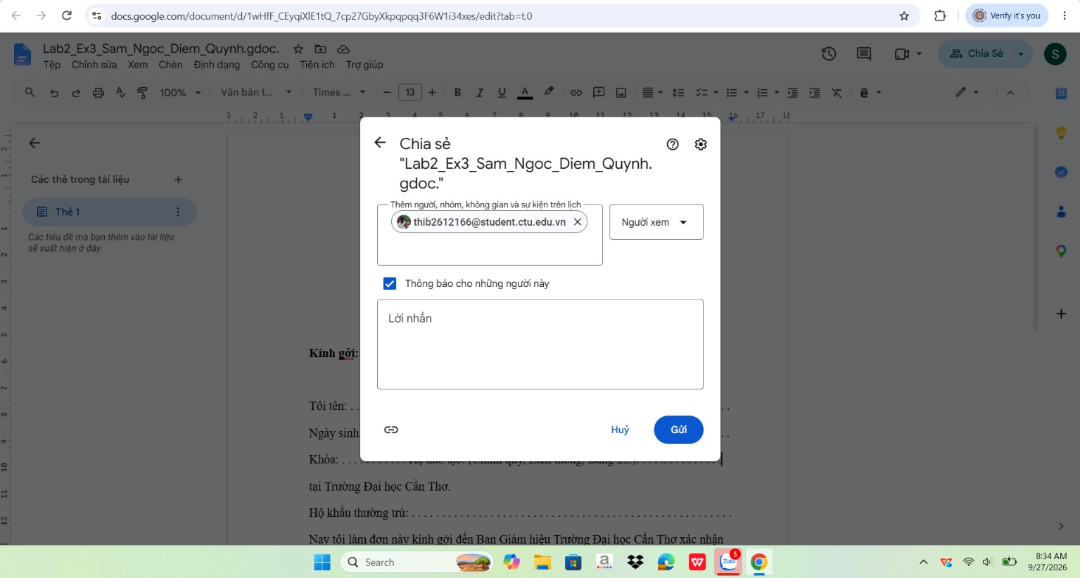
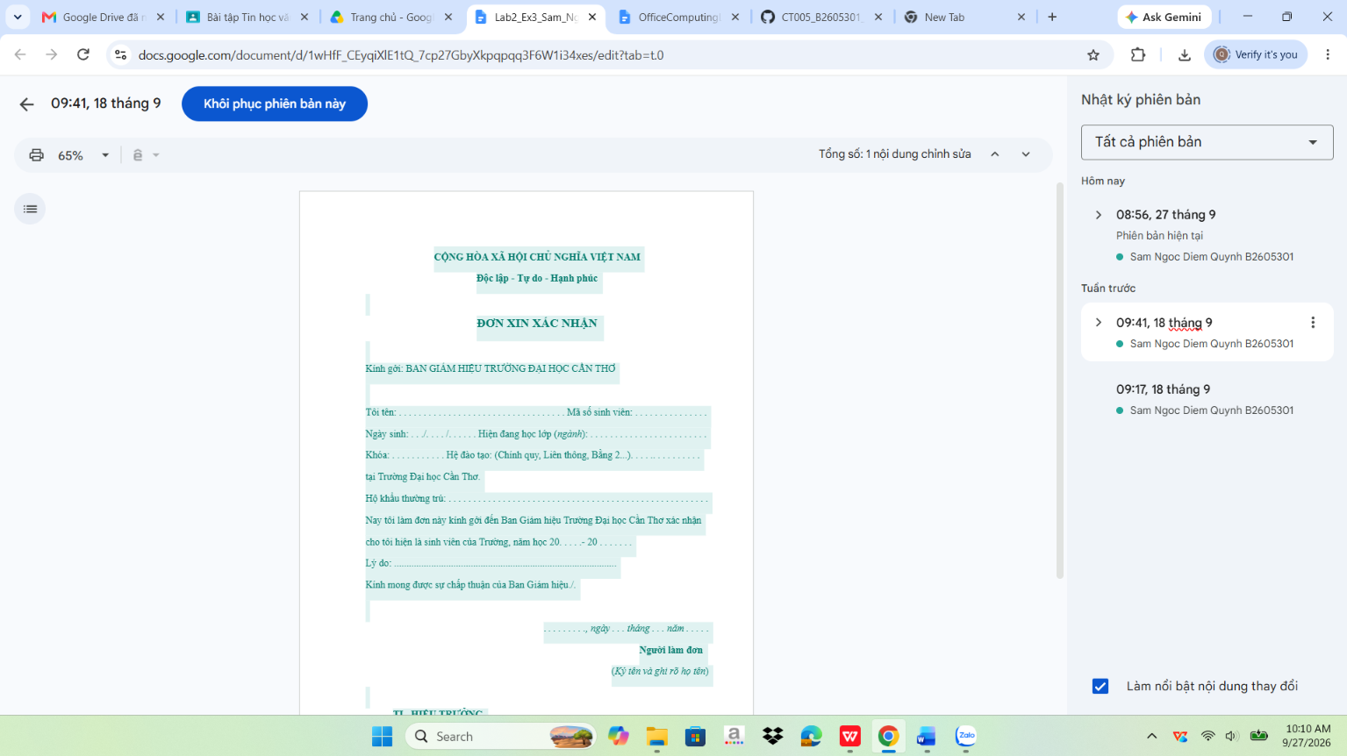
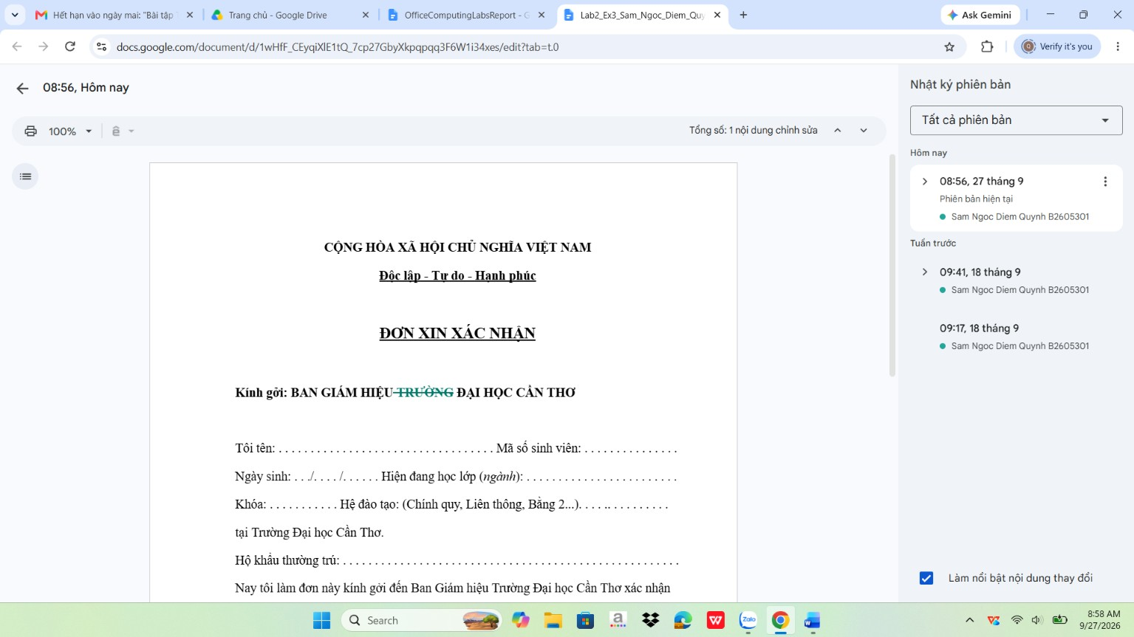

Bài thực hành 3: Microsoft Excel và Google Sheets

Bài thực hành số 1 – Excel
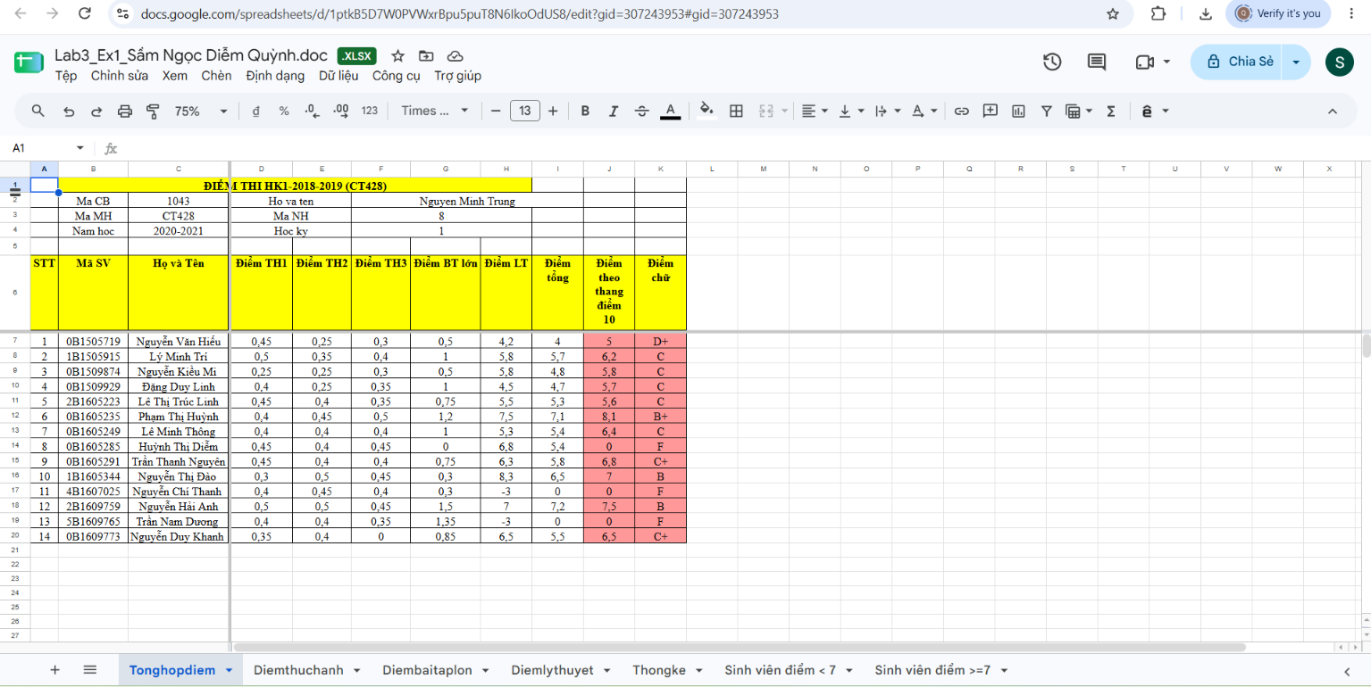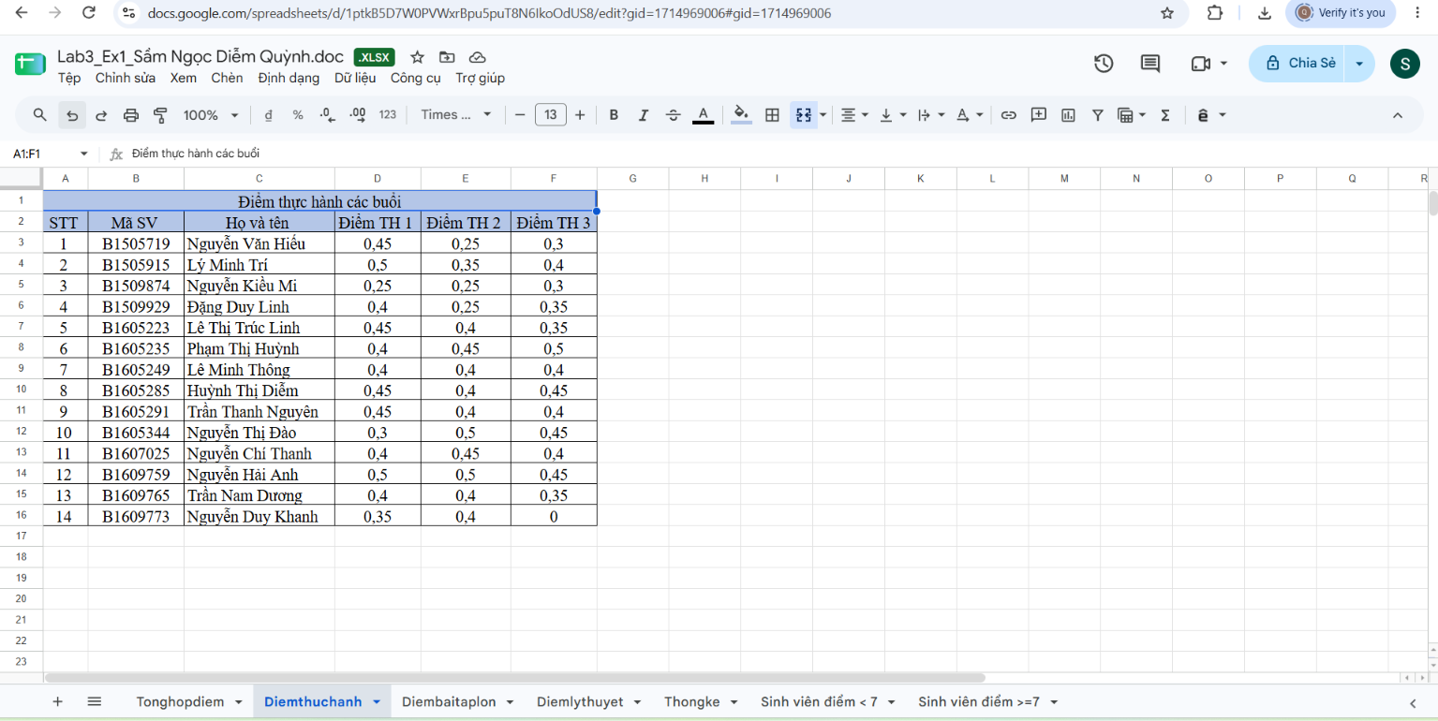
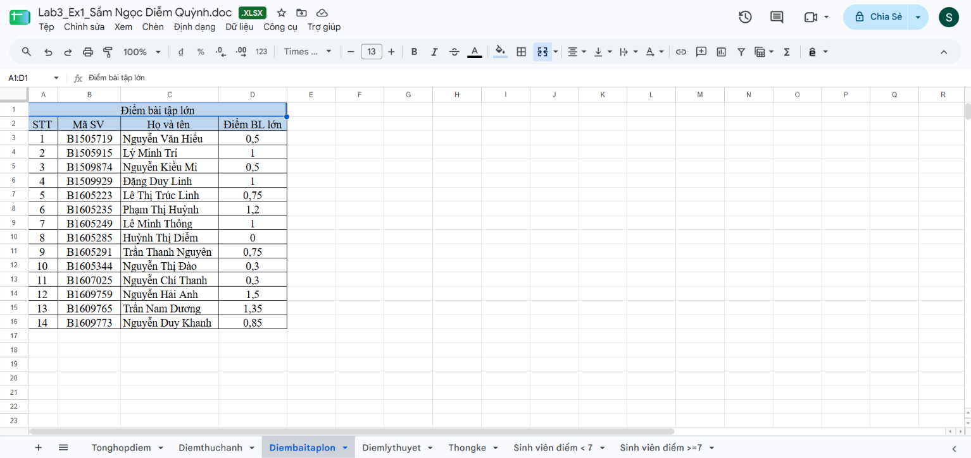
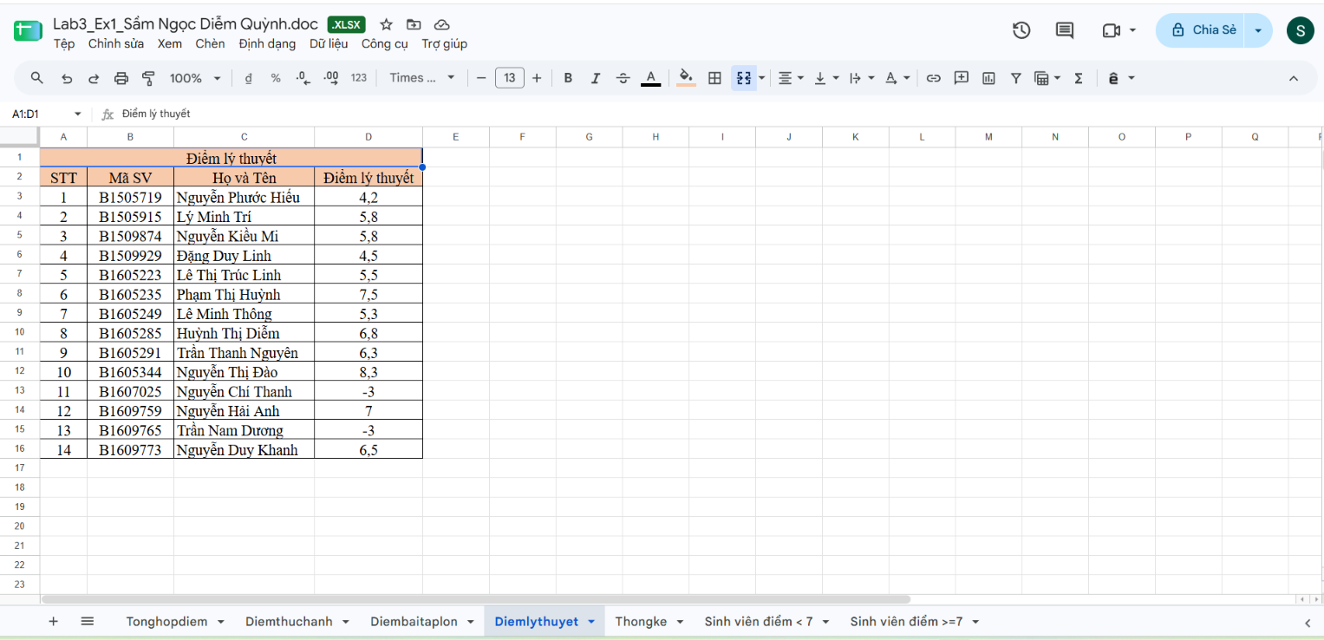
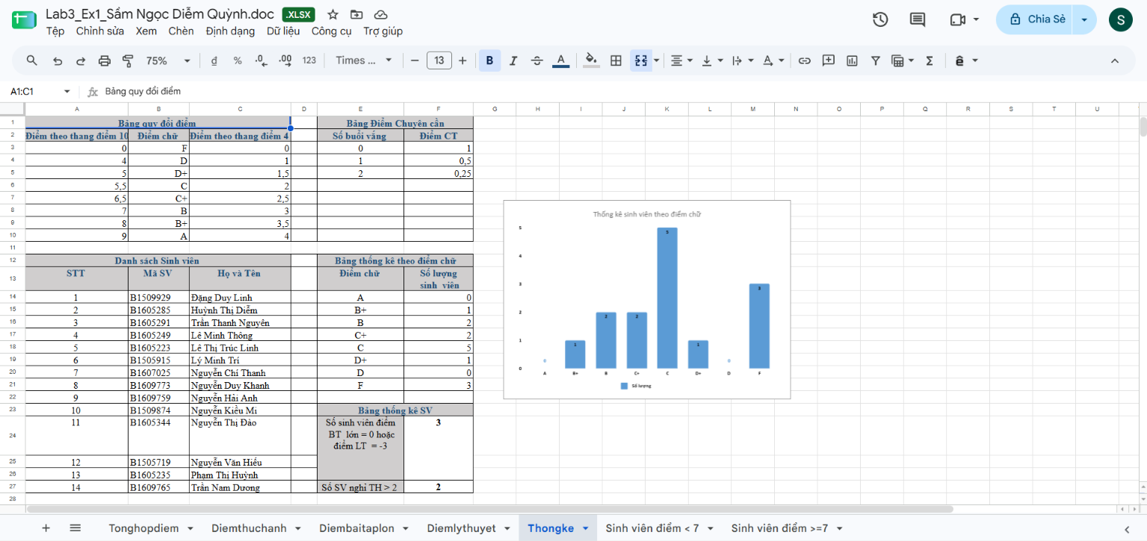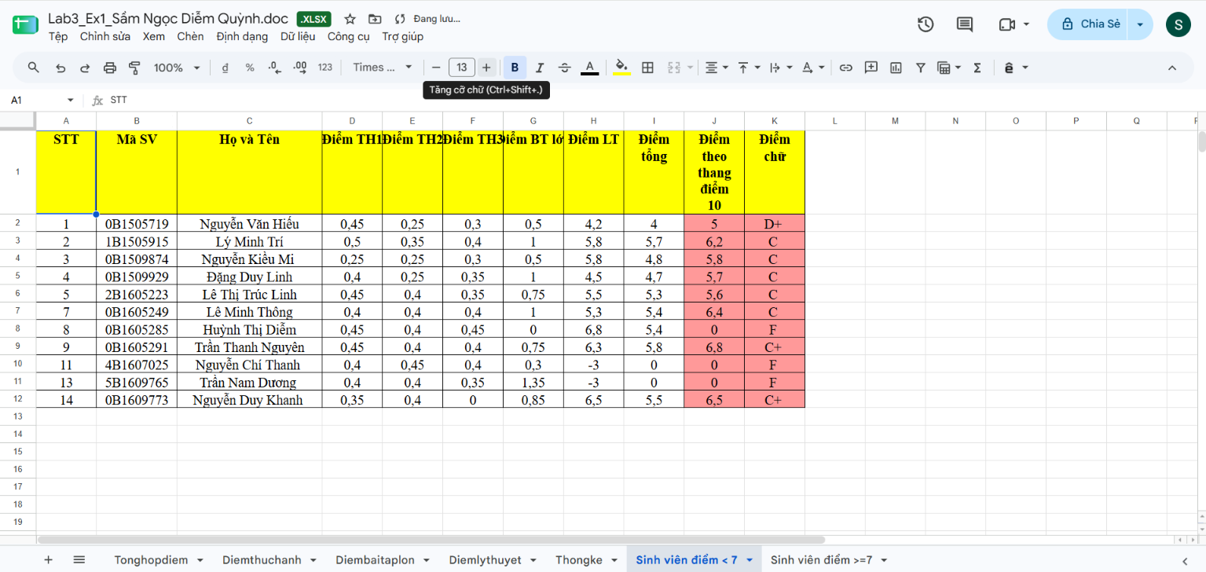
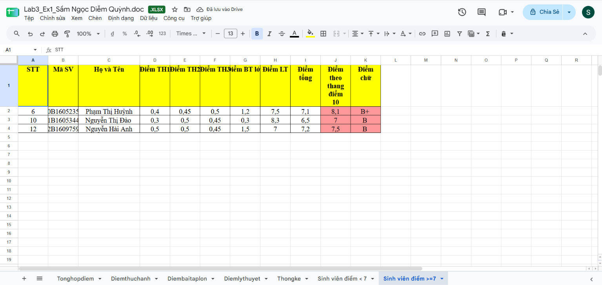

Bài thực hành số 2 - Google Spreadsheet

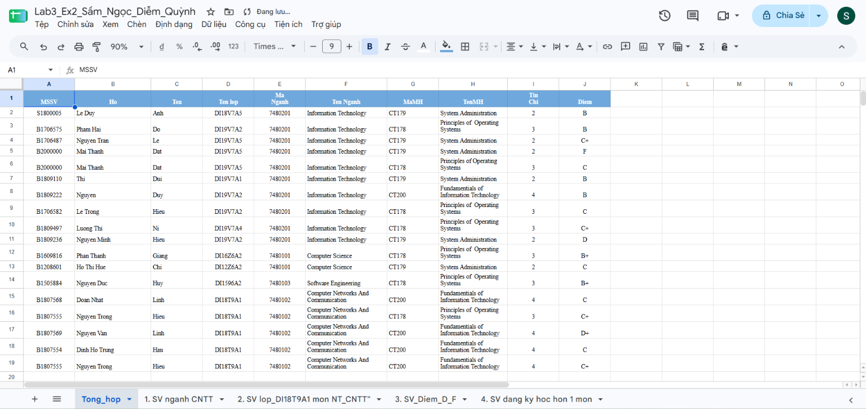

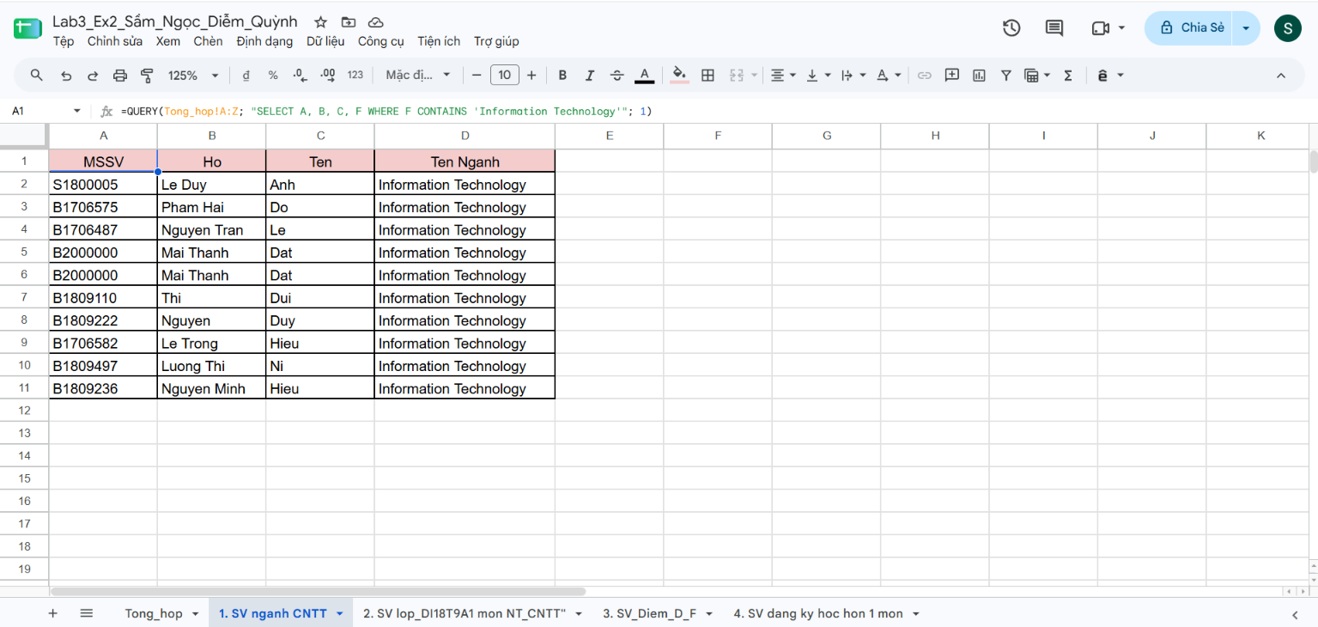

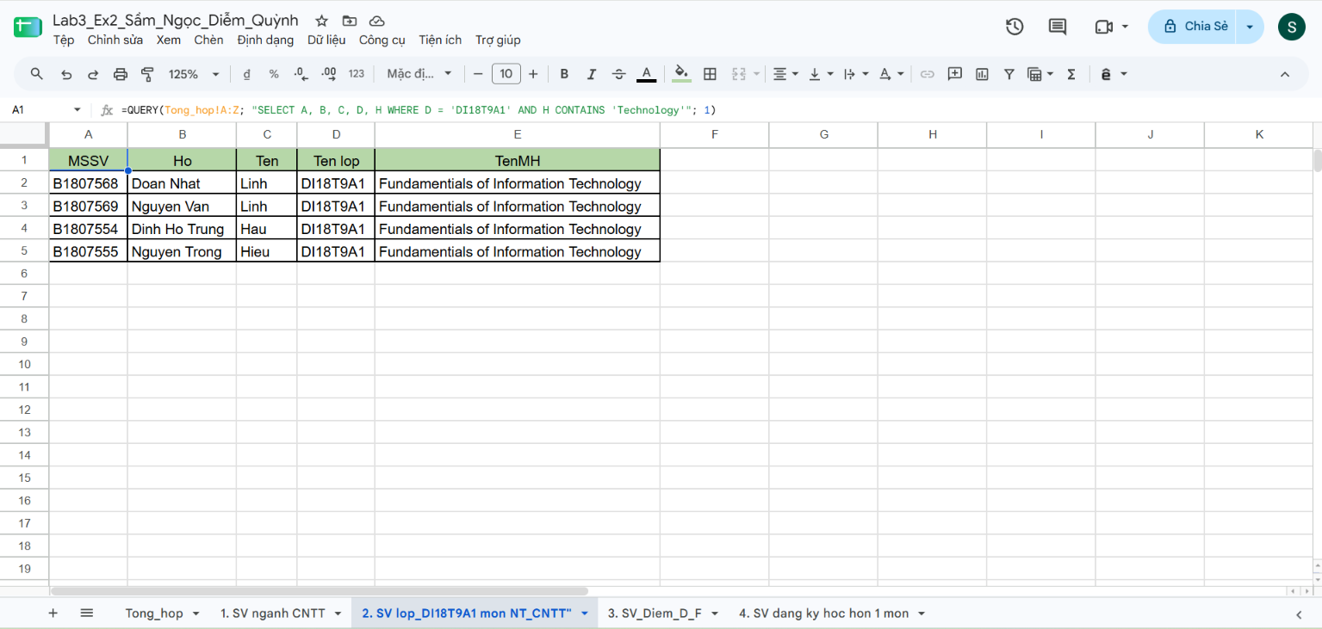

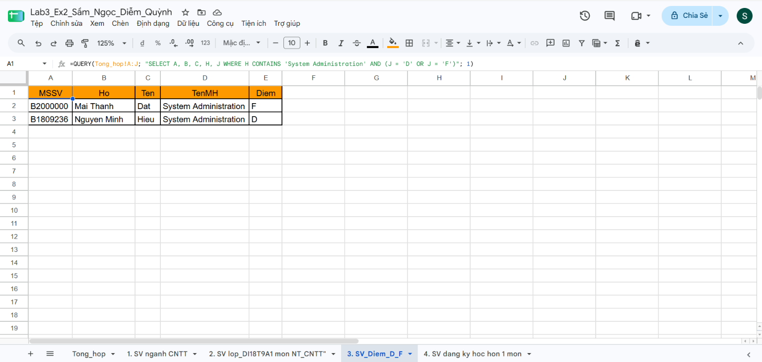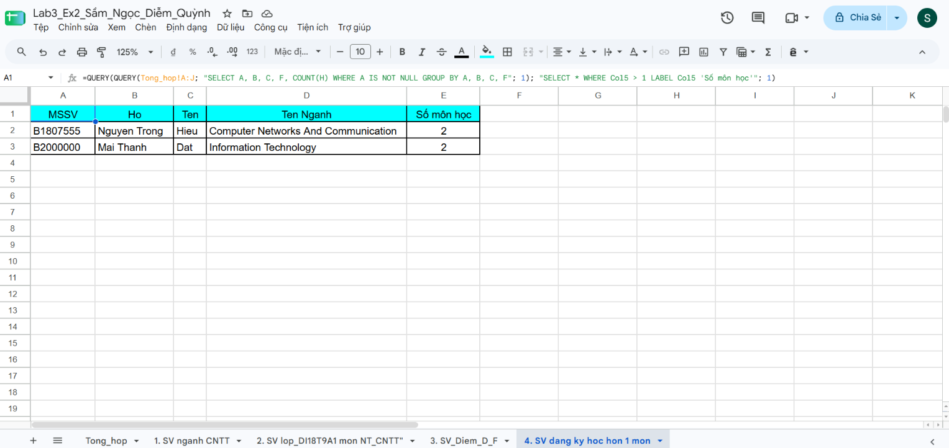

Bài thực hành 4: Microsoft Powerpoint

Bài thực hành số 1
https://docs.google.com/presentation/d/15R_fWJQt4DP8o0vJlgi_TJAxZJuw8vbx/edit?usp=sharing&ouid=115318323040831634606&rtpof=true&sd=true

Bài thực hành số 2

https://docs.google.com/presentation/d/10BkHajPtHl3kyoStkgfPioMq6go4AJBx/edit?usp=sharing&ouid=115318323040831634606&rtpof=true&sd=true

Bài thực hành 5: Tạo, quản lý và chia sẻ nội dung số
ĐƯỜNG DẪN:
https://github.com/CT005B2605301Lab05/CT005_B2605301_Lab05./blob/main/LICENSE.md

