Q.1 Match the column:

A B(answer)

1. Float 20.3586
2. String “156”
3. Python 3 Release date 3 December 2008
4. Full form of CWS Coding With Sagar
5. Founder of python Guido Van Rossum

Q.2 Ask a number from user. Print 'Yes' if the number is divisible by 2,3 but not 8. Otherwise print 'No'

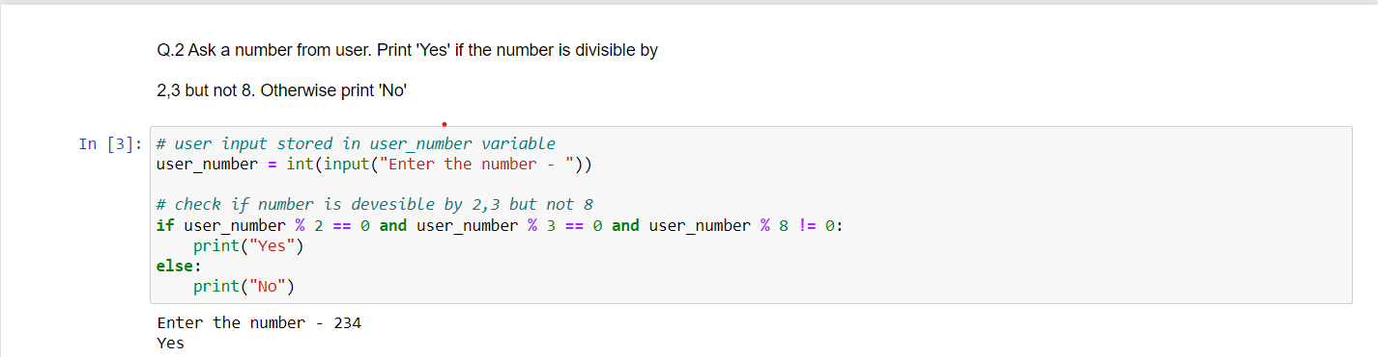

Q.3 Implement Rent Calculator in Python

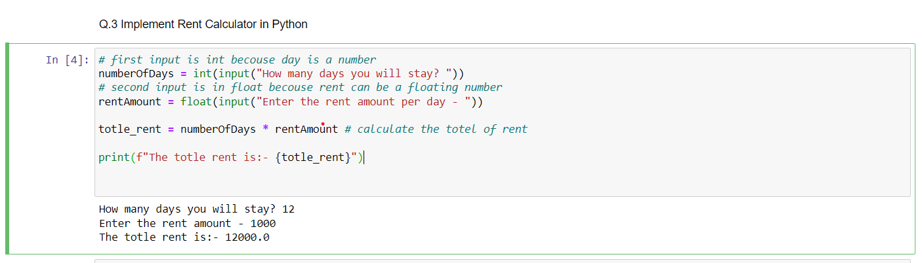

Q.4 What have you learned since the start of this class till now, write the names of the topics and how was your overall experience in the class.

Ans:- On the first day we start with Python introduction and who is the creator of Python and etc.

After that, we start setup up a system to program with Python language. For that, we install Python and all. And then we code over the first program print(“Hello world!”).

The topic name is variables, operators(in operators Assignment operators, comparison, logical, etc ), if, Elif, else, nested if condition, comments, data types, projects like carrier guidance, etc.

Overall I learned a lot of things it was excellent.

Q.5 Fill in the blanks:

a- An ordered set of instructions or commands to be executed by a computer is called a..............

Ans:- program

b- Full form of IDLE is ..............

Ans:- Integrated Development and Learning Environment

c- ..............is an identifier whose value can change.

Ans:- Variable

d- .............are reserve words.

Ans:- Keywords are reserved words ex:- if, else, True, False

Q.6 MCQ-

A- Which of the following is true about the code below?

x = 3

if (x > 2):

x = x \* 2;

if (x > 4):

x = 0;

print(x)

Ans:- c. if x is greater than 2, x will equal 0 after this code executes

B-True is what type of variable?

Ans:- C. Boolean

C- What is the output from the following code?

a = 3

b = (a != 3)

print(b)

Ans:- B. False

Q.7 An extra day is added to the calendar almost every four years as February 29, and the day is called a leap day. A leap year contains a leap day.

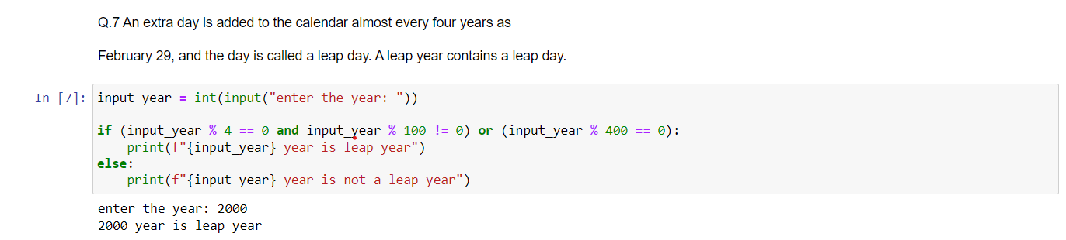

Q.8 You are tasked with creating a program for a CWS contest results calculation system. The program should take in the following inputs from the user: Each question is of 5 marks.



