SEAK SPFI and FPA File for BPC

Last updated on October 8, 2018

# SPFI and SPFI to FPA Inputs

## Program flow

Note the following order of operations: 1. Read in HRJ data 2. Create a SPFI Input Object a. Stock and ages to include in the index b. Catch time series by SPFI fishery strata c. ERA fisheries that are to be used to compute SPFI d. Define the SPFI fishery strata 3. Read in model fishery definitions 4. Read in STK file (depends on 2) 5. Read in MDL files (depends on 3)

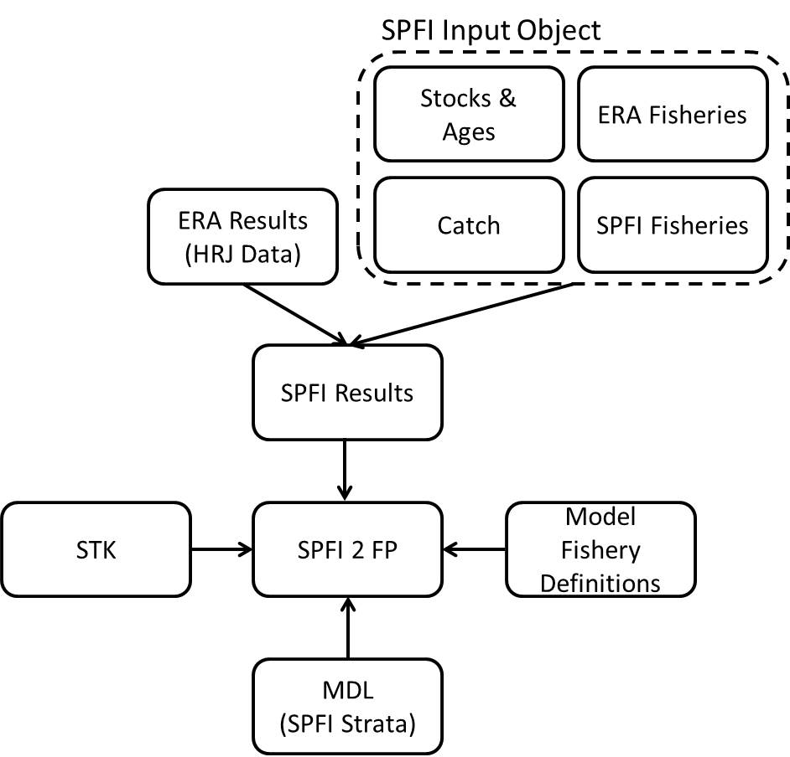

## Load functions

The first thing you need to do is load all the functions:

source("Code/GarciaFunLibrary.R")  
source("Code/SPFIFunLibrary.R")  
source("Code/SPFItoFPAfun.R")

## Load HRJ data

The SPFI is computed using output from the CTC’s exploitation rate analysis program CoShak12. The core data needed for SPFI computations are saved in what are called HRJ files. Data from HRJ files can be obtained in one of two ways: from a HRJ database or from the list of HRJ files used to create the HRJ database. For this example I will use the latter, but note that both options are available.

#Read in HRJ files in a directory  
 by=readHRJdir("Data/Phase2/2018ERA_HRJ", nFisheries=79, straysinescap=TRUE, Age6="include")  
#Convert to CY layout  
 cy=convertHRJ_BYtoCY(by)  
#Convert HRJ from R to Access format  
 z.cy=convertHRJ_RtoAccess(cy)  
#add the 'preferred' table to the Access format  
 z.cy = addPTableHRJ(z.cy, hrjclass = "Access")

## Create SPFI input objects

We will need three SPFI input objects: 1) 9806 stock definitions, 2) phase 2 stock definitions, and 3) christmas stock definitions.

### 9806 stock definitions

#SPFI input data is a list object  
 seak9806=list()  
#Which fisheries?  
 seak9806$erafisheries = 1:6  
#Combine fisheries?  
 seak9806$combinefisheries = data.frame(rbind(c(1,1),c(2,2),c(3,3),c(4,4),c(5,5),c(6,4)))  
 names(seak9806$combinefisheries) = c("ERAFishery","SPFIFishery")  
#Stock/age matrix  
 seak9806$stockage = read.delim("Data/9806/seakTroll.STF", header=TRUE)  
#Catch  
 seak9806$catch = read.csv("Data/2018ERA_CatchDataforSPFI/seakTroll7916.CAT",header=FALSE)  
 names(seak9806$catch) = c("Year","SPFIFishery","SPFIFisheryName","Catch","Addon")  
#Set the object class  
 class(seak9806) = "spfi_input"

kable(seak9806$stockage)

|  |  |  |  |  |  |
| --- | --- | --- | --- | --- | --- |
| StockAcronym | Age2 | Age3 | Age4 | Age5 | Age6 |
| AKS | 0 | 0 | 1 | 1 | 1 |
| QUI | 0 | 0 | 1 | 1 | 0 |
| RBT | 0 | 1 | 1 | 1 | 0 |
| SRH | 0 | 0 | 1 | 1 | 0 |
| URB | 0 | 0 | 1 | 1 | 0 |
| WSH | 0 | 0 | 1 | 1 | 0 |

### 9806 stock definitions modified for phase 2

#SPFI input object modified with phase 2 stock definitions  
 seakphase2 = seak9806  
 seakphase2$stockage = read.delim("Data/Phase2/seakTrollbpP2.STF", header=TRUE)

kable(seakphase2$stockage)

|  |  |  |  |  |  |
| --- | --- | --- | --- | --- | --- |
| StockAcronym | Age2 | Age3 | Age4 | Age5 | Age6 |
| SSA | 0 | 0 | 1 | 1 | 1 |
| NSA | 0 | 0 | 0 | 1 | 1 |
| QUI | 0 | 0 | 1 | 1 | 0 |
| RBT | 0 | 1 | 1 | 1 | 0 |
| SRH | 0 | 0 | 1 | 1 | 0 |
| URB | 0 | 0 | 1 | 1 | 0 |
| WSH | 0 | 0 | 1 | 1 | 0 |

### Phase 2 Christmas stock definitions

#SPFI input object modified with phase 2 christmas stock definitions  
 seakphase2christmas = seak9806  
 seakphase2christmas$stockage = read.delim("Data/Phase2/seakTrollbpP2christmas.STF", header=TRUE)

kable(seakphase2christmas$stockage)

|  |  |  |  |  |  |
| --- | --- | --- | --- | --- | --- |
| StockAcronym | Age2 | Age3 | Age4 | Age5 | Age6 |
| ATN | 0 | 0 | 1 | 1 | 0 |
| ELK | 0 | 0 | 1 | 1 | 0 |
| NSA | 0 | 0 | 0 | 1 | 1 |
| QUE | 0 | 0 | 1 | 1 | 0 |
| QUI | 0 | 0 | 1 | 1 | 0 |
| RBT | 0 | 1 | 1 | 1 | 0 |
| SHU | 0 | 0 | 1 | 0 | 0 |
| SRH | 0 | 1 | 1 | 1 | 0 |
| SSA | 0 | 0 | 1 | 1 | 1 |
| SSF | 0 | 0 | 1 | 0 | 0 |
| SUM | 0 | 0 | 1 | 1 | 0 |
| URB | 0 | 0 | 1 | 1 | 0 |
| WSH | 0 | 0 | 1 | 1 | 0 |

## SPFIs

### 9806 stock definitions

seak9806_spfi <- spfi(spfidat=seak9806, hrjdat=z.cy, hrjtype="P")

summary(x=seak9806_spfi, unit="aeq cat")

## Years spfigrand 1 2 3 4 5  
## 1979 0.78 1.20 1.05 0.57 0.70 0.36  
## 1980 1.29 0.63 0.94 1.46 1.57 1.84  
## 1981 1.13 1.21 1.12 0.91 1.10 0.87  
## 1982 0.80 0.96 0.88 1.07 0.63 0.93  
## 1983 0.87 1.04 0.59 0.63 1.26 0.82  
## 1984 0.62 0.36 0.93 1.06 0.53 0.28  
## 1985 0.67 0.45 0.58 0.80 0.83 0.71  
## 1986 0.45 0.44 0.15 0.39 1.26 0.54  
## 1987 0.47 0.59 0.16 0.53 0.62 1.30  
## 1988 0.41 1.37 0.00 0.13 0.64 1.16  
## 1989 0.50 0.83 0.20 0.41 0.54 0.50  
## 1990 0.70 0.63 0.11 0.86 1.17 1.10  
## 1991 0.59 1.35 0.21 0.86 0.79 0.49  
## 1992 0.38 1.02 0.06 0.48 0.40 0.21  
## 1993 0.46 0.73 0.02 0.26 0.92 0.25  
## 1994 0.40 0.64 0.04 0.11 0.66 0.15  
## 1995 0.48 0.46 0.05 0.31 0.79 0.92  
## 1996 0.42 0.56 0.09 0.56 0.55 0.48  
## 1997 0.59 0.63 0.15 0.55 1.47 0.08  
## 1998 0.39 0.80 0.05 0.14 0.95 0.38  
## 1999 0.56 0.80 0.11 0.25 0.96 0.10  
## 2000 0.43 0.88 0.08 0.10 1.42 0.05  
## 2001 0.38 0.53 0.07 0.13 0.64 0.12  
## 2002 0.49 0.39 0.06 0.11 1.10 0.14  
## 2003 0.45 0.68 0.06 0.12 0.85 0.30  
## 2004 0.40 0.81 0.06 0.15 0.95 0.27  
## 2005 0.45 0.90 0.11 0.20 1.21 0.39  
## 2006 0.59 1.50 0.11 0.63 1.36 0.11  
## 2007 0.58 1.23 0.14 0.82 1.15 0.17  
## 2008 0.44 0.82 0.07 0.69 0.68 0.09  
## 2009 0.57 0.72 0.15 0.32 1.08 0.15  
## 2010 0.34 1.13 0.04 0.25 0.73 0.07  
## 2011 0.38 1.03 0.05 0.25 0.82 0.13  
## 2012 0.61 1.62 0.09 0.18 1.15 0.08  
## 2013 0.33 0.80 0.09 0.43 0.49 0.12  
## 2014 0.55 1.25 0.08 0.52 1.03 0.13  
## 2015 0.45 1.15 0.09 1.31 0.72 0.34  
## 2016 0.55 1.50 0.11 0.58 1.04 0.12

### 9806 modified for Phase 2 stock definitions

seakphase2_spfi <- spfi(spfidat=seakphase2, hrjdat=z.cy, hrjtype="P")

summary(x=seakphase2_spfi, unit="aeq cat")

## Years spfigrand 1 2 3 4 5  
## 1979 0.78 1.21 1.07 0.58 0.71 0.37  
## 1980 1.27 0.63 0.95 1.43 1.57 1.81  
## 1981 1.16 1.21 1.12 0.95 1.10 0.92  
## 1982 0.79 0.96 0.87 1.04 0.62 0.90  
## 1983 1.04 1.03 0.62 0.74 1.37 1.05  
## 1984 0.65 0.40 0.95 1.06 0.55 0.25  
## 1985 0.69 0.45 0.58 0.84 0.84 0.72  
## 1986 0.46 0.45 0.15 0.42 1.34 0.59  
## 1987 0.43 0.62 0.16 0.53 0.63 1.22  
## 1988 0.38 1.34 0.00 0.14 0.65 1.24  
## 1989 0.50 0.86 0.20 0.43 0.54 0.51  
## 1990 0.69 0.64 0.11 0.86 1.16 1.10  
## 1991 0.61 1.36 0.21 0.91 0.80 0.54  
## 1992 0.39 1.06 0.06 0.49 0.40 0.21  
## 1993 0.49 0.73 0.02 0.28 0.94 0.28  
## 1994 0.42 0.66 0.04 0.12 0.67 0.16  
## 1995 0.45 0.46 0.04 0.30 0.82 0.86  
## 1996 0.37 0.53 0.08 0.52 0.55 0.43  
## 1997 0.68 0.59 0.15 0.57 1.48 0.09  
## 1998 0.44 0.79 0.05 0.15 0.97 0.40  
## 1999 0.60 0.83 0.11 0.26 0.98 0.10  
## 2000 0.48 0.88 0.08 0.10 1.44 0.05  
## 2001 0.37 0.53 0.07 0.14 0.64 0.13  
## 2002 0.50 0.39 0.07 0.11 1.10 0.14  
## 2003 0.46 0.67 0.07 0.13 0.86 0.31  
## 2004 0.42 0.83 0.08 0.15 0.97 0.26  
## 2005 0.49 0.89 0.12 0.20 1.20 0.38  
## 2006 0.65 1.45 0.12 0.66 1.37 0.11  
## 2007 0.63 1.26 0.13 0.83 1.14 0.17  
## 2008 0.41 0.81 0.07 0.72 0.68 0.09  
## 2009 0.57 0.73 0.15 0.33 1.06 0.15  
## 2010 0.36 1.13 0.04 0.26 0.73 0.08  
## 2011 0.41 1.01 0.06 0.25 0.82 0.13  
## 2012 0.62 1.62 0.09 0.18 1.15 0.08  
## 2013 0.34 0.79 0.09 0.44 0.49 0.12  
## 2014 0.54 1.26 0.08 0.53 1.03 0.13  
## 2015 0.49 1.14 0.10 1.35 0.72 0.34  
## 2016 0.59 1.49 0.11 0.59 1.04 0.12

### Phase 2 Christmas stock definitions

seakphase2christmas_spfi <- spfi(spfidat=seakphase2christmas, hrjdat=z.cy, hrjtype="P")

summary(x=seakphase2christmas_spfi, unit="aeq cat")

## Years spfigrand 1 2 3 4 5  
## 1979 0.80 1.20 1.06 0.62 0.73 0.37  
## 1980 1.29 0.64 0.95 1.43 1.61 1.80  
## 1981 1.14 1.19 1.13 0.92 1.09 0.92  
## 1982 0.77 0.98 0.86 1.02 0.58 0.91  
## 1983 0.98 1.03 0.62 0.72 1.24 1.03  
## 1984 0.62 0.39 0.94 1.04 0.51 0.26  
## 1985 0.67 0.44 0.57 0.82 0.81 0.72  
## 1986 0.44 0.44 0.15 0.41 1.33 0.59  
## 1987 0.43 0.60 0.17 0.52 0.61 1.21  
## 1988 0.35 1.26 0.00 0.14 0.64 1.20  
## 1989 0.47 0.81 0.18 0.42 0.50 0.49  
## 1990 0.67 0.60 0.11 0.84 1.15 1.08  
## 1991 0.61 1.29 0.21 0.91 0.82 0.56  
## 1992 0.39 1.04 0.06 0.48 0.40 0.21  
## 1993 0.47 0.75 0.02 0.27 0.89 0.27  
## 1994 0.40 0.68 0.03 0.11 0.67 0.16  
## 1995 0.42 0.43 0.04 0.29 0.79 0.83  
## 1996 0.36 0.49 0.08 0.50 0.56 0.40  
## 1997 0.65 0.56 0.14 0.53 1.49 0.08  
## 1998 0.45 0.74 0.05 0.18 1.00 0.45  
## 1999 0.57 0.80 0.10 0.24 0.98 0.10  
## 2000 0.48 1.00 0.08 0.10 1.44 0.06  
## 2001 0.39 0.57 0.06 0.14 0.79 0.11  
## 2002 0.54 0.74 0.06 0.13 1.38 0.16  
## 2003 0.50 1.12 0.07 0.14 0.92 0.31  
## 2004 0.39 0.77 0.07 0.14 0.93 0.29  
## 2005 0.48 0.71 0.11 0.21 1.14 0.47  
## 2006 0.61 1.23 0.11 0.62 1.24 0.13  
## 2007 0.65 1.04 0.13 0.80 1.22 0.22  
## 2008 0.39 0.73 0.07 0.70 0.73 0.08  
## 2009 0.55 0.75 0.14 0.32 1.02 0.16  
## 2010 0.37 1.05 0.05 0.28 0.78 0.07  
## 2011 0.40 0.98 0.05 0.27 0.89 0.21  
## 2012 0.70 1.51 0.10 0.21 1.43 0.10  
## 2013 0.35 0.66 0.10 0.51 0.52 0.13  
## 2014 0.55 1.23 0.09 0.48 1.02 0.13  
## 2015 0.49 1.07 0.09 1.22 0.70 0.44  
## 2016 0.60 1.66 0.11 0.60 1.09 0.14

## Comparison of results

### AEQ landed catch

plot(summary(seak9806_spfi, unit="aeq cat")$spfi[,1],type="l",bty="l",xlab="Year",ylab="SPFI",main="SEAK SPFI Comparison", xaxt="n")  
lines(summary(seakphase2_spfi, unit="aeq cat")$spfi[,1],col="blue")  
lines(summary(seakphase2christmas_spfi, unit="aeq cat")$spfi[,1],col="red")  
legend("topright",c("9806", "Phase 2", "Christmas"), lty=c(1,1,1), col=c("black","blue","red"),bty="n")  
axis(1,at=1:length(1979:2016),labels=1979:2016)

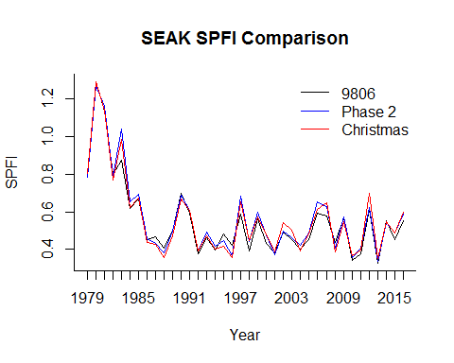

### AEQ total mortality

plot(summary(seak9806_spfi, unit="aeq tot")$spfi[,1],type="l",bty="l",xlab="Year",ylab="SPFI",main="SEAK SPFI Comparison", xaxt="n")  
lines(summary(seakphase2_spfi, unit="aeq tot")$spfi[,1],col="blue")  
lines(summary(seakphase2christmas_spfi, unit="aeq tot")$spfi[,1],col="red")  
legend("topright",c("9806", "Phase 2", "Christmas"), lty=c(1,1,1), col=c("black","blue","red"),bty="n")  
axis(1,at=1:length(1979:2016),labels=1979:2016)

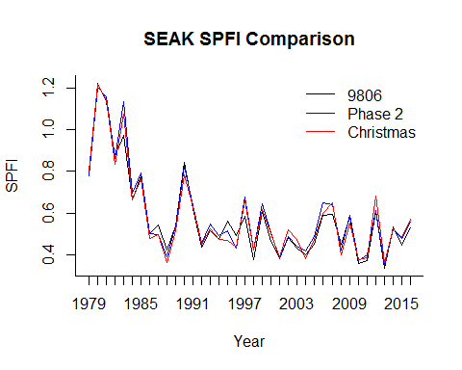

## FPAs

### Model fishery definitions

fishery48 <- readLines("Data/Phase2/48FisheryName.txt")

### STK

stkDAT <- readSTK(filename = "Data/Phase2/2017BPC_PII_V1.22.STK", stkCharLength=3, fisheryNames = fishery48, outname = "Data/Phase2/Phase2STK_ReFormatted.txt")

### MDL

myList <- list.files("Data/Phase2/56F-adj/", pattern=".MDL", full.names=TRUE)  
 myListNoDir <- list.files("Data/Phase2/56F-adj/", pattern=".MDL")  
 mdlList <- list()  
 for(i in 1:length(unique(stkDAT$Stock))) {  
 dirLoc <- grep(paste(unique(stkDAT$Stock)[i],sep=""), toupper(myListNoDir))  
 mdlList[[i]] <- readMDL(filename = myList[dirLoc], numChar = 5, escapement = TRUE)  
 }

### FPA with 9806 stock definitions

seak9806_spfifallmod = data.frame(YEAR=seak9806_spfi$years, summary(seak9806_spfi, unit="aeq cat")$spfi)  
seak9806_spfifallmod$X6 = seak9806_spfifallmod$X4  
names(seak9806_spfifallmod)[2]="SPFI"

seak9806_spfitofp = SPFItoFP(modfishery="ALASKA_T", spfistratvec=1:6, spfidat=seak9806_spfifallmod, baseperiod=1979:1982, mdldat=mdlList, stkdat=stkDAT, npredfuture=3)

writeFP(seak9806_spfitofp, "Results/Phase2/1AKTR18, 79-82 BP 9806 stock list.fpa", modfisherynumber=1)

### FPA with 9806 modified for Phase 2 stock definitions

seakphase2_spfifallmod = data.frame(YEAR=seakphase2_spfi$years, summary(seakphase2_spfi, unit="aeq cat")$spfi)  
seakphase2_spfifallmod$X6 = seakphase2_spfifallmod$X4  
names(seakphase2_spfifallmod)[2]="SPFI"

seakphase2_spfitofp = SPFItoFP(modfishery="ALASKA_T", spfistratvec=1:6, spfidat=seakphase2_spfifallmod, baseperiod=1979:1982, mdldat=mdlList, stkdat=stkDAT, npredfuture=3)

writeFP(seakphase2_spfitofp, "Results/Phase2/1AKTR18, 79-82 BP 9806 stock list modified for phase 2.fpa", modfisherynumber=1)

### FPA with Phase 2 Christmas stock definitions

seakphase2christmas_spfifallmod = data.frame(YEAR=seakphase2christmas_spfi$years, summary(seakphase2christmas_spfi, unit="aeq cat")$spfi)  
seakphase2christmas_spfifallmod$X6 = seakphase2christmas_spfifallmod$X4  
names(seakphase2christmas_spfifallmod)[2]="SPFI"

seakphase2christmas_spfitofp = SPFItoFP(modfishery="ALASKA_T", spfistratvec=1:6, spfidat=seakphase2christmas_spfifallmod, baseperiod=1979:1982, mdldat=mdlList, stkdat=stkDAT, npredfuture=3)

writeFP(seakphase2_spfitofp, "Results/Phase2/1AKTR18, 79-82 BP christmas stock list.fpa", modfisherynumber=1)