Computing a SPFI-derived FPA file

Last updated on October 3, 2018

# SPFI to FPA Inputs

## Program flow

Note the following order of operations: 1. Read in SPFI data 2. Read in model fishery definitions 3. Read in STK file (depends on 2) 4. Read in MDL files (depends on 3)

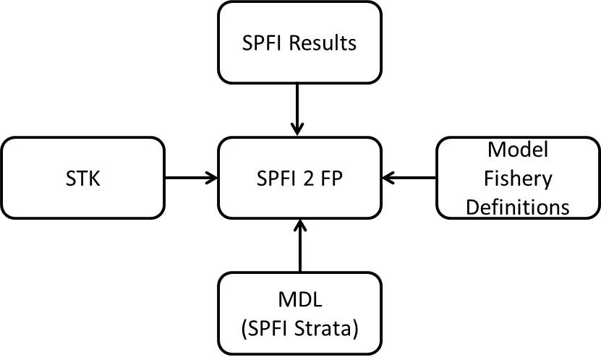

## SPFI

SPFI output as generated by the SPFI program.

## Model fishery definitions

File contains just the names of the model fisheries. Note that fishery names can’t have spaces in it because fishery names are used to reference. You will need this file prior to reading in the STK file.

## STK

STK file as generated by the base period calibration program.

## MDL

MDL files as generated from CoShak4 and/or summarized MDL recovery data both in terms of the SPFI-fishery strata.

# Example: SEAK FPA for CLB9806

## SPFI

### 2017ERA

spfiDAT.seak2017era <- readSPFI(filename = "Results/2017ERA/SEAK15LC_v3.CSV", outname = "Results/2017ERA/2017era_seakspfi_formatted.csv")

### 2018ERA

spfiDAT.seak2018era <- readSPFI(filename = "Results/2018ERA/seak_spfi_LC.CSV", outname = "Results/2018ERA/2018era_seakspfi_formatted.csv")

## Model fishery definitions

fishery25 <- readLines("Data/9806/25FisheryName.txt")

## STK

stkDAT <- readSTK(filename = "Data/9806/9806STK.STK", stkCharLength=3, fisheryNames = fishery25, outname = "Data/9806/9806STK_ReFormatted.txt")

## MDL

The original SPFI-strata MDL files from the 9806 base period calibration no longer exist (as far as I’m aware, that is); however, the data contained in these files is preserved in the SEAK SPFI-to-FPA Excel workbook. The data contained in the 9806spfimdl.txt file is this data.

MDL9806 = read.delim("Data/9806/9806spfimdl.txt")

Additional data wrangling is needed to convert the 9806 MDL data into a format readable by the SPFI-to-FPA functions.

mdlList = list()  
for(i in 1:nlevels(MDL9806$Stock)) {  
 modstock = as.character(unique(MDL9806$Stock))[i]  
 recoveriesbyfishery = subset(MDL9806, Stock==modstock)[,3:ncol(MDL9806)]  
 mdlList[[i]] = list(ModelStock=modstock,RecoveriesByFishery=t(recoveriesbyfishery))  
 #NOTE that the SPFI strata as defined in 9806 differ than it's definition today  
 #However, note that this "translation" is made in the SPFI computations  
 #and does not need to be made here  
 #Strata definitions  
 #Strata 1 = AK Win/Spr Troll  
 #Strata 3 = AK June Inside Troll  
 #Strata 2 = AK June Outside Troll   
 #Strata 5 = AK July Inside Troll   
 #Strata 4 = AK July Outside Troll   
 #Strata 6 = AK Fall Troll = Strata 4   
}

## SPFI to FPA

### 2017ERA

seak2017era_SPFItoFP = SPFItoFP(modfishery="ALASKA_T", spfistratvec=1:6, spfidat=spfiDAT.seak2017era, baseperiod=1979:1981, mdldat=mdlList, stkdat=stkDAT, npredfuture=3)  
 writeFP(seak2017era_SPFItoFP, "Results/2017ERA/1AKTR17, 79-81 BP.fpa", modfisherynumber=1)

### 2018ERA

seak2018era_SPFItoFP = SPFItoFP(modfishery="ALASKA_T", spfistratvec=1:6, spfidat=spfiDAT.seak2018era, baseperiod=1979:1981, mdldat=mdlList, stkdat=stkDAT, npredfuture=3)  
 writeFP(seak2018era_SPFItoFP, "Results/2018ERA/1AKTR18, 79-81 BP.fpa", modfisherynumber=1)

# Example: SEAK, NBC, and WCVI FPAs for Base period phase 2

## SPFI

### SEAK

spfiDAT.seakPhase2 <- readSPFI(filename = "Results/Phase2/seak_spfi_lc_bpc.CSV", outname = "Results/Phase2/2018era_seak_BPCspfi.csv")

### NBC

spfiDAT.nbcPhase2 <- readSPFI(filename = "Results/Phase2/NBC15LC_CT, 79-82 BP.CSV", outname = "Results/Phase2//2017era_nbc__BPCspfi.csv")  
 spfiDAT.nbcPhase2 <- spfiDAT.nbcPhase2[,-4]  
 names(spfiDAT.nbcPhase2) <- c("YEAR", "SPFI", "Total")  
 spfiDAT.nbcPhase2$YEAR = as.numeric(spfiDAT.nbcPhase2$YEAR)

### WCVI

spfiDAT.wcviPhase2 <- readSPFI(filename = "Results/Phase2/WCVI15LC_4000, 79-82 BP.CSV", outname = "Results/Phase2//2017era_wcvi__BPCspfi.csv")  
 names(spfiDAT.wcviPhase2) <- c("YEAR", "SPFI", "FALL.WIN", "SPRING", "SUMMER")

## Model fishery definitions

fishery48 <- readLines("Data/Phase2/48FisheryName.txt")

## STK

stkDAT <- readSTK(filename = "Data/Phase2/2017BPC_PII_V1.22.STK", stkCharLength=3, fisheryNames = fishery48, outname = "Data/Phase2/Phase2STK_ReFormatted.txt")

## MDL

myList <- list.files("Data/Phase2/56F-adj/", pattern=".MDL", full.names=TRUE)  
 myListNoDir <- list.files("Data/Phase2/56F-adj/", pattern=".MDL")  
 mdlList <- list()  
 for(i in 1:length(unique(stkDAT$Stock))) {  
 dirLoc <- grep(paste(unique(stkDAT$Stock)[i],sep=""), toupper(myListNoDir))  
 mdlList[[i]] <- readMDL(filename = myList[dirLoc], numChar = 5, escapement = TRUE)  
 }

## SPFI to FPA

### SEAK

seak_SPFItoFP = SPFItoFP(modfishery="ALASKA_T", spfistratvec=1:6, spfidat=spfiDAT.seakPhase2, baseperiod=1979:1982, mdldat=mdlList, stkdat=stkDAT, npredfuture=3)  
 writeFP(seak_SPFItoFP, "Results/Phase2/1AKTR18, 79-82 BP.fpa", modfisherynumber=1)

### NBC

nbc_SPFItoFP = SPFItoFP(modfishery="NORTH_T", spfistratvec=8, spfidat=spfiDAT.nbcPhase2, baseperiod=1979:1982, mdldat=mdlList, stkdat=stkDAT, npredfuture=3)  
 writeFP(nbc_SPFItoFP, "Results/Phase2/3NTR17, 79-82 BP.fpa.txt", modfisherynumber=3)

### WCVI

wcvi_SPFItoFP = SPFItoFP(modfishery="WCVI_T", spfistratvec=10:12, spfidat=spfiDAT.wcviPhase2, baseperiod=1979:1982, mdldat=mdlList, stkdat=stkDAT, npredfuture=3)  
 writeFP(wcvi_SPFItoFP, "Results/Phase2/5WCRBT17, 79-82 BP.fpa", modfisherynumber=5)