Hong Kong Institute of Vocational Education

Department of Information and Communications Technology
Department of Multimedia & Internet Technology
ITP4507 - Contemporary Topics in Software Engineering
ITP4605 - Contemporary Topics in CSA

Laboratory Exercise 9 – Dynamic HTML & JSON

Q1.
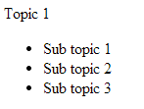
click ‘Topic 1’

click ‘Topic 1’

Figure 1

Write an HTML web page with JavaScript code to implement a dynamic web page. When the page is loaded, The left side of Figure 1 is shown. When ‘Topic 1” is clicked, ‘Topic 1” is expanded and the sub-topics are shown as the right side of Figure 1. When ‘Topic 1” is clicked again, the sub-topics are collapsed and hidden as shown in the left side of Figure 1.
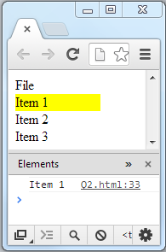

Q2.
mouse over ‘Item 1’
click ‘File’
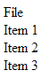

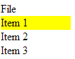

click ‘File’
click ‘Item 1’

Figure 2

Write an HTML web page with javascript code to implement a ‘File’ Menu:
- When the ‘File’ menu is clicked, the items (‘Item 1’, ‘Item 2’, ‘Item 3’) under the menu is shown.
- When the user mouse the mouse pointer over an item, the item is highlighted with yellow as the background color.
- When the user clicks an item, the item’s text is displayed in the console.
- When the user clicks ‘File’ again, the menu items are hidden.

Q3. Write an HTML web page with JavaScript code to implement a stack simulator.

- When the web page is loaded:
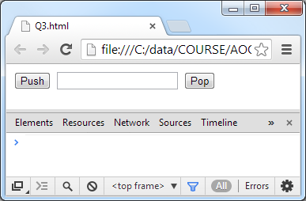

- The user enters ‘item 1’ and clicks the push button:
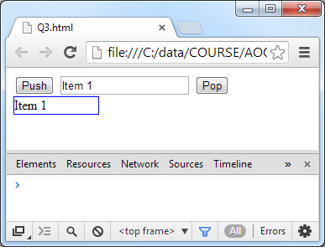

- The user enters ‘item 2’ and clicks the push button:
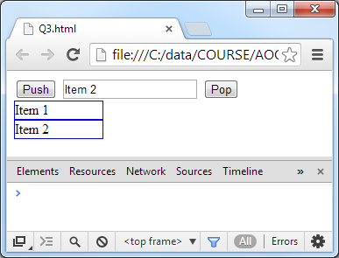

- The user clicks the pop button:
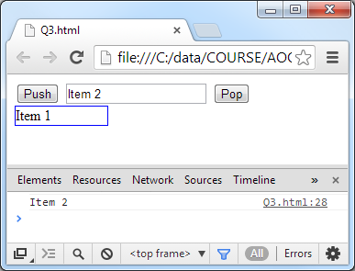

Q4. Write an HTML web page with JavaScript code to implement a simple demonstration for JSON conversion.

- When the page is loaded:
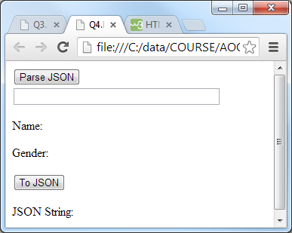

- When the user enters a JSON string and clicks the ‘Parse JSON’ button, the system parses the string in the input field to an object and displays the values of the name and gender attributes of the object.
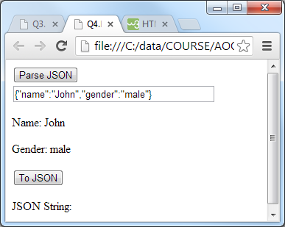

- When the user clicks the ‘To JSON’ button, the system displays the JSON string of the object which has been created in Step 2.
