To generate the error you must enable to designer to be added to swagger. Open API => StartupExtensions => SwaggerGenExtension

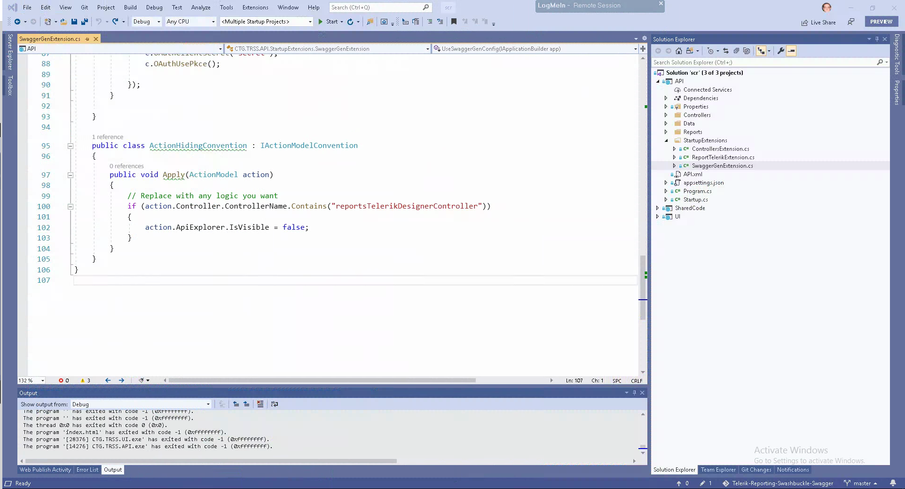
Change line 100 from

if (action.Controller.ControllerName.Contains("reportsTelerikDesignerController"))

to

if (action.Controller.ControllerName.Contains("xreportsTelerikDesignerController"))

