QC Tool Description

|  |  |
| --- | --- |
| Last Revised: | Dec 14, 2010 |
| Produced By: | NBIA Team |
| Version: |  |

Document Approvals

The list contains the name and contact information for the core project team and any key stakeholders who have an interest in the success of the project. An “S” identifies persons responsible for approval from the stakeholder groups. Sign off of the document would be required when a decision is made not to take action for defined gaps.

|  |  |  |
| --- | --- | --- |
| S | Name | Role |
| S | Robert Shirley | NCICBIIT |
| S | Peter Yan | COTR/PM |
|  | Eric Kascic | Technical Lead |
|  |  |  |

Revision History

When you make a change to a document, you must add an entry to this Revision History table and you must manually type the Last Revised Date on the front cover.

|  |  |  |  |
| --- | --- | --- | --- |
| Date | Version | Description | Revised by |
| Dec. 14, 2010 | 1.o | First draft of feature description for QC Tool. | Qinyan Pan |
|  |  |  |  |
|  |  |  |  |

Copyrights and Trademarks

© Copyright 2010 by CBIIT, caBIGTM. All rights reserved.

Table of Contents

1. Introduction 1

2. Summary of Feature 1

3. Architectural Diagram 1

4. Note for Future Development 2

5. To Be Developed 2

# Introduction

The purpose of this document is to describe the software design and implementation of QC Tool. A brief feature summary is provided and an architecture diagram is also included for better understanding of the code of QC Tool.

# Summary of Feature

QC Tool is one of the admistrative tool for managing the visibility of DICOM images submitted into NBIA. It includes the following funcationalities:

• allow the curator (who has MANAGE_VISIBILITY_STATUS) to search on the specified Collection//Site, Status, Patient IDs to retrieve a list of the image series

• allow the curator to change multiple image series's status

• allow the curator to view individual image series information (individual image thumbnail, DICOM tag value for individual image)

• allow the curator to change individual image series status.

#### • allow the curator to view the status history report of the individual or multiple image series.

#### QC Tool has a user interface which is visible only if the user logged in has the privilege to perform QC task and can be invoked from ADMIN Tools section on the left menu bar of NBIA home page. A set of back beans designed for QC tool work with QC data access objects to perform the search, update and visualizing functionalities through QC data transfer objects.

# Architectural Diagram

The following Architectural Diagram shows how QC back beans work with QC data transfer objects through QC data transfer objects.

Figure Architectural Diagram

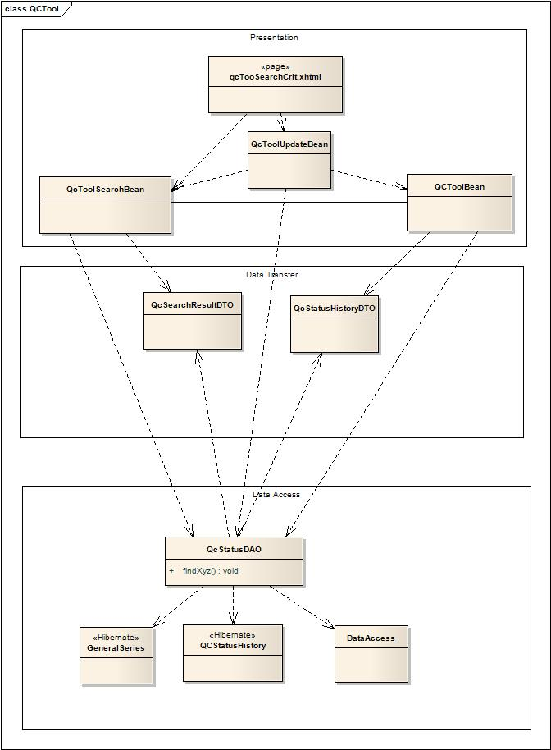

Change Example 1

Current QC tool has four visibility status, Not Yet Reviewed, Visible, Not Visible and To Be Deleted. If there is need to add more visibility status, the following changes needed to be done:

* + - 1. Add enum definition to VisibilityStatus.java in gov.nih.nci.ncia.qctool in nbia-dao project
      2. Add new qcStatusItems in getQcStatusItems()to QcToolBean.java in gov.nih.nci.ncia.beans.qctool in ncia-web
      3. Rebuild everything and do a new deployment.

The QC Tool will have more visibility status check box in QC status section for user to select. The user can select the new status to query the NBIA repository and update the series with the newly added visibility status.

Change Example 2

If the user wants to add patient info to QC Status History Report page, the following steps needs to be performed:

* + - 1. Add one more ice:column to qcTooStatusRpt.xhtml page for patient info.
      2. Add patient field to QcStatusHistoryDTO in gov.nih.nci.ncia.dto in nbia-dao project.
      3. Modify the string of selectStmt in QcStatusDAOImpl.java in gov.nih.nci.ncia.dao of nbia-dao project.
      4. Rebuild everything and do a new deployment.

The QC Tool will have patient info in the QC Status History Report page.