Cedara Software Integration Description

|  |  |
| --- | --- |
| Last Revised: | Dec 09, 2010 |
| Produced By: | NBIA Team |
| Version: |  |

Document Approvals

The list contains the name and contact information for the core project team and any key stakeholders who have an interest in the success of the project. An “S” identifies persons responsible for approval from the stakeholder groups. Sign off of the document would be required when a decision is made not to take action for defined gaps.

|  |  |  |
| --- | --- | --- |
| S | Name | Role |
| S | Robert Shirley | NCICBIIT |
| S | Peter Yan | COTR/PM |
|  | Eric Kascic | Technical Lead |
|  |  |  |

Revision History

When you make a change to a document, you must add an entry to this Revision History table and you must manually type the Last Revised Date on the front cover.

|  |  |  |  |
| --- | --- | --- | --- |
| Date | Version | Description | Revised by |
| Dec. 8, 2010 | 1.o | First draft of feature description for Cedara Software Integration. | Qinyan Pan |
|  |  |  |  |
|  |  |  |  |

Copyrights and Trademarks

© Copyright 2010 by CBIIT, caBIGTM. All rights reserved.

Table of Contents

1. Introduction 1

2. Summary of Feature 1

3. Architectural Diagram 1

4. Change Example 1 2

5. Change Example 2 3

# Introduction

The purpose of this document is to describe the software design and implementation in NBIA for using Cedara Software to display DICOM images and perform markups. A brief feature summary is provided and a architecture diagram is also included for better understanding of the interactions between NBIA and Cedara software.

# Summary of Feature

NBIA provides an integrated image visualization/markup tool with the Cedara I-Response Workstation (IRW) and Imaging Service Grid Server (ISG). ISG is a web application server which provides distributed image rendering service and is a client application for the ISG. When the user makes a request to view the images on the search result page, NCIA sends the list of series UIDs, user credential information, and Cedara Imaging Grid Server (ISG) address to a HTTP endpoint established by IRW. IRW relays the request to ISG. ISG ensures the number of concurrent users does not exceed the licensed value and then queries NCIA for each requested series. NCIA validates user credentials and returns a file path list of the DICOM files associated with the series. ISG loads the DICOM data, prepares rendering engine, and sends DICOM header information of the loaded data back to IRW. IRW then displays the image the user requested. In addition, IRW provide functionalities allowing users mark up on the displayed image. The markup can be persist in the NCIA and retrieved later along with the associated DICOM images.

# Architectural Diagram

The following Architectural Diagram shows how Cedara IRW, ISG and NBIA interact with each other to provide the user the capability to visualize a series DICOM images and perform markups on it.

Figure Architectural Diagram

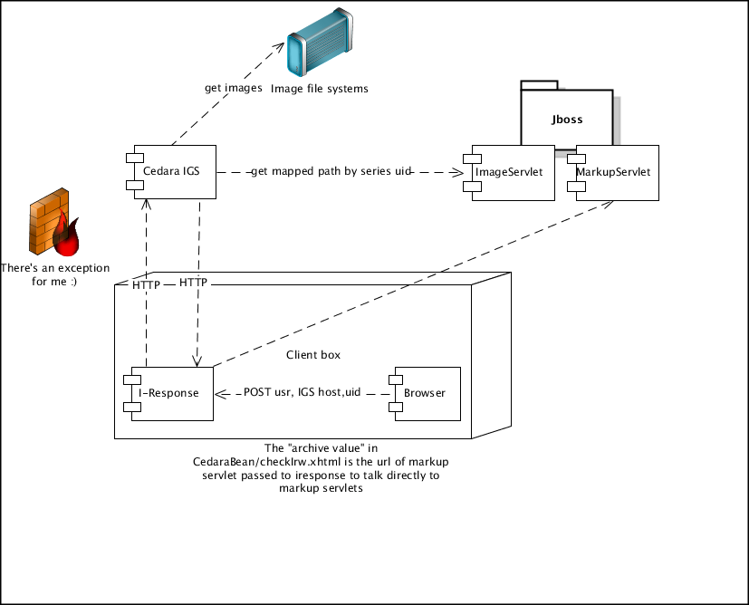

Change Example 1

NBIA, Cedara Imaging Grid Server (**ISG**) and Cedara I-Response workstation (**IRW**) are HTTP endpoints and their addresses have to be predefined in order to have three components talk to each other.

Communication interface between **NBIA**, Cedara Imaging Grid Server (**ISG**) and Cedara I-Response workstation (**IRW**) are defined in machine running ISG and JBoss server which hosts NBIA respectively. If NBIA is going to be hosted in different server, the property “gov.nih.nci.ncia.imaging.server.url” in properties-service.xml of deploy directory of JBoss has to modified accordingly. This can also be achieved by specified the installation properties in the deployment time. However, the change on ISG machine is a manual process. NBIA server info is stored at property [provider@service.endpoint](mailto:provider@service.endpoint) in joex.exe.properties in the install directory of Cedara ISG. And it needs to be defined accordingly.

Change Example 2

The integration of NBIA and Cedara was designed to expect the change of file system for DICOM image storage. If the NFS mount and file path are changed, properties “gov.nih.nci.ncia.mapped.image.path.head” and “gov.nih.nci.ncia.image.path.pattern” in properties-service.xml have to be modified or expanded to accommodate the change. The real path should be specified in “gov.nih.nci.ncia.mapped.image.path.head” and the mapped network path in ISG machine should be specified in “gov.nih.nci.ncia.image.path.pattern”. Each mapping is separated by “,” and the order of definition in the each property is important , meaning they have to be exactly same order. Also remember to use “\\\\” for root and “\\” for subdirectory in property “gov.nih.nci.ncia.mapped.image.path.head”. The change is also can be handled in the deployment time by modifying the install.properties in the build directory.