Ultrasound Support Description

|  |  |
| --- | --- |
| Last Revised: | Dec 09, 2010 |
| Produced By: | NBIA Team |
| Version: |  |

Document Approvals

The list contains the name and contact information for the core project team and any key stakeholders who have an interest in the success of the project. An “S” identifies persons responsible for approval from the stakeholder groups. Sign off of the document would be required when a decision is made not to take action for defined gaps.

|  |  |  |
| --- | --- | --- |
| S | Name | Role |
| S | Robert Shirley | NCICBIIT |
| S | Peter Yan | COTR/PM |
|  | Eric Kascic | Technical Lead |
|  |  |  |

Revision History

When you make a change to a document, you must add an entry to this Revision History table and you must manually type the Last Revised Date on the front cover.

|  |  |  |  |
| --- | --- | --- | --- |
| Date | Version | Description | Revised by |
| Dec. 8, 2010 | 1.o | First draft of feature description for ultrasound support. | Qinyan Pan |
|  |  |  |  |
|  |  |  |  |

Copyrights and Trademarks

© Copyright 2010 by CBIIT, caBIGTM. All rights reserved.

Table of Contents

1. Introduction 1

2. Summary of Feature 1

3. Architectural Diagram 1

4. Note for Future Development 2

5. To Be Developed 2

# Introduction

The purpose of this document is to describe the software design and implementation in Ultrasound Support and items to-be-completed when the task is resumed. A brief feature summary is provided and an architecture diagram is also included for better understanding of ultrasound features.

# Summary of Feature

#### The main objective of this feature is to support ultrasound images in DICOM format in NBIA. This includes the support of data submission to the image archive and providing the ability to search for ultrasound DICOM images based upon ultrasound specific search criteria. The submission of ultrasound DICOM images to NBIA is through CTP as other types of DICOM images. The DB adapter of CTP will capture values of predefined set of DICOM tags related to ultrasound images and to persist them in database. A new user interface is created to let user specify the search criteria related to ultrasound modality. The development of GUI interface for specifying ultrasound search is done and the slide show for showing ultrasound image in cine loop is also completed. However, the modification of DB adapter of CTP is yet to be implemented and query database with user specified criteria is also need to be completed and tested.

# Architectural Diagram

The following Architectural Diagram shows how CTP and NBIA interact with each other to provide the user the capability to submit ultra sound DICOM images and perform a search on it.

Figure Architectural Diagram

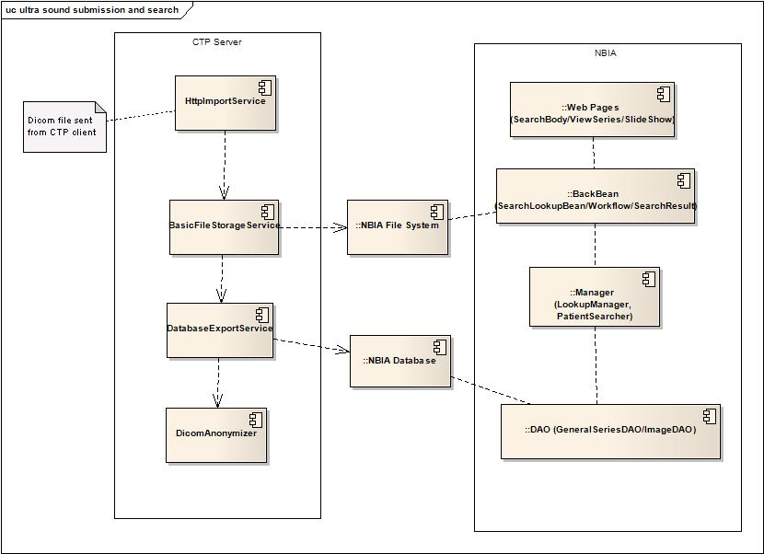

Note for Future Development

NBIA is in process of developing the feature to support ultra sound submission and search while waiting for the requirement to be clarified by Anna Fernandez. The initial requirement can be found on <https://tracker.nci.nih.gov/secure/ManageAttachments.jspa?id=16915>. However there are two issues. The requirement specifies that “B-Mode” is a searching criteria but the related DICOM tag for storing the relevant information can not be identified in DICOM standard, thought it is supported by manufacturer GE. The second issue is search criteria for Ultrasound Image Mode and US Image Type seem overlapping. To keep development moving forward, NBIA decide to set aside the requirement for searching Image Mode for ultra sound image and domain object and its hibernate mapping is shaped without adding the field for image mode.

To Be Developed

To support ultrasound related search, relevant information stored in a set of DICOM tags has to be extracted out and persisted in NBIA database while a DICOM image is submitted into NBIA. To accomplish this task, dbadapter of ncia-ctp module has to be modified to parse a extend set of ultrasound tags and store the information into the database. The database change script is created and the change to database is yet to be applied.

In the NBIA portal side, GenerImage domain object and its hibernate mapping are modified to accommodate the incoming changes. Related DTO and Searchworkflow bean and lookup beans have been modified. ImageDao is yet to be modified to expand its data access capability to images with specified ultrasound search criteria.