TimesArrow: system architecture
WisBees Investment Advisory · 8 October 2026 · Status: running locally, not yet deployed
One Next.js app on Vercel serves the public site, the client sign-up flow and the CMS. Supabase (Mumbai) holds the data, the files and client logins. There is no separate backend service.
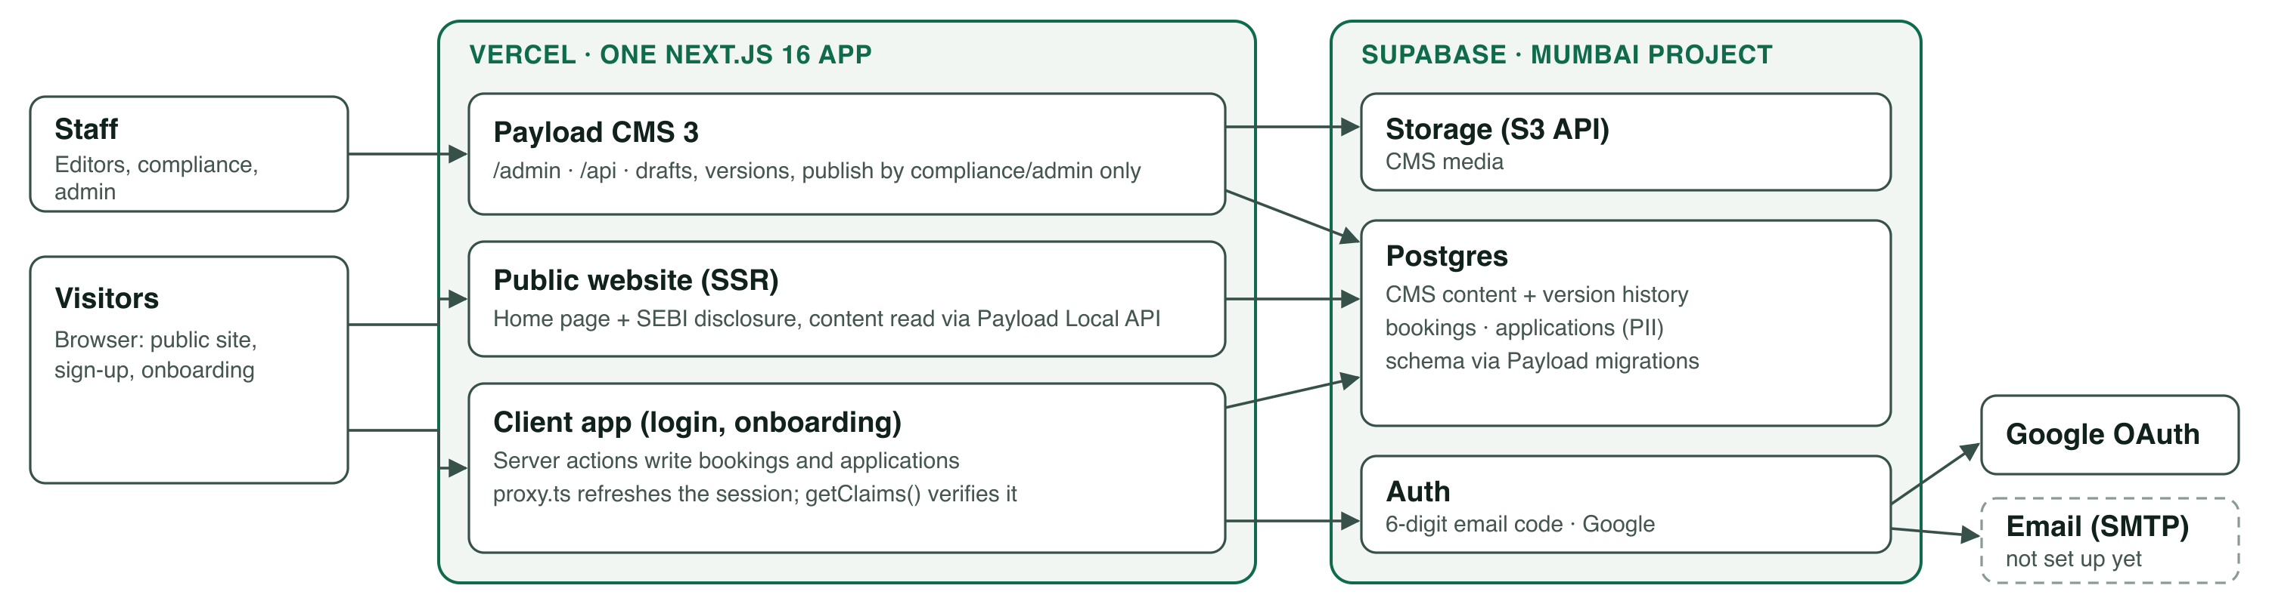
Dashed box: not set up yet.
Components
Web app | Next.js 16 (App Router) + React 19 + TypeScript, one codebase on Vercel. Public site, client app and CMS ship together.
CMS | Payload 3 embedded in the same app (/admin, /api). All site copy lives here. Drafts and version history on every item; only compliance/admin roles can publish. Staff log in with Payload users, separate from client accounts.
Database | Supabase Postgres, Mumbai. Schema changes ship as Payload migrations, run in the Vercel build. Local dev uses a local Postgres, never Supabase.
Auth (clients) | Supabase Auth: 6-digit email code or Google. Session lives in cookies, refreshed by proxy.ts and verified on the server with getClaims(), never trusted from the client.
Files | Supabase Storage through its S3 API, for CMS media only.
Main flows
- Public page. Browser requests the site; the server reads published content from Postgres through Payload and renders it. Publishing in the CMS revalidates the pages.
- Call booking. The form calls a server action: validates, checks a honeypot and a limit of 5 requests per IP per hour, then writes the booking. Public REST create and read are closed.
- Sign-up and onboarding. Account (email code or Google), then an investor profile (PAN, date of birth, city, income, goal, horizon, risk), then an "in review" screen. A server action keyed on the verified user id writes the application; staff review it in /admin.
Data and compliance
- Personal data (name, email, phone, PAN, date of birth) sits in Postgres in India. Only admin and compliance roles can read it. Consent wording and time are stored with each record. No personal data in URLs or logs.
- Site content needs compliance approval to publish. Search indexing stays off (noindex) until BASL approves. The SEBI disclosure footer is driven from the CMS on every page.
Open points for your call
- Database exposure. Payload creates its tables in the public schema with row-level security off. Before launch we need to confirm the Supabase Data API cannot reach them (disable it, or enable RLS on every table), since the publishable key is public.
- PAN and date of birth are plain columns today. Decide on field-level encryption and a retention period.
- Email. Supabase’s built-in sender allows only a few emails an hour and limits template edits. We need our own SMTP sender before real users sign up.
- Environments. We have one Supabase project, and local testing used its Auth. A separate staging project is advisable. A local-only demo switch skips sign-in; it is ignored in production builds.
- Not yet done: Vercel deployment and domain, backup and point-in-time recovery policy, monitoring and alerts, rate limiting beyond the booking form.
- Next phases (client dashboard, "Bees Copilot" chatbot with pgvector in the same Supabase database) build on this same app.

