External Data Users Survey to Inform the 2025-2026 CT State Data Plan

This document highlights findings from the survey of external data users to inform the 2025-2026 State Data Plan, which was conducted using Microsoft Forms starting on October 17, 2024. As of November 18, 2024, 99 responses have been submitted.

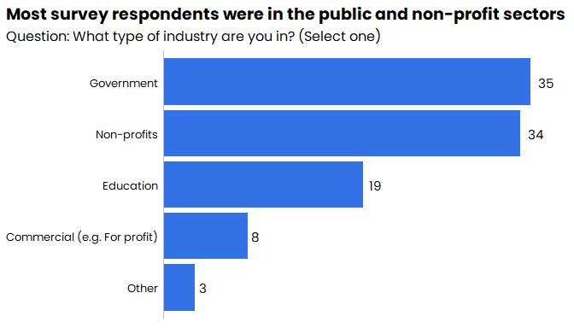

* Most survey respondents worked in government or the non-profit sector.

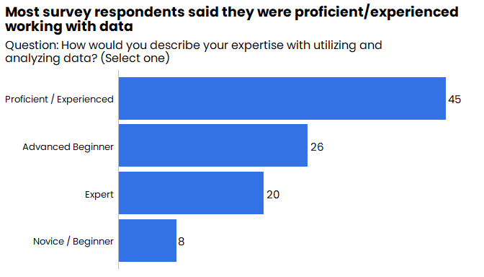

* Most respondents said they were “proficient/experienced” working with data.
* 20% identified themselves as experts.

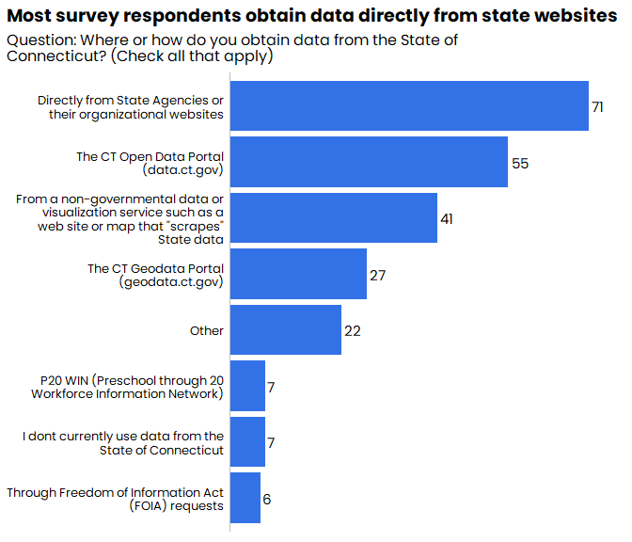

* The majority of respondents said that they access state data directly from state agency websites.
* The second most frequent response was finding data through the Open Data Portal.

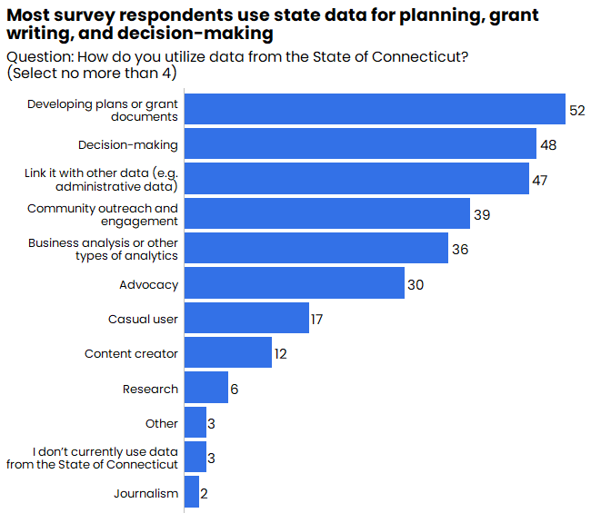

* The most common usage of state data by respondents was for planning and grant-writing.
* Almost half of respondents reported linking state data with other datasets.

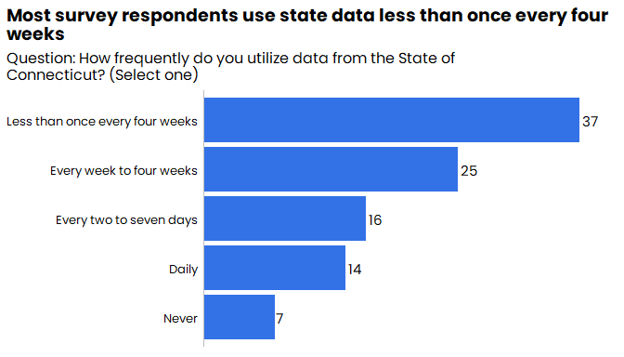

* Over half of respondents said they accessed state data at least every four weeks.
* Fourteen respondents said they used state data on a daily basis.

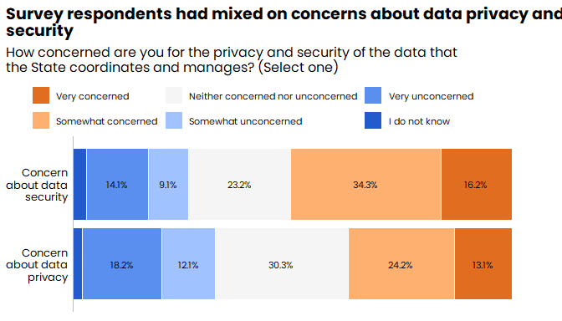

* Respondents said they were slightly more concerned about data security than data privacy.

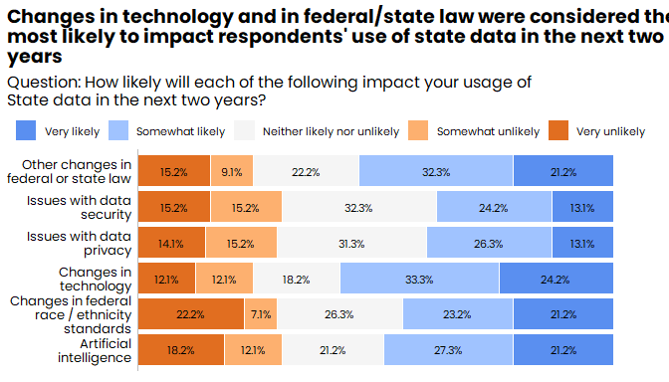

* 57.5% of respondents said changes in technology would be either somewhat or very likely to impact their use of state data in the next two years.
* 53.5% of respondents said changes in federal or state law would be either somewhat or very likely to impact their use of state data in the next two years.

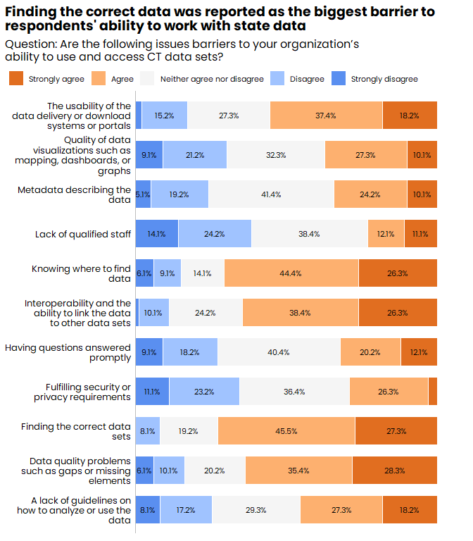

* 72.8% of respondents said finding the correct data is a barrier to working with state data.
* 70.7% of respondents said knowing where to find data is a barrier to working with state data.
* 64.7% of respondents said challenges with data interoperability is a barrier.
* 63.7% of respondents said that data quality is a barrier.