**Boston Regional STOPS Model**

**README: STOPS Summary Script *(Summary.R)***

**June 2025**

**Tested with R version 4.4.1**

**Purpose**

This R script processes the *Results.prn output file from a STOPS model run – along with the associated GTFS files – to generate two summary outputs for each of the three scenarios: **Existing**, **No-Build**, and **Build**. The two summary types produced are:

* **Boardings and alightings** by route and stop
* **Boardings by station mode of access**

The script is designed to be run from a directory that includes an Inputs folder, where the user provides all necessary inputs.

**Required Inputs**

All input files must be placed in the Inputs folder:

1. **STOPS Output File:** Copy the *Results.prn file from the STOPS model run’s “Reports” folder into the Inputs folder.
2. **GTFS files:** Copy all GTFS folders used in the STOPS model run (those that produced the *Results.prn file) into the Inputs folder.
3. **Input_Data&Parameters.xlsx:** Update the following sheets in the Excel file:
   * **Route_Mode_Lookup Sheet:** In the Route_ID column, list all route IDs used in the STOPS model run (these can be found in Table 10.01 of the *Results.prn file). In the Mode column, assign the corresponding transit mode for each route ID.
     + The provided Excel file includes route IDs and mode definitions for the 2024 and 2050 GTFS networks of the Boston Regional STOPS model.
   * **GTFS Sheet:** Column 1: List the GTFS folder names used in the STOPS run (these must match the folder names); Column 2: Enter the corresponding agency names; Column 3: Specify the GTFS suffix (as defined in the STOPS parameter file).
     + The provided file includes folder names, agencies, and suffixes for the 2024 and 2050 Boston Regional STOPS scenarios.
   * **Results.prn Sheet:** In cell A2 enter the full name of the *Results.prn file from the STOPS run.

**Running the Script**

Once all inputs are placed in the Inputs folder and the Excel file is updated, run the Summary.R script.

**Runtime:** 2-3 minutes

**Outputs**

The script will automatically create an Outputs folder (if it doesn't already exist) and generate **six summary CSV files** asshown below:

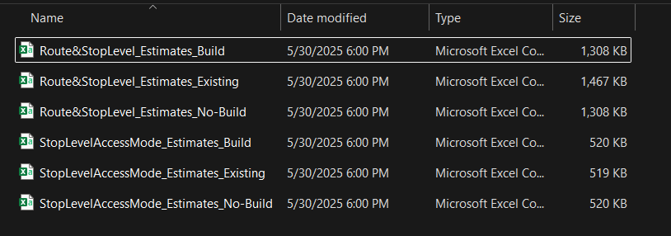

Sample output from the Route&StopLevel_Estimates is shown below:

Sample output from the StopLevelAccessMode_Estimates is shown below:

