

PHASE 1 · PROJECT PROPOSAL
Team name | TEAM NRZB

IEEE Computational Intelligence Society Student Chapter, IIT
Project: Early-Warning and Decision-Support System for Staple Food Prices in Colombo District

Choose one domain
Tick exactly one. The problem you choose must sit inside that domain.
☑ | 01 | Cost of living and everyday economics
☐ | 02 | Climate, environment and disaster risk
☐ | 03 | Health and well-being - non-clinical only: no diagnosis, no treatment advice

1. Problem statement and definition

The problem: Food prices in Sri Lanka are highly volatile, especially after economic shocks and weather events. When prices of rice, vegetables, coconut, onions, dried fish and other essentials rise sharply, the people who have to respond to them usually find out too late. The specific problem we address is the lack of an early, location-specific and honest warning about which food prices are rising or behaving abnormally, and how far that signal can be trusted.
Who suffers: Informal workers and low-income households, including those in estate communities, are hit the hardest. They have little or no savings, so a sharp rise in the price of staple foods immediately cuts their purchasing power. Officials and institutions responsible for food security and consumer protection suffer too, because they are asked to act on price movements they only see after everything is over. Ex: the peak of food inflation in 2022
What it costs today: Households learn about a price rise only when they reach the market, by which time the damage is done. The result is a forced trade-off between food quantity, food quality and other basic needs. For officials, the cost is lost time spent reading and comparing price tables, and lost opportunity to investigate, advise or release the buffer stocks before a price rise spreads to control the situation.
How people cope now, and why it is not good enough: Households typically buy in less quantity, switch to cheaper foods or cut other spending.
“In WFP’s September 2022 (peak of food prices) household survey, 77% of households relied on less preferred food, 47% limited portion sizes and 30% reduced the number of meals, while 27% cut spending on education and health and 29% borrowed money or pawned goods.”
Officials rely on price bulletins and tables that report what has already happened. Nothing in those materials say which items are likely to keep rising, which prices look unusual compared with their own history and how reliable the information is.

2. The user

Who we build for: A district-level or local government food security officer, or a similar official at an institution that monitors food prices and protects vulnerable communities. A secondary group is the intermediaries who can pass practical information on to communities: Grama Niladhari officers, cooperative societies and estate welfare officers. The system is built for these users rather than for households directly, because the households most at risk are often the least able to use a technical tool.
The decision: Once a week, the officer decides where to look first: which items deserve closer monitoring, a field check, a local advisory, or a case for targeted support, within the authority they already have. Today they decide using bulletins and price tables compiled by hand, and their own judgement.
What changes: Instead of reading tables, the officer opens one ranked list: where prices look abnormal now, where a rise is likely to continue, how confident the system is, and why. They spend their time verifying and responding, not searching.

3. Literature review

What already exists, and where it falls short for our user:
- HARTI price bulletins - The Hector Kobbekaduwa Agrarian Research and Training Institute publishes price information for food commodities. [Prices from 2015 – 2026.10.13 (up-to-date), but most of data wholesales, & only of a limited number of markets] It reports observed prices and does not forecast or flag unusual movements.
- HARTI DSS (Decision Support System) exists - but they are mostly wholesale, not strongly predictive for next-month retail, and not designed for informal rural/estate workers. (more specific; found when looked up the internet)
- Department of Census and Statistics - Publishes retail price information for commodities. The foundation of our system [Retail prices exits from 2018 to 2026 OCT 1st week but limited to a few markets]
- Central Bank daily price report - The Central Bank of Sri Lanka publishes daily price reports as PDF documents for selected items and markets. They are timely, but they are documents rather than a structured time series, and they offer no trend analysis or warning.
- Sri Lanka Food Prices on HDX - WFP market prices for Sri Lanka are published through the Humanitarian Data Exchange as a structured dataset going back to 2004. (Stale food prices, It has a higher breadth but a lower depth)
- World Bank Real-Time Food Prices - A modelled price series that fills gaps using statistical estimation. It is useful context, but because many values are estimates rather than observations, we do not use it as our main source (see section 6).
- Prior competition entries – Found None
The gap. The data is not missing. What is missing is a tool that turns it into a forward-looking, ranked and honest warning for the people who can act on it, and that tells them when the data is too weak to trust.

4. Proposed solution

We will build an early-warning and decision-support system for staple food prices. Each week it reads the latest observed retail prices across Colombo district markets and produces:
- A one-week-ahead forecast for key items in each market, shown as a range rather than a single number.
- A spike alert when the forecast indicates a rise above a defined threshold.
- An anomaly flag when an observed price is unusual compared with that market's own recent history
- A ranked alert list showing which item and market combinations need attention first.
- A confidence note on every output, including an explicit "not enough reliable data" result when the history is too thin or too old.
The insight it produces. A prediction, an anomaly and a risk ranking: for example, "rice in this market is rising faster than usual and is likely to keep rising next month; confidence medium". None of this exists in the raw tables. It is computed from about seven years of observed prices.
Why the user could not reach it alone. Comparing every item in the market against its own history and its peers, week after week, is not something a person can do by reading tables. The system does it systematically and says how much to trust each result.
What it is not. It is decision support, not a decision-maker. It tells an officer where to look and how confident it is. The response remains the officer's judgement.

5. Data

5.1 Source and access
What it is - Our main dataset is Department of Census and Statistics weekly open-market retail prices for the main markets in Colombo District. Central Bank of Sri Lanka daily price reports provide supplementary named-market observations.
Evidence we can obtain it - We downloaded the pdf files from the DCS website and developed a script that extracts data from them it in Python. It includes 37,539 rows with Observation Date, commodity, price, unit, source..
https://www.statistics.gov.lk/InflationAndPrices/StaticalInformation/RetailPrices
https://www.cbsl.gov.lk/statistics/economic-indicators/price-report
(Links as follows: 1st one DCS Food prices Dataset, 2nd one CBSL weekly data)

How much, and what it covers.
- DCS current layer: 37,539 extracted weekly retail rows covering 162 commodities and 354 observed reporting weeks from 2019 to 7 October 2026. The DCS series represents a Colombo District aggregate, not a separate weekly series for every named market.
- Sri Lanka Food inflation data (WFP) from 2009 -2026 used as an additional factor to enhance the predictions.
- CBSL current layer: 831 extracted Today-only retail rows covering 24 commodities across 3 named markets from 1 October to 16 October 2026. The latest available CBSL observation is 16 October 2026.
- The operational scope is intentionally limited to compatible staple commodities and units.
- Prices are in Sri Lankan rupees per kilogram for most items, with some per unit or per liter

Supplementary source - DCS is the primary current weekly layer, CBSL is the current named-market cross-check.
Moreover, we would try to add more compatible, relevant datasets/factors that defines the prices of day to day markets such as climate changes, fuel prices, inflation which enhance the accuracy of the model’s estimations.
Origin and personal data. The data is collected at market level and describes prices of goods, not people. No personal data is involved.

5.2 Extraction method
How - The DCS and CBSL reports are extracted with deterministic Python tools into a canonical schema. The pipeline preserves source, date, frequency, market coverage, measurement basis and provenance so that incompatible rows can be excluded rather than guessed..
Why this method - The official reports are the most recent observed retail sources available for this scope. Deterministic extraction is reproducible and auditable; explicit source fields make it possible to evaluate DCS weekly, CBSL reporting-day and WFP monthly outputs separately.

Cleaning and compatibility controls:
- Standardize dates, commodity names and units only where the mapping is explicit and safe.
- Keep DCS Colombo District aggregate, CBSL named markets and WFP market series as distinct source definitions.
- Convert frequency only inside a source-specific model: DCS remains weekly, CBSL remains reporting-day.
- Exclude missing, zero or non-retail values and retain provenance, review status and trust basis for every extracted official row.
- Expected difficulties include inconsistent names, unit mismatches, missing publication weeks, missing reporting days, short CBSL history and different market definitions. The system records these limitations instead of silently filling or merging them.

5.3 Temporality
What it is - The current operational DSS is Colombo-focused. DCS observations cover 27 December 2019 to 7 October 2026 at weekly frequency across 354 observed reporting weeks; CBSL observations cover 1 to 16 October 2026 reporting days.
Why this fits the user – A Food security officers need verifiable, stable data that can use to monitor Colombo market price spikes, receive next-week forecasts with confidence scores .
Refresh and failure - Re-running the extraction and validation tools refreshes the official layers. As of 22 October 2026, DCS is 15 days old and CBSL is 6 days old. If a source is unavailable, stale or incompatible, the dashboard shows its age and returns a low-confidence or "not enough reliable data" result rather than fabricating a current forecast.

6. Approach and methodology

Approach - Source-specific time-series analysis with simple, explainable models and robust anomaly detection. The design prioritizes a clean current DSS for Colombo.
- Baselines first: DCS weekly forecasts are compared with "next week equals this week" and recent-average baselines; CBSL projections are compared with "next reporting period equals the latest value"
- Forecasting: DCS weekly observations are eligible for a one-week-ahead model when sufficient recent history and data quality are present; candidate methods are selected by rolling one-week-ahead validation. CBSL uses no strong forecast claim yet because its current history is short
- Spike definition: a spike or fall is based on the source-specific distribution of changes and is labelled with its source, horizon and evidence strength. Thresholds are calibrated from historical DCS rather than chosen only by visual inspection.
- Anomaly detection: a movement is flagged when it is far from the source series’ recent behavior. Persistence.

- Uncertainty and failing safely: every output carries source, date, horizon and confidence. DCS forecasts receive confidence based on rolling validation and data age; CBSL current signals remain low-confidence context until future holdout evaluation is possible; insufficient history produces no projection.

Alternatives we considered and set aside.
- A chatbot or language model that answers price questions: Set aside because it would retrieve existing data rather than produce new insight.
- The World Bank modeled series as our main data: Set aside because many of its values are estimates rather than observations, and we want our results to rest on observed prices.
- The HDX HAPI food price dataset: Set aside because it repackages the same WFP data, so it would add complexity without new information.
- The HARTI food commodities bulletins weekly data: set aside because it mostly consists the wholesale prices.
- Thought to use the WFP as the main dataset – But the data gap forced us to focus on DCS as the main dataset.

How we will work: First, maintain the verified source inventory and Colombo operational scope. Second, build source-specific cleaning, crosswalk and frequency-preserving outputs. Third, implement and evaluate DCS weekly baselines and candidate models with rolling holdouts. Fourth, calibrate alert thresholds and explanations. Fifth, expose the results through the single alert board and document coverage, limitations and failure cases. We test each step and report where a model does not help.
Use of AI tools: We utilized Claude & Grok Chat Bots for the research, planning, drafting and will be utilizing for coding as well. We understand and take responsibility for everything we submit.

7. System design

7.1 Architecture
The analysis runs in Python scripts that work without the dashboard. The dashboard only displays their output.

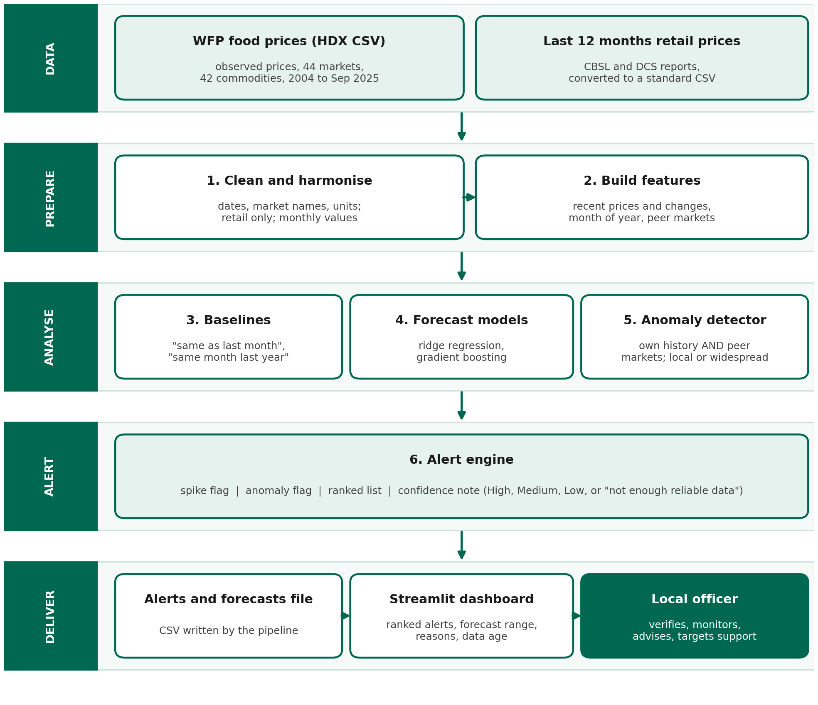
(Note: The main dataset is DCS due to the data gap of WFP)

- Ingestion and cleaning: loads DCS and CBSL data while preserving source, frequency, market definition and provenance.
- Feature builder: creates source-specific recent prices, changes, seasonal features and peer-market evidence only where comparable.
- Models: Next-week forecast using historical residuals; generates confidence, inflation_rate, anomaly, anomaly_score fields; Historical median as forecast reference; Seasonal-Based Average seasonal pattern detection
- Alert engine: applies the spike rule and anomaly rule, assigns confidence, and ranks results
- Dashboard: reads the saved output and displays it insightful & legibly.

7.2 Technical stack
- Python for everything, because the team knows it and the data tools are mature
- pandas for data handling and scikit-learn for models
- pdfplumber (or similar) for extracting tables from published PDF reports
- Streamlit with Plotly or Altair for the dashboard, because it needs only Python
- Git and GitHub for version control, with a public repository and a README that runs the project
Everything above is free. We do not currently need paid services or special access. If we host a live demo, we will use a free tier and keep a local fallback.

7.3 Interface and interaction
The user reaches the output through a simple web dashboard.
- Alert list (first screen): the ranked item based on the severity, each with the expected change range, and confidence rating
- Detail view: a chart with the forecast range for a selected item and market, the reasons the flag was raised, and the model's historical accuracy
- Data panel: the age of the data for each item and any "not enough reliable data" results
- Filters – Allows you to filter forecast by the commodities.
The officer uses the list to decide where to verify, monitor or advise.

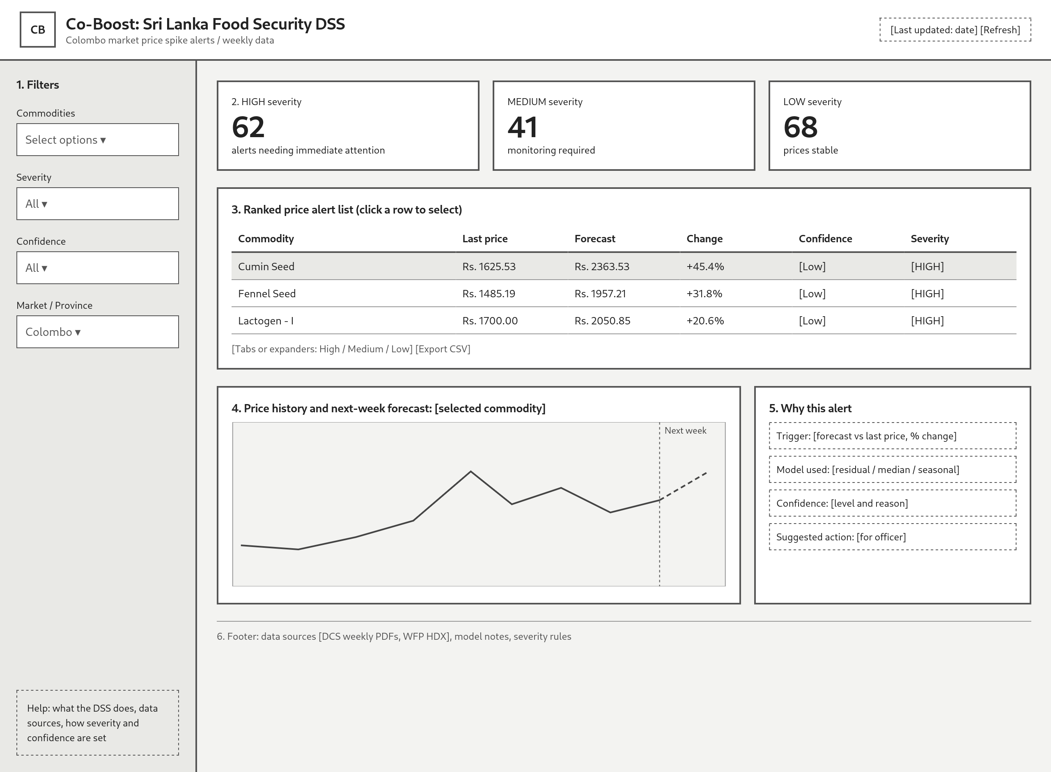

8. Implementation plan

Milestones (build phase)
- 20–22 Oct: finalize the current DCS weekly dataset
- 23–26 Oct: implement DCS one-week-ahead baselines and check for candidate models (Historical median,residual-based, seasonal-based, Ridge Regression)
- 27–29 Oct: calibrate spike, fall and anomaly rules; align the decision-support alert board and detail view with source-specific confidence.
- 30 Oct–1 Nov: complete evaluation write-up, technical report, README, two-page summary and three-minute video; publish the reproducible repository.
- 2–14 Nov (if selected for the finalists): refinement, a reliable live demo and preparation for questions
Who owns what - [Nethum: data cleaning and extraction; Dilith: modelling and evaluation; Both Members: dashboard, report, video and README.]
What finished looks like - A reproducible public repository with deterministic ingestion, explicit source boundaries, a current Colombo-focused alert board, decision support system that monitors Colombo market price spikes, forecasts next week's staple food prices, and provides confidence scores (High/Medium/Low)
What we cut first if we run short - In order: Dashboard, WFP Data set (2004-2025),

9. Evaluation plan

What “correct” means - The system is correct if it gives a Colombo officer timely, interpretable and honest signals: DCS weekly projections that are evaluated against simple baselines.
How we measure it.
- Forecast accuracy: evaluate DCS weekly projections on different type of baselines and recent-average baselines; Evaluate the data set in different baseline logics & develop the ML models and test them whether they beat those simple baselines. If not, continue using simple logic base rules.
- Temporal usefulness: report the latest observation date, source age and horizon for every alert, and verify that current official rows appear in the primary DSS. At the current proposal snapshot, DCS is 15 days old and CBSL is 6 days old.
- Spike and fall detection: measure precision, recall and false alarms against source-specific threshold baselines when sufficient held-out observations exist.
- Anomaly flags: review a sample signals against the source history and known events where available.
- Uncertainty: the inherent uncertainty of forecasting staple food prices 1 week into the future, ensuring officers understand that detected anomalies represent genuine price movements beyond normal statistical variation rather than model error alone.
- Honesty: confirm that incompatible definitions are not merged, current and historical rows are labelled, and thin histories return “not enough reliable data.”
- Usefulness: can test through walking a food-security officer or consumer-protection officer through the ranked alert list and record whether each row supports a clear verification action.
What would tell us the approach is not working: if DCS does not beat simple rule-based baselines for most of the data, wee keep the baselines removing the complex ML models.

10. Risks and contingencies

Here is what could go wrong -
Risk | What we will do
The DCS archive has publication gaps | Keep missing weeks as missing, disclose the exact coverage, and require sufficient recent observations before forecasting.
Current sources have different coverage and freshness | Use DCS as the primary weekly aggregate, CBSL as short named-market context,
DCS/CBSL extraction or reconciliation fails | Keep deterministic local extraction, provenance and the WFP benchmark; exclude incompatible rows and return not enough reliable data.
Models do not beat the baselines | Try different model families, if model still not beating the baselines keep the working baselines.
Names, units or definitions differ between sources | Use explicit crosswalks, preserve source frequency and coverage, check overlap, and exclude unsafe matches  (If we are using multiple datasets)
False alarms or overconfidence mislead the user | Require transparent evidence, show confidence and data age, validate thresholds, and frame outputs as decision support
A team member drops out or time runs short | Keep the core pipeline simple as in the section 8, & build functions as possible as possible the last man standing can.
The live demo fails | Keep a recorded demo and local copy of the data and output, and test the demo environment before the final

11. References

- World Food Programme. Sri Lanka - Food Prices [dataset]. Humanitarian Data Exchange.
( licence: [Publicly Available Data]) - https://data.humdata.org/dataset/0298c598-d312-4771-b564-f4ac4d831f05/resource/3638f0d6-9969-48cf-a919-1d879d037ec6/download/wfp_food_prices_lka.csv
- Central Bank of Sri Lanka Daily food prices - https://www.cbsl.gov.lk/en/statistics/economic-indicators/price-report (license: Publicly Available Data)
- Hector Kobbekaduwa Agrarian Research and Training Institute. (weekly price of Food Commodities
bulletin) - https://www.harti.gov.lk/weekly-price.php
- Department of Census & statistics weekly retail prices of consumer items (2018 – till now ) - https://www.statistics.gov.lk/InflationAndPrices/StaticalInformation/RetailPrices
(license: Publicly Available Data)
- HARTI DSS for wholesale food prices - https://www.harti.gov.lk/idat.php
- Sri Lanka Food Inflation (WFP) - https://dataviz.vam.wfp.org/data-explorer/economic/inflation
- Tools: Python, pandas, scikit-learn, pdfplumber, Streamlit, Plotly.

12. Team details

  Mr. Nethum Muthugala  nethum.muthugala13@gmail.com  Sri Lanka Technology Campus |   Mr. Dilith Madhushyan  dilithmadhushyan@gmail.com  Sri Lanka Technology Campus

