**P1 App GFE System Description**

1. Capabilities, System and Components 1
2. P1, P2 Processor Specifications 3
3. Xilinx UltraScale+ Design Implementation 4
4. Vivado Project Settings 6
5. Address Mapping 6
6. Interrupt Mapping 7
7. Pmod GPIO Header Pin Assignments 8
8. FreeRTOS 8

# Capabilities, System and Components

Figure 1 shows a block diagram of the P1 App GFE hardware. The system in the XCVU9P FPGA is a physical memory system with P1 processors inserted and a virtual memory system with P2 processors. Programs can run on bare metal or in an operating system (FreeRTOS for P1 and Linux for P2). A host-based gdb debugger connects to the system over the USB/JTAG connector, and a host-based console connects over the USB/UART connector. The system can access 1 GB of the 4GB on-board DRAM through the Xilinx DDR controller and PHY.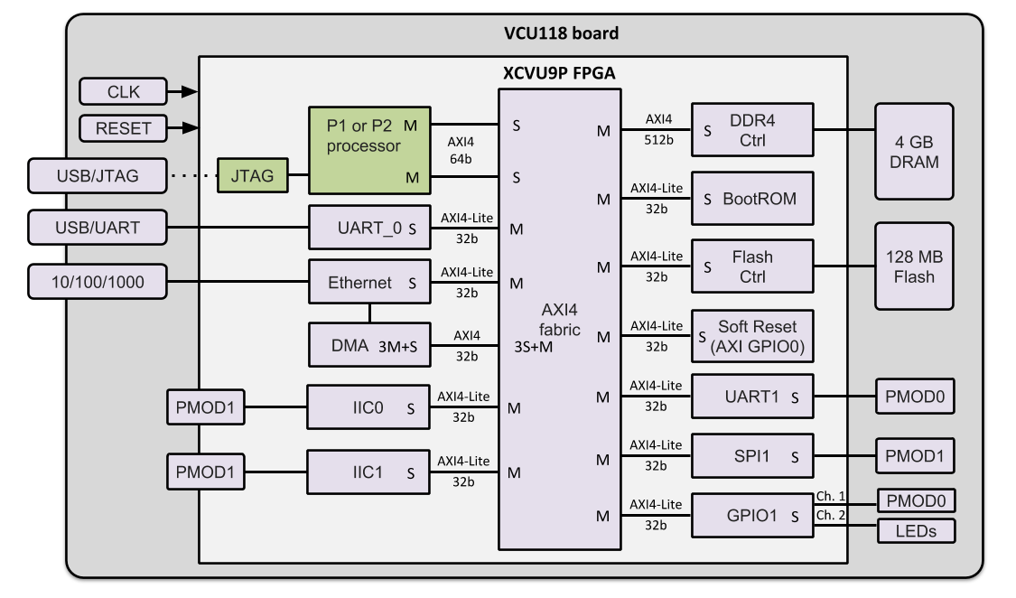

**Figure 1: GFE P1/P2 VCU118 FPGA board and FPGA device block diagram**

The GFE system consists of a Rocket, Piccolo or Flute RISC-V core (see specifications below), a BootROM, Soft Reset and JTAG, UART, Ethernet/DMA, DDR4 and Flash controllers. All components but the P{1,2} processors and the JTAG block (green) are Xilinx IP (purple). The BootROM is a read only memory constructed from a BRAM and AXI BRAM controller. The GFE system is the same whether the processor is Rocket, Piccolo or Flute.

The P{1,2} processors include Debug Modules (not shown) that connect to a custom JTAG block (<https://gitlab-ext.galois.com/ssith/gfe/tree/master/jtag>) that uses Xilinx BSCAN primitives under the hood. This enables a tap into the FPGA’s JTAG system controller to multiplex the P{1,2} JTAG channel onto the external USB/JTAG port (dotted line connection).

The components are connected through an AXI4 fabric with 12 ports. The fabric automatically translates between protocols (AXI4-Lite and AXI4) and channel widths (32, 64, 256, 512 bit).

See section “Xilinx UltraScale+ Implementation” for the Xilinx circuit implementation of this block diagram.

Table 1 lists the Xilinx IP cores used in the GFE system:

|  |  |  |  |
| --- | --- | --- | --- |
| **Component** | **Product** | **Documentation** |  |
| AXI Interconnect | PG059 | <https://www.xilinx.com/support/documentation/ip_documentation/axi_interconnect/v2_1/pg059-axi-interconnect.pdf> |  |
| DDR4 Controller | PG150 | <https://www.xilinx.com/support/documentation/ip_documentation/ultrascale_memory_ip/v1_4/pg150-ultrascale-memory-ip.pdf> |  |
| AXI BRAM Controller | PG078 | <https://www.xilinx.com/support/documentation/ip_documentation/axi_bram_ctrl/v4_0/pg078-axi-bram-ctrl.pdf> |  |
| AXI UART 16550 | PG143 | <https://www.xilinx.com/support/documentation/ip_documentation/axi_uart16550/v2_0/pg143-axi-uart16550.pdf> |  |
| AXI 1G/2.5G Ethernet | PG138 | <https://www.xilinx.com/support/documentation/ip_documentation/axi_ethernet/v7_0/pg138-axi-ethernet.pdf> |  |
| AXI DMA | PG021 | https://www.xilinx.com/support/documentation/ip_documentation/axi_dma/v7_1/pg021_axi_dma.pdf |  |
| AXI Quad SPI (Flash ctrl) | PG153 | https://www.xilinx.com/support/documentation/ip_documentation/axi_quad_spi/v3_2/pg153-axi-quad-spi.pdf |  |
| AXI GPIO Controller | PG144 | https://www.xilinx.com/support/documentation/ip_documentation/axi_gpio/v2_0/pg144-axi-gpio.pdf |  |
| AXI IIC Bus Interface | PG090 | https://www.xilinx.com/support/documentation/ip_documentation/axi_iic/v2_0/pg090-axi-iic.pdf |  |
| **Table 1: Xilinx IP Cores** | | | |

# P1, P2 Processor Specifications

|  |  |  |  |  |
| --- | --- | --- | --- | --- |
|  | **P1 Rocket** | **P1 Piccolo** | **P2 Rocket** | **P2 Flute** |
| Instruction set | RV32IMAC | | RV64IMAFDC | |
| Privilege levels | machine, user | | machine, user, supervisor (SV39) | |
| Memory management | No | | Yes | |
| Physical memory protection | No | | No | |
| Compliance tests | https://github.com/riscv/riscv-tests | | | |
| rv32u{i,m,a,c}-p, rv32mi-p | | rv64u{i,m,a,f,d,c}-{p,v},  rv64{m,s}i-{p,v} | |
| Pipeline stages | 5 | 3 | 5 | 5 |
| Default GFE clock MHz | 50 | 50 | 50 | 50 |
| Max GFE clock MHz | 150 | 83 | 150 | 83 |
| Superscalar | No | | | |
| Out-of-order | No | | | |
| ICache/DCache | 4 KB | | 8 KB | |
| Multiply-Divide unit | Yes | | | |
| Single/double FPU unit | No | | Yes | |
| RISC-V debug module | RISC-V External Debug Support Version 0.13 | | | |
| program buffer | system bus | program buffer | system bus |
| Interrupts (PLIC) | Chapter 8, SiFive U54-MC-RVCoreIP v1p0 – 16 interrupts | | | |
| Timer (CLINT) | Chapter 9, SiFive U54-MC-RVCoreIP v1p0 | | | |
| System bus | 64-bit AXI4 | | | |
| Operating system | FreeRTOS | | Linux kernel | |
| Implementation language | Chisel | BSV | Chisel | BSV |

**Table 2: Processor Specifications**

“Default GFE clock MHz” is the current frequency setting for the ACLK signal (see Figures 2 and 3) that clocks all GFE components except the DDR4 controller. ACLK is generated by the clock generator inside the DDR4 controller (for convenience, not necessity). The ACLK frequency can be modified by adjusting the advanced clocking settings of the DDR controller.

“Max GFE clock MHz” is the maximum clock frequency at which the GFE has been tested with Rocket and Piccolo.

For Rocket, it may be possible to run faster than 150 MHz if the rest of the system can keep up (this hasn’t been tried). For Piccolo, the GFE clock frequency is currently limited by Piccolo, not the rest of the system.

# Xilinx UltraScale+ Design Implementation

The block diagram in Figure 1 is implemented using Vivado’s IP Integrator design flow: <https://www.xilinx.com/content/dam/xilinx/support/documentation/sw_manuals/xilinx2018_3/ug995-vivado-ip-subsystems-tutorial.pdf>

The IP Integrator enables quick and easy graphical connections of Xilinx IP that is instantiated and configured within an IP Integrator project session. In addition, the P{1,2} processors are imported into IP Integrator as 3rd party reusable IP blocks that can be connected as easily as Xilinx IP.

The top-level GFE system is a Vivado block design. It consists of three instances (Figure 2): a Xilinx JTAG module (xilinx_jtag_0) and a P{1,2} processor (mkP2_Core_0) that correspond to blocks in Figure 1; and a subsystem module (gfe_subsystem) that instantiates all the other Xilinx modules.

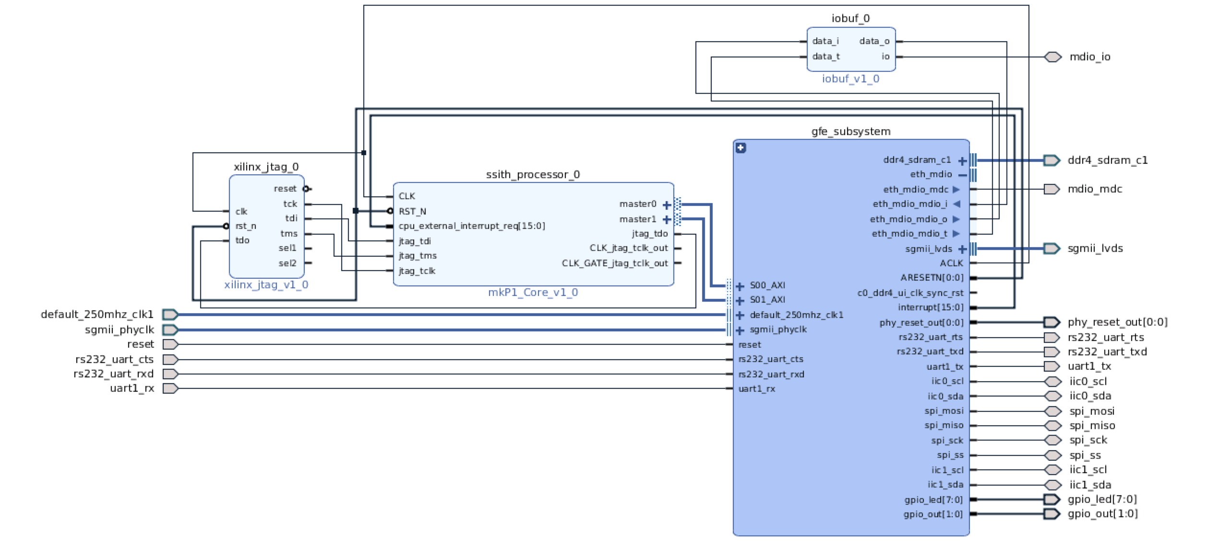

**Figure 2: Top-level Vivado block design for P1 App GFE**

The *gfe_subsystem* module is shown in Figure 3. It instantiates all the Xilinx cores that are necessary to implement the fabric, UART, DDR4, Ethernet, Flash, BootROM, GPIO, SPI and IIC. in Figure 1. In addition, it instantiates two blocks to implement reset.

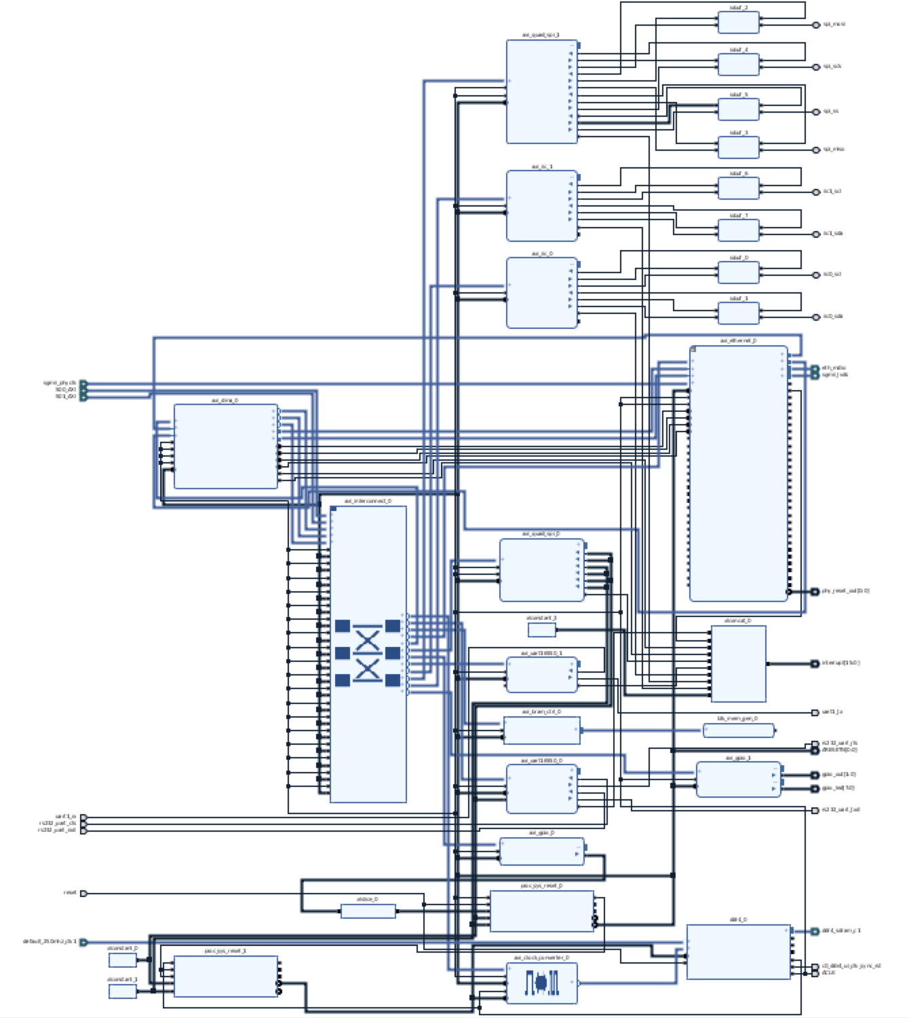

**Figure 3: Xilinx block design implementation for *gfe_subsystem***

# Vivado Project Settings

Note that when generating the bitstream, the Implementation Strategy should be set to Vivado Implementation Defaults to avoid the faster strategy resulting in route conflicts. This can be changed in Flow Navigator -> Project Manger -> Settings -> Project settings -> Implementation -> Options -> Strategy. The strategy is originally set when the project is first built, and this can be changed by modifying impl_1’s strategy in tcl/soc.tcl.

The SPI block used for the SD card (axi_quad_spi_1) should have its Frequency Ratio set based on the AXI clock and the desired SPI clock.

# Address Mapping

The following table provides the memory map for the memory mapped devices. The CLINT and PLIC are included inside the P{1,2} processors and are therefore not mapped into the AXI fabric.

|  |  |  |  |  |  |  |
| --- | --- | --- | --- | --- | --- | --- |
| **Device** | **GFE Instance Name** | **Slave Interface** | **Base Name** | **Offset Address** | **Range** | **High Address** |
| CLINT | Addressed inside processor |  |  | 0x0000_0000_1000_000 | 64K | 0x0000_0000_1000_FFFF |
| PLIC | Addressed inside processor |  |  | 0x0000_0000_0C00_000 | 4M | 0x0000_0000_0C3F_FFFF |
| FLASH | axi_quad_spi_0 | AXI_FULL | MEM0 | 0x0000_0000_4000_000 | 64K | 0x0000_0000_4000_FFFF |
| ETHERNET | axi_ethernet_0 | s_axi | Reg0 | 0x0000_0000_6210_000 | 256K | 0x0000_0000_6213_FFFF |
| DMA | axi_dma_0 | S_AXI_LITE | Reg | 0x0000_0000_6220_000 | 64K | 0x0000_0000_6220_FFFF |
| UART0 | axi_uart16550_0 | S_AXI | Reg | 0x0000_0000_6230_000 | 4K | 0x0000_0000_6230_0FFF |
| GPIO0 | axi_gpio_0 | S_AXI | Reg | 0x0000_0000_6FFF_000 | 64K | 0x0000_0000_6FFF_FFFF |
| Boot ROM | axi_bram_ctrl_0 | S_AXI | Mem0 | 0x0000_0000_7000_000 | 4K | 0x0000_0000_7000_0FFF |
| DRAM | ddr4_0 | C0_DDR4_S_AXI | C0_DDR4_S_AXI_ADDRESS_BLOCK | 0x0000_0000_8000_000 | 2G | 0x0000_0000_FFFF_FFFF |
| UART1 | axi_uart16550_1 | S_AXI | Reg | 0x0000_0000_6234_000 | 4K | 0x0000_0000_6234_0FFF |
| I2C0 | axi_iic_0 | S_AXI | Reg | 0x0000_0000_6231_000 | 4K | 0x0000_0000_6231_0FFF |
| SPI | axi_quad_spi_1 | AXI_LITE | Reg | 0x0000_0000_6232_000 | 4K | 0x0000_0000_6232_0FFF |
| I2C1 | axi_iic_1 | S_AXI | Reg | 0x0000_0000_6235_000 | 4K | 0x0000_0000_6235_0FFF |
| GPIO1 | axi_gpio_1 | S_AXI | Reg | 0x0000_0000_6233_000 | 4K | 0x0000_0000_6233_0FFF |
| **Table 3: Address Mapping** | | | | | | |

The memory map for devices connected to the AXI fabric can be viewed in the “Address Editor” tab next to the “Diagram” tab in the Vivado GFE project window.

Addresses 0x8000_0000 to 0xBFFF_FFFF are configured as uncached in the Bluespec and Chisel processors. This designation enables coherent memory between the DMA engine and RISC-V processors. The Linux device tree (bootrom/devicetree.dts) reserves this region for DMA.

Note that the first UART register is at 0x6230_0000, not 0x6230_1000 as the UART documentation would suggest. This is a result of the small address space allocated to UART in the Xilinx interconnect. The interconnect allocates 0x6230_0000 to 0x6230_0fff to the UART, but the UART registers in the Xilinx documentation are defined at 0x6230_100X. Synthesis causes the upper bits to be ignored within the UART block, so the resulting UART registers are located at 0x6230_000X

Our reference code uses the proper addresses (0x6230_000X). Writing to and reading from 0x6230_100X causes undefined behavior (this is processor dependent). This is also true for the UART_1 with offset address 0x6234_0000.

# Interrupt Mapping

The following table shows the interrupt mapping for cpu_external_interrupt_req[15:0]:

|  |  |
| --- | --- |
| **Pin** | **Connection** |
| 0 | uart_0 |
| 1 | interrupt pin on axi_ethernet |
| 2 | mm2s_introut on axi_dma |
| 3 | s2mm_introut on axi_dma |
| 4 | quad_spi_0 |
| 5 | uart_1 |
| 6 | iic_0 |
| 7 | quad_spi_1 |
| 8 | iic_1 |
| 15:9 | tied to zero |

**Table 4: Interrupt Mapping**

The PLIC used by the GFE processors indexes interrupts starting from 1. This means that the interrupt signal connected to cpu_external_interrupt_req[0] corresponds to PLIC interrupt 1. This offset is reflected in the Linux device tree provided in bootrom/devicetree.dts.

# Pmod GPIO Header Pin Assignments

Several of the memory-mapped peripherals are connected to the Pmod GPIO headers. The Pmod header pinout from the VCU118 Evaluation Board User Guide is shown below, and the pin assignment is below that.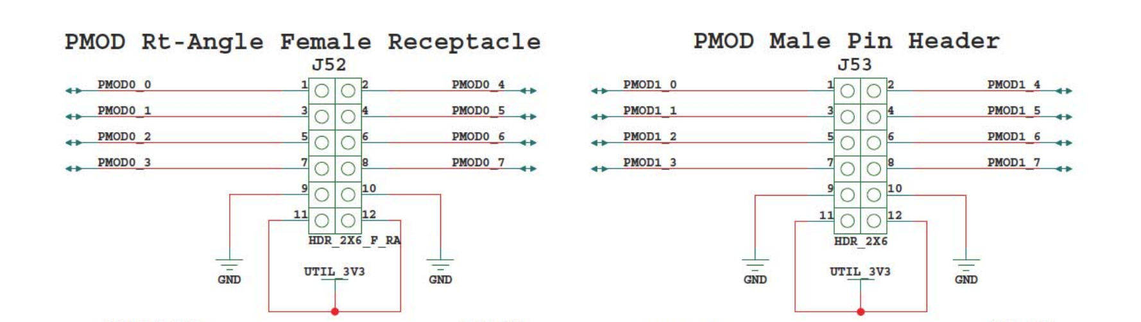

**Figure 4: Pmod GPIO Header Pinout**

|  |  |  |  |  |  |  |  |
| --- | --- | --- | --- | --- | --- | --- | --- |
| **PMOD0** |  |  |  | **PMOD1** |  |  |  |
| **0** | GPIO_1[0] | **4** | UART_1 TX | **0** | IIC_0 SDA | **4** | SPI_1 SS |
| **1** | GPIO_1[1] | **5** | UART_1 RX | **1** | IIC_0 SCL | **5** | SPI_1 MOSI |
| **2** | GPIO_1[2] | **6** |  | **2** | IIC_1 SDA | **6** | SPI_1 MISO |
| **3** | GPIO_1[3] | **7** |  | **3** | IIC_1 SCL | **7** | SPI_1 SCK |

**Table 5: Pmod GPIO Header Pin Assignment**

The pin assignment can be changed in xdc/vcu118_soc.xdc. Note that GPIO1 has 2 channels: Channel 1 connects to the Pmod GPIO header outputs pins, while Channel 2 corresponds to the onboard LEDs on the VCU118 board.

# FreeRTOS

The P1 processors boot FreeRTOS 10.2.0.

The Galois FreeRTOS repository is a fork of <https://github.com/coldnew/FreeRTOS-mirror> which is just a mirror of FreeRTOS SVN, the upstream FreeRTOS. The folder FreeRTOS-mirror/FreeRTOS/Demo/RISC-V_Galois_P1/demo contains applications specific to the P1 and GFE.

See gfe/README.md for instructions on how to run the FreeRTOS demo applications.