**VIETNAMESE LABOR UNION**

**TON DUC THANG UNIVERSITY**

**FACULTY OF INFORMATION TECHNOLOGY**



**FINAL PROJECT**

**SOFTWARE TECHNOLOGY**

**COFFEE SHOP MANAGEMENT SYSTEM**

*Instructing Lecturer*: **ĐẶNG MINH THẮNG**

*Student’s name*: **CAO TRẦN TUẤN DUY – 517H0111**

**TRẦN TUẤN KHẢI – 517H0120**

*Class*: **17050311**

*Course*: **21**

**HO CHI MINH CITY, 2020**

**VIETNAMESE LABOR UNION**

**TON DUC THANG UNIVERSITY**

**FACULTY OF INFORMATION TECHNOLOGY**



**FINAL PROJECT**

**SOFTWARE TECHNOLOGY**

**COFFEE SHOP MANAGEMENT SYSTEM**

*Instructing Lecturer*: **ĐẶNG MINH THẮNG**

*Student’s name*: **CAO TRẦN TUẤN DUY – 517H0111**

**TRẦN TUẤN KHẢI – 517H0120**

*Class:* **17050311**

*Course:* **21**

**HO CHI MINH CITY, 2020**

ACKNOWLEDGEMENTS

During the past time, we could not have been done without the kind support from many individuals and organizations – which is why we would like to send our most profound gratitude to all of them.

First of all, we would like to express a special appreciation to Tôn Đức Thắng University’s teachers for their conscientious guidance, we have learned a lot of useful things and accumulated some knowledge to complete into this report.

We are highly indebted to **Mr. Thắng** for his guidance and constant supervision as well as for providing necessary information regarding the project & also for his support in completing the project. Again, we sincerely thank you.

We would like to express our gratitude towards our parents & member of class 17050311 for their kind co-operation and encouragement which help us in completion of this project.

Our thanks and appreciations also go to our colleague in developing the project and people who have willingly helped us out with their abilities.

THE REPORT ARE COMPLETED AT TON DUC THANG UNIVERSITY

We assure this is our own project product. The research contents, results in this topic are honest and unpublished in any form before. The data in the tables for analysis, comment and evaluation are collected by the author from various sources in the reference section.

In addition, a number of comments and assessments as well as data from other authors and organizations are also used in the project, with references and annotations.

**If any fraud is detected, we will take full responsibility for the contents of my project.** Ton Duc Thang University is not related to violations of copyright and copyright caused by us during the implementation process (if any).

*Ho Chi Minh city, date month năm*

*Authors*

(Sign and write your full name)

*Cao Trần Tuấn Duy*

*Trần Tuấn Khải*

EVALUATION OF INSTRUCTING LECTURER

**Confirmation of the instructor**

_______________________________________________________________________________________________________________________________________________________________________________________________________________________________________________________________________________________________________________________________________________________________________________________________________________

Ho Chi Minh city, date month year

(Sign and write your full name)

**The evaluation part of the teacher marking the lesson**

_______________________________________________________________________________________________________________________________________________________________________________________________________________________________________________________________________________________________________________________________________________________________________________________________________________

Ho Chi Minh city, date month year

(Sign and write your full name)

TABLE OF CONTENTS

ACKNOWLEDGEMENTS i

THE REPORT ARE COMPLETED AT TON DUC THANG UNIVERSITY ii

EVALUATION OF INSTRUCTING LECTURER iii

TABLE OF CONTENTS 1

CHAPTER 1 – INTRODUCTION 4

1.1 Existing System 4

1.2 Existing System 4

1.3 Proposed System 4

1.4 Feasibility Study 4

CHAPTER 2 – BUSINESS REQUIREMENTS*.* 6

2.1 System analysis and design 6

2.2 Business Modeling 6

2.3 List of Requirements 7

CHƯƠNG 3 – SYSTEM REQUIREMENTS ANALYSIS 8

3.1 System Narrative 8

3.2 Actors 9

3.3 Use Case Diagrams 10

10

3.4 Use Case Specification 10

a. Login/Logout use case 10

b. Add drinks use case 12

c. Update drinks use case 13

d. Update drinks use case 14

e. Make order use case 15

f. Reservations use case 16

3.5 Class Diagram 17

3.6 Activity and Sequence Diagrams 18

3.7 Entity Relationship Diagram, Relational Data Model 19

3.8 UI Design 20

CHAPTER 4 – PROJECT PROCESS 21

4.1 Coding Convention 21

4.2 Test Case and Unit Test 22

4.3 GIT 23

CHAPTER 5 – ABOUT OUR SYSTEM 24

5.1 Admin Login 24

5.2 Admin Dashboard 25

5.3 Admin Modify menu 26

CONCLUSION AND FUTURE WORK 27

REFERENCES 28

CHAPTER 1 – INTRODUCTION

1. Existing System

Nowadays small companies are facing the problem in managing their shop. They have to write by hand on white board or go to printer for printing the menu. Therefore, it takes a considerable amount of time to check availability of the products to sell to a customer. As the result, we have developed this application to help those who are facing the issue save their time. By using this application, people now can stay anywhere and manage their business conveniently.

1. Existing System

A customer entering the shop doesn’t know where are the items located in. He/she has to look for that particular product throughout the shop. Employees have to walk around with them to introduce each of the products the shop has sold. Then they have to go to the storage to check whether they have enough quantity to sell to customer. After customer confirm the order, they have to write down all the details of the order to calculate the total bill. This is a time-consuming process and it makes customer feel uncomfortable. Moreover, management is time consuming and managers have to go to the physical shop to control the working flow of the shop.

1. Proposed System

To overcome all these problems, we have been developed a solution that is, instead of walking around and doing separated jobs, employee and manager now can search and check availability of the product using their phone or personal computer, through wireless communication which makes their business easier. Automatically, customer can check the product they need in one place and order them immediately without any time consuming. Bill can be calculated instantly after customer confirm the order. Moreover, payment can also be done using customer’s credit card.

CHAPTER 2 – BUSINESS REQUIREMENTS*.*

* 1. System analysis and design

Through the actual survey of large coffee systems such as “Phúc Long”, The Coffee House, Viva star coffee ... we have gained some system requirements necessary for the problem to be solved.

We recognize that online ordering and print order are necessary for the purpose of reducing the time required to complete a process and improving productivity in a working time. Instead of having to write your order in paper or without an online ordering system.

* 1. Business Modeling

|  |  |  |  |  |
| --- | --- | --- | --- | --- |
| **Customer** | **Server** | **Cashier** | **barista** | **Shop Owner/ Admin** |
| - Go to shop.  - Choose what to buy.  - Provide personal information | - Onsite service  - Receive order | - Create Order  - Check payment information. | - Receive Order  - Make drinks | - Manage menu.  - Manage employee.  - Check profit. |

* 1. List of Requirements

|  |  |  |
| --- | --- | --- |
| **Requirements** | **Functional** | **Non-funtional** |
| Every employee in shop can login to the system by their account (username and password). | X |  |
| Only manager can manage menu | X |  |
| System can display product’s status. | X |  |
| System can allow sale employee to send an order placed by a customer to cashier to proceed payment. | X |  |
| System allows cashier to proceed payment of customer using credit card. | X |  |
| System can allow sale employee to process multiple orders from different customers at one time. |  | X |
| System allow shop owner / admin to manage menu | X |  |
| System shall be running all the times. |  | X |

CHƯƠNG 3 – SYSTEM REQUIREMENTS ANALYSIS

1. System Narrative

**Sale employee proceeds an order from customer:**

* Sale employee logs into the system with his account.
* System checks his account information including username, password, and authority in database.
* Sale employee wants to view product catalogue to proceed customer’s requirement.
* System displays current product information in database.
* Sale employee can search for particular product and system save it to “Cart” for customer.
* After confirmation from customer, sale employee will confirm the order. Then system will send the order to warehouse employee and cashier.

**Cashier proceeds an order from sale employee and export invoice for customer:**

* Cashier logs into the system with his account.
* System checks his account information including username, password, and authority in database.
* Cashier wants to view customer’s order to proceed invoicing.
* Cashier send order to barista to make drinks.
* Cashier requires customer’s information and payment method.
* If customer choose to pay by credit card, system will verify customer credit card.

**Barista proceeds an order from cashier**

* Barista receive order from cashier and make drinks was listed on order

**Manager:**

* Manager logs into the system with his account.
* System checks his account information including username, password, and authority in database.
* Manager can choose to:
* Add, edit, or delete a product in database.
* Add, edit, or delete an account in database.
* Check shop profit.
* System receives manager’s option and displays the required interface.

1. Actors

* Admin: who is responsible for planning, directing and overseeing the operations and fiscal health of a business unit, division, department, or an operating unit within an organization. The manager is responsible for overseeing and leading the work of employee in many instances.
* Sale employee: who interacts with system to selling products and confirm order of customers.
* Cashier: who interacts with system to receive order from sale employee. He then proceeded invoicing through the system, print the bill, and receive money from customer.
* Barista: who receive order from cashier and make drinks
* Customer: who interacts with the system to buy and pay for his order.

1. Use Case Diagrams

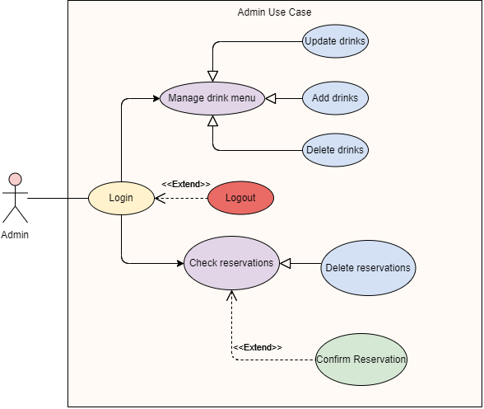

*Picture 3.3.1: Admin function use case.*

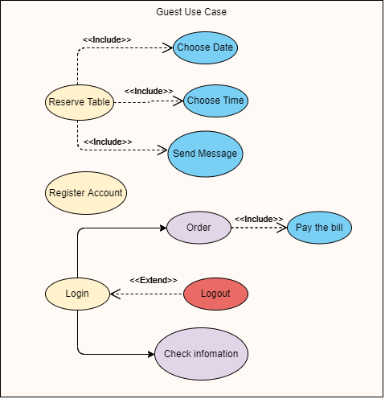

*Picture 3.3.2: Guest function use case.*

1. Use Case Specification
2. Login/Logout use case

|  |  |  |
| --- | --- | --- |
| Use case name: | Login/Logout use case | |
| Scenario: | Login/Logout to system | |
| Trigger event: | Admin, cashier employee wants to login/logout to the system | |
| Brief description: | User login to the system by account exists with information (name, email…) | |
| Actors: | Admin, cashier | |
| Pre-condition: | Admin or cashier must have the account exists | |
| Post-condition: | Login successfully | |
| Flow activities: | Actor | System |
| Want to login to the system  Provide information | Display the login form  Send information request.  2.1 Checking information  2.2 Provide access |
| Exception condition | Fail to check information | |

1. Add drinks use case

|  |  |  |
| --- | --- | --- |
| **Use case name:** | Add drinks | |
| **Scenario:** | Add drinks | |
| **Trigger event:** | Admin want to add drinks to menu | |
| **Brief description:** | Admin login to system and choose add drinks for adding drinks to menu | |
| **Actors:** | Admin | |
| **Pre-condition:** | Admin must login success to the system | |
| **Post-condition:** | Add new drinks complete | |
| **Flow activities:** | **Actor** | **System** |
| 1. Want to add new drinks to menu  2. Provide the information about the drinks | 1.1 Display the adding form  1.2 Request information about drink.  2.1 Upload information about new drinks to data base  2.2 Update menu |
| **Exception condition** | Fail to login | |

1. Update drinks use case

|  |  |  |
| --- | --- | --- |
| **Use case name:** | Update drinks | |
| **Scenario:** | Update drinks | |
| **Trigger event:** | Admin want to update drinks details | |
| **Brief description:** | Admin login to system and choose update drinks for update drinks details | |
| **Actors:** | Admin | |
| **Pre-condition:** | Admin must login success to the system | |
| **Post-condition:** | Update drinks complete | |
| **Flow activities:** | **Actor** | **System** |
| 1. Want to update drinks details  2. Provide the information about the drinks | 1.1 Display the update form  1.2 Request information about drink.  2.1 Update details to database  2.2 Update menu |
| **Exception condition** | Fail to login | |

1. Update drinks use case

|  |  |  |
| --- | --- | --- |
| **Use case name:** | Delete drinks | |
| **Scenario:** | Delete drinks | |
| **Trigger event:** | Admin want to delete drinks from menu | |
| **Brief description:** | Admin login to system and choose delete drinks for delete drinks from menu | |
| **Actors:** | Admin | |
| **Pre-condition:** | Admin must login success to the system | |
| **Post-condition:** | Delete drinks complete | |
| **Flow activities:** | **Actor** | **System** |
| 1. Want to delete drinks from menu  2. Choose drink want to delete | 1.1 Display list of drink  2.1 Delete from database  2.2 Update menu |
| **Exception condition** | Failed to login / Drink already deleted | |

1. Make order use case

|  |  |  |
| --- | --- | --- |
| **Use case name:** | Make order | |
| **Scenario:** | Make order | |
| **Trigger event:** | Cashier want to make order | |
| **Brief description:** | Admin login to system and choose update drinks for update drinks details | |
| **Actors:** | Cashier/ cashier | |
| **Pre-condition:** | Admin must login success to the system | |
| **Post-condition:** | Update drinks complete | |
| **Flow activities:** | **Actor** | **System** |
| 1. Want to update drinks details  2. Provide the information about the drinks | 1.1 Display the update form  1.2 Request information about drink.  2.1 Update details to database  2.2 Update menu |
| **Exception condition** | Fail to login/ customer want to change drinks | |

1. Reservations use case

|  |  |  |
| --- | --- | --- |
| **Use case name:** | Reservations | |
| **Scenario:** | Reservations | |
| **Trigger event:** | Customer want to Reservations | |
| **Brief description:** | Customer/cashier want to reservations system will proceed booking process | |
| **Actors:** | Cashier | |
| **Pre-condition:** | Cashier/customer must login success to the system | |
| **Post-condition:** | Booking complete | |
| **Flow activities:** | **Actor** | **System** |
| 1. Want to make reservations  2. Provide the information | 1.1 Display reservations form  1.2 Request information about the reservations.  2.1 Save information to database  2.2 Display booking complete |
| **Exception condition** | Fail to login | |

1. Class Diagram, Activity and Sequence Diagrams

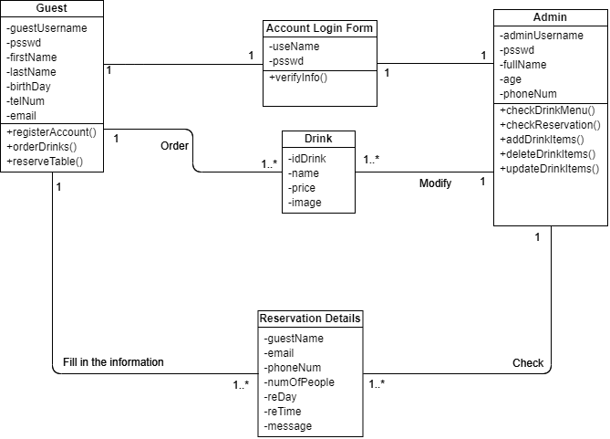

*Picture 3.5.1: Class Diagram*

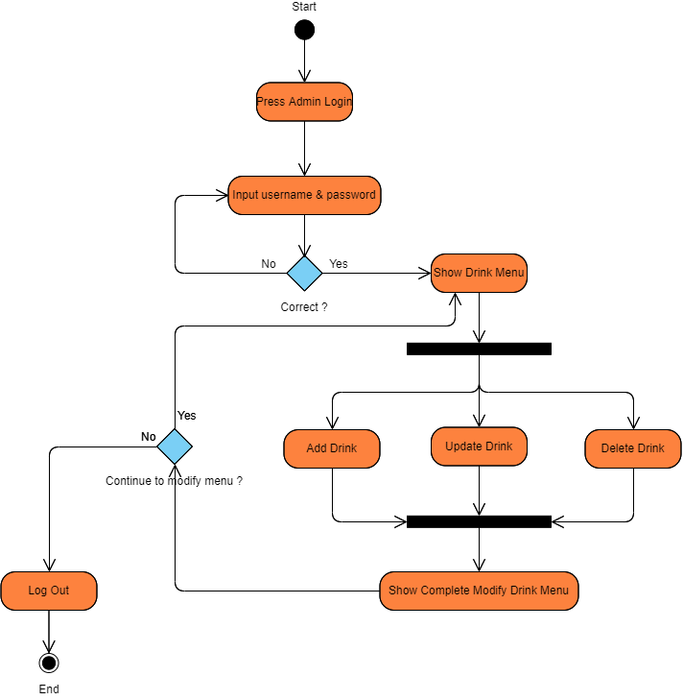

*Picture 3.5.2: Activity Diagram for Modify Drink Menu*

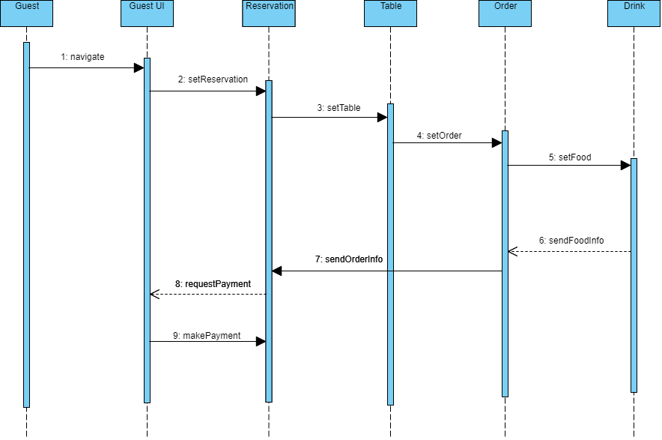

*Picture 3.5.3: Guest Sequence Diagram*

1. DataBase
2. **adminacc table**

|  |  |  |  |
| --- | --- | --- | --- |
| # | Name | Type | Null |
| 1 | **adminUsername**🔑 | varchar(30) | No |
| 2 | **psswd** | varchar(30) | No |
| 3 | **fullName** | varchar(30) | Yes |
| 4 | **age** | int(11) | Yes |
| 5 | **phoneNum** | char(15) | Yes |

1. **drinks table**

|  |  |  |  |  |
| --- | --- | --- | --- | --- |
| # | Name | Type | Null | Extra |
| 1 | **id**🔑 | int(11) | No | Auto_Increament |
| 2 | **name** 🔑 | varchar(150) | No |  |
| 3 | **price** | int(11) | No |  |
| 4 | **image** | varchar(150) | No |  |

1. **guestacc table**

|  |  |  |  |
| --- | --- | --- | --- |
| # | Name | Type | Null |
| 1 | **guestUsername**🔑 | varchar(30) | No |
| 2 | **psswd** | varchar(30) | No |
| 3 | **firstName** | varchar(30) | No |
| 4 | **lastName** | varchar(30) | No |
| 5 | **bDay** | text | No |
| 6 | **address** | text | No |
| 7 | **tel** | int(10) | No |
| 8 | **email** | varchar(30) | No |

1. **reservation table**

|  |  |  |  |
| --- | --- | --- | --- |
| # | Name | Type | Null |
| 1 | **guestName**🔑 | varchar(30) | No |
| 2 | **email** | varchar(30) | No |
| 3 | **phoneNum** | varchar(30) | No |
| 4 | **numOfPeople** | text | No |
| 5 | **reDay** | date | No |
| 6 | **reTime** | time | No |
| 7 | **message** | varchar(300) | Yes |

CHAPTER 4 – PROJECT PROCESS

1. **Login interface**

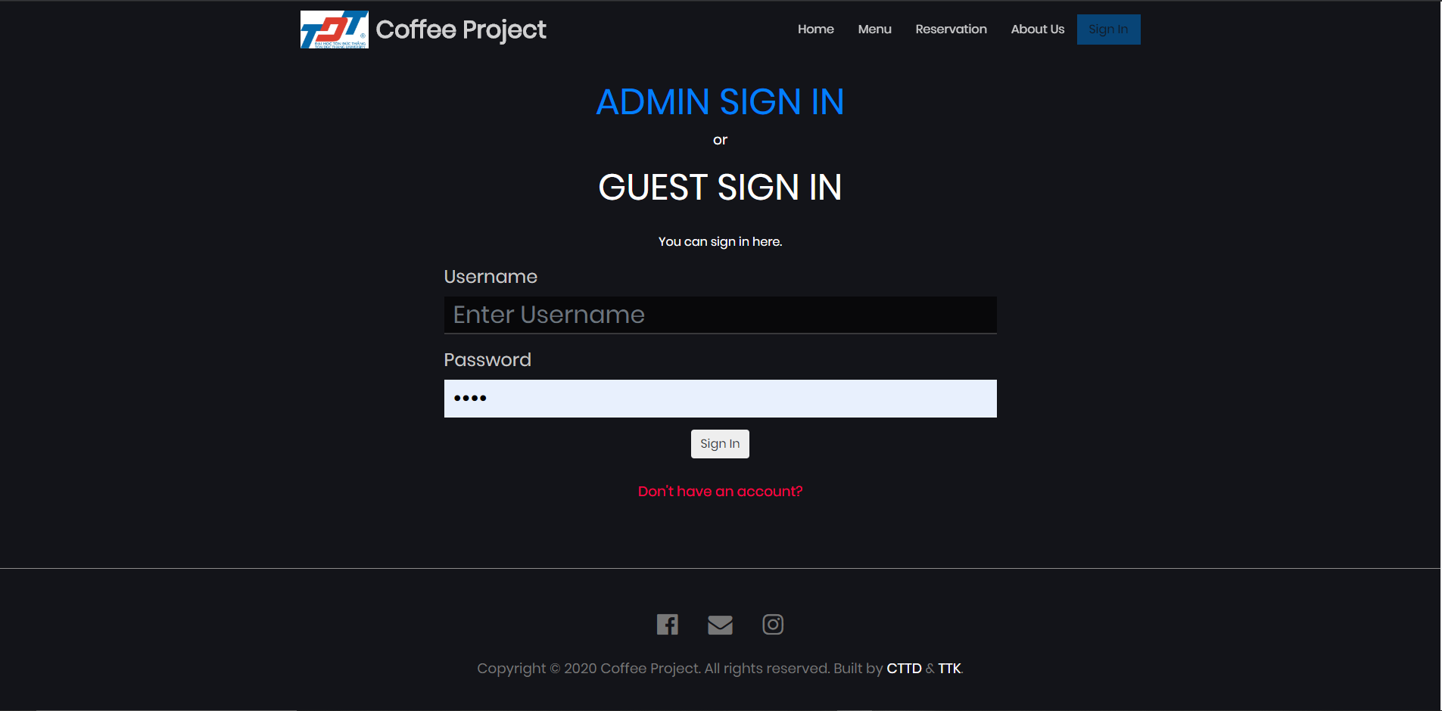

Picture 4.1.1: Guest login

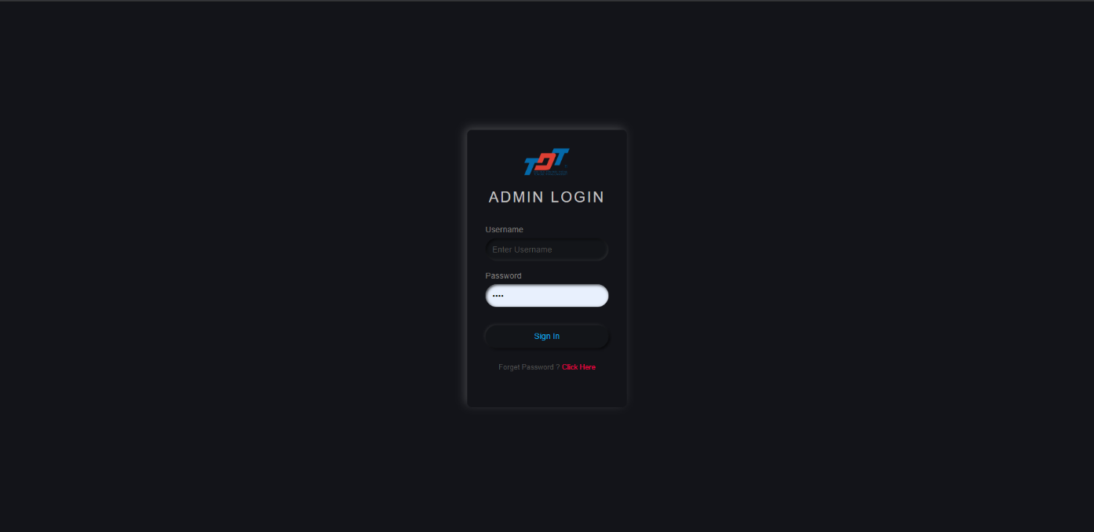

Picture 4.1.2: Admin login

* This is “Login” interface which requires user to input their “username” and “password” to get into the system. It also has two more functions which are “Remember me” and “Forgot password”. To more be specific, “Remember me” function helps user remember their account for the next login without input “username” and “password” again. Turning to “Forgot password” function, it helps user to set the new password in case they forget their password through their email account.
* Theoretically, there are two types of authority which are “manager” and “employee”.
* Manager: The account of those who manage something in the shop or hold a high level of position. For example:
  + Username: [manager@gmail.com](mailto:manager@gmail.com)
  + Password: 123
* Employee: The account of low level staffs. For example:
  + Username: [employee@gmail.com](mailto:employee@gmail.com)
  + Password: 123
* After filling in all the necessary information, user clicks “Login” button: The system will automatically check the validation of the account and set authority for that user.

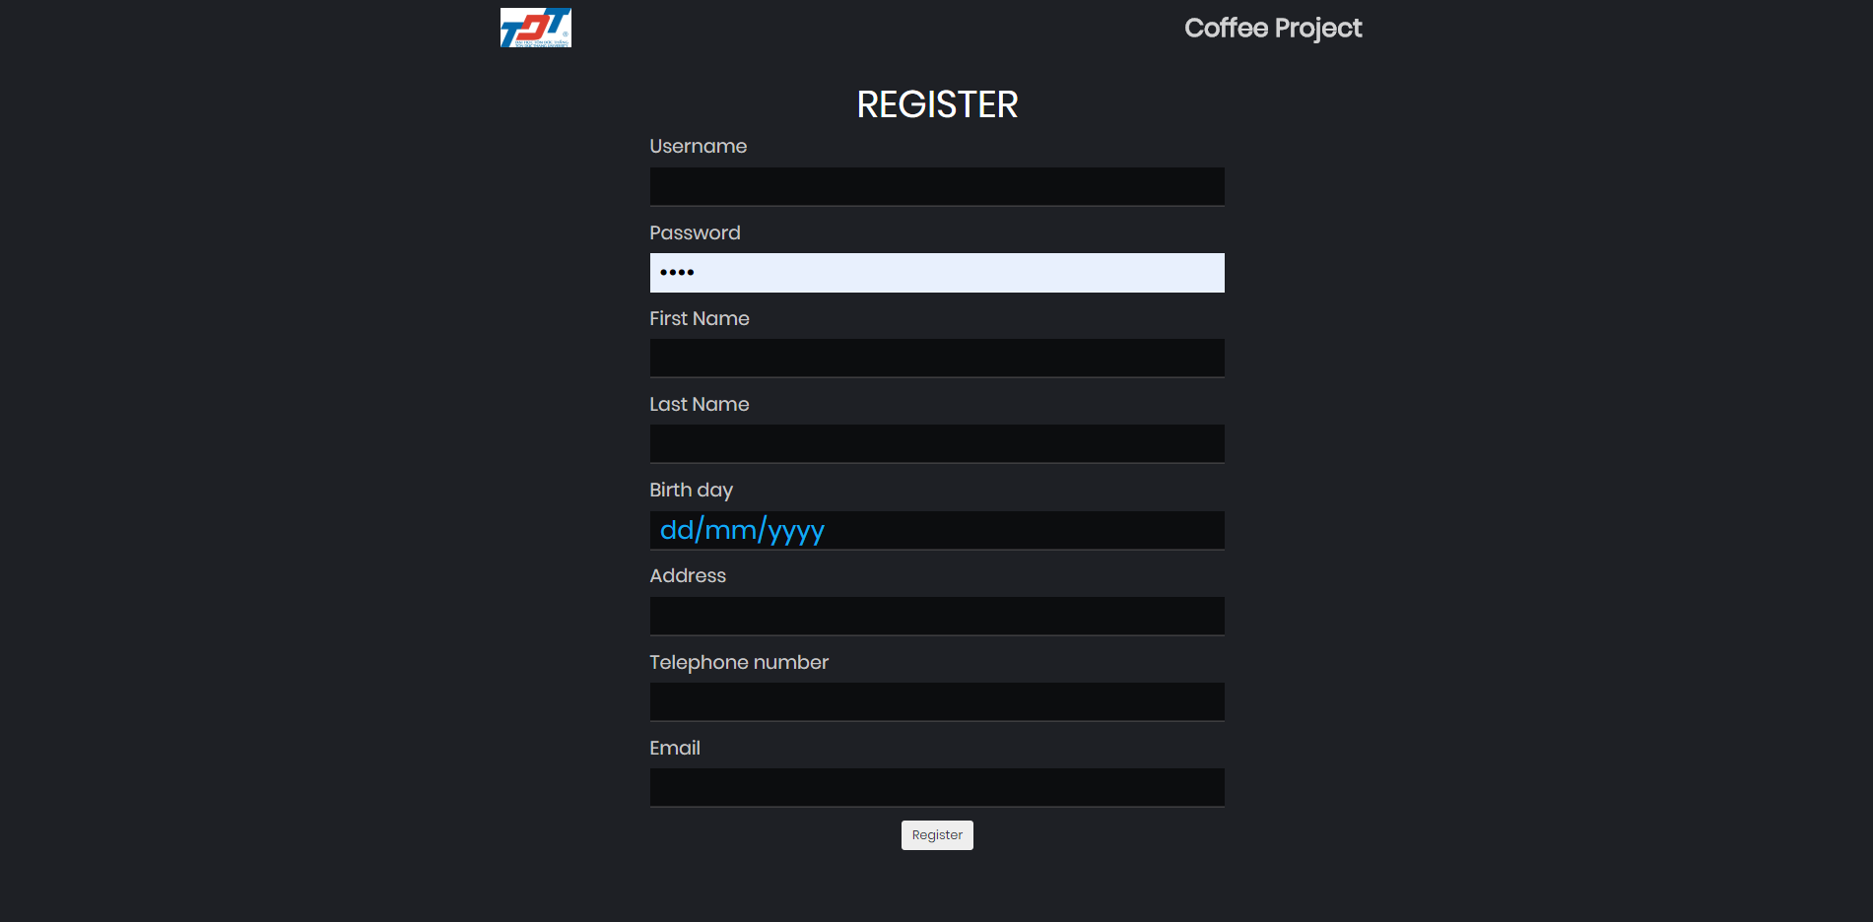

Picture 4.1.3: Register form

1. Reservation interface

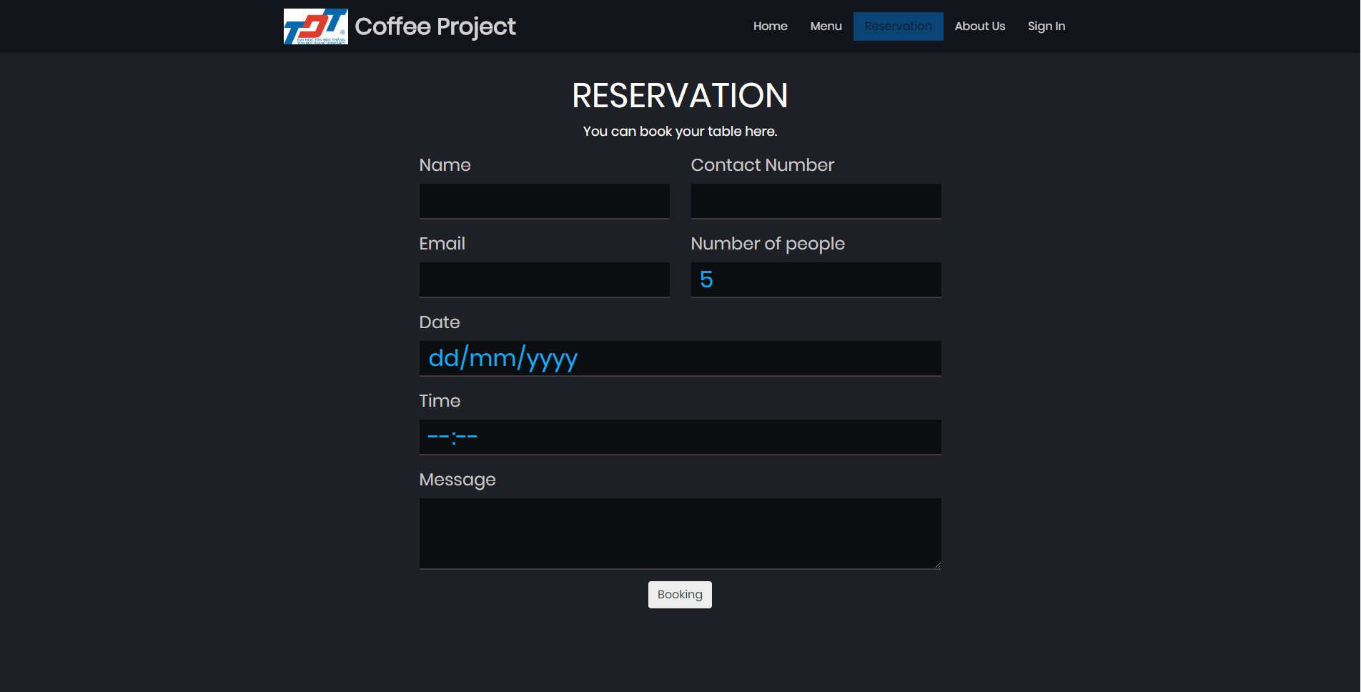

4.2.1: Reservation for user

* At this section, the user can make the reservation by provide the information for all the form and the system will store at database so th server or admin can confirm the reservation.

1. Admin Panel

* After the admin login to the system, the system wil display admin panel for the admin to use the function.

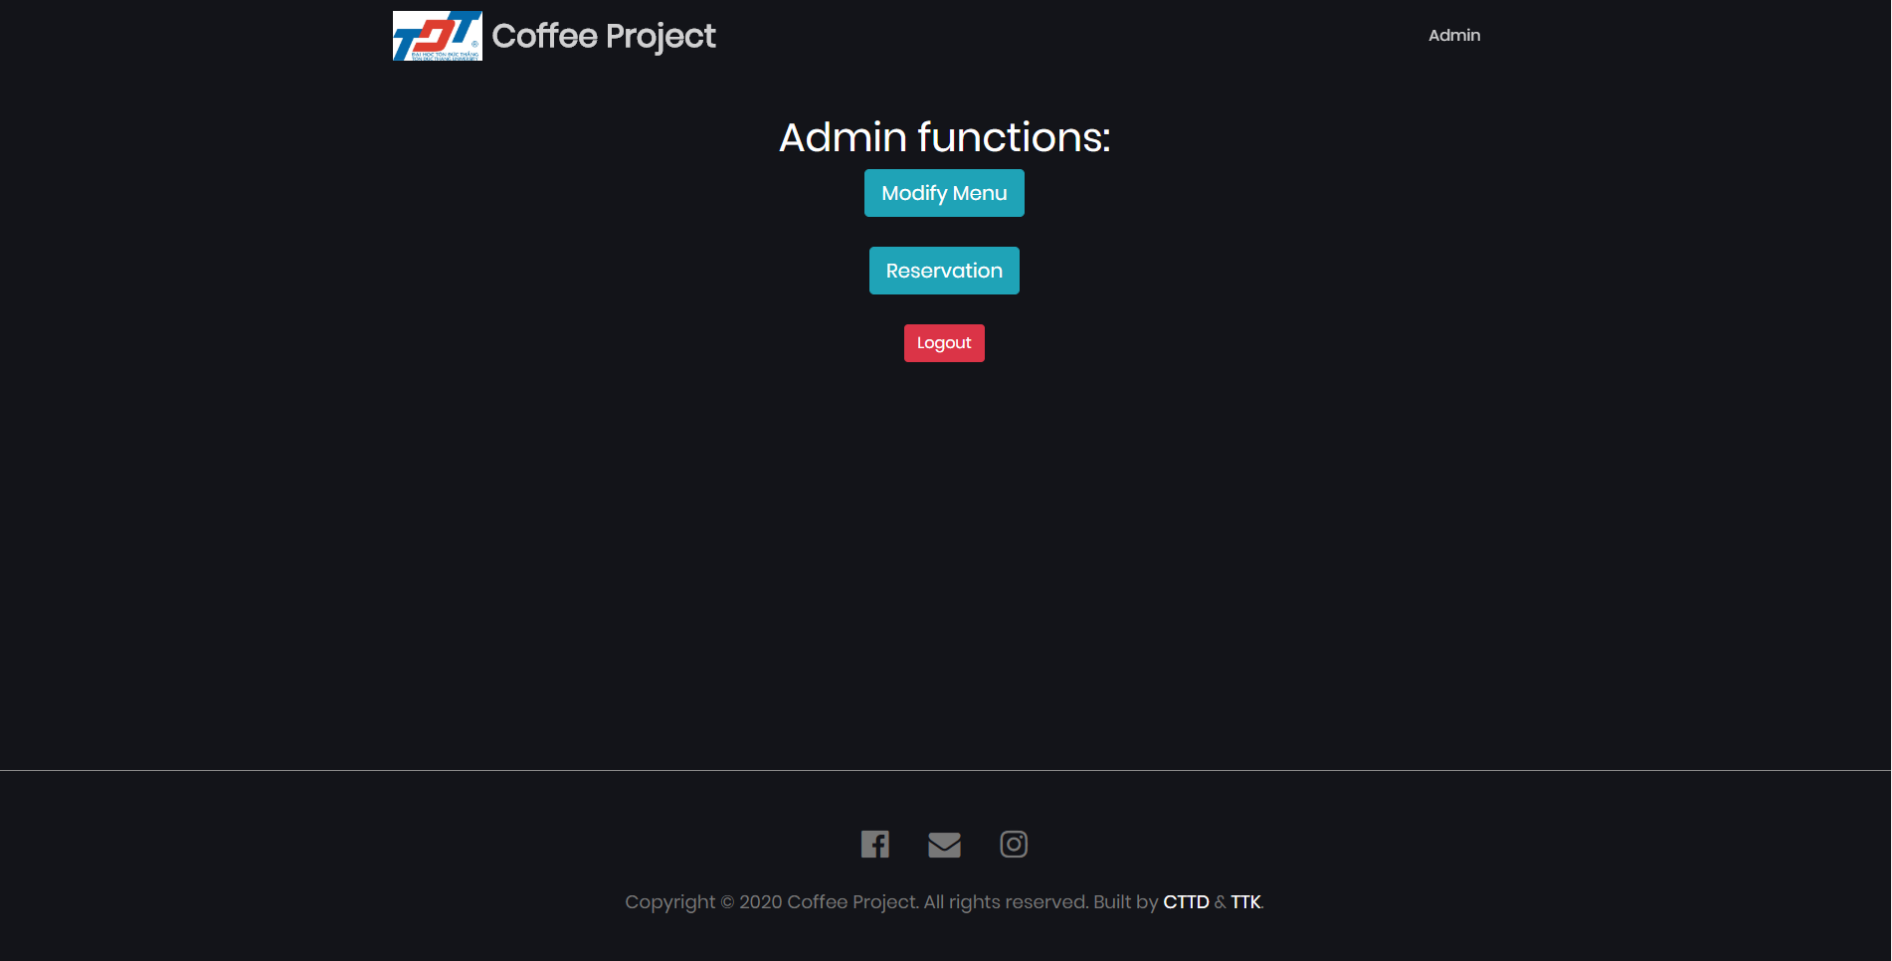

4.3.1: Admin panel

* Admin has 2 main function is modify menu or can checking the reservation to serve the customer.
* Admin can add new drink to menu by provide name, price, picture and the system will save information to database and update the menu so the customer can order new drink.

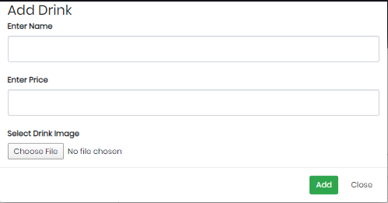

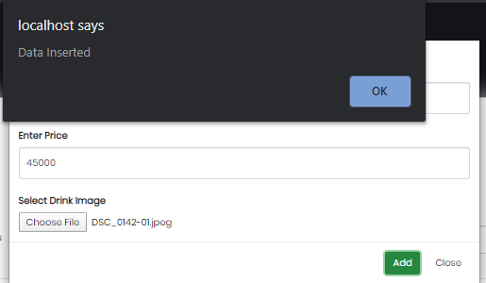

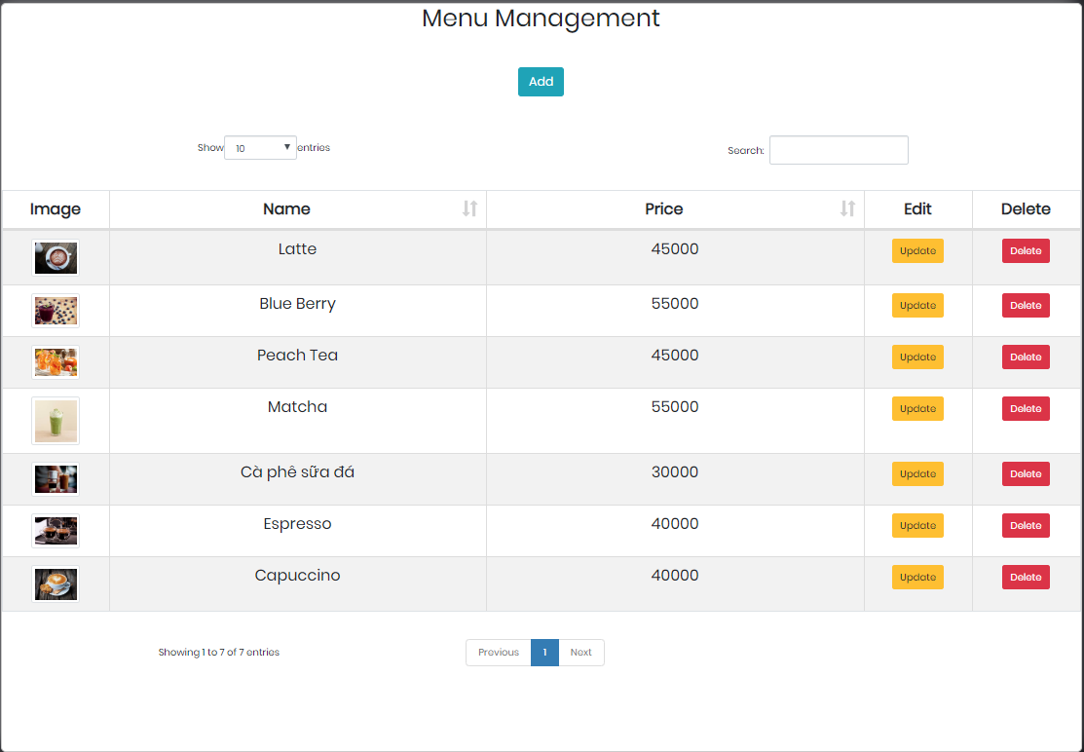

Picture 4.3.2: Adding new drink

* The design of “Add product” interface was based on “New account” interface, we focus on the friendly aspect as the board managers wish. It also has 3 main parts which are product’s information form, product’s picture, and buttons. The product’s information form is the main part of this interface, it works as the same way user’s information form in “New account” interface. System will require user to fullfil all the information of a product in order to add it into database.

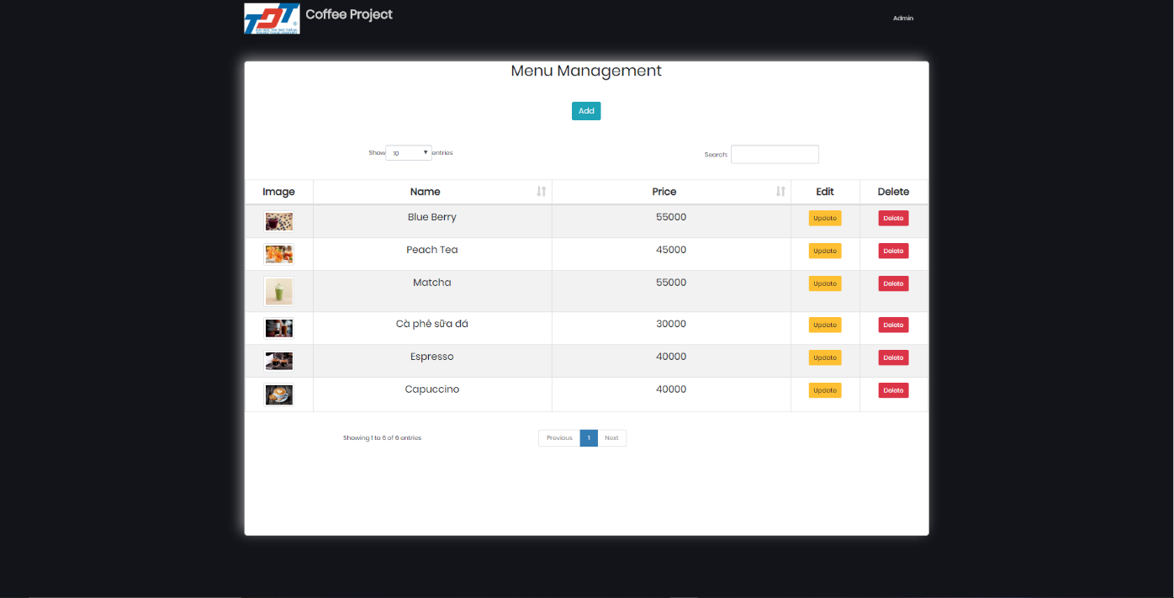

Picture 4.3.3 : Menu manage

* The reservation will display all the booking time of customer

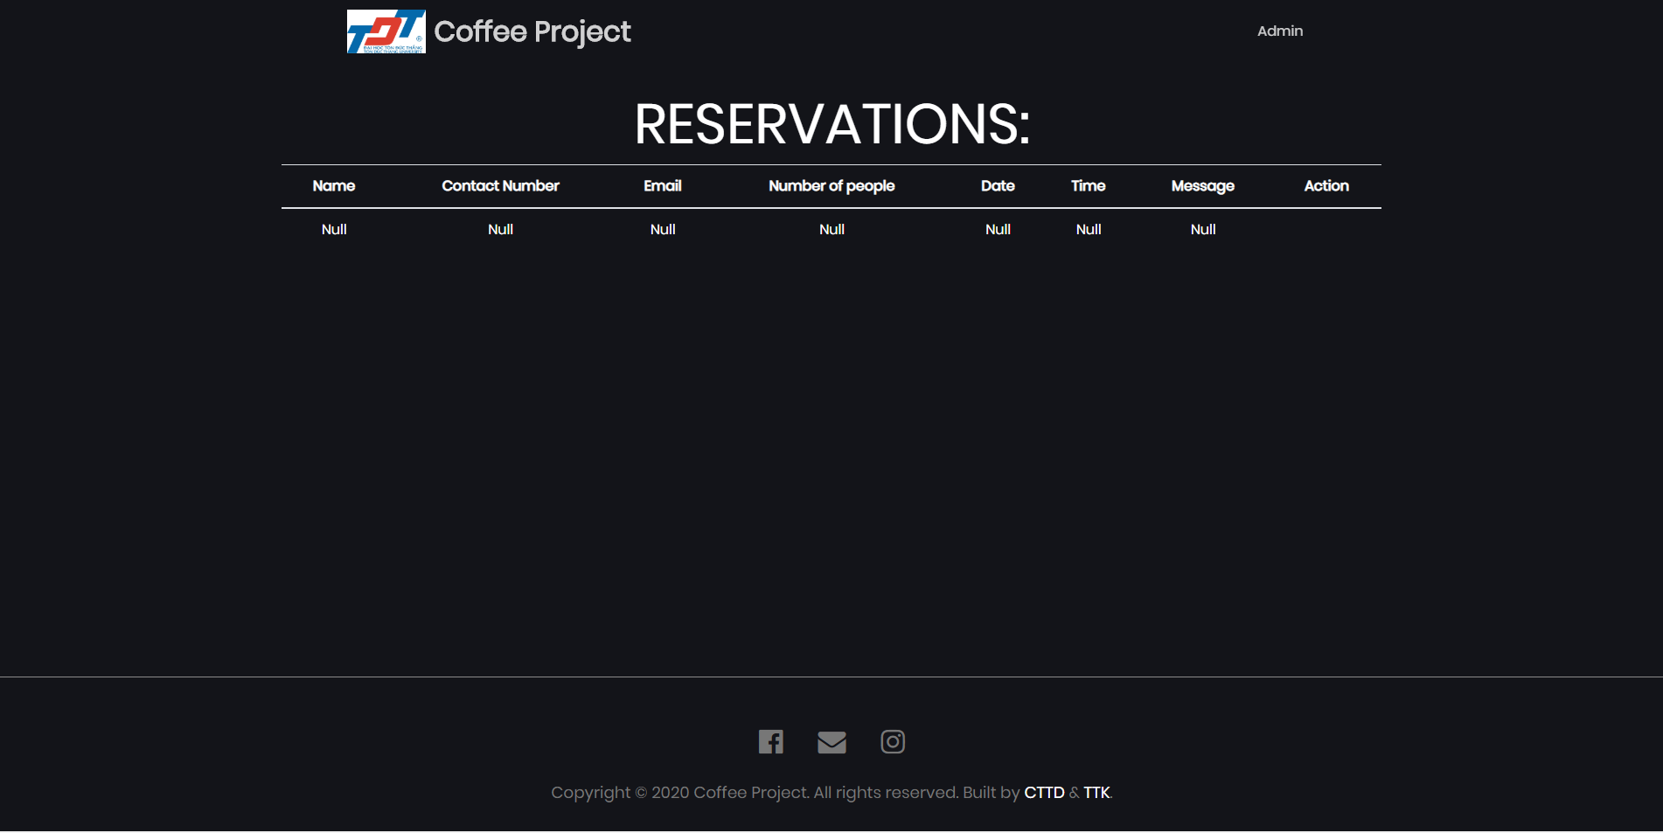

Picture 4.3.4 Reservation checking

1. Cart interface

* Turning to the function of “Make order” section, when user click “Add to cart” button to choose product for customer, “Cart” button will change the number which represents the quantity of product which is added to cart.

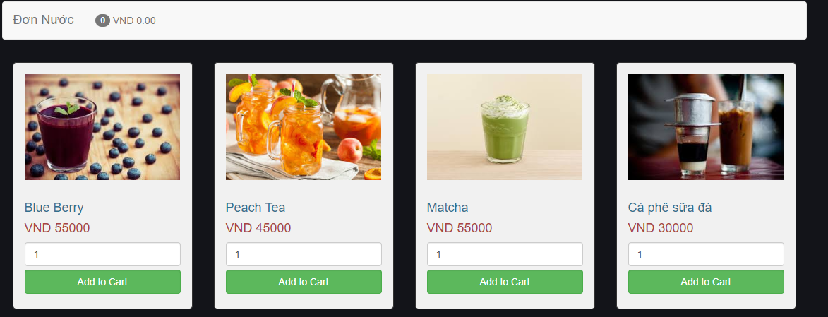

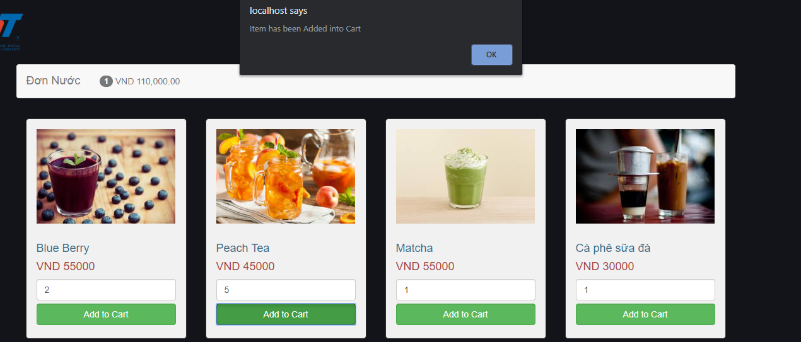

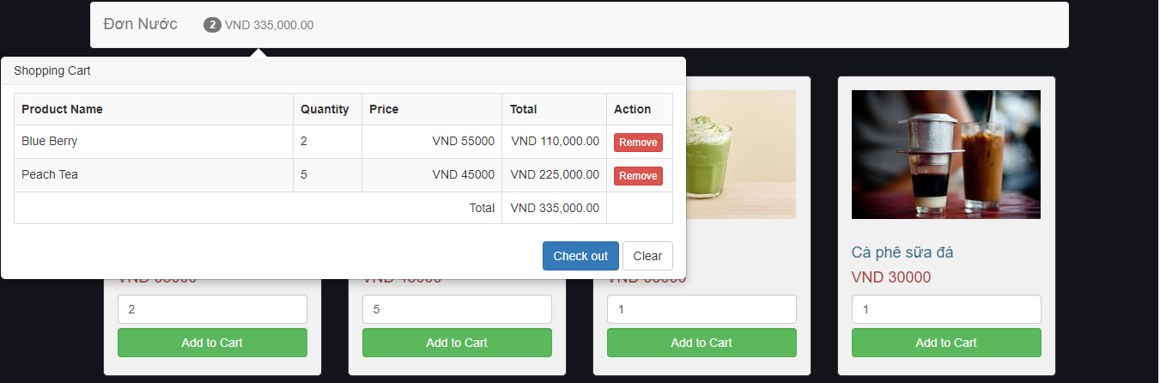

Picture 4.4.1: Add to cart

CONCLUSION AND FUTURE WORK

* In general, the main functions of business process are functional. They can help an employee proceed an order from customer and extract bill. However, checkout function is not working yet. As the result, every worker in the shop can do orthers job without any permission.
* There are still several functions that can improve user experience such as creating a function

REFERENCES