Jayden Hamilton 20231849
Week 1 (6–12 March) – Project Planning & Azure Setup

1) Business Requirements for CTU Training Solutions
Scalability - The system must support increasing numbers of students and staff.
Availability - Systems must remain available with minimal downtime.
Security - Student and institutional data must be protected.
Cost Efficiency - The cloud solution must remain affordable and manageable.
Remote Access - Students and lecturers must access systems from anywhere.

2) Azure Services Required
Resource Groups
Azure Virtual Machines
Azure Storage
Azure Virtual Network
Azure Active Directory

3) Screenshots
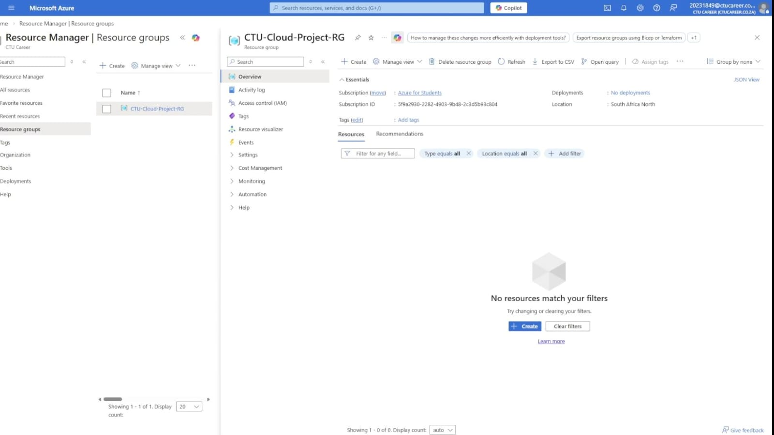
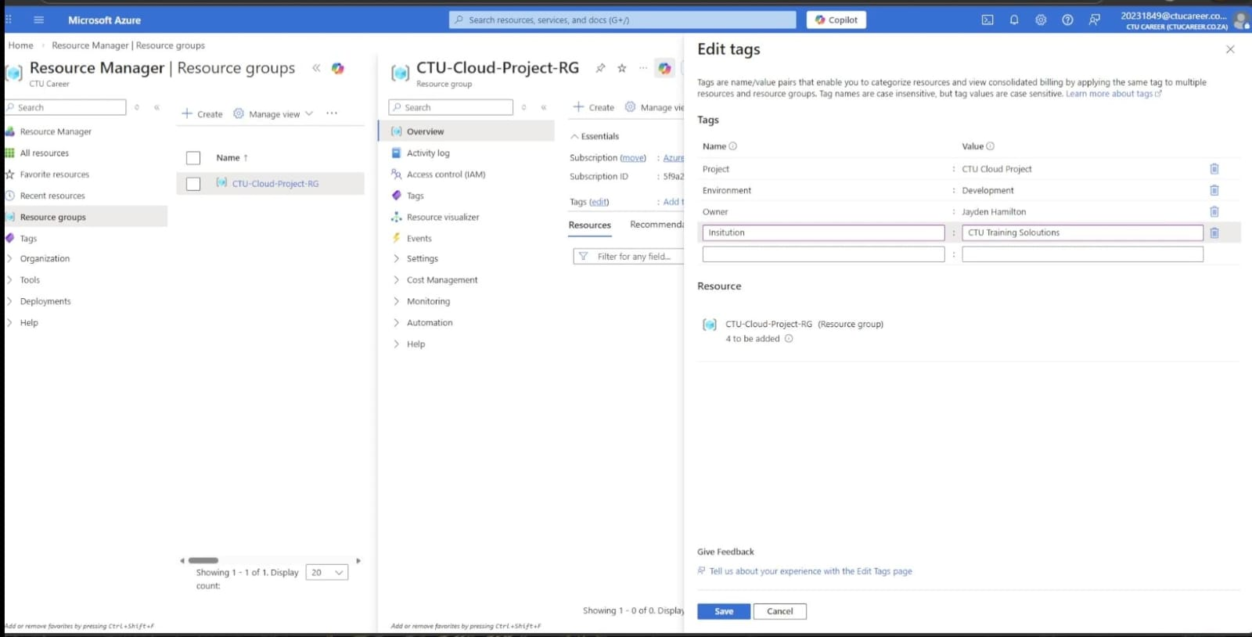

4) References
https://azure.microsoft.com

https://learn.microsoft.com

https://aws.amazon.com/what-is-cloud-computing

